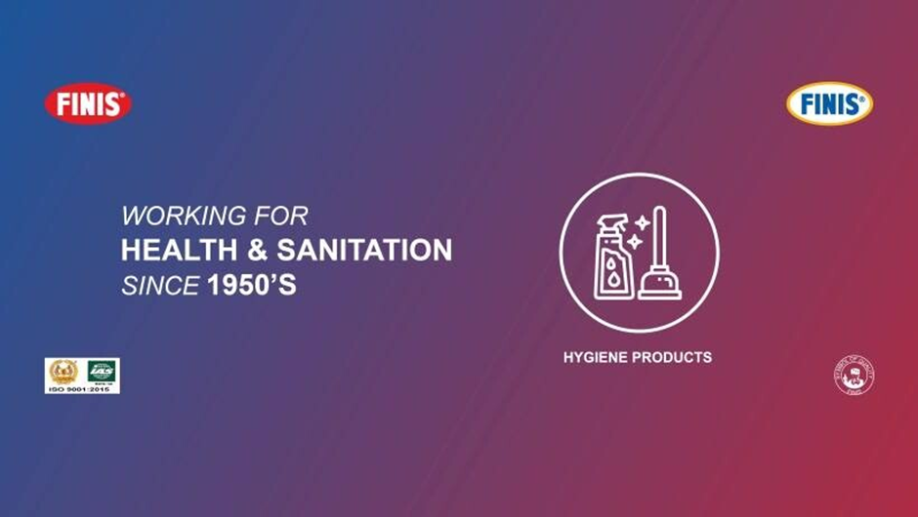



Impact of HRIS in Decision Making

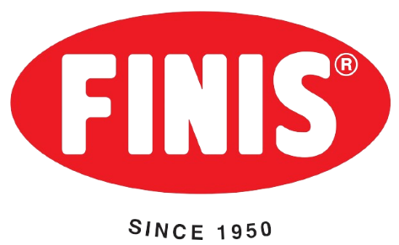

The Case of Standard Finis Oil Company
By
Marziah Islam Bhuiyan Fariha



United International University
INTERNSHIP REPORT

Submitted to:
Ms. Nasrin Akter
Assistant Professor,
School of Business & Economics (SoBE)
United International University
Submitted by:
Marziah Islam Bhuiyan Fariha
ID: 111201165
Major: Human resource management (HRM)
School of Business & Economics (SoBE)
United International University

Registration Trimester: Summer 2025

School of Business and Economics
Date of submission: November 22, 2025

Letter of Transmittal

Ms. Nasrin Akter
Assistant Professor
United international university.
Subject: Submission of an Internship Report on the topic of HRIS at Standard Finis Oil Company.
Dear Ma'am,
It is with deep respect, that I am so delighted to present my internship report, which is in the form of a part of of my Bachelor of Business Administration (BBA) degree, with a major in Human Resource Management at United International University., HRIS at Standard Finis Oil Company.
My experience as an intern in the HR and Administration Department of Standard Finis Oil Company was one such opportunity to work and learn various activities related to HRIS-based activities such as employee data management, employee attendance records and administrative support activities. During the internship, I was lucky and had an opportunity to observe and get a glimpse of actual HR activity, and this allowed me to put my theoretical knowledge into practice.
The reason is that I would like to send my deepest regards to you, Ms. Nasrin Akter ma'am, who has been guiding me, supervising me, and giving me useful advice throughout the report preparation. I am also grateful that the officers and the employees of Standard Finis Oil Company collaborated and supported me during my internship experience.
I have done my level best in preparing this report with good faith and honesty. Nevertheless, it is possible that some accidental errors or constraints can occur, and I am asking you to please understand me. I wish you to be able to make use of this report as I believe it is informative and to your expectations.
Thanks to your precious time, support, and encouragement.


Sincerely yours,
Marziah Islam Bhuiyan Fariha
ID: 111201165
School of Business and Economics
United international university.

Certification of Similarity Index

Declaration of the Student

With my ID - 111201165, a student of Bachelor of Business Administration (BBA) program with a major in Human Resource Management (HRM) under the School of Business and Economics, United International University, I do hereby confirm that I have prepared and submitted the internship report titled as HRIS at Standard Finis Oil Company on behalf of fulfilling a partial requirement of my BBA degree.
This report is a culmination of my personal work, analysis and observation during my internship period in Standard Finis Oil Company. Other than the information and data sources that have been duly recognized and mentioned, there is no content in this report that has been submitted or published elsewhere either academically or professionally.
I also confirm that I have been absolutely honest and upright in the process of preparing this report and I am fully responsible of what is contained in the report.

Sincerely yours,
Marziah Islam Bhuiyan Fariha
ID: 111201165
School of Business and Economics
United International University

Corporate Evidence

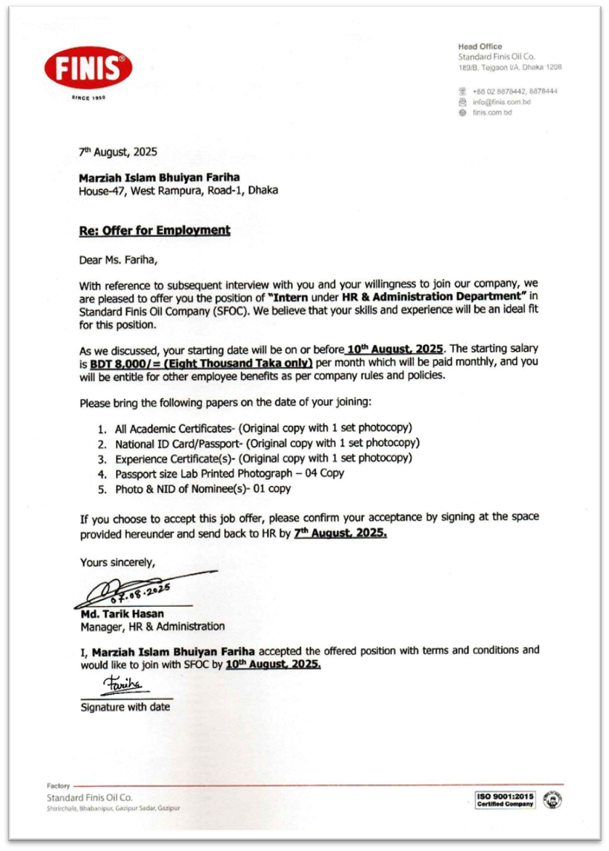

Acknowledgement

First of all, I would like to say that my gratitude to the Almighty who provided me with strength, patience, and competence to complete my internship and prepare this report successfully within the specific time frame.
This is to express my great thanks to my academic supervisor, Ms. Nasrin Akter, Assistant Professor, School of Business and Economics, United International University, who through her guidance, helpful suggestions, and friendly support helped me all along in creating this report. Her valuable feedback and support has been very motivational and inspiring.
My gratitude would also like to be given to my company supervisor, Mr. Naimus Sadat, who has always supervised, guided and cooperated with me throughout my internship in Standard Finis Oil Company. I am also grateful to my Line Manager, Mr. Tarik Hasan and Dotted supervisor (HR), Ms. Jannatul Fardousy, who were patient, mentored, and supported me in learning and knowing different HR operations and HRIS activities.
I would wish to acknowledge all the members of the HR and Administration Department and other coworkers at Standard Finis oil Company, who were very accommodative, encouraging, and cooperative throughout my internship period. They worked and acted in a professional manner that enabled me to learn and adjust well within the organizational culture.
And lastly, I would like to say that I am extremely grateful to my family and friends who have supported me, motivated, and encouraged me to complete this journey, which was possible thanks to their unremitting support. This report would not have been completed successfully without them and their inspiration and prayers.
Sincerely,
Marzia Islam Bhuiyan Fariha

Executive Summary

The following internship report is made with the partial provisional completion of my Bachelor of Business Administration (BBA) at the United International University. I was able to have an internship in Standard Finis Oil Company (SFOC) in the HR and Administration Department where I got a pragmatic experience with the role of human resources and how they can be used with the use of digital technology such as HRIS (Human Resource Information System). As an intern, I was able to operate in four key areas of the company: the Head Office and Factory Unit 1, Factory Unit 2, and Salesforce Team (Marketing and Sales Department). This gave a broad perspective of the management of the HR activities in various operational environments. My tasks were entry of employee data, attendance and leaves, creation of appointment and separation letters, organization of interviews, creation of ID cards, and files. I also created Excel-based employee record trackers and purchase requisitions, which assisted the organization to have a proper and precise documentation. A significant portion of my education was associated with the implementation and the effects of HRIS in the essential functions of HR. The system enabled the effective management of recruitment, selection, training, performance appraisal and compensation. In the recruitment and selection, the HRIS simplified the candidate tracking and evaluation process, which saves both cost and time because the data collected is reusable. As a component of training and development, HRIS data were used to determine the gaps in skills and to track training progress. The HRIS gave accurate and data-driven information during performance appraisal and compensation decisions, and this ensured that there was fair evaluation and timely processing of salary.The practical value of accuracy, coordination, and communication in HR, I acquired during this internship. I was able to get real-life experience on how to handle employee information of both factory employees and executives, the differences in employee payroll, eligibility to receive overtime and digital payment. The fact that I worked with various departments also enhanced my time management, teamwork, and problem-solving skills.
Finally, this internship helped in the transition between the theoretical concepts and actual HR practice. It has also shown that digital platforms such as HRIS can increase efficiency within organizations, provide grounds to make informed decisions, and minimise administrative tasks. Not only did the experience enhance my technical and professional skills, but it also helped to get a clear understanding of how HR operations impacted the overall organizational success.This report is a detailed report on my internship experience, HRIS application, and its relevance to HR decisions, and the lessons as well as recommendations concerning further improvement of HR operations.

Top Keywords for Reports
- Human resource information system (HRIS)
- Standard finis Oil Co. (SFOC)
- Decision making
- Impact
- HR Digitalization

FOR INTERNSHIP
Table of Contents
Letter of Transmittal i
Certification of Similarity Index ii
Declaration of the Student iii
Corporate Evidence iv
Acknowledgement v
Executive Summary vi
CHAPTER 1: INTRODUCTION 1
I.1 Background of the Report 2
I.2 Objectives of the Report 3
I.3 Rationale of the Report 4
I.4 Scope and Limitations of the Report 5
I.5 Definition of Key Terms 6
CHAPTER 2 : COMPANY AND INDUSTRY PROFILE 9
2.1 Company Analysis 9
2.1.1 Overview and History 12
2.1.2 Trend and Growth 13
2.1.3 Product / Service / Customer mix 13
2.1.4 Company Operations / Activity 16
2.1.5 SWOT Analysis 18
2.2 Industry Analysis 20
2.2.1 Specification of the Industry 20
2.2.2 Size, Trend, and Maturity of the Industry 21
2.2.3 Industry SWOT Analysis 23
CHAPTER 3: IMPACT OF HRIS ON DECISION MAKING
3.1 HRIS overview of the Standard Finis oil Co. 28
3.2 The Disparity between Factory Workers and Executive in HRIS use. . 32
3.3 Effect of HRIS in Recruitment Decision. 33
3.4 Effect of HRIS in Selection Decision. 36
3.5 Effects of HRIS in Compensation Decision. 38
3.6 Summary of Findings 40
CHAPTER 4: INTERNSHIP EXPERIENCE 42
4.1 Position, Duties, and Responsibilities 42
4.2 Training & Development 44
4.3 Contribution to Organization / Operations 45
4.4 Evaluation 47
4.5 Skills Applied 48
CHAPTER 5: CONCLUSIONS AND KEY FACTS 52
5.1 Recommendations 52
5.2 Key understanding 53
5.3 Conclusion 54
Reference 55

CHAPTER 1

INTRODUCTION

INTRODUCTION

The internship program will form a necessary aspect of the curriculum of the Bachelor of Business Administration (BBA) at United International University (UIU). It offers a learner a chance to get a practical experience, learn how organizations work, and close the gap between the theory and the business working experiences. The program enables the students to see, take part and contribute in the working environments, and thus get some skills that they require in their future occupations.
Lucky I was to be on my internship at Standard Finis Oil Company (SFOC), one of the oldest and most reputable oil company producers of insecticides, disinfectants and home cleaning products in Bangladesh. SFOC started its operation way back in 1950 and this has a long history of offering affordable yet vital health products to the people. My company will have four primary areas: Head Office, Factory Unit 1, Factory Unit 2, and Salesforce (Marketing and Sales) Department, which provided a thorough insight into how HR and administrative processes serve all areas of the company.
I had various practical activities during my internship in the HR and Administration Department that gave me an opportunity to learn the real HR practice. These were entering and handling employee data into the HR software of the company, preparing appointment and separation letters, arranging employee files, maintaining attendance and leave history, and arranging interviews. I also designed Excel-based employee data and purchase requisition tracking systems that served to keep records straight and also enhanced operational efficiency of all the departments.
The internship helped me to realize the practical significance of HRIS (Human Resource Information System) in decision making. I got to know that information gathered using the system helps in recruiting, selection, training, performance appraisal and compensation, thereby lowering cost and enhancing efficiency. Moreover, the experience of working in the departments allowed me to enhance my communication, teamwork, time management, and technical abilities, as well as allow me to gain an insight into the professional culture and workflow in a developing manufacturing organization.
This report will be a documentation of my internship experience, an overview of SFOC operations, Hr practices, and the influence of HRIS on the decision-making. It also identifies my roles, skills I gained, contributions I made, and the difficulties I faced and how this experience contributed to my personal and professional development. In this report, I would like to illustrate the role of practical exposure in augmenting the students academic learning and equipping them to face the realities of business.

Background of the Report

This report will be a documentation of my internship experience in the Standard Finis Oil Company (SFOC) in accordance with a portion of the requirement to attain my Bachelor of Business Administration (BBA) degree in United International University (UIU). The internship has offered a chance to get a hands-on experience in a working environment, especially within the HR and Administration Department, which is a key component in providing the management of employee information, operational effectiveness and support of various departments.
The oldest insecticides, disinfectants and household cleaning products manufacturer in Bangladesh is Standard Finis Oil Company that was founded in 1950. The company has a history of more than 75 years when it has been involved in contributing to the common health and sanitation, and producing affordable and necessary goods without compromising on quality. Through the internship, I was able to work in four significant areas of the company which included, Head Office, Factory Unit 1, Factory Unit 2 and the Salesforce (Marketing and Sales) Department providing me with the opportunity to see administrative and operational processes in various organizational settings.
The activities that I engaged in during the internship included data management of employees, issuing appointment and release letters, keeping records of attendance and leaves, file organization, and interview coordination. I also designed Excel based tools to ensure proper records are kept of different departments and designed a system of tracking purchase requisitions. These assignments made me realize how HR activities work in reality and how computer applications such as HRIS (Human Resource Information System) facilitate things, increase accuracy, and aid decision-making in the recruitment, selection, training, performance appraisal, and compensation fields.
This report in general indicates my practical learning process, which illustrates how my theoretical understanding of HR courses was put to practical application. It demonstrates the contribution and formulation of major professional skills I made to the organization and the understanding of the value of data-driven decision-making and proper HR management in a modern organization such as Standard Finis Oil Co.

Objectives of the Report

The main goal of this report is to give a detailed presentation of the internship experience in Standard Finis Oil Company, and show how the practical exposure into the HR operations has increased my appreciation of the management of an organization. The report will help fill the gap between the knowledge taught in the classroom and the application in real world in a professional work setting.
Certain goals of this report are:
1. Learning about HR Practices in an Existing Organization: In order to study and observe the work of the HR and Administration Department on a structured and dynamic working environment, such as data management, employee records, attendance and leaves monitoring.
2. The Role of HRIS in Organizational Operations: To examine how Human Resource Information System (HRIS) could be utilized to store data on employees, facilitate the recruitment, selection, training, performance appraisal and compensation-related decisions effectively.
3. Practical Skills Learning: To obtain practical experience in such activities as the preparation of appointment and release letters, files organization, records maintenance in different departments, and creation of tracking systems with the help of such digital tools as the Excel and HRIS software.
4. Comparison of the HR Effect on the decision-making process: To test the effect of the information gathered using HRIS on HR decision making, cost reduction, efficiency, and fair and accurate management of employees at various levels of the organization.
5. Personal and Professional Development: To consider the learning process, attain soft skills such as communication skills, coordination, time management, and comprehend the value of teamwork and ethical conduct in a professional environment.
The attainment of these goals will enable this report to give a clear picture of practical challenges and duties of HR professionals and also point out the strategic role of HRIS in enhancing efficiency and decision-making in an organization.

Rationale of the Report

The reason why this internship report has been prepared is to write and report on the real experiences and learning outcomes in the course of my stay in Standard Finis Oil Company. In contrast to the classroom education, the real business world demands a practical knowledge of how the organization works and this is essential to a student studying the Bachelor of Business Administration (BBA) degree.
This report has a number of purposes. First, it gives me a systematic overview of the tasks, functions, and projects I completed within the HR & Administration Department that has given me the opportunity to bridge the gap between theory and practice. By this, I am able to prove that I have the knowledge of important HR functions like the management of employee data, employee recruitment, selection, training, performance appraisal, and compensation.
Second, the report emphasizes on HRIS (Human Resource Information System) to control information about the employees and make decisions. Through the review of the efficiency, error reduction and economical operations that HRIS can offer, the report indicates the practical rewards of utilizing technology in HR practices.
Third, the report highlights the aspect of my personal and professional development. Through active involvement in real life processes, e.g. keeping of employee records, taking attendance, official letter preparation and coordination between various departments, I was in a position to improve my technical, analytical and interpersonal skills.
Lastly, the report serves as a source of knowing how the modern HR departments functions in an organized company and the strategic value of HRIS in decision making. It offers future students and professionals information regarding challenges, learning prospects, and viable solutions that define effective human resource management.
To conclude, this report rationale is to combine academic knowledge with practice as well as present my learning outcomes and demonstrate the importance of technology-based HR practices in enhancing organizational effectiveness and decision-making.

Scope and Limitations of the Report

Scope of the Report:
In the current report, I am going to concentrate on my internship experience with Standard Finis Oil Company, namely, in the HR and Administration Department. It encompasses the practical implementation of the human resource management processes, such as the management of the employee data, recruitment, selection, training, performance appraisal and compensation processes.
The report highlights the application of the HRIS (Human Resource Information System) to handle the information of employees and aid in decision-making. It emphasizes in the application of the system in various sections of the company, including; the Head Office, Factory Unit 1, Factory Unit 2 and the Salesforce ( Sales and Marketing) Department.
Besides, the report discusses the effect of HRIS in enhancing efficiency, error reduction, and cost-effective operations. It comprises my individual work, projects, and real-life learning experience, which gives a holistic picture of how the work of the modern HR is performed in the real business setting.
Limitations of the Report:
Although this report is comprehensive, it has the following limitations:
- The overview is confined to the HR and Administration Department and most other areas of the company like production or finance are not explored in depth.
- The company policies on employees privacy did not allow inclusion of some information especially information on confidential employee records or strategic decisions.
- My personal observations and experiences as an intern may not reflect all of the aspects of the HRIS system and organizational functioning, which is why the findings and conclusions are personal.
- The report is based on practical experiences and not a large amount of theoretical analysis, therefore, certain academic frameworks or literature might not be used in a profound way.
- The internship timeline did not permit the time needed to be exposed to some of the HR processes, which could potentially influence the understanding of particular fields.
Finally, though the report is a clear overview of my practical learning and use of HRIS at Standard Finis Oil Company, it should be noted that it is a limited and experience-driven analysis as opposed to the comprehensive analysis of the organization.

Definition of Key Terms

It is necessary to define the following key terms to be clear and have a proper understanding of the report:
- Internship:
An organized work experience in an organization whereby a student gets to acquire practical knowledge, skills and exposure to professional settings pertinent to his or her field of study.
- The HRIS (Human Resource Information System):
An electronic platform that is employed by organizations to store and handle information, attendance, leave and payroll among other HR related items of employees effectively. HRIS in this report is the system employed in Standard Finis Oil Company in the process of streamlining the HR operations and decision-making.

- Recruitment:
The act of attracting, screening and selecting competent employees to a job. HRIS assists in organizing information about the candidates, application tracking, and saves time and cost involved in recruitment.
- Selection:
The evaluation and the selection of the best candidate to fill a post. HRIS aids in selection where it can be seen that the data is structured to eliminate bias and improve decision-making.
- Training & Development:
Plans aimed at enhancing the employees in terms of skills and knowledge as well as performance. HRIS assists in defining training requirements, monitoring attendance and evaluating performance.
- Performance Appraisal:
The planned appraisal of the job performance of an employee. HRIS enables managers to record performance indicators, track as well as give fair assessments.
- Compensation:
All the benefits provided to the employees; salary, allowances, bonuses, and benefits. HRIS facilitates the correct and prompt payment and allowance calculation.
- Head Office:
The head office of Standard Finis Oil Company in which the main administrative and HR functions are implemented.
- Factory Unit 1 & Unit 2:
The factories where employees are engaged to work in the company. In this case, HRIS is applied in terms of attendance monitoring and record keeping.
- Salesforce/Marketing Department:
The sales and marketing staff. In this department, HRIS assists in the maintenance of employee attendance, leave as well as performance records.
- Employee Data Management:
The storage, updating and maintenance of proper records of employees. HRIS streamlines this process.

CHAPTER 2

COMPANY AND INDUSTRY PROFILE

COMPANY AND INDUSTRY PROFILE

This chapter gives a summary of Standard Finis Oil Company (SFOC) the company I had my internship. It entails the history of the company, its products, its operations and its general stance in health and sanitation sector in Bangladesh.
Standard Finis Oil Company is a reputed and among the oldest manufacturing company in Bangladesh that was founded in the 1950s. It began its operations as the pioneer industry to manufacture insecticides and disinfectants in the country to promote the health and sanitation of the people in more than 75 years. The company has succeeded on the premise of quality, new technology, and affordability.
The chapter also brings out the growth trends of the company, mix of products and services and customers segmentations. It speaks about the way SFOC can easily control its operations by its production units, head office, and the nationwide distribution network.
Besides that there is a SWOT analysis to appreciate the strengths, weaknesses, opportunities, and threats that the company has in the present competitive market. All in all, this chapter contributes to forming a clear image of the company structure, functions, and good standing in the health and sanitation industry in Bangladesh.

Company Analysis

Standard Finis oil Company (SFOC) is a very renowned and reputable manufacturing company in Bangladesh and it is proud to have served the country more than 75 years. SFOC was a pioneer in ensuring the promotion of public health and hygiene through the production of high-quality insecticides, disinfectants, and sanitation products since its formation in the early 1950s. It is the first Bangladeshi company to produce insecticides and disinfectants in Bangladesh.
The Head Office of the company is located in Tejgaon Industrial Area, Dhaka, whereas there are Factory Unit 1 and Unit 2, situated in Shirirchala, Bagher Bazar, Joydebpur, Gazipur. These two manufacturing plants are the core of production operations in SFOC, which are manned with the advanced technology and high-quality workforce.
SFOC is currently producing and selling more than 50 varieties of products under its brand name FINIS that is a household name in Bangladesh. Its products comprise of mosquito coils, aerosol, toilet cleaners, floor cleaners, hand wash, disinfectants and other hygiene related products that directly help in the health and cleanliness of Bangladeshi families.
Mission
To produce and supply quality, disease-preventive and affordable health and sanitizing products that respond to the daily hygiene needs of the people and ensure that communities are resistant to the harmful germs and insects.
Vision
To make sure that all houses in Bangladesh have access to quality and affordable health-saving products, hence a cleaner, safer, and healthier country.
Nature of Business
Standard Finis Oil Company is a manufacturing and marketing company that deals with health, hygiene and sanitation business. Its business units comprise product research and development, sourcing of raw materials, mass production, quality assurance, marketing and distribution across the country. The company is certified on ISO 9001:2015, BSTI, and BCSIR which offers quality on a global dimension and safety standards of the country and international standards.
Product Range
The FINIS brand has a wide product line that is offered by SFOC:
- Insecticides: medallions, aerosols, mosquito repellent sprays.
- Sanitizers / Disinfectants and Cleaners: Toilet cleansers , floor cleansers , glass cleaning product and multi-surface disinfectants.
- Personal Hygiene: Antiseptic liquids, hand wash and hand sanitizers.
- Other Health-Protective Items: Air fresheners and domestic cleaning agents.
These products are well distributed in Bangladesh both in the urban and rural markets and further exported to other countries such as Nepal and other Africa countries, and as such, the company is experiencing increased exposure across the globe.
Organizational Structure
SFOC also has a functional organization structure where roles are segregated according to the departments like Production, Marketing and Sales, Human Resources, Finance, and Administration. The departments have highly experienced managers who report to the senior management.
Current Management Roles:
• Chairman: Ms. Nurjahan Sulaiman Ajanee.
• Managing Partner: Ms. Adiba Sulaiman Ajanee.
The Late Mr. Sulaiman Ajanee, who died on Saturday, September 14, 2024, was one of the main contributors to the good reputation of SFOC, as he had combined his leadership, hard work, and commitment to family values such as honesty, discipline, and social responsibility to achieve good reputation. His wife and daughter are competent to carry on his legacy.
Work Environment
The company has a good disciplined and people friendly work environment. SFOC encourages collaboration, openness, and respect between the employees. It also offers good working environments in its factories and equitable remunerations, equal opportunities and career development programs. The organization is of the opinion in motivating the employees by recognizing them and managing them ethically.
Market Position
Standard Finis Oil Company is also a top player in the hygiene and sanitation industry in Bangladesh. Having decades of consumer loyalty, steady quality of products, and a broad range of distribution, FINIS has established itself as one of the most familiar and trusted brands on the market. The fact that it has remained focused on innovation, affordability, and social awareness initiatives e.g. campaigns against dengue and cholera has also enhanced its reputation as people-oriented and socially responsible company.
The fact is that Standard Finis Oil Company (SFOC) is not only a leader in the industry it represents the Bangladesh heritage, creativity, and community good. SFOC has a visionary leadership and a well-developed production hub coupled with a lot of dedication to health and hygiene making it the benchmark of quality and trust to serve generations with purpose and pride.

Overview and History

Standard Finis Oil Company is a reputable and reliable manufacturing firm in Bangladesh that deals with manufacture of health, hygiene and cleaning products. The company has served its customers over several years and its core principles of quality, innovation and customer satisfaction have served as the core principles of the company.
- Inaugural ceremony and History:
The Standard Finis Oil Co. began its adventure with one purpose in mind that is to provide good quality hygiene and cleaning products to every home and organization in Bangladesh. It has over the years become a household name in the industry in terms of constant betterment and commitment.
- Growth and Development:
The company started simple by making a number of basic cleaning products in the initial stages. As time went by, it extended its product range, introduced new technologies and improved its distribution network. It has a vast clientele today including home, hospital, schools and industries.
- Status and Market Presence:
The company has established a good reputation of offering good, safe and efficient hygiene solutions. Offering quality assurance, good management, and client satisfaction, Standard Finis Oil Co. has managed to gain a good reputation in the Bangladeshi market and become a recognized brand.
- Commitment to Quality:
Since its inception, the company has been primarily concerned with the quality of its products and meeting its hygiene requirements. All the products are produced under a stringent quality control process in order to address the needs and expectations of the customers.

Trend and Growth

Consistently, Standard Finis Oil Co. has been growing over the years as it has been enhancing its products and expanding its market base. Innovation, quality and customer satisfaction are the key objectives of the company and have enabled it to remain in a high position in the health and sanitation market of Bangladesh.
The important areas of trend and growth are:
- Product innovation: The company has been launching better health and hygiene products to satisfy customers and market trends on 1st regular basis.
- Market expansion: It has increased its distribution network throughout the country and the availability of the products is easily available both in the urban and rural regions.
- Brand reputation: Standard Finis Oil Co. has gained the customer trust over the years due to the quality and good marketing strategies that have enabled the company to win the trust of the customers.
- Employee development: The company focuses on employee training and development to ensure efficiency and growth.
- Sustainability initiatives: It has begun to embrace green operations and technology to ensure that production becomes more sustainable.
On balance, the trend of development of the company shows a moderate approach to the business performance, customer confidence, and innovation. Its steady development has seen it become one of the established brands in health and sanitation business in Bangladesh.

Product / Service / Customer mix

The mix of products, services and customers.
Standard Finis Oil Co. is a reputed company that produces health, hygiene, and sanitation products in Bangladesh. The company is determined to enhance cleanliness and health of the people using innovative, affordable, and quality products. It has over time diversified its products and developed a high level of customer confidence through a stable level of quality.
A. Product Mix
Standard Finis Oil Co. provides a wide range of portfolio through two large brands namely FINIS and TARA (TARA CARE). These brands in combination have a total of more than 54 Stock Keeping Unts (SKUs) that cater to the household and institutional markets.
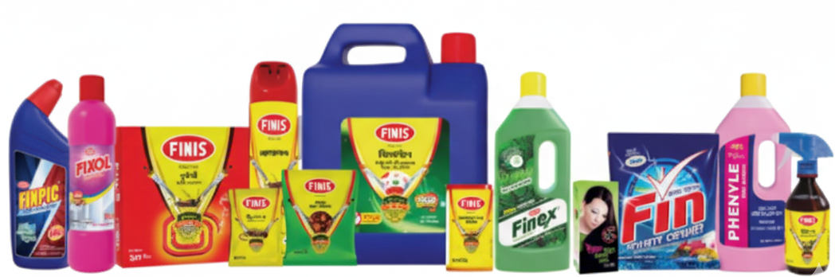

- FINIS Brand Products ( Flagship Brand):
FINIS brand is mostly revolved around insecticides, disinfectants, and cleaning solutions, which have assured protection and hygiene.
- Insecticides & Pest Control:
- FINIS Insect Powder - Which is Cockroach Killer
- Insect Powder (Ant Killer) FINIS.
- FINIS Liquid Spray (Flying And Crawling insect killer)
- FINIS AEROSOL - Which is All Insect Killer
- FINIS Rat Killer (Wheat Bait)
- FINIS New Booster Mosquito Coil.
- FINIS Max Jumbo Coil
- FINIS Black Booster Mosquito Coil.
- FINIS Wood Preservative (Woodworm and termites control)
- Cleaning Agents & Washing:
- FINIS Phenyle, Phenylle Extra Strong, Perfume Phenyle.
- FINIS GermX (Disinfectant)
- FINIS Stable Bleaching Powder.
- FINIS Finpic Toilet Cleaner (New Gel Formula)
- FINIS Fin Power White Detergent Powder.
- FINIS Fixol Tiles Cleaner
- FINIS Finex Liquid Floor Cleaner (Lime and Pine Flavor)
- FINIS Finray Glass Cleaner (Spray gun and refill pack)
- Multi-purpose Cleaners FINIS Pure LTD. & FINIS pure LTD.
- Lebu+ Dish Wash Bar

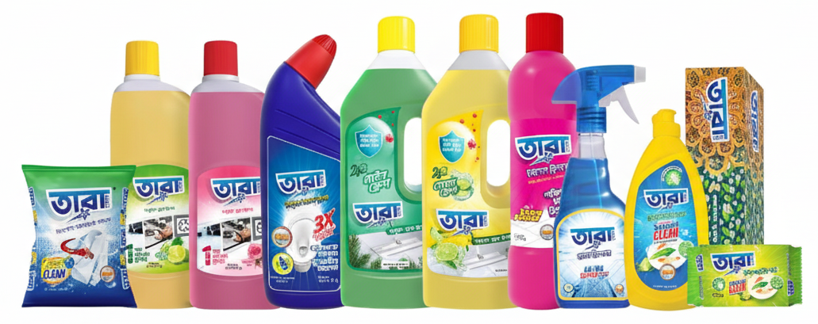
- TARA Brand Goods (TARA CARE):
The TARA brand has a parallel collection of cleaning and hygiene necessities which are used in everyday home.
Cleaning and hygiene products do not necessitate an extensive product range; however, the variety of items available serves to differentiate the company alongside its competition.<|human|>Cleaning and Hygiene Products:
<|human|>Cleaning and hygiene products do not require significant product range; the number of products available is used to distinguish the company as well as its competitors.
- Cleaning and hygiene products
- TARA CARE Liquid Floor Cleaner (Lime and Pine Flavor)
- TARA CARE Tiles Cleaner
- TARA CARE Glass Cleaner
- TARA CARE Toilet Cleaner
- TARA CARE Washing Powder
- TARA CARE Dish Wash Bar
- TARA Dish Wash Liquid
- TARA Agarbati Daxzen Box (Incense Sticks)
B. Service Mix
The company also ensures, along with product excellence,:
- On time delivery and logistics all over Bangladesh.
- Corporate client, hospital and institution bulk supply.
- Customer services and channels of quality improvement.
- Advertisement and sensitization on cleanliness and hygiene.
C. Customer Mix
These are just some of the customers served by Standard Finis Oil Co. which include:
- Individual consumers and households.
- Hospitals and clinics
- Corporate factories, corporate offices.
- The government organizations and educational institutions.
- Retailer, wholesalers and distributors.
Quality assurance, affordability and accessibility have helped the company to develop long term relation with its customers. Its non-stop product diversification is an indication of its commitment to address the varying hygiene requirements of its consumers in Bangladesh.

Company Operations / Activity

Standard Finis Oil Co. has a well organized system that allows a smooth production, distribution and the general performance of the business. The company is operation based on producing superior quality health, hygienic, and sanitation commodities at the same time being efficient, safe and maintaining customer satisfaction.

- Manufacturing Operations:
The company manufactures a variety of products under FINIS and TARA names.
  - The manufacturing is carried out in the well-equipped plants with high-quality control measures.
  - The products are also checked on a regular basis at every production level to provide consistency and safety.
  - Other applications of the modern technology and machinery use in the company is to enhance efficiency and minimize errors.
- Quality Assurance:
  - Quality Standard Finis Oil Co. is ISO certified.
  - Raw materials are carefully selected and tried prior to the production.
  - Final goods are scrutinized carefully in order to assure safety and hygiene standards.
- Distribution and Logistics:
  - The company has an excellent distribution system throughout Bangladesh, both in the urban and the rural set-up.
  - Products are distributed to the retailers, wholesalers, corporate clients, hospitals and institutions in an efficient and timely manner.
  - The company also handles the level of stocks and the delivery time to prevent shortages.
- Customer Commitment and Marketing:
- Promotional activities, awareness initiatives on hygiene and sanitation, and education of the various marketing activities are carried out.
- Illustration Customer feedback: It is a constant collection of customer feedback which is used to enhance products and services.
- The company aims at establishing good relationships with distributors, retailers and end consumers.
- Administrative and HR Activities:
- Standard Finis Oil Co. has a professional work environment where there is a well-coordinated work of the departments such as the HR, Finance, Marketing, and Administration.
- Employee training and development are also accorded importance so as to ensure efficiency and skill development.
- Innovation and Sustainability:
- The company constantly develops the formulations of products keeping in touch with changing consumer demands.
- It is working towards the embracement of green and sustainable production and packaging.
In general, the activities of Standard Finis Oil Co. can be characterized as the compromise between the efficient production, the strict quality control, the successful distribution, and the constant innovation that ensure the company will be the reliable leader in the health and hygiene market of Bangladesh.

SWOT Analysis

A SWOT analysis can be used to know strengths, weaknesses, opportunities and threats of Standard Finis oil Co. This discussion offers an idea of how the company is able to sustain itself within the health and hygiene business of Bangladesh.
Strengths:
  - The reputation: The company is the oldest producer of insecticides and disinfectants in Bangladesh; it is 68 years old and was founded in 1950.
  - Strong product line: More than 54 SKUs of FINIS and TARA brands that satisfy the needs of varied customers.
  - Quality assurance: Reliability and trust are guaranteed by the use of products that are ISO certified and quality control.
  - Good distribution network: Nationwide, both cities and rural markets.
  - Customer loyalty: Households, institutions and corporate clients have confidence in the company because of the quality of the products.
  - Innovation: Ongoing product advancement and launching of current cleaning products.

Weaknesses:
  - Poor internationalization: It is largely based in Bangladesh with little export base.
- Dependence on supply of raw materials: Overdependence on the local and imported raw materials may impact on production.
- Marketing constraints: The inadequate level of online sales and marketing in comparison to the competitors.
Opportunities:
  - International market growth: International markets have the potential of receiving more products.
  - Digital transformation: The younger customers can be reached by implementing more advanced IT and e-commerce strategies.
  - Health and hygiene consciousness: Due to the increased interest in cleanliness at the post-COVID-19 stage, the products become demanded.
  - Diversification of the products: Potential to introduce new hygiene and household markets.
Threats:
  - harsh competition: Competes with local and international companies dealing with hygiene and cleaning products.
  - Economic shifts: Production costs may be affected by inflation or pauses in the supply chain.
- Regulatory changes/ Regulatory changes can necessitate further compliance.
- Market saturation: This could decrease market distribute due to increased competition and related goods.
The SWOT analysis reveals that the Standard Finis Oil Co. has a solid base that developed on the levels of quality, trust, and innovation. There are threats and challenges, but there is a lot to be tapped especially in the international markets and with digital expansion. The approach to strategic planning and constant improvement will assist the company to retain its dominance in the hygiene and sanitation industry.

Industry Analysis

Standard Finis Oil Co. operates in the health, hygiene and sanitation product industry, which is located in Bangladesh. This industry is very essential in the sustenance of the health of the people, prevention of illnesses, and promotion of cleanliness in homes, offices, and institutions. This industry has also been very competitive in the years and there are both local and international firms that have played their part in increasing variety of products, innovativeness, and accessibility.

Specification of the Industry

The industry will be specified.
- Nature of the Industry:
The sector specializes in the manufacture of insecticides, cleaning agents, household hygiene and disinfectants. Such products are necessities in the everyday life and community wellbeing particularly in overcrowded areas such as Bangladesh.
- Target Market:
The market is composed of households, hospitals, schools, corporate offices, government institution, and retail outlets. These products are needed by the consumers as they provide hygiene, safety, and pest control.
- Regulatory Environment:
BSTI (Bangladesh Standards and Testing Institution) is one of the organizations regulating the industry to provide safety, quality, and adherence to national standards.
- Technology and Innovation:
Companies are moving towards modern manufacturing technologies, and environmentally friendly formulations, and digital tools so as to enhance efficiency, quality and customer interaction.
- Market Trends:
- Increasing awareness of personal health and hygiene, in particular, following the COVID-19 pandemic.
- There is a growing demand of environmentally friendly and safe products.
- The growth of retail stores and online shopping sites has increased the availability of products in the country.
To conclude, the health and hygiene product sector in Bangladesh is expanding, competitive and changing. The continual innovations, quality and efficient approach to customers are what firms such as Standard Finis Oil Co. have to do to remain on top of this industry.

Size, Trend, and Maturity of the Industry

Health, hygiene and sanitation product business in Bangladesh has experienced tremendous growth in recent few decades. It is important in the conservation of the health of the populace and the elimination of diseases, particularly in overpopulated urban and semi-urban regions.
Size of the Industry:
- Some of the sources through which the industry caters to include high number and varieties of households, hospitals, schools, corporate offices, government institutions, and retail industries.
- This is because the population is more than 170 million and there is a constant and high demand of insecticides, disinfectants and cleaning product.
- Local domination of the market is associated with such companies as Standard Finis Oil Co., although there are many other domestic and international brands that also play a role in the overall size of the industry.
- Institutional and corporate demand also contributes to the expansion of the market size as offices, factories and hospitals need to have bulk purchases of hygiene products on a regular basis.
Trends in the Industry:
  - Higher Health Consciousness: The post-COVID-19 consumers are more health-conscious and aware of cleanliness, hygiene, and disease prevention.
  - Eco-Friendly Products: This is driven by increasing demand in having eco-safe and chemical free products and this has pushed firms into thinking of innovative products.
  - Product Diversification: Firms are diversifying their products, diversifying to aerosols, gels, floor cleaners, and specialty disinfectants, to suit the needs of the different customers.
  - Digital Marketing and E-commerce: Retail outlets that are online are expanding exponentially allowing consumers in urban and rural regions to access them easily.
  - Community: Community- The companies participate in community awareness campaigns regarding dengue, cholera, and other health-related problems, which enhance brand equity.
Maturity of the Industry:
- The industry is deemed as moderately mature. The companies have put in place production and distribution channels as well as customer bases, particularly within the local market.
- Innovation and new product development: the market continues to grow due to innovation and new product development that make it competitive and dynamic.
- The industry is mature in the home market, but the growth in the foreign market has a high potential especially in the South Asian and African markets.

The health and hygiene product market is an established but a dynamic sector in Bangladesh with a healthy growth due to the rising health awareness, product development and expansion of market share. Such companies that integrate quality, low cost, and availability such as Standard Finis Oil Co. are well placed in remaining at the top of such industry as seeking new opportunities.
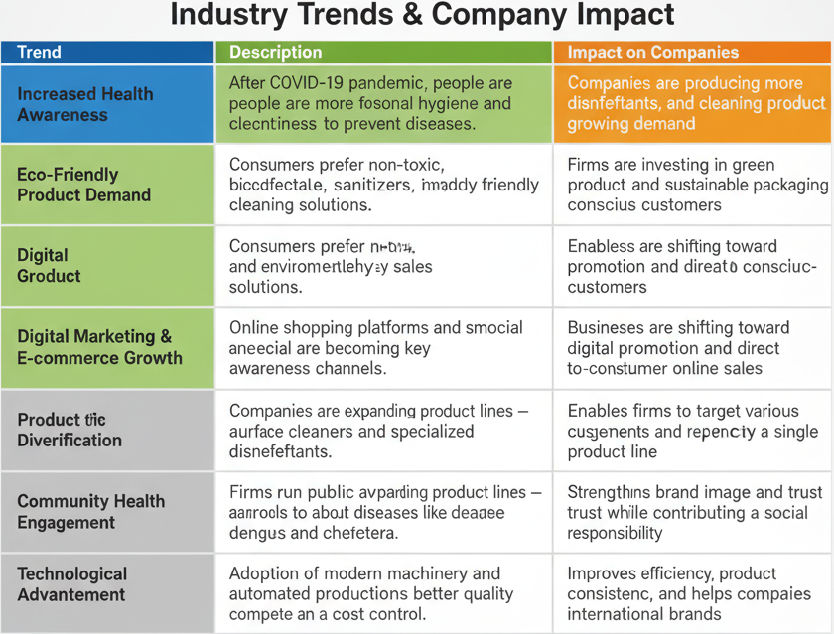

Industry SWOT Analysis

A market analysis of Bangladesh, health, hygiene and Sanitation product industry demonstrates the main internal and external forces that determine the performance and competitiveness of the industry. This market, which is a result of the requirements of the population in the health field and growing consumer awareness, has a great positive growth but has difficulties linked with economic fluctuations, technological changes, and competition.
Strengths
- Consistent Market Demand:
The need of hygiene, disinfectants and pest-control products can be regarded as the necessities in ensuring the health of the population. Their demand is stable throughout the year particularly when such mosquito-borne diseases as dengue are on outbreak.
- Increasing Health and Hygiene consciousness:
The COVID-19 pandemic has made the population more conscious about cleanliness and prevention of diseases, thus resulting in the perpetual increase of household and institutional consumption.
- Well-established Distribution and Brand Loyalty:
The main players in the industry like Standard Finis Oil Co. have established a great network of distribution in the country by incorporating the urban and rural dwellers through distributors, retailers and online stores.
- Quality Assurance and Technological Development:
The use of modern production tools, automated packaging, and digital tools of quality monitoring will guarantee high product consistency, efficiency, and compliance with such standards as BSTI and ISO 9001:2015.
- Low Substitution Risk:
The threat of consumer switching is quite low since hygienic and disinfectant products do not have a lot of viable substitutes.
Weaknesses
- High Industry Competition:
Competition in the market is intense with many local and international brands and the market prices have been competing with each other and the marketing expenses of the product are high to sustain brand visibility.

- Reliance on imported Raw Materials:
Most of its active ingredients and packaging materials are imported thus production costs are subject to changes in foreign exchange and delays in supply channels.
- Sensitivity of consumers to price:
significant portion of the Bangladeshi consumers are very price-sensitive, and thus high pricing cannot be maintained and hence this can be a limitation to the profit margin.
- Limited R&D Investment:
As the utilisation of technology grows, the innovation of research and products in smaller local companies tends to be low and it is hard to compete with major brands in the world that offer eco-friendly or advanced cleaning consumes.
- Operational Cost Pressure:
Increased energy, labor and transportation expenses affect the overall profitability particularly to firms that run various production units.
Opportunities
- Market Development in the Rural and International areas:
The market penetration potential in rural Bangladesh is huge and the market has the potential to be exported to South Asian and African markets where the demand of hygiene products is on the increase.
- Digitalization and Technological Integration:
Use of digital marketing, data analytics, and HRIS systems is increasing and assisting companies to increase operational efficiency, workforce management, and customer engagement.
- Green and Natural Product Lines:
The increasing awareness in the environmental front has provided avenues through which companies could launch biodegradable and natural cleaning products that are considered by environmental conscious people.
- Collaborations with local health centers:
Cooperation with government and NGOs in preventing disease and sanitation campaigns may increase brand names and sales levels.
- E-commerce Growth:
The recent development of online stores such as Daraz, Chaldal, and company websites makes a new channel of sale, which will decrease the reliance on traditional retail chains.
Threats
- Economic Unstable and Inflation:
Economic cycle, inflation, and high prices of raw materials may decrease profitability and purchasing power by consumers.
- Compliance with Regulations:
The government controls on chemical composition, labeling, and environmental influence are more stringent and one has to constantly monitor and change in order to be kept in line.
- Threat of Substitutes:
Although the risk is moderate, the introduction of home made or herbal cleaning alternatives and low cost substitutes that are imported can threaten to the established product lines.
- Obstacles to New Entrants:
The barriers to new entrants in this industry include high initial capital, brand awareness, distribution network, and regulatory restrictions and shields the existing players at the expense of innovation.
- Intense Industry Rivalry:
The availability of good local competition (ex: Square Toiletries, Reckitt, ACI) and international brands is a constant pressure to be differentiated in terms of price, packaging, and marketing strategies.
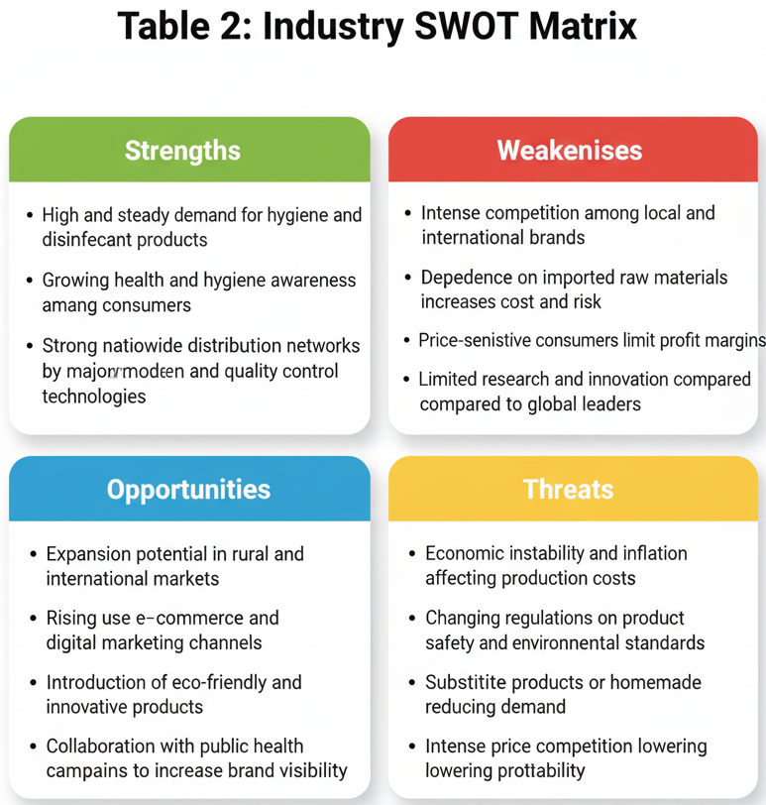
The health, hygiene and sanitation product market in Bangladesh has a good growth potential and stability in the long-term due to the growing awareness of people regarding health and modernization. Nevertheless, the industry has economic, regulatory, and competitor threats, which need to be handled through strategic management.
In order to achieve sustainable growth, such companies as Standard Finis Oil Co. should:
  - Keep on investing in technology and innovation.
  - Enhance supply chain resiliency.
  - Challenge towards environmentally friendly products.
  - Grow online and overseas markets.
In such ways, companies will be able to become more competitive, handle the threats of the external environment, and contribute to national health improvement.

IMPACT OF HRIS ON DECISION MAKING

CHAPTER 3

IMPACT OF HRIS ON DECISION MAKING

3.1 HRIS overview of the Standard Finis oil Co.

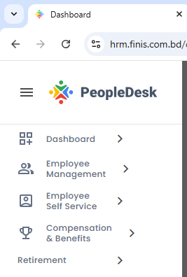
The Human Resource Information System (HRIS) at the Standard Finis Oil Co. is the focal point in the management of activities related to employees in all the departments. It is an online platform that unites the information about the employees, automation of the HR processes, and aids in the decision-making process by gathering and examining the data.
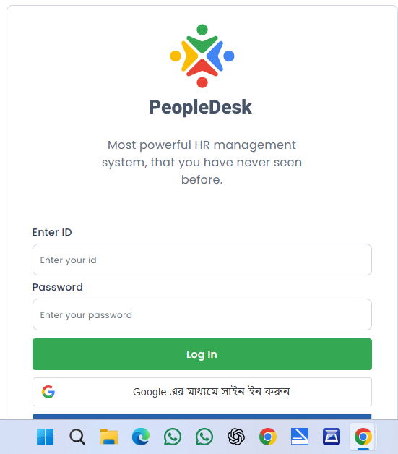
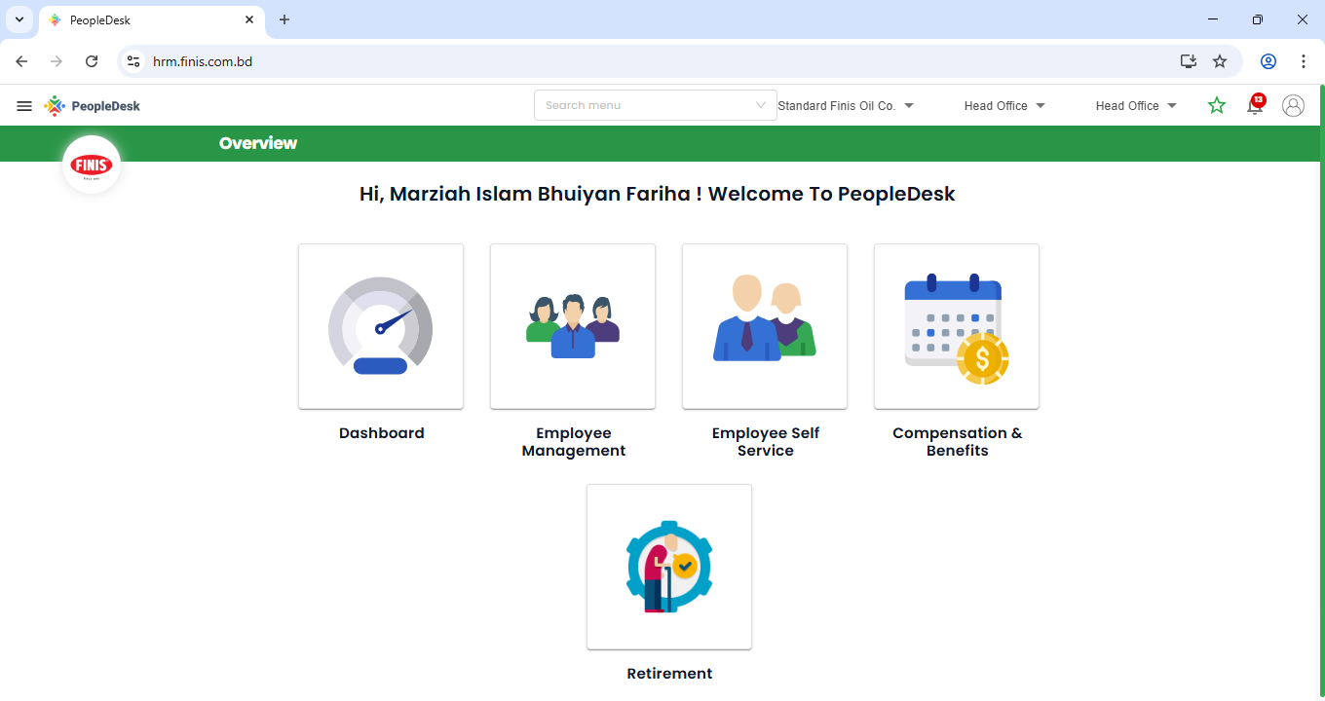

Interface Overview
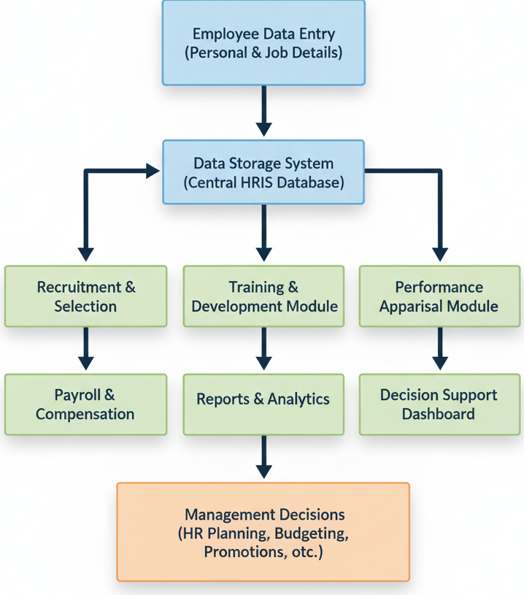
The HRIS interface is user friendly and well structured, hence enabling the HR officers and the management to obtain significant information within a short period. It is categorized in several sections where the executives and the factory employees are split and thus the data of each category can be handled according to their requirements.
Once the profile of the employee is accessed in the HRIS, he or she will see a detailed view which contains:
- General Information - including; Employee ID, Full Name, Department, Designation and Superiors.
- Contact & Personal Details - Address, NID, Date of Birth, Blood Group and Gender.
- Work and Employment Information (Name):- The Joining Date, Type of Employment, Salary Type, Overtime Policy, Job Territory, and Job Location.
- Shift and Attendance Data- which has such fields as Calendar Type, Off Days, and Holidays.
- Other Sections - to include Bank Details, Education, Training, Transfer and Promotion, and Increment History.
All the profiles also have an option to create a user account in the system where the intended employees (mostly the executives and the HR staff) can log in, update and view the records as per the access levels.
Role of HRIS in the Company
The HRIS is the driver of HR department of Standard Finis Oil Co. It will save on paper work by hand, decrease human error and create transparency in the handling of the employees. The system has enabled the HR professionals to make quicker and more informed choices in recruitment, training, and compensation by digitizing and arranging data.
In summary, the HRIS has modernized the operations of the human resources in the company into more efficient, accurate and integrated system which makes the HR functions to reflect the strategic objectives of the company.
HRIS Modules Used
The system will be subdivided into a number of functional modules, each of which will be in charge of specific HR activities:
- Employee Information Management:
Keeps all the employee related information and enables to track work history, job role and departmental placement easily.
- Attendances and Temporal Management:
Records day in day out attendance, works schedules and overtime, particularly on factory workers.
- Compensation and Payroll Module:
Combines payroll information, remuneration (bank or digital), and computation of overtime to make payments at the right time and amount.
- Recruitment and Selection Module:
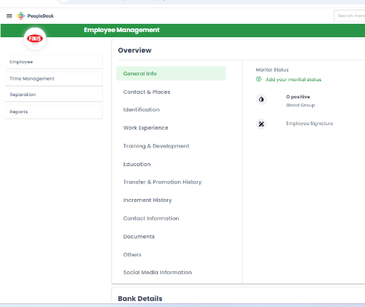
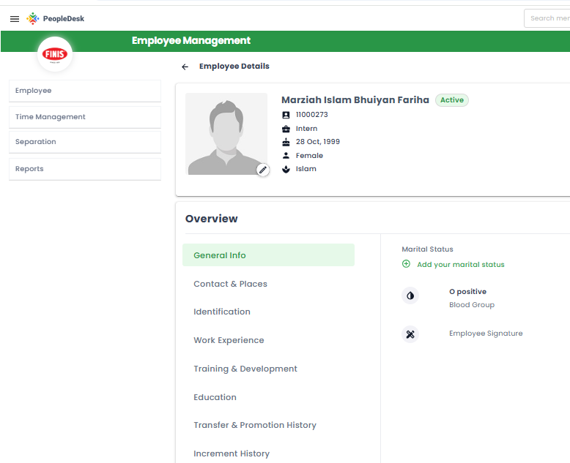
Maintains a database of job seekers, interview history, and selection information to be used at a later time, which assists the HR to save time and money in recruitment.

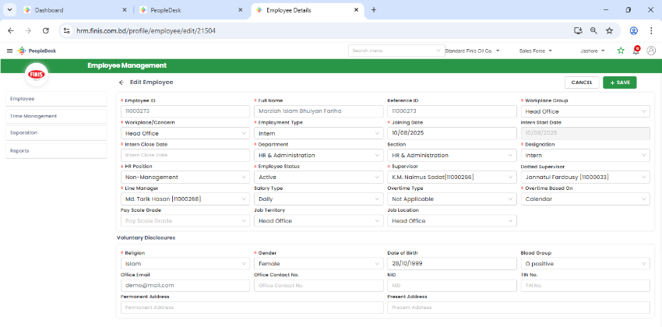
Employee Information Management
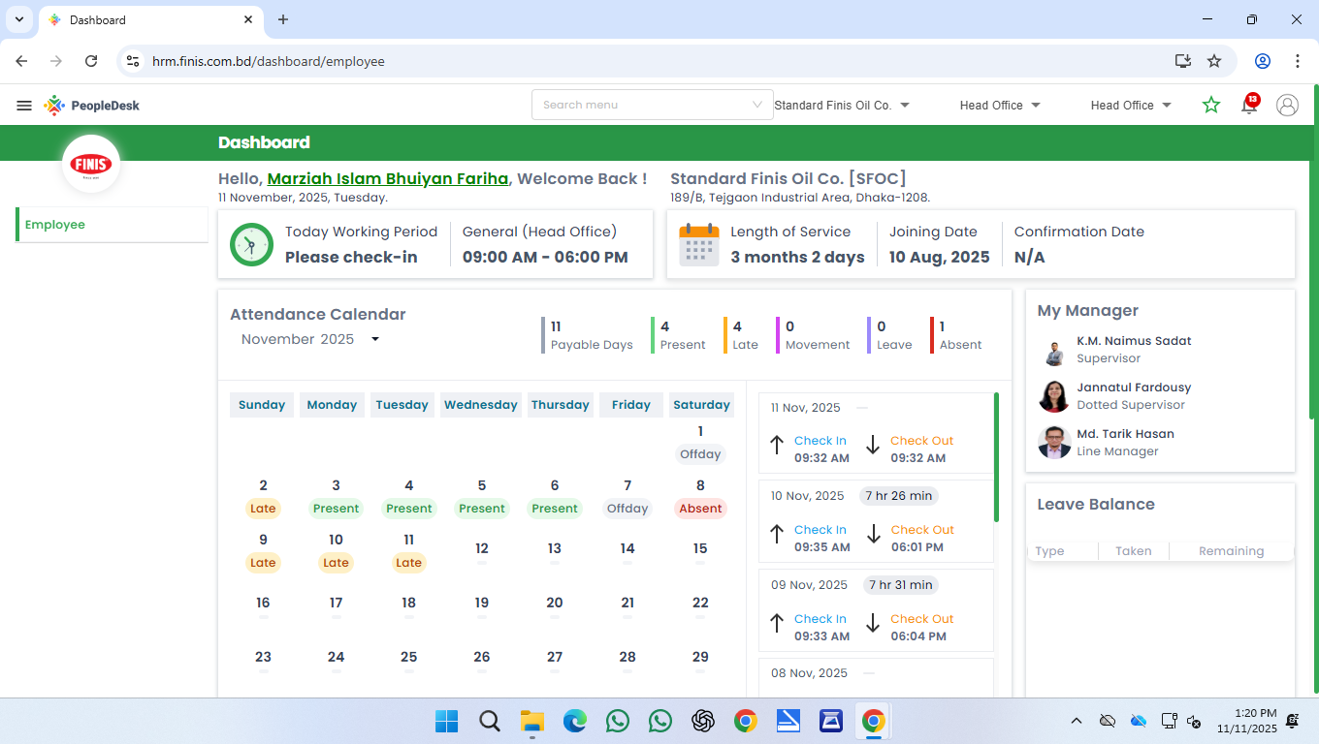
Attendances and Temporal Management

3.2 The Disparity between Factory Workers and Executive in HRIS use.

The HRIS deployed by Standard Finis Oil Company is significant in promoting maintenance and management of all employee-related information. Nonetheless, the data access structure and level vary greatly between employees of Head Office and Sales Force (Executives) on the one hand and those of Factory or Daily Casual Workers on the other hand.
The existence of these differences is mainly because of the nature of work, employment type, salary process, and data accessibility requirements.
Important differences in HRIS Data and application.
Category | Executives (Head Office and Sales Force) | Factory / Daily Casual Workers.
Type of Employment | Permanent / Full-time | Daily Casual / Contractual.
Salary Paying | Paid via Bank Account | Paid via Digital or MFS (Mobile Financial Service).
Overtime Policy | None | Overtime paid with pay.
Official Email/ Contact | The Summit sponsor has both the official email ID | The office phone number of each employee.
HRIS Access Level | Full profile access with personal, professional, and training information | Limited profile access with attendance, overtime, and pay.
Employee Details Section | Has such simplified fields as Supervisor, Dotted Supervisor, Line Manager, Salary Type, Overtime Type, Job Territory, Job Location. | Not as detailed as the managerial or dotted supervisor & Sales force fields.
Voluntary Disclosures | Includes Religion, Gender, DOB, Blood Group, NID, Permanent and Present Address, Office Email, and Office Contact | Includes same data, but no office email/contact field.
Shift/Calendar Info | Calendar Type Calendar Name Off Day, Holiday | To manage the shifts and overtime working scheduling
Other Overview Sections | Marital status, employee signature, education, work experience, training, transfer, and promotion, increment, bank details, social media. | Identification through other details – Birth certificates, Number, Pay Details
Pay Details | Includes full Bank Details section | Includes Digital / MFS Pay (0) option.
User Creation (HRIS Login) | All executives are users of HRIS | Limited or no direct access of casual workers.

3.3 Effect of HRIS in Recruitment Decision.

The HRIS used at Standard Finis Oil Co. is significant in enhancing the recruitment decision making process. It assists the HR department in organizing, monitoring, and analyzing data of the candidates in an organized and efficient manner.
The value of HRIS in Data collection and tracking of candidates.
In the recruitment process, the HR department gathers various kinds of information regarding the candidates -including personal information, educational levels, work experience and performance at the interview. All these records are stored in a central database by the HRIS and are readily retrieved and analyzed in future.
Some key benefits include:
✅ Centralized Data Storage: The complete data regarding the candidates are stored in a single system, therefore, there is no information that is lost or misplaced.
✅ Monitoring Candidate Position: HR is able to follow the recruitment status of each particular candidate (applied, shortlisted, interviewed, selected, or rejected).
✅ Quick Search Feature: The system enables the HR to search its previous applicants depending on their skills, qualifications, or experience.
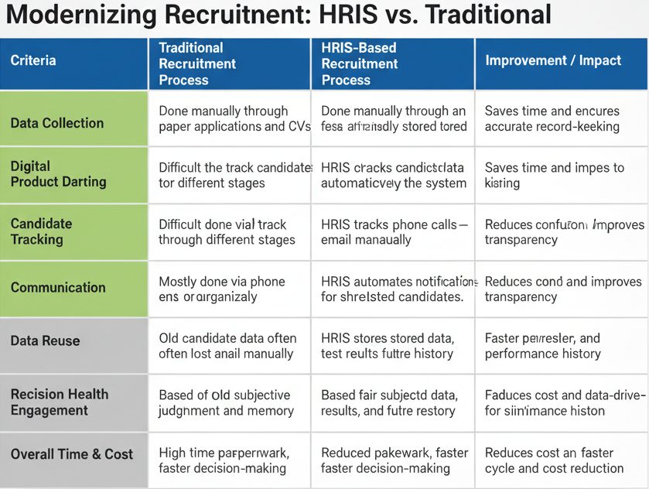
✅ Better Co-ordination: HR and departmental heads will be able to access the same candidate data and it will assist them to make better and quicker decisions.

Utilizing Recruiting Data to save Cost and Time.
Among the most feasible benefits of HRIS is that it enables the HR manager to use already gathered information about candidates.
To give a case in point, when a shortlisted candidate failed to be chosen in a previous staffing exercise because of limited vacancies, then the HR can readily locate that profile in the future when the same or an analogous position is advertised.

This helps in:
- Reduction of Recruitment Cost: No advertisement of a fresh job circulation or again undergoing the whole process of recruitment.
- Saving Time: The HR department could directly call the appropriate candidates who are immediate.
- Better Hiring Quality: The firm can recruit at a quicker rate and more firmly by utilizing past execution or interview reactions in the system.
Mini Case Study: The effective hiring with the HRIS.
Case Example:
As we will see, areas of Marketing (Salesforce) had to urgently recruit a Sales Representative at Standard Finis Oil Co. recently.
The HR team did not need to initiate a new recruitment campaign but searched the HRIS database and located several applicants who had applied to a similar position three months before.
The HR department contacted the top two after passing their past interview feedback and data on qualification saved in HRIS.
One of them was picked in less than three working days, which saved time and advertising costs.
Result:
✅ Recruitment was done 60 percent faster.
✅ No advertisement expense
✅ Full-fledged applicant already knows company structure.
Standard Finis Oil Co. has streamlined its recruitment process by using HRIS to make the process data, cost and time efficient.
The system does not only assist in gathering and storing candidate information, but also makes sure that there are reuses of such information in a wise manner to make informed and quick hiring choices.

3.4 Effect of HRIS in Selection Decision.

Selection process in Standard Finis Oil Co. has become organized, transparent and fair with the help of the Human Resource Information System (HRIS). It assists HR managers to make accurate judgements of the candidates rather than relying solely on personal judgements. Through HRIS, the company can guarantee that the right individual gets the right job depending on the qualification, skills and performance information as opposed to being based on prejudice or assumptions.
The way HRIS can enhance the process of evaluating candidates.
All pertinent data about the candidates, including educational history, level of experience, test results, interview reviews, references, and so on, are organized in an organized format in HrIS.
This assists the HR department and departmental heads in assessing every candidate in a non-biased manner and arrive at objective judgments.
Key advantages include:
✅ Standardized Evaluation: All the information of the candidates is stored in the same format, which is easy to compare.
✅ Performance Data Tracking: The system allows checking the previous interview results or assessment scores.
✅ Decision-making: This enables departmental managers to access the same data in HRIS, and final decision-making in selection will become more precise and unified.
✅ Open Bookkeeping: All the decisions that are to be made based on selection are documented in the system to be accountable and to refer to it in future.
How HRIS Reduces Bias
In the traditional sense, manual selection processes may occasionally be biased with respect to the individual selecting the applicant to occupy the position - the individual may have a preference or be lacking sufficient information on the applicant.
Through HRIS, these biases are minimized since all assessment will be on the facts, qualification and performance in the store. The system deals with quantifiable information as opposed to individual perceptions.
For example:
- •The HRIS will automatically sift out applicants that match certain job requirements (education, skills, experience).
- It gives emphasis to candidate performance during tests or interview thus making the selection fair.
- It minimizes the role of subjective views thereby rendering the ultimate decision credible.
Mini Case Study: Equitable and Rapid Choice with HRIS.
Case Example:
When the HR team of Standard Finis Oil Co. was making the selection of a Junior HR Assistant, there were several applications. They did not have to go through all the CVs manually as they used HRIS to shortlist the candidates that fit the established criteria of BBA background, good communication skills, and Excel knowledge.
The HRIS was used to give a side-by-side comparison of shortlisted, with test results and interview notes.
This facilitated easy evaluation of every applicant by the HR manager. The system assisted the company to choose the most suitable candidate in a limited period of time without subjectivity and misunderstanding.
Result:
✅ Unbiased and factual selection.
✅ manual evaluation time stored.
✅ Minimized possibility of injustice.
Application of the HRIS in the choice procedure of Standard Finis Oil Co. has resulted in increased fair, transparent and efficient decisions.
The company is able to hire individuals who actually fit into the job description and bring long term value to the organization by relying on precise data and methodical analysis of the information instead of relying on personal choice.

3.5 Effects of HRIS in Compensation Decision.

Human Resource Information System (HRIS) is significant in guaranteeing that compensation decisions are equitable, precise, and statistically-based.
It assists the HR department at Standard Finis Oil Co. to handle salary organization, allowances, bonuses, and other material remunerations in an organized manner.
Calculation of Pay and allowances using data.
The HRIS contains specific data concerning every employee, including his/her job, grade, experience, attendance, and overtime work, as well as performance ratings.
This data is automatic and is interconnected with the pay system of the company, which enables the HR department to compute the salaries and allowances fast, and in an accurate manner.
For example:
- The system will automatically apply overtime allowance on the basis of the number of hours that are registered in the attendance information.
- It also computes deductions of the leave or eligibility on the bonus based on pre-established Policies of the HR.
✅ Outcome: This automation will minimize the errors and time wastage, and will make sure that all the employees get their due pay as per the company policy.
The use of HRIS in making impartial and effective decisions.
HRIS promotes fairness as it maintains clear data of the work of every employee.
In deciding on changes in salary, increments or even festival bonuses, the HR managers can consider actual performance records, attendance history and training attendance records that are registered in the system.
This eliminates any form of favoritism or speculation since the decisions made will be backed by the correct and well-informed data.
✅ Efficiency Benefit: The HR team will have less time to spend on manual calculations and paperwork, which will give them greater time to analyse and employee satisfaction.
Internship Case Study.
At Standard Finis Oil Co., where I was an intern, I noted that HRIS information was used by the HR team in preparing the payroll sheet at the end of every month.
As an example, an operator that worked overtime during a week was automatically allowed overtime as calculated by the system.
In the past, these calculations would be carried out manually and this was very likely to result in errors or time wastage.
The process was significantly more fast and precise with HRIS, the employees themselves were also more convinced in the results of the payment as they could view their attendance and work records in the system.
✅ Impact: HRIS enhanced accuracy, minimized payment disputes, and enhanced satisfaction levels among employees due to the timely and equitable compensation.
To conclude, HRIS is beneficial in ensuring that Standard Finis Oil Co. has a clear, uniform, and effective compensation management mechanism.
It makes sure that the salary, bonuses, and allowances are computed correctly according to verified data about the employees, which results in fairness and trust in the organizations.

3.6 Summary of Findings

My internship with Standard Finis oil Company made me realize that Human Resource Information System (HRIS) affects various spheres of HR decision-making to a considerable degree.
- Recruitment: HRIS allows the proper recording of data and tracking of the candidates. The company saves time and expenses on repeated hiring procedures as the applicant information used by the company is reused. This guarantees quicker and efficient recruitment process.
- Selection: HRIS will offer systematically arranged data on candidates, enhancing the examination and reducing bias. The process of decision making is more transparent and objectivity of comparing the applicants and choosing them can be done based on their skills, experience and past tests by the HR team.
- Compensation /Payments: HRIS automates calculation of salaries, allowances and overtime payment. Decision making is objective, precise, and unbiased and minimizes mistakes and administration. Workers enjoy prompt and open remuneration.
Overall Findings:
The HRIS of the Standard Finis Oil Company has enhanced the overall quality of the HR decisions in all spheres. It saves on administrative work, cost minimisation and consistency and equity. The system is also very efficient and it provides more employee trust and satisfaction, demonstrating that digital HR tools can be of great help in improving the performance of a given organization.

CHAPTER 4

INTERNSHIP EXPERIENCE

INTERNSHIP EXPERIENCE

This chapter details the general experience of my internship at Standard Finis oil company, which was in the HR and Administration department. My internship allowed me to do various practical assignments that have to do with managing employees, data entry, preparing documents, and coordinating various departments.
The internship experience allowed me to know how the HR functions are handled in actual office environments. I was engaged in four large departments Head Office, Factory Unit 1, Factory Unit 2, and Salesforce (Marketing and Sales) Department. The experience helped me to learn how to cope with tasks like employees data management, time tracking, composing appointment and release letters, record keeping, and digital tools, including People Desk App and excel.
Altogether, this internship provided me with some useful skills in practice, enhanced my ability to communicate and manage time, and adjust the academic knowledge to the real workplace functioning.

Position, Duties, and Responsibilities

Position, Duties and responsibilities: The candidate must serve as a marketing manager for the company and execute all the marketing tasks in the company.
As an intern at Standard Finis Oil Company, I have been placed under the Human Resource and Administration Department in the role of HR Intern. My job was mainly to offer administrative and operational assistance to the HR department in various aspects including employee data, recruitment management, documentation and records maintenance.
HR Department of Standard Finis Oil Company deals with four significant areas of operations of the company which include Head Office, Factory Unit 1, Factory Unit 2, and Salesforce Team (Sales and Marketing department). During my internship, I got a chance to work in all these areas, with different assignments, thus acquired a clear picture of HR activity within a real-life environment.

Major Duties and Responsibilities:
- Record Management and Data entry of employees.
- Input the correct employee details onto the People Desk App and made sure that all the information was updated in the right manner.
- Gathered employee records and kept files of individual employees in each unit.
- Created and maintained the HR database so that the records of the employees can be readily available.
- Preparation of Documents and Letters.
- Helped in preparing and issuing appointment letters, release letters and separation letters to the employees.
- Verified all the documents adhered to the company format and ensured that they were verified prior to distribution.
- Recruitment and Interview Co-ordination.
- Assisted in the organization of interviews, including initiating contacts with candidates, as well as scheduling interviews.
- Ensured that required documents were prepared to conduct the interview sessions and aided the HR officers in the recruitment efforts.
- Payment and Leave Management.
- Kept track of daily attendance by the factory workers and kept records of the same.
- Maintained leave records and absence records of the Salesforce team and reported them to the HR officer on a regular basis.
- Assisted the HR team to monitor the attendance and leave record in the form of Excel sheets.
- Resignation, Separation Process.
- Documented data pertaining to the resignation of employees who made sure that their separation files were kept in order.
- Brought the database up to date with the resignation status and helped to do the separate formalities.
- Communication and Co-ordination.
- Composed and forwarded official e-mails concerning internal communication and departmental coordination.
- Ensured a good communication with the vendor when it comes to preparing new employee ID cards.
- Organization and Excel Management of Data.
- Prepared and compiled Excel employee records tracking sheets of four sectors (Head Office, Unit 1, Unit 2, and Salesforce).
- Created a Purchase Requisition Tracker that was broken down into three categories which included entertainment, stationery and grocery goods.
- Helped the HR department to plan and modernize various Excel based HR tools to enhance efficiency in the workflow.

These duties enabled me to understand how to handle data correctly, ensure confidentiality, be a professional communicator, and organize various departments. My work as an HR Intern contributed to the realization of the significance of attention to detail, collaboration, and corporate discipline in a professional setting.

Training & Development

- Personal Growth
Other than professional abilities, this internship experience contributed to my personal development. I was taught about the value of responsibility, teamwork and time management. It also enhanced my capabilities to respond to pressure and adjust well to new activities and settings.
The training and development that I had, as a result of the internship was practical, skills based and experience-based. It not only increased my technical and professional skills, but also equipped me with the challenges of future in the HR profession.
- Skill Development
At a result of constant work and observation, I managed to gain some valuable professional skills that include:
- Technical Skills: Practical experience with People Desk (HR Software), MS Excel and email communication instruments.
- Organizational Skills: Handling various files, accuracy of data, and deadlines.
- Interpersonal Skills: Be able to communicate with the team members, employees and supervisors.
- Analytical Skills: Interpretation and preparation of information to make decisions and reports.

Contribution to Organization / Operations

The two teams contribute to the organization/operations in different ways.
Through my intern experience in the Standard Finis Oil Company, I was able to take part in the routines of the daily operations of the Human Resource and Administration Department. My primary responsibilities were to assist in HR operations, data management and assist in enhancing documentation systems in different organizational units.
- Employee Data Management
Employee information management is one of the areas where I made my major contribution. I was engaged in the input and updating of information about employees in the People Desk App (HR information system adopted by the company). This involved inputting of personal information, job, and department records. I was keen on details and this made me minimize errors and enhance accuracy of employee databases.
- Documentation and Record Keeping.
I also helped in preparing, organizing and supporting different HR documents. This included:
- Designing and structuring of employee personal files in Head Office, Unit 1, Unit 2, and Salesforce departments.
- Preparation of appointment letters, release letters and separation documents to the employees.
- Monitoring of resigned employees and recording the separation records appropriately. These activities assisted the HR department to keep the right records and the availability of valuable information within a short time whenever required.
- Absence and Timesheet Support.
I was involved in checking and maintaining the attendance log and leave information of factory workers and Salesforce team. I confirmed the correctness of the data and changed the records, when needed. This assistance assisted the HR department in monitoring the attendance patterns and detecting the atypicalities effectively.
- Tracking Tools Development.
In order to streamline the HR operations, I created an Excel based system of tracking files of the entire four departments including Head Office, Unit 1, Unit 2 and Salesforce.
A Purchase Requisition Tracker was also developed by me to keep a track of various office requisitions in three categories:
  - Entertainment items
  - Stationery items
  - Grocery items
The internal tracking and reporting was improved with faster speed and better structured and user-friendly to the HR team by these tools.
- Communication and Coordination.
My internal communication was based on the drafting and sending official email, coordination of the interview, and facilitation of communication with the vendor to prepare employee id cards. The experience allowed me to enhance the communication between the departments and external partners.
- Serving the HR Daily Operations.
I was also assisting in numerous daily administrative operations like employee inquiries, filing of documents, and facilitation of file movement across departments. My proactive nature and my readiness to be responsible enabled the HR department to accomplish a number of tasks effectively and within the stipulated time.
During my internship, I attempted to make significant contributions to the organization in terms of knowledge use, initiative, and contribution to the work of the HR. My input was used to enhance accuracy of data, organize records and efficiency in communication in the HR department. This was not only an added value to the organization but also helped me to learn and develop professionally.

Evaluation

Standard Finis oil Company is the place where I spent my internship period and this experience was significant in my academic and professional experience. This experience helped me to observe and get involved in the actual organizational processes, particularly in the Human Resource and Administration Department. My internship experience can be examined in terms of three key areas, including learning outcomes, skill acquisition, and professional output.
- Learning Outcomes
Through my internship, I had a proper idea of how the business of HR operates in a real-life scenario. I was taught about data entry, handling of employee records, attendance tracking, preparation of documents, and coordination of departments. The experiences assisted me in the closing the gap between what we study in the university and in the actual practical business activities. I also learned the importance of policies and HR systems including HR Information Systems (HRIS) in handling information about the employees.
- Skill Development
The internship also assisted me to gain diverse technical skills and soft skills as well.
- Technical skills: I was able to become skilled in the use of such tools as Microsoft Excel, People Desk (HRIS) and email communication systems. I also got to know how to maintain databases, make up reports and how to use excel formulas to organize data.
- Soft skills: I enhanced my communication, time management and teamwork skills. I have acquired skills on how to deal professionally via emails, manage daily activities, and coordinate the various groups of people - Head Office, Unit 1, Unit 2 and Sales Force.
These competencies helped me to be an effective and flexible worker in the workplace.
- Professional Performance
Based on the responses that I got out of my supervisors and team members, I performed satisfactorily and effectively during the internship. I was valued on the grounds of my precision in working with the employee information, the ability to fulfill the given tasks, and a good attitude towards studying. I attempted to be selective in every task undertaken and was very secretive in handling HR related documents.
My initiative was also manifested in the development of Excel-based file tracking system and Purchase Requisition Tracker that were acknowledged as helpful tools in the daily HR activities. My supervisors also motivated me because of my attitude of solving problems and my determination to learn.
- Overall Evaluation
Altogether, my internship experience in the Standard Finis Oil Company was a great experience. It enabled me to get a glimpse into the actual working environment, learn about the functions of HR in detail, and have the necessary skills in the profession. The experience increased my confidence and I was able to prepare myself to work in the future under professional capacities.
This analysis demonstrates that the internship was not only an academic achievement but also a value addition to the organization by my hands-on work attitude and passion to learn.

Skills Applied

Through the internship period with Standard Finis Oil Company, I was able to implement most of the theoretical concepts and practical skills that I had studied in my academic courses. This internship gave me an opportunity to apply those skills to actual workplace scenarios and develop those skills even more as a result of constant practice and being instructed by my supervisors.
- Technical Skills
- Data Management: I used my data management skills by keying and arranging data of employees in the HR Information System (HRIS) and Microsoft Excel.
- Microsoft Office Tools: I actively used Excel to record keeping, attendance, and create reports, Word to write letters and PowerPoint to document and present the information.
- Digital Communication: I was able to utilize professional email writing to communicate with employees, departments and vendors which enhanced my digital communication.
- System Usage: I should mention that I was able to learn how to update the information on employees, create ID cards, and maintain the HR records using the HRIS software.
- Administrative and HR Skills.
- Employee Record management: I used HR concepts by ensuring that I updated and maintained employee personal files as well as aiding in documentation of employee records such as appointment and release letters.
- Recruitment Support: I assisted with the scheduling of interviews, management of candidate information, and aided in the delivery of appointment letters, which provided me with an opportunity to have firsthand experience regarding recruitment.
- Attendance and Leave Management: I used accuracy and consistency in managing attendance data of factory and Salesforce employees and entered information of leave.
- Soft Skills
- Communication Skills: The experience of working in different departments assisted me in gaining confidence and clarity in verbal and written communication.
- Time Management: I was taught to work with several tasks according to the deadlines by creating a work checklist every day and prioritize the tasks effectively.
- Teamwork and Coordination: Cooperation with various teams including the Head Office, Unit 1, Unit 2, and Salesforce helped me to understand the significance of teamwork and coordination.
- Problem Solving and Adaptability: In any case challenges came up, I would carefully analyze the situation and would adapt soon to identify ways of getting a solution.
- Analytical and Organizational skills.
- My analytical capacity was also utilized when I was preparing the Purchase Requisition Tracker and the Excel-based File Tracking System, where I had to organize and track information in an organized manner.
- My organizational competencies assisted in keeping the records of a big number of employees in an organized and convenient manner.
- Professional Ethics
During my internship, I was able to keep confidentiality of information about employees and observed the right working protocol in the organization. I also got to know how valuable integrity, discipline and respect are to be upheld in a professional environment.

All in all, the internship enabled me to put into practice the academic knowledge and skills in practice. It developed my capacity to work in an organized, data-filled and teamwork setting - making me become a competent, responsible and confident HR professional.

CHAPTER 5

CONCLUSIONS AND KEY FACTS

CONCLUSIONS AND KEY FACTS

Recommendations

After the internship experience with the Standard Finis Oil Company and the actual implementation of HRIS, the recommendations are made as follows to advance HR operations:
- Improved HRIS Usage: More departments should be encouraged to make complete use of HRIS to ensure that there is minimal manual work and errors.
- Periodic Training on HRIS: Conduct periodic training to the employees to make sure they know how to use the HRIS effectively and harness on its potential.
- Monitoring of Data Accuracy: Stipulate routine audits of the staff to ensure accuracy and reliability of HR data.
- Connectivity to Payroll and Performance Modules: Add the features of the HRIS to payroll and performance appraisal reporting to complete quicker and less opaque work.
- Feedback Mechanism: Implement feedback mechanism where employees can report on any system problem or make recommendations on how HRIS activities may be improved.

Key understanding

This internship helped me to understand the overall effects of HRIS on the overall HR management and the efficiency of an organization. The understanding of some of the key points is:
- Effectiveness of HR Processes: HRIS saves a lot of time in handling of data manually and the HR personnel are able to concentrate on strategic processes.
- Data-Driven Decision Making: Decision making in HR is now quick, more precise and economical in relation to recruitment, selection, training, performance and compensation.
- Employee Record Management: It has become simpler, organized and transparent in keeping the employee records in the various departments and units in an organization.
- Preferred Practice: Ideas acquired during HR courses, including employee engagement, appraisal and training, are implemented in a digital setting in the real world.
- Cross-departmental Cooperation: The use of the HRIS helps to coordinate the activities of the Head Office, Factory Units, and Salesforce as well as enhance the overall communication of the whole organization.

Conclusion

The HR operations and the great influence of HRIS in decision-making could be thoroughly comprehended during my internship at Standard Finis Oil Company. I got to feel the benefits of technology in simplifying HR functions by being involved in employee data management, managing attendance, managing leaves, recruiting, and training.
HRIS has also been found to be an effective instrument in increasing efficiency, cost savings and efficiency of HR decisions. It does the transition between theory and practice, which enables organizations to run without any problems and at the same time, maintain high levels of employee management. All in all, this internship allowed me to not only reinvent my technical expertise, but also to build my knowledge on the functioning of organizations, teamwork, and professional accountability.

Reference

      - HRIS & HR Decision Making
Kavanagh, M. J., Johnson, R. D., and Thite, M. (2015). Human Resource Information Systems: Basic, Uses and Future (3 rd ed.). SAGE Publications.
→ Gives your Chapters 4.1, 4.2, Recruitment, Selection, HRIS flowchart.
- HRM Practices & Technology
Dessler, G. (2020). Human Resource Management (16 th edition). Pearson.
→ aids HRIS as training, performance appraisal, job analysis.
- HRIS & Company Effectiveness.
Hendrickson, A. R. (2003). Human Resource Information Systems: 21st Century Backbone Technology of Human Resources. Journal of Labor Research, 24(3), 381–394.
→ Good in the section of Impact of HRIS.
- Effect of HRIS in Recruitment.
Strohmeier, S. (2007). E-HRM: Research in the field. Human Resource Management Review, 17(1), 1937.
→ Antonymously backs your Traditional vs. HRIS-based recruitment table.
- HRIS in Performance Appraisal.
Aguinis, H. (2019). Performance Management (4 th ed.). Chicago Business Press.
→ Attaches your Figure 6: HRIS Performance Dashboard conversation.
- Bangladesh Hygiene and Sanitation Market.
Bangladesh Bureau of Statistics (BBS)in 2023. 2023 Industry and Economic Analysis Report. Dhaka: Bangladesh Government.
→ Favoring your 2.2.2 Market Trends and Size.
- Hygiene and Disinfectant Growth Market.
Euromonitor International. (2023). Home Care: Bangladesh Market Analysis Report.
→ Strengthens your Figure 1 (Growth Trend in the Industry).

- Compliance with Regulations and Standards.
BSTI. (2024). Bangladesh Chemical and Hygiene Products Standards Catalogue.
→ Applied in your SWOT (Regulatory Threat).
- Public Health and Hygiene Awareness.
World Health Organization WHO in 2023. Hygiene and Health in South Asia: Regional summary Report.
→ Favours the industry prospect due to increasing health consciousness.
- Analytics of HR, Digitalization.
Marler, J. H., & Boudreau, J. W. (2017). Evidence-Based Review of HR Analytics. International Journal of human resource management 28(1), 326.
→ Favors debate on HRIS value addition in decision-making.

- https://www.finis.com.bd/

