Market Development Practices of
Hemas Consumer Brands:
A hands-on initiative of Direct Marketing Campaign

Rezaul Karim Anik

This report is submitted to the school of Business and Economics, United International University as a partial requirement for the degree fulfillment of Bachelor of Business Administration

Market Development Practices of
Hemas Consumer Brands:
A hands-on initiative of Direct Marketing Campaign

Submitted to:
Dr. Md Shariful Alam
Professor
School of Business and Economics

Submitted by:
Rezaul Karim Anik
Id: 111 201 245
Major: Marketing

School of Business and Economics

Date of submission
Nov 16, 2025

Letter of transmittal

Nov 16, 2025
Dr. Md Shariful Alam
Professor School of Business & Economics
Subject: Market Development Practices of Hemas Consumer Brands: A hands-on initiative of Direct Marketing Campaign

Dear sir,
Glad to submit my report on “Market Development Practices of Hemas Consumer Brands: A hands-on initiative of Direct Marketing Campaign” I have conducted my internship program at Hemas Consumer Brands. This is a part of the entire requirements to complete the BBA program.
While preparing this report, I have followed all the instructions that you have given me. I tried my best to prepare this report and believe that all the ideas from this report will help me in my future practical life. I would be grateful to you if you accepted this report.
I hope that you will find this paper worthy of my labor.
Sincerely yours,
Rezaul Karim Anik
ID: 111 201 245
BBA Program
United International University

Declaration of the student

I, Rezaul Karim Anik declare that the internship report titled “Market Engagement Strategy for New Products: A on Hemas Consumer Bangladesh Limited” been developed by me to meet part of the requirements for my Bachelor of Business Administration (BBA) degree at United International University (UIU).
I verify that this report reflects my original work, except where appropriate citations have been included. It has not been submitted to any other university or institution for any academic or professional reason.
I also affirm that I have upheld academic integrity while crafting this report and have followed all guidelines established by the School of Business and Economics at UIU.
I acknowledge that any instances of plagiarism or unethical behavior in this report may lead to disciplinary measures according to university policies.
Name: Rezaul Karim Anik
ID:111201137
Major: Marketing

Acknowledgement

I would like to express my sincere gratitude first and foremost to Almighty Allah for granting me. I have the strength, perseverance, and resolve to do and finish my internship. Compile this report. I am extremely thankful to my academic supervisor, Sarker Rafij Ahmed.
Ratan, Ph.D., is an associate marketing professor at a business school. Economics, United International University. His ongoing guidance, insightful suggestions,
Your help and constructive criticism have helped so much while creating this report. My research owes a lot to the support and observations of many people. I would also like to express my appreciation to the management and staff of Hemas.
I want to thank Consumer Brands Bangladesh Limited for allowing me to do my intern there. A special acknowledgment goes to my supervisor at. Hemas’ guidance, mentorship, and practical knowledge have enhanced my wisdom.
understanding of market engagement techniques.
Overall, I want to thank all those who assisted me directly or indirectly.
This report was a group effort. This work would not have been achievable.
Without their assistance and cooperation.
Rezaul Karim Anik
ID: 111 201 245
Major: Marketing

Abstract/ Executive summary

The current report is a study on Hem Typical of Market Engagement Strategy New Products.
Marketing of Hemas Consumer investigated by Consumer Brands Bangladesh Limited. utilizes in Bangladesh. Promotional ideas for Colombo Coconut Hair and BIC. Getting companies to buy specific consumer benefits to enhance interaction According to the report, Hemas Brands uses a diverse range of marketing techniques. Use of tools for marketing communication, site activation activities, and consumer incentive. Marketing programs study the business practicality of marketing and evaluate. Using feedback, sales results, and engagement metrics to measure effectiveness of the campaign. Hemas has been successful in employing localized marketing strategies that resonate with Bangladeshi consumer habits. Initiatives like the Ramadan-focused. A rural incentive programmed for mobile top-ups in Colombo and the BIC Body Razor campaign. Coconut Hair Oil has proven impactful influencing target customers. Nonetheless. They face issues like short time, limited access to customer information and more. Products from established FMCG brands continue to affect campaign results negatively. The report further highlights that digital marketing and we are becoming increasingly important. commerce in consumer engagement. It suggests that Hamas Consumer Brands could. Provide more data-driven insights to enhance its marketing strategies further. Expanding advertising on regular media and strengthening distribution networks in rural areas. areas. The current report is a study on Hem Typical of Market Engagement Strategy New Products. Marketing of Hemas Consumer investigated by Consumer Brands Bangladesh Limited utilizes in Bangladesh. Promotional ideas for Colombo Coconut Hair and BIC. Getting companies to buy specific consumer benefits to enhance interaction According to the report, Hemas Brands uses a diverse range of marketing techniques, Use of tools for marketing communication, site activation activities and consumer incentive. Marketing programs study the business practicality of marketing and evaluate. Using feedback, sales results, and engagement metrics to measure effectiveness of the campaign.
Hemas has been successful in employing localized marketing strategies that resonate with Bangladeshi consumer habits. Initiatives like the Ramadan-focused. A rural incentive programmed for mobile top-ups in Colombo and the BIC Body Razor campaign. Coconut Hair Oil has proven impactful influencing target customers. Nonetheless,
They face issues like short time, limited access to customer information and more. Products from established FMCG brands continue to affect campaign results negatively. The report further highlights that digital marketing and we are becoming increasingly important. commerce in consumer engagement. It suggests that Hemas Consumer Brands could. Provide more data-driven insights to enhance its marketing strategies further. Expanding advertising on regular media and strengthening distribution networks in rural areas. Areas.
By connecting academic marketing theories with practical applications in the industry, this report acts as a valuable resource for both students and marketing experts eager to grasp effective market engagement tactics within the Bangladeshi FMCG landscape.
Keywords: Market Engagement, Product Launch Strategy, FMCG, Consumer Activation, Integrated Marketing Communication, Bangladesh.

Table of contents
Table of contents 7
1.0 Introduction 8
1.1Background of the Report 8
1.2 Diversified sectors of Hemas Group 9
1.3 Fast Moving Consumer Goods (FMCG) 10
1.4 Objectives of the Report 11
1.5 Scope and limitations of the Report 15
2.0 Company And Industry Preview 15
2.1 Customer mix 18
2.2 Operations 19
2.3 SWOT Analysis 21
3.0 Industry analysis 23
3.1 Specification of the industry 23
3.2 External economic factors 25
3.3 Technological factors 27
3.4 Barriers to entry 27
3.5 Supplier Power 28
3.6 Threat of Substitutes 30
3.7 Industry rivalry 31
4.0 Internship Experience 31
5.0 Learning Outcomes 34
6.0 Skills Applied 35
6.1 Application of academic knowledge 36
7.0 Conclusion and Key Factors 38
7.1 Recommendations for Improving Departmental Operations 38
7.2 Key understanding 38
8 Conclusion 39
References 40

Introduction

1.1Background of the Report
Hemas Holdings PLC in Sri Lanka
Hemas is one of the leading Multinational Company in Sri -Lanka which has strong presence in the diversified sectors. It started its journey in 1948 as a pharmaceuticals and trading enterprise, founded by Sheikh Hasannally Esufally (MBE). In Sri Lanka it has strong presence in FMCG, Pharmaceutical, Hospital, Transportation and Leisure and some of other's sectors.
A short history of Hemas is given below in terms of the key milestones:

Year | Description
1948 | Started its journey as Hemas (Drugs) Ltd
1962 | Started manufacturing toiletries in the collaboration with French Multinational
19670 | Diversified its journey in travel and tourism
1978 | Started exporting business
1990 | Lunched Clogard Toothpaste
1992 | Re-entry into apparel manufacture and freight and logistics
1993 | Hemas Drugs renamed as Hemas Holdings (Pet) Ltd
1994 | Started Airlines Business
1998 | Acquisition of Goya Perfume Brands
2003 | Hemas Holdings is listed on the Colombo Stock Exchange
2003 | Established Power Plant
2003 | Entry into the Food Sectors
2008 | Established Hemas Hospital
2010 | Started Business in Bangladesh as “Hemas Consumer Brands Ptv Ltd.

1.2 Diversified sectors of Hemas Group
Hemas is successfully operating in several industries in Sri Lanka as well as and managing businesses in various markets. It is also expanding its market in the international market.

FMCG

HEALTHCARE

TRANSPORTATION

LEISURE

NEW VENTURES

POWER PLANT

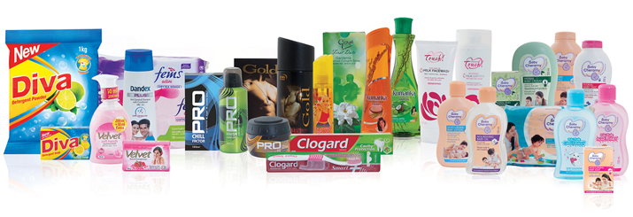

1.3 Fast Moving Consumer Goods (FMCG)
Hemas group produces products under several consumer brands and distributes these directly and indirectly around the world. It always tries to enrich the human lifestyle via innovation, trustworthiness, and in an exceptional way. Hemas is the market leader in the personal care sectors, and it also encompasses a range of products for adults and babies in skin care, hair care, toiletries, fragrances and oral care.
FMCG Brands of Hemas Group

Personal Care

Clogard
Kumarika
Colombo
Eva
Actisef
Bic Razor

Home Care

Diva

Skin Care

Velvet

Traded Brand

Godrej

Logo of Hemas FMCG Global Brands:
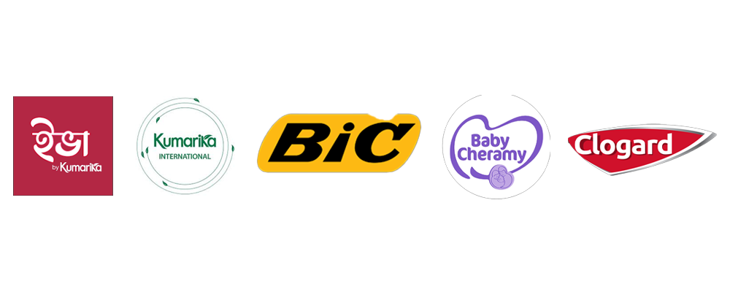

FMCG International Market of Hemas Group:
This group is now exporting its FMCG products in 12 countries around the world.

International Marketplace of Hemas Group.
- The Maldives | - Zambia
- Lebanon | - Malaysia
- Belize | - Pakistan
- Bangladesh | - Australia
- New Zealand | - The Middle East

1.4 Objectives of the Report

Market Engagement Strategy of Hemas Consumers Brands Bangladesh:
Hemas Consumer Brand began its operations in Bangladesh on February 15, 2010, under the company act of 1994. It serves as a fundamental part of the Hemas group. The brand's entry into the Bangladeshi market began with "Kumarika oil," using Transom distribution before introducing another brand called “Sunny Day.” Over the past decade, the company has experienced remarkable growth and established itself as a significant player in the value-added hair oil sector in Bangladesh, notably with its brand Kumarika. Currently, Kumarika Hair Oil ranks as one of the leading brands in the Bangladeshi hair oil market.

In this report, we will analyze and document the Market Engagement. Strategy for New Products at Hemas Consumer Brand (Pvt) LTD, with particular emphasis on launching and activating campaigns for Colombo Coconut Hair Oil and BIC. Body Razor. Based on my internship experience, the report attempts to relate to theory. Applying marketing ideas in a constantly changing business environment. Here are the summarized objectives:
● Grasp Marketing Plan Implementation in a Corporate Environment:
Learn more about how marketing strategies, from inception, are created. Execution of procedures relating to execution at a global corporation is created. This involves it. Looking into the teamwork of different departments, such as marketing and sales. Transport and Priorities to ensure proper product launches.
● Assess Campaign Impact:
Evaluate the effectiveness of activation campaigns, such as the Ramadan-focused promotion for BIC Body Razor, which emphasized cleanliness in Islam, and the semi-rural mobile recharge incentive for Colombo Coconut Hair Oil. This assessment considers consumer feedback, sales outcomes, and engagement metrics.
● Examine Market Engagement Strategies:
Take a look at how Hemas Consumer Brand uses what they learn for their process. Advertising and direct marketing are both types of marketing communication strategies. On-ground activation to enhance brand visibility and connect with varied consumers in the region. Demographics.
● Identify Challenges and Opportunities:
Highlight the problems faced in executing the campaign, lack of time, and. Restricted entry to essential data, while recognizing potential methods for enhancement. Marketing strategies are going forward. ￼
● Personal and Professional Development:
My personal learning experience referring the consumer stuff. I work with other departments in the industry and use behavior. We were careful of overlooking importance should not be marketed in anti-competitive. environment.
● Contribute to Future Strategies at Hemas Consumer Brand:
Provide actionable insights and amplify recommendations that help achieve the objectives of the Consumer Brands Division in the marketing area of sharp-elbowed market competitive, customer-oriented, relevant, and best in innovation and value products.
This report is meant to summarize my marketing education at United International University, and at the same time, to show the value of the learning I received during the internship experience. I want to share it with the marketing and the academic community in the consumer goods industry region, who work on the effective marketing of consumer goods products.
● Motivation of The Report:
Last year, I had the opportunity to do an internship at Hemas Consumer Brand (Pvt) LTD. Get involved in creating and carrying out marketing strategies for their objectives. Colombo Coconut Hair Oil and BIC Body Razor are two new entries. Witness. Product launches which involve campaign design to execution broadened my knowledge. How organizations and customers interact with one another and understand. Companies Handle Market Competition. Provide Examples. One of the most memorable aspects of it. For me, this internship was participating in campaigns that had a positive impact on the market. For example:
- BIC Body Razor's Ramadan-centric activation program highlighted cleanliness as an Islamic value and illustrates the importance of context in marketing messages.
- The activation in semi-rural Colombo for Coconut Hair Oil where consumers are being given mobile recharge incentivization, exemplifies the power of creativity in profiting from the “long tail". Being involved in these activities helped me learn how to implement first-hand.
I improved my consumer insight skills and re-evaluated a campaign through measurement. The success of the campaign calls for modifying it as per the feedback received from the market.
In addition, my experience with a multinational company, Hemas, illuminated the extent to which local market adaptations are made by global brands and how they systematically incorporate cross-functional decision making, to achieve their set goals. This experience, in turn, piqued my understanding regarding the application of marketing concepts, in particular Integrated Marketing Communications (IMC), how they are used in the real world, and how strategies can be engineered to foster greater innovation and growth.
Through the internship experience, I have accumulated knowledge and skill on a certain subject. Additionally, it helps me sharpen my learning objectives, all while being aware of the important potential I devoted in my internship period. My knowledge of consumer brands such as Hemas who seek to enrich useful and quality products improve customers’ lives It marks a personal achievement. My understanding has improved in the sense that I have dealt with concrete examples. In my career as a marketer, I hope so.

1.5 Scope and limitations of the Report
Limitations of the Report

I faced difficulties while preparing this report and it affected its completeness and reach of the analysis. These challenges include:
- The short duration of the internship did not allow for a deep dive further into certain elements of the study.
- Limited access to secondary data. The secondary information could not be disclosed because of confidentiality restrictions.
- Organizational rules. It was challenging to collect primary data.as a few particulars were elusive or difficult to obtain. .
Despite these hurdles, I made every attempt to ensure that the report delivers valuable insights and meets its aims.

2.0 Company and Industry Preview
The fast-growing FMCG sector in Bangladesh is powered by its increased demand. The level of urbanization, change in consumer behaviors, and an increased focus on discretionary spending. Hemas Consumer Brand (Private) Limited is using an advertising strategy. Here are some notable trends and areas of growth in the market.:

Trends in the Bangladeshi FMCG Market:
- Preference for Natural and Herbal Products:
Natural and herbal based products are becoming increasingly popular among Bangladeshi consumers. Hemas products that include Colombo Coconut Hair Oil with 100% pure coconut oil and Kumarika Herbal Beauty Soap that has Neem and aloe vera are also fitting for this emergent trend.
- Localized and Culturally Relevant Campaigns:
Now, more than ever, localized customs and culture are influencing marketing. The Bone BIC Body Razor from Hemas Focuses on Ramadan. The cleanliness-infused advertisement improved the onboarding of the product. This translates to “that is an important value in Islam, and it resonated with the people of Bangladesh in” the holy month.
- Growing Importance of Health and Hygiene Products:
After the Pandemic, Bangladeshi societies are growing more interested in conformity. cleanliness, health, and wellness. Health protective products such as Active Soap. People are showing more interest as safety and hygienic practices dominate day-to-day activities.
- Rise of Digital Platforms and E-Commerce:
Consumers are shopping for products differently in line with the digital consumer. transformation taking place in Bangladesh. Through Facebook and Instagram, Hemas. Promoting and marketing its products and using these platforms to connect with the youth of Bangladesh.
- Youth-Centric Campaigns:
Because the young people in the country are a large proportion, marketers are designing strategies for this section. Hemas’ mobile recharge rewards for Colombo Coconut Hair Oil promotion targets young women from a budget semi-rural area using innovative advertising in conjunction with low price.

Growth Opportunities in the Bangladeshi FMCG Market:
The rural and semi-urban markets of Bangladesh are growing. Relatively modest now, but possibilities for growth are high. Strategic promotional. The campaigns by Hemas targeted the rural and village sector focusing on its Colombo Coconut Hair Oil advertisement.
The company has targeted these areas as part of its exploration program. Marketing Colombo Coconut Hair Oil, Actisef: Expansion of Product Range. Hemas' presence in Bangladesh is boosted by BIC Body Razor and soap. It also caters to the particular requirements of the consumers.
Increasing Consumption Among the Middle Class:
The growth of the middle class in Bangladesh, shifting from low to mid-level wage earners, is increasing the demand for quality FMCG items. Premium and accessible products from Hemas are poised to attract this middle-class segment.
Incorporating Consumer Insights:
Gaining consumer feedback through innovative contests such as capturing mobile numbers and adding them to a digital ‘wheel of fortune’ can help Hemas improve various aspects of the business, from customer engagement to better serving them in the mobile ecosystem through apps.
Enhancing Brand Recognition:
Through the application of IMC (Integrated Marketing Communication), Hemas has the possibility to strengthen brand and consumer relations, as well as to increase loyalty and engagement in the increasingly competitive Bangladeshi FMCG market. Adjusting to market trends, opportunities and the competitive landscape, Hemas Consumer Brand (Pvt) LTD has a solid chance to reinforce and sustain growth in the ever-evolving Bangladeshi FMCG market.
2.1 Customer mix
Hemas Consumer Brand (Pvt) LTD operates in the Bangladeshi market with diverse product line. The budget hotel industry caters to a wide range of consumer segments. The company’s customers mix. Its versatile product portfolio meets the varied needs and demands of the clients. preferences of its target audience.
1. Health-Conscious Consumers:
A large segment of Hemas's customer base consists of consumers looking for natural alternatives and herbal infusions. Items like Colombo Coconut Hair Oil, which is packed with coconut oil, and Kumarika Herbal Beauty Soap and oil, which has Neem, Aloe Vera, and Cucumber are liked by this group.
2. Natural and Herbal Product Enthusiasts:
Hemas has a large customer base who is looking for more natural options and herbal infusions. Coconut hair oil enriched products like Colombo Coconut Hair Oil, Kumarika Herbal Beauty Soap and oil containing Neem, Aloe Vera, Cucumber have well been accepted by the above group.
3. Price-Sensitive Consumers:
In Bangladesh, many people are very conscious of price. That is something that plays a huge role. Hemas try their best to counter WITH affordability products and a cost-oriented marketing strategy.
4. Youth and Young Adults:
Young people are a very important market for Hemas. This is because they make up a large share of the population. The BIC Body Razor Ramadan activation targets this categorization as it meets the cultural needs of the Gradation and also an innovative grooming device.
5.Rural and Semi-Urban Consumers:
Hemas’s coverage in semi-urban and rural areas of Bangladesh is limited, thereby giving plenty of room for the growth of this demographic. Hemas is penetrating these untapped areas with activation campaigns that promote subsidized products like Colombo Coconut Hair Oil to young girls living in these areas.

2.2 Operations
Hemas Consumer Brand (Pvt) LTD has a supply chain and distribution network that ensures the effective delivery of products to all corners of Bangladesh. The company is committed to quality and responsiveness to the market by mobilizing own and partnerships with foreign companies.
- Manufacturing and Product Sourcing
Hemas has their own factories where they manufacture most of their products including Colombo Coconut Hair Oil and Kumarika Herbal Beauty Soap. These factories employ advanced technology to maintain high quality and efficiency standards.
New products (like the BIC Razor) are obtained through a contract with a foreign company. Hemas is highly dependent on its strong distribution network to effectively communicate and ensure the inclusion of these products in the Bangladeshi market.
- Distribution Network
Hemas has designed its distribution network to guarantee timely delivery and extensive availability of its products. The operational flow includes:
  - Manufacturing Plant:
    - Products are either made in Hemas’ facilities or imported from partner firms.
    - Quality inspections are carried out to ensure adherence to company and market standards.
  - Central Depot:
    - Finished products are moved to a central depot for temporary storage before dispatching to regional warehouses.
  - Territory Warehouses:
    - Products are shipped to strategically located territory warehouses across Bangladesh, ensuring they are readily available to satisfy regional demands.
  - Retail Stores and Online Stores:
    - From these territory warehouses, products are distributed to local shops, supermarkets, and online platforms. Hemas utilizes both traditional and digital sales channels to enhance its market presence.
- Key Features of Hemas’ Operations: ￼
  - Efficient Logistics: Hemas employs an effective logistics system to reduce delays and ensure a consistent flow of products from manufacturing to consumers.
  - Integrated Distribution: With its established distribution network, Hemas ensures that all products, including those sourced through collaborations, are delivered smoothly to the market.
  - Omnichannel Availability: Products are accessible through various channels, including traditional retail outlets and e-commerce sites, catering to a wide range of consumer preferences.
Hemas’ operational strategy that combines in-house manufacturing with partnerships ensures high quality for all products, product range expansion, and effective response to the changing needs of the markets in Bangladesh.

2.3 SWOT Analysis
Strengths:
Quality Ingredients and Products:
Hemas uses natural and quality raw materials which consumers can trust. For herbal and natural products, Colombo Coconut Hair Oil and Kumarika Herbal Beauty Soap are there to fulfill your demand.
Established Distribution Network:
Hemas has a fully integrated supply chain that guarantees delivery from its factories to all retail and online outlets on time.
Brand Reputation:
Hemas is a reputed name in personal care, enjoying good brand equity in Bangladesh.
Diverse Product Portfolio:
Hemas offers a wide range of products, from haircare and skincare to hygiene items, catering to various consumer needs.
Adaptability to Consumer Trends:
The company is quick to act on emerging trends in the market with the help of the BIC Body Razor. This along with their other product lines of hygiene products like Actisef Soap.
Weaknesses:
Limited Traditional Advertising:
  - Hemas is relatively less popular in traditional forms of advertising like television and radio, which impacts their audience in certain segments.
Weak Distribution in Rural Areas:
  - While the company has a strong network, remote rural areas continue to be difficult to access, which leaves untapped potential markets.
Marketing Team Capacity:
  - The marketing department’s efficiency can be improved to better manage and execute large-scale campaigns.

Opportunities:
Expansion in Rural and Semi-Urban Markets:
  - Industries and economic development in Bangladesh offer a chance to market increasing middle-class items with higher values.
Rising Middle-Class Consumption:
  - The rising awareness of personal hygiene will help you in marketing Actisef soap and other personal care products.

Health and Hygiene Trends:
  - Because individuals are more aware about their hygiene and care, Actisef soap and other products can be marketed.
Digital Marketing and E-Commerce Growth:
  - Urbanization and digitization have made it easy to reach tech-savvy customers.
Product Diversification:
  - Hemas can assess various product lines to meet customer needs and expand into new markets; for example, organic skin care and cosmetic products for males.
Consumer Feedback Integration:
  - Promotions that do consumer feedback collection like mobile recharges help fine-tune strategies to back data on consumer spending habits.
Threats:
Intense Market Competition:
  - Competing against well-established FMCG brands like Unilever and Marico poses challenges in maintaining market share.
Economic Instability:
  - Changes in economic conditions, such as inflation or currency fluctuations, may impact consumer purchasing power and operational costs.
Dependence on Key Products:
  - Over-reliance on star products like Kumarika Hair Oil could limit growth if market dynamics shift or new competitors emerge. ￼

3.0 Industry analysis

3.1 Specification of the industry

The FMCG (fast-moving consumer goods) industry of Bangladesh has a distinguishable competitive character, the growth rate of the industry, and verities of products. This industry is also a part of the economy of the nation as it helps to sustain the needs of consumers and is affected by the criticism of population growth, urban migration, and rise in per capita income levels. Below are the salient features of the FMCG industry as regards to Hemas Consumer Brand (Pvt) LTD:
- Industry Type:
The FMCG industry contains goods that are inexpensive, essential, and frequently purchased. This also includes Consumables, Personal care items, cleaning agents, food and beverages as well as OTC products.
- Size, Trend, and Maturity of the Industry:
  - Industry Size:
    - The FMCG sector in Bangladesh is a multi-billion-dollar industry and stands as one of the largest contributors to the country's GDP.
    - As of 2022, the industry was valued at about USD 4 billion and is anticipated to experience substantial growth due to increasing population, urbanization, and higher disposable incomes.
- Industry Trend:
The FMCG sector in Bangladesh is advancing swiftly with several significant trends influencing its development:
    - Shift Toward Natural and Herbal Products:
In the case of personal care products, natural and herbal items are preferred by consumers that are health or environmentally conscious. These include products like Kumarika Herbal Beauty Soap and Colombo Coconut Hair Oil.
    - Digital Transformation:
E-commerce and online platforms have changed the methods used to promote and sell FMCG products. Social media, online shops, and target digital. Strategies are essential for tech-savvy customers.
    - Rural Market Expansion:
With 70% of the population residing in rural regions, FMCG brands are targeting semi-urban and rural markets.
    - Premiumization of Products:
As incomes rise in the middle class, there is a growing demand for premium yet affordable goods, offering brands opportunities to broaden their product range.
- Industry Maturity:
- The FMCG industry in Bangladesh is growing and has not reached maturity yet. Increasing Discretionary Spending: As people in India have got more disposable incomes, they are spending more on commodities.

- Due to the high competition in the sector, there are options available to the consumer. But at the same time, there is scope for innovation and the opening up of the market.

Infrastructure Development:
The ongoing improvement of distribution networks and logistical capabilities is enhancing market reach.

3.2 External economic factors
The external economic factors of the FMCG industry in Bangladesh the economic factors of Hemas Consumer Brand (Pvt) LTD. Consumer behavior, market dynamics and operational strategies are shaped by these factors.
1. Economic Growth and GDP:
Bangladesh has been getting high growth rate of GDP for the last few years. Due to this growth, disposable incomes have gone up, mostly in an expanding middle class, which has driven consumer spending on personal care and hygiene products.
2. Rising Middle-Class Population:
There is a rise in the purchase of premium FMCG products that offer good quality and value by the middle class.
3. Inflation and Price Sensitivity:
- Inflation can raise expenses for raw materials, transportation, and production, which can dent to the profit margins of FMCG firms.
- Consumers in Bangladesh pay great attention to prices, making it most critical in rural areas.
4.Political Instability:
When there is political instability like strikes (hartals), road blockades, or civil unrest, it disrupts the supply chain. In turn, it delays the movement of goods from factories to shops.
5. Urbanization and Infrastructure Development:
Rapid urbanization is increasing the demand for fast-moving consumer goods (FMCG) in urban and peri-urban areas with a fast-changing lifestyle.
The Hemas group is now being helped by improved infrastructure and transportation networks that improved distribution and market penetration.

6. Trade Policies and Taxation:
The FMCG sector is affected by government policies with respect to import duties, taxation, and tariffs. For example, higher import duties are capable of increasing expenses for imported products and raw materials.
7. Digital Economy and E-Commerce Growth:

- Digital transformation in Bangladesh has created scope for online selling and digital marketing.
- A growing channel for FMCG companies to reach the tech-savvy youth is through platforms like Daraz, shajgoj and Facebook marketplace.
.
8. Global Economic Trends:
Disruptions in global supply chains, changes in commodity prices, or economic slowdowns in trading partner countries can indirectly impact the Bangladeshi FMCG market. ￼

3.3 Technological factors
Hemas Consumer Brands (Pvt) Ltd is an example of a company in Bangladesh that is able to capitalize on technological innovations in the FMCG sector (Fast Moving Consumer Goods). This is made possible because of the rising e-commerce platforms like Daraz and Chaldal that provide wider market access and provide direct to consumer (DTC) marketing. Facebook and Instagram provide opportunities for targeted marketing and direct marketing towards consumers. In manufacturing, automation ensures that products are of consistent quality and minimizes costs. Furthermore, making use of online surveys allows for data driven market insights that are very crucial to make informed decisions about future moves in the market. Bkash and Nagad provide mobile banking solutions which make seamless reward systems like recharging incentives in activation campaigns. Also, sophisticated measures in supply chain management are provided to safeguard the consumer's trust while optimizing operations. Through the use of the above technological aids, Hemas will be able to retain competitiveness in the changing legal and market frameworks of the Bangladeshi FMCG industry. ￼

3.4 Barriers to entry
New entrants into the Bangladeshi FMCG sector will face a number of well-defined and expensive hurdles that shield companies like Hemas Consumer Brand (Pvt) Ltd.

- High Capital Investment:
Setting up manufacturing plants, distribution networks, and marketing campaigns requires substantial financial resources.
- Strong Brand Loyalty:
Established companies like Unilever and Marico benefit from consumer trust and brand loyalty, making it challenging for new entrants to gain market share.
- Distribution Network Complexity:
Building an extensive and efficient distribution network across urban and rural areas is time consuming and resource intensive.
- Regulatory Compliance:
Adhering to government regulations on product standards, labeling, and advertising adds complexity and cost for new entrants.
- Economies of Scale:
Established players like Unilever, and Marico operates on a large scale, enabling cost advantages in production and pricing that new entrants cannot easily replicate.

These hurdles will pose welcoming challenges for other major market players alongside Hemas that result in increased competitive position.

3.5 Supplier Power
In the FMCG industry of Bangladesh, the supplier power depends on the types of raw materials and the nature of the supply chain. Companies like Hemas Consumer Brand (Pvt) LTD do not face a suppliers’ power threat as the suppliers are more moderate.
1. Availability of Alternatives:
Hemas, a company, gets its ingredients like coconut oil and herbs from the best sources. They make products like Colombo Coconut Hair Oil and Kumarika Herbal Beauty Soap. When suppliers are available for these raw materials, they do not have the bargaining power.
2.Volume and Scale:
Hemas makes large purchases so it can negotiate with suppliers and receive good delivery, suppliers, and prices.

3.Impact of Market Conditions:
Changes in the price of raw materials or supply chain disruptions may temporarily shift power in favor of suppliers.

4.Buyer Power
Buyer power in the FMCG industry of Bangladesh is generally high due to the following factors:
5.Price Sensitivity:
Bangladeshi consumers are highly price-sensitive, especially in rural and semi-urban areas. Buyers frequently compare prices across brands, giving them significant bargaining power.
6.Low Switching Costs:
With a wide range of competing brands offering similar products, such as hair oils, soaps, and razors, consumers can easily switch to alternatives without incurring additional costs.
7.Access to Information:
Consumers have become more cautious and selective in their purchases due to increased internet penetration and digital marketing. Consumers can access product reviews, prices, and promotions easily.
8.Retailer Bargaining Power:
Retailers and wholesalers become buyers who exert influence over Hemas as they act as middlemen between FMCG players and final consumers. The choice of fast-selling and high-demand products gives rise to an important company’s distribution and marketing strategy.
9.Demand for Quality and Value:
Consumers increasingly expect high-quality products at competitive prices; compelling companies like Hemas to continuously innovate and offer value-for-money solutions.
Although buyer power is strong in the FMCG industry, established brands like Hemas Consumer Brand (Pvt) LTD mitigate this by building brand loyalty, leveraging economies of scale, and offering differentiated products.

3.6 Threat of Substitutes
In the context of the FMCG sector in Bangladesh, the threat of substitutes is moderate to high, primarily because of the existing numerous options in most categories of products. For example, products of Hemas Consumer Brands Pvt. Ltd like Kumarika Herbal Beauty Soap are in competition with branded products like Lux, Lifebuoy, and Dettol and even face competition from unbranded local products. Additionally, the low cost and ease of switching for consumers significantly increases the threat of substitution. Also, the price sensitivity noticed in rural and semi-urban regions of the country tends to worsen this danger, as numerous consumers tend to favor inexpensive products, and even home-made remedies. Though this risk is high, Hemas mitigates this with the sale of goods with distinctive features such as Colombo Coconut Hair Oil, famous for its 100% natural ingredients, as well as the BIC Body Razor which is marketed for its high-quality value. For Hemas to stay proactive, the company needs to adjust its goods to the evolving needs like the increase in demand for environmentally friendly and organic products, while still providing quality and value to drive brand loyalty.

3.7 Industry rivalry
The Fast-Moving Consumer Goods (FMCG) market sector in Bangladesh faces both local and international competition. Companies like Hemas Consumer Brand (PVT) LTD faces off against older and newer brands, including industry leaders Unilever, Marico, and P&G. The competition heightens due to saturation in the market—for example, in the hair oil, soap, and hygiene product categories. Parachute and Emami are strong competitors to Kumarika Hair Oil, and Kumarika Herbal Beauty Soap competes with Lux and Dettol.
The Bangladesh market suffers from a low-cost, high-supply industry. The indistinctive branding and low-quality advertising make differentiation difficult, while brand perception and competition spike. To stand out, marks and issues related to quality all become essential. As advertising garners heavy competition, this raises the demands to stand out and quality. To excel, companies like Hemas work tirelessly on their brand reputation, engagement, and distribution to stay relevant, even as nimble competitors try to outpace them. The older brand is known for high-quality, all-natural items boasting a strong reputation for a reliable name in the market, while gaining exposure on social media is a relatively recent competition area. The digitization of customer engagement and E-commerce widened the scope of competition in the previously narrow market. Despite this, the newly coupled opportunities and challenges have provided the agile brands' flexibility to experiment, securing the gap in market position.

4.0 Internship Experience

Position, duties, and responsibilities:
I was working in the Marketing Department at Hemas Consumer Brand (Pvt) LTD with the designation of Marketing Intern. My focus was on developing strategies to engage in the market with newly launched products. I worked closely with marketing and activation teams to develop, implement and measure campaigns designed to enhance brand visibility and consumer engagement.
Duties and Responsibilities.
Campaign Planning and Execution:

Helped in the rollout and development of the BIC Body Razor and the Colombo Coconut Hair Oil marketing campaigns.
Collaborated with a creative team to produce promotion materials as per the required target.
I handled logistics for on-ground activation events for specific consumers.

Consumer Engagement:
I was engaged with the Ramadan activation for BICs Body Razor product which portrayed the importance of cleanliness in Islam.

Market Research and Data Collection:
I surveyed and gathered consumer feedback on activation events and campaigns to judge their success.

Collaboration with Marketing Agency:
Collaborated with Brand Promoters (BPs) for effective local campaign execution and implementation.
I consistently worked with marketing agencies to align creative and campaign strategies.
Report Preparation:
Wrote weekly reports about campaigns activities, outcomes, and consumer responses.
Working at Hemas Consumer Brand provided me with extensive hands-on experience in various areas, including marketing operations, engaging with consumers, and managing campaigns, which contributed not only to my personal growth but also to the projects.
Training and Contribution to Departmental Functions.
I worked in the Marketing Department of Hemas Consumer Brand (Pvt) LTD with my internship and it helped me a lot to achieve the aims of the organization.
Supporting Campaign Development and Execution:

I was involved in thinking of ideas and carrying out the execution of a few activation campaigns of the BIC Body Razor and Colombo Coconut Hair Oil.
Organized the Ramadan activation program successfully with brand promoters for the distribution of the razor and communication of its key benefits.
Managed logistical requirements of on-ground promotions to ensure timely delivery of material and supplies.

Enhancing Consumer Engagement:
I Asked What People Think About the Campaign and Got Some Great Answers about Their Taste.

Coordinating with Stakeholders:
I acted as a bridge between the marketing team, field brand promoter teams, and external agencies for communication purposes.
Market Research and Reporting.
I helped with market evaluations and data gathering from different regions all across different campaigns.
I am not sure if you are referring to me, but if you are then the answer is yes.
Enhancing Team Collaboration.
I organized and conducted training sessions in collaboration with the marketing company for brand promoters.
Teams were able to modify their strategies and be aligned to consumers’ needs and market insights based on field evaluation.
I got an internship at Hemas Consumer Brand (Pvt) LTD. It was a great opportunity for me to put the theories into practice and learn some important professional skills.

Performance Assessment:
During my internship I demonstrated enthusiasm, flexibility, and commitment to my work on a daily basis. I was constantly involved in the planning and execution of campaigns for products such as BIC Body Razor and Actisef Soap. I got good experience in marketing strategy and consumer engagement. My supervisors always appreciated my ability to manage responsibilities, meet deadlines, and work with different teams.

5.0 Learning Outcomes
Practical Marketing Knowledge:
My knowledge greatly deepened in integrated marketing communication, executing campaigns, and understanding consumer behavior in the FMCG sector.
Teamwork and Collaboration:
Working with more experienced marketing people and outside agencies helped me to learn to work well in a team.
Analytical Skills:
While performing surveys, evaluating customer feedback and preparing reports improved my interpretation and critical thinking skills.
Areas for Improvement:
I did well in several areas, but I know I have to get better at marketing communication.

6.0 Skills Applied
While I was at Hemas Consumer Brand (Pvt) LTD, I used my skills gained through education and experience to work with the Marketing Department.
- Marketing Knowledge:
● During my BBA years, I put marketing theories and models into practice. I planned campaigns, assessed consumer behavior, and the like.
- Communication Skills:
● I utilized my verbal and written communication skills to speak and coordinate with team members, external agencies and brand promoters (BPs).
- Analytical Skills:
● I did surveys and checked what the consumer said to find out how well the activation of Colombo Coconut Hair Oil and BIC Body Razor works.
● The collected data from market evaluations interprets the strategic decision.
- Teamwork and Collaboration:
● Worked closely with marketing teammates, sales reps in the field and agencies to create a good working relationship. ￼

6.1 Application of academic knowledge
The internship opportunity provided by Hemas Consumer Brand (Pvt) LTD made hands-on experience and put into practice what I learned during my BBA degree program, especially in Marketing. I contributed to the campaigns of the firm through key concepts like consumer behavior, market segmentation, integrated marketing communications, etc. For example, given my understanding of target audience segmentation, BIC Body Razor activation programs were developed based on cultural relevance for Ramadan. Similarly, Colombo Coconut Hair Oil was developed as semi-rural women targeted activation, which brazenly offered mobile recharges.
In addition, I worked with the creative team on marketing campaigns by using ideas on brand positioning and promotional strategy. The ideas presented in market research helped me collect and analyze consumer feedback. The campaign evaluation process garnered useful insights. Using the analytical tools and techniques taught in school, I was able to examine market audit data and suggest improvements to the campaign strategies.

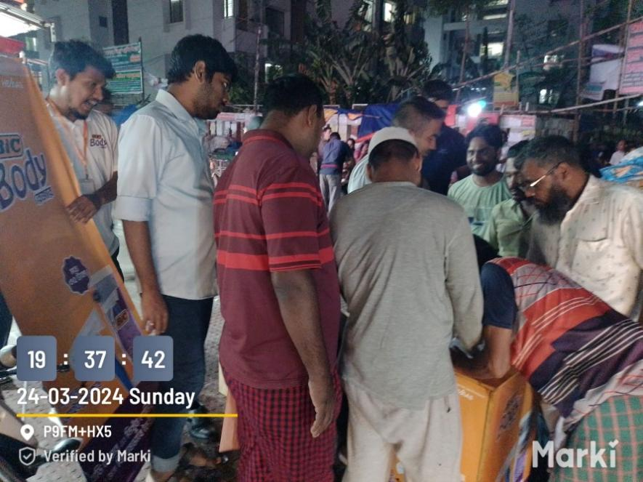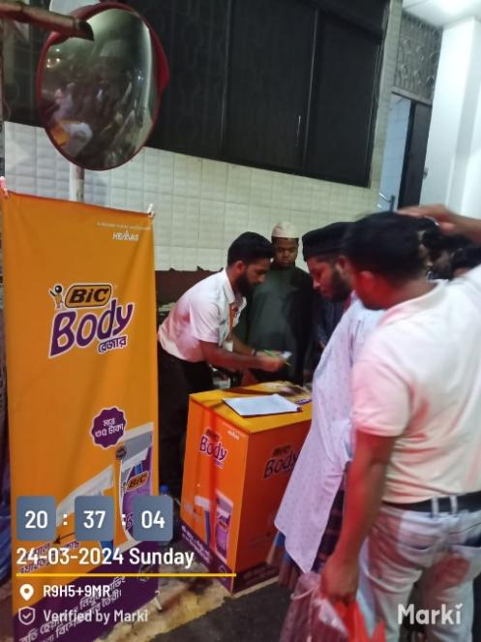
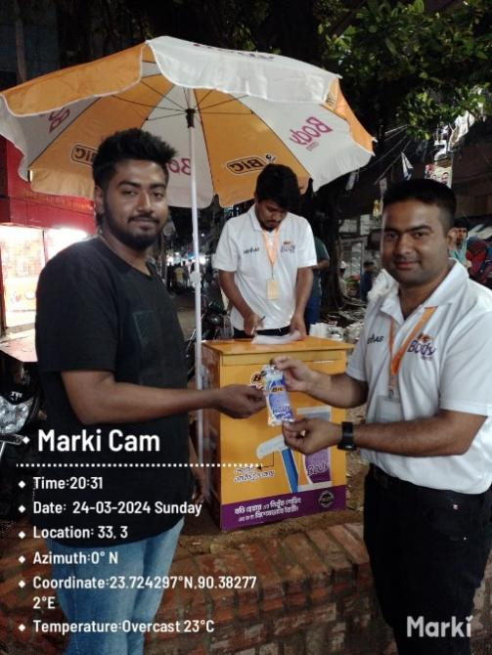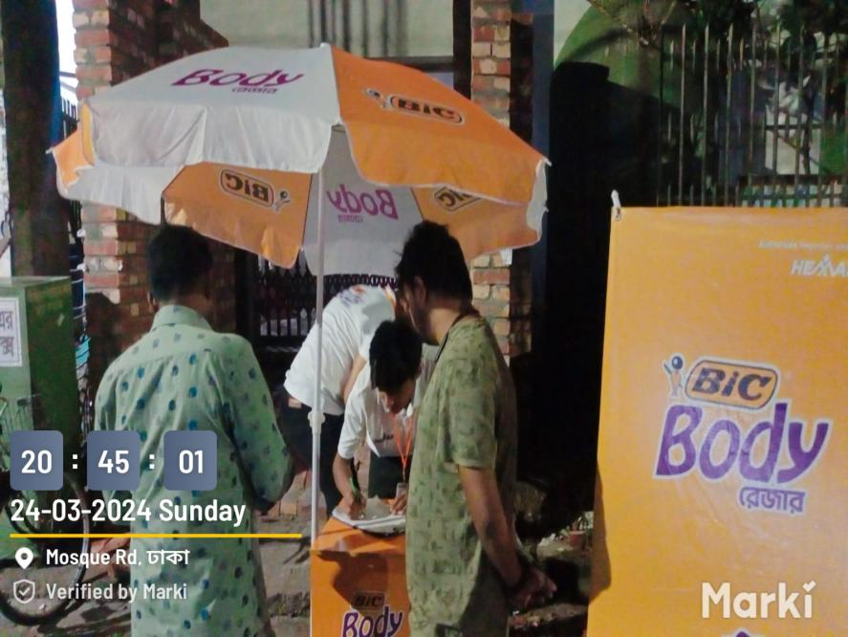
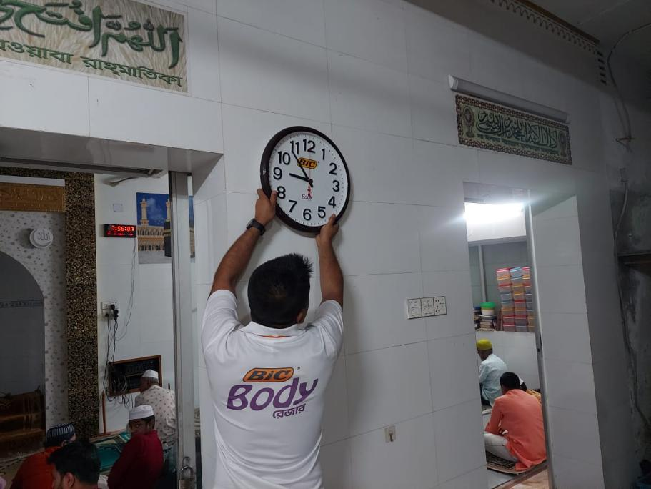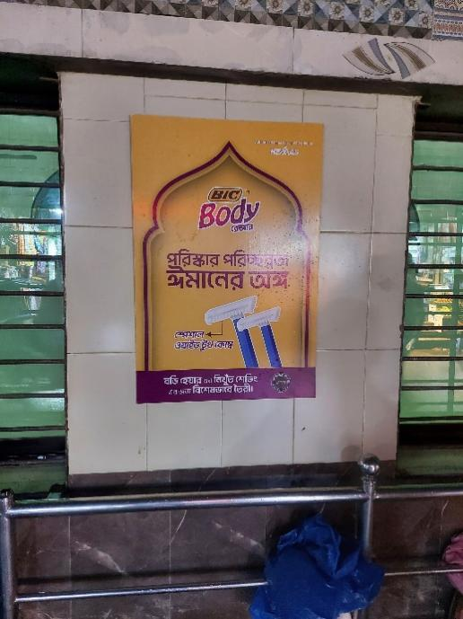

7.0 Conclusion and Key Factors

7.1 Recommendations for Improving Departmental Operations
Drawing on my observations and experiences during my internship at Hemas Consumer Brand (Pvt) LTD, I recommend implementing the following suggestions to improve the efficiency and effectiveness of marketing operations.
- Broaden the marketing department's emphasis on digital platforms by allocating resources towards advanced analytics tools, which will help to better understand online consumer behavior and enhance campaign optimization.
- Create a centralized database for marketing information, encompassing campaign results, market trends, and consumer insights, to support more informed decision-making and strategy development.
- Improve collaboration with Trade Sales Officers (TSOs) and Trade Sales Managers (TSMs) to ensure that marketing strategies align with on-the-ground sales activities.
- Schedule regular feedback sessions with field teams to pinpoint challenges and refine campaign execution tactics.
- Increase investment in traditional advertising channels, such as television and print media, to engage a wider audience, particularly in rural regions where digital access is limited.
- Combine traditional and digital marketing strategies to form a comprehensive and cohesive marketing approach.

7.2 Key understanding
My internship at Hemas Consumer Brand (Pvt) LTD gave me knowledge about how companies apply integrated marketing communication and consumer-targeting strategies in the FMCG sector. I've seen how advertising like the one BIC made for Ramadan, or the one that promoted Colombo Coconut Hair Oil, can both inspire customers, and drive sales. The internship stressed the importance of working together, adapting, and using data analysis, along with management of marketing resources, technology, and teamwork, to produce good results. I also learned about the quickly rising importance of the digital marketing space, the emerging rural market, and the requirement of aggressive strategies for capturing tailored approaches to different consumer slices. I gained valuable knowledge of marketing and operations in an aggressive sector.

8 Conclusion
My internship at Hemas Consumer Brand (Pvt) LTD was positive for many reasons, and it allowed me to gain considerable insight into the FMCG sector while helping to bridge the gap between theory and practice. I learned about how marketing activities take place, how campaigns work, and how to deal with customers. During the Ramadan activation campaign of BIC Body Razor and the mobile recharge activation of Colombo Coconut Hair Oil, I realized that there is a need to research marketing and a need to factor in cultural and behavioral aspects in relation to marketing. My internship helped me understand better integrated marketing communication, information technology in business, marketing, business intelligence, and the problems in the operations of the market. I worked with several departments and collected insights to create campaigns on consumer behavior that improved my experience and my knowledge of the industry.
This report provides a description of my work, analysis, and some proposals to improve the marketing functions of the Hemas Company. It is an attempt to combine what I have learned with what I have put to practice and in doing so, suggesting ideas for the ever-evolving world of FMCG in Bangladesh. The impact of this experience helped me gain knowledge.

References

Since much of the information comes from practical experience and company resources, the references are based on direct involvement rather than publicly available reports. However, the inclusion of academic literature helps in aligning practical insights with established marketing theories.
Bangladesh Brand Forum. (2022). The state of FMCG in Bangladesh. Bangladesh Brand Forum. https://www.bangladeshbrandforum.com
Statista. (2023). Market share of personal care products in Bangladesh. Statista. https://www.statista.com
Bangladesh Bureau of Statistics. (2023). Report on consumer behavior and economic indicators. Bangladesh Bureau of Statistics. https://www.bbs.gov.bd.

