

Internship Report

On

BPO Industry Growth in Bangladesh And

Taskeater as a Growing BPO Firm



Internship Report

On

BPO Industry Growth in Bangladesh And

Taskeater as a Growing BPO Firm

Submitted To:

S. M. Asif-ur-Rahman

Assistant Professor

School of Business & Economics

United International University

Submitted By:

Mallik Sahruk Sadman Ruslan

ID: 111 143 219

United International University

Submission Date: 3rd February, 2019



Letter of Transmittal

3rd February, 2019

S. M. Asif-ur-Rahman

Assistant Professor

School of Business & Economics

United International University

Subject: Submitting the Internship Report on BPO Industry Growth in Bangladesh and Taskeater as a Growing BPO Firm.

Dear Sir,

I am delighted to inform you that for the partial fulfillment of my BBA Program I have completed my internship Program at Taskeater Bangladesh. I am submitting the internship report on BPO Industry Growth in Bangladesh and Taskeater as a growing BPO Firm. The report will preview how BPO industry had grown in past few years and how Taskeater is becoming one of the leading BPO Firm. I have placed my best effort to gather extensive experience and collect information about the topic. I am submitting the report for your kind perusal and acceptance. I have learnt a lot while preparing this report which will support me in my real life work.

I will be thankful, if you kindly acknowledge this report. It would be gratification for me if this report can serve its purposes and I will be available to explain your queries, if you feel necessary.

Sincerely yours,

___________________

Mallik Sahruk Sadman Ruslan

ID: 111 143 219

School of Business & Economics

United International University
Letter of Acceptance

It is my gratification to accept the internship report entitled BPO Industry Growth in Bangladesh and Taskeater as a Growing BPO Firm, prepared by Mallik Sahruk Sadman Ruslan, did major in Marketing (MKT) and did minor in Human Resource Management (HRM) in Bachelor of Business Administration (BBA), United International University of Bangladesh. I do here by certify that this report was solely prepared by him by using the relevant documents related to the assigned topic.

__________________________

S. M. Asif-ur-Rahman

Assistant Professor
School of Business & Economics
United International University
Declaration

I am Mallik Sahruk Sadman Ruslan, a Student of United International University, BBA Program. ID Number: 111 143 219, hereby declare that the internship report on BPO Industry Growth in Bangladesh and Taskeater as a Growing BPO Firm, was prepared after the completion of my internship at Taskeater Bangladesh, CRP Building, Mirpur 14, Dhaka-1206. I in addition declare that the internship report is made for an academic use and had not been submitted by me before of any degree.

__________________

Mallik Sahruk Sadman Ruslan

ID: 111 143 219

School of Business & Economics

United International University

Certification

This is hereby certified to Mallik Sahruk Sadman Ruslan, ID: 111 143 219, Student of BBA program, United International University, School of Business & Economics, has successfully completed the Internship program for three months from October 10th, 2018 to January 10th, 2019 from Taskeater Bangladesh, Dhaka. At the time of Internship he had achieved the practical knowledge about BPO sector and how is the working method of this sector. I wish him the successful future for his life.

__________________________

S. M. Asif-ur-Rahman

Assistant Professor

School of Business & Economics

United International University

Dedication

I would like to dedicate my internship report to Almighty Allah, who had blessed me with capability to complete my internship period and complete the internship report very calmly and with no trouble, in a friendly environment without facing any problem and harassment. Another, I would like to bestow this report to the family of Taskeater as well. All of the supportive and helpful people from the office made me learn with no trouble and fit in with them properly. I would also like to dedicate my report to my academic mentor S. M. Asif-ur-Rahman for his kind co-operation and support.

Acknowledgement

All praise to Almighty Allah, who gives me potency to complete this report. In the process of doing this research paper me, Mallik Sahruk Sadman Ruslan would like to give my gratitude and respect to some person for their kind co-operation to complete my internship report on BPO Industry Growth in Bangladesh and Taskeater as a Growing BPO Firm.

First and foremost, I owe a debt of gratitude to my course instructor Mr. S. M. Asif-ur-Rahman, Assistant Professor, School of Business & Economics, United International University for his benefiting guidance and encouragement, astute advice and endless endurance throughout the semester without which this paper have not been flourishing. Secondly, I would also like to thank, my colleagues of Taskeater for helping me to prepare this report with adequate and collect information.

The report might never have been completed without the necessary academic knowledge, assistance of reference books, web pages and some practical knowledge, assistance of Taskeater Officials, and what is worth mentioning the sincere and enthusiastic cooperation from the course faculty. I would like to thank all those, especially the employees of the Office; who have assisted me to prepare the report, and special thanks to my course instructor, I will remain grateful to all of them.

Table of Contents

Serial No. | Content | Page No.
Chapter-1 | Introduction | 01
1.1 | Introduction | 02-03
1.2 | Objective | 04
1.3 | Scope of the Study | 04
1.4 | Methodology | 04
1.5 | Leading and Growing BPO Firms in Bangladesh | 05-06
1.6 | BPO Opportunities and Challenges in Bangladesh | 06-07
1.7 | Bangladesh as a BPO destination of choice | 07
1.8 | Factors that make Bangladesh a favourable BPO Destination | 07-08-09
Chapter-2 | Taskeater Organization Overview | 10
2.1 | Introduction: Taskeater Bangladesh Limited | 11
2.2 | Organization Structure | 11
2.3 | SWOT Analysis of Taskeater | 12
2.4 | Job Description | 13
2.5 | Services offered by Taskeater | 13
2.6 | Learning Experience | 14-15
Chapter-3 | Client Management Practice | 16
3.1 | The Business Process Outsourcing | 17
3.2 | Client Relationship Practices of Taskeater | 17-18
3.3 | Challenges | 18
Chapter-4 | Conclusion and References | 19-20-21

Chapter-1
Introduction

1.1 Introduction: The journey of BPO industry started back in 2007 with few BPO firms operating here in Bangladesh. It is more than 11years now and Bangladesh is considered as one of the leading BPO markets in the world with over 500 BPO and IT firms providing their services to clients around the world. Foreign companies are now happy to outsource their work from Bangladesh instead of India, China or Philippines, due to the increasing costs in these places and due to the fact that Bangladesh's BPO sector have been able to provide the same quality, if not better, as that provided by the competitors in India or Philippines.
BPO sector is the subsequently considerable area of international business concerning more than 500 billion dollars annually. If Bangladesh try to utilize this opportunity then BPO sector can be the highest foreign currency earning sector making the RMG in second. Countries such as India, Philippines, and Sri Lanka have by now made their results in establishing a flourishing BPO sector. Even Sri Lanka has exceeded three billion dollars of earning through BPO. A enormous portion of our educated population is female. Many obstacles might be present in their way of getting involved in conventional jobs. BPO sector has the correct characteristics to considerate an excellent opportunity for them. BPO sector businessmen should encourage more and more educated women in this sector. Along with, we also need to focus on making internet safer for the women and children.
The earning from this sector in 2017 was $230 million and this is growing every year with a excellent rate and Bangladesh Association of Call Centre and Outsourcing (BACCO) expects to hit $1 Billion mark soon. Currently more than 40000 young people works in this sector and the number is increasing every year. The ICT ministry of Bangladesh is trying their best to make this sector bigger than now and they are proving financial support to many firms to expand their business and create employment for unemployed people. The Business Process Outsourcing (BPO) sector in Bangladesh is growing at fast speed. According to Bangladesh's Department of Information and Communication Technology (ICT), the export revenue of the BPO sector had been grown rapidly in past few years. The government of Bangladesh had taken a single-minded goal of creating 300,000 jobs through this sector by 2023. The excellent news is that a few globally competitive companies had emerged in Bangladesh in recent years. These companies are taking work orders from abroad and placing them in their operations office in Dhaka, from where they deliver their work. As well as these companies should be more focused and concern about future business developments. Making the BPO business more technologically modernized should be their aim for future. The outsourcing journey of an organisation starts with outsourcing non-core processes and most large global business corporations have already begun this journey. Many organizations are now identifying the needs of outsourcing their back end jobs to the countries that generates cheap labor. Bangladesh BPO companies should be ready and aware of new technologies and more complex outsourcing works. More than 2000 large contracts are signed in BPO sector worldwide which are very high in volume and it can be very big opportunity for country like Bangladesh to avail some of these big contracts. The contracting trend is moving towards executing a greater amount of contracts with smaller contract values. Such initiatives will be helpful for Bangladesh BPO sector future growth and will increase the capabilities of the firms. In addition, modernisation of the existing capabilities will help them get ready for future contracts. BPO firms operating in Bangladesh has the advantage of high availability of workforce in cheap price. The young population of the country comprises a vast pool of educated youth who are ready for on-the-job training and deployment. Among these students any are fluent in English and have good communication skills which make them more competitive to their competing countries workforce. However, such skills are unlikely to be adequate for future service needs. The future workforce will need to deliver their service by using refined technology and they might need AI for this sector in future. It is essential for the stakeholders of this to be more updated about the technological needs and demands.
Most of the companies had been able to restructure their resources after successfully outsourcing their internal functions. They had outsourced their work so that they can put more focus on their important jobs and identify the more complex business problems. For example, staff members in the finance function were given the task of analysing data more frequently and in a more comprehensive fashion once their job lying on payables and receivables was outsourced. The successful analysis resulted in the development of business performance such as dropping working capital needs, collecting receivables sooner and reducing the risk of debtor defaults. As a result, outsourcing some of the processes has helped organisations modernise the operational processes that delivered business benefits. Many alike companies are looking forward to outsource such modernised operational processes. Outsourcing service providers will require the capabilities to deliver such modernised processes and results for their customers. Thus, BPO companies of the future will be recognised by their ability to develop insights for their customers.
1.2 Purpose: There are two major purposes behind conducting this study. These are:
- Primary Objective: To give emphasis to the ‘BPO Industry Growth’ and to analyze the prospects of outsourcing in Bangladesh. Moreover, to apply knowledge gained from books and lectures over the last four years to a practical environment. Also to learn the code of conducts of a corporate office and to adapt to it.
- Secondary Objective: This report is a obligatory requirement for the completion of BBA program of United International University.
1.3 Scope of the Study:

The report will re-present the prospects of outsourcing in Bangladesh in brief and then gradually move onto the main topic of BPO Industry Growth in Bangladesh and Taskeater as a Growing BPO Firm, its opportunities and its challenges in everyday business operations.
The report is composed and written based on my experience gained from working as an intern and working as one of the five people team for managing the American client "Houlihan Lokey" for Taskeater Bangladesh.
1.4 Methodology:

The whole report was done in an orderly process, from selection of the topic to finalizing the work and everything in between. The first step was to select the topic, which I discussed with my intern supervisor, Ms Fiza Tasmia. It was with her help and guidance I selected this topic to work on. Secondly, data sources, both primary and secondary were needed to be identified, categorized and analyzed in order to conduct this study. Lastly, a big portion of all the information presented here are collected from practically working in the office and discussing with the current employees of the company and also with my supervisor at office and from the client I worked with during my intern period at Taskeater.

1.5 Leading and Growing BPO Firms in Bangladesh:
- Genex Infosys Ltd. is a sister concern of IPE Group UK, Genex is one of the leading outsourcing firm in Bangladesh, with a multinational team of experts from around the world. Its current clientele consists of companies in the telecom industry, banking sector, government and in the retail industry. A major portion of its services include Inbound and Outbound Customer Support, as well as Digital Services and Back office Management.
- ASL is a start-up BPO firm founded by Zayed Ahmed. It currently provides round the clock 24/7 Back End Office Support to a large number of Real Estate and Asset Management Companies in USA, providing support in areas such as Comparative Market Analysis (CMA) and Broker Price Opinion (BPO). Another foremost sector that it provides service to is in Digital Marketing (SEO, SEM, and SMM) to small and medium sized companies. One of its largest successes in 2017-18 was to partnering up with European and Chinese businesses in handling back-end projects.
- Search Engine BPO SEBPO is one of the pioneer BPO companies which is founded in Bangladesh. It is the subsidiary of one of the largest conglomerate in this country and currently has 1200 workforce who are involve in providing services to US companies such as AOL, AdTheorent and Scroll Motion. Its proficiency includes but is not limited to Digital Advertising Operations, Application Development and Quality Assurance services.
- Digicon Technologies Ltd. is a pioneer in Bangladesh's Call Center Industry; they are providing its Outbound and Inbound Customer Service Support to the Commercial Vehicle Industry, Banking Companies, Pharmaceutical Industry, Multinational Beverage and Electronics Companies, they are generating annual revenue of about $350,000 USD.
- FifoTech was founded by Towhid Hossain who is currently its Managing Director & CEO. It is also one of the oldest Contact Center, that had been providing is services since its inception in 2004. Other Areas that it has expertise in are Finance Accounting Outsourcing, DLP Solutions and Human Resource Management.
- Quintos is also another name in the BPO Startup firms list, which is founded by Gazi Musayab Raffan. It offers its business solutions services in areas such as Digital Marketing, Web Development, Software Solutions, Mobile App Development and eCommerce Solutions.
- Aamra Outsourcing LTD is a subsidiary of Aamra Companies who are a leading business corporation, and operating in Textiles, Information & Communication Technologies and Lifestyle Services.

1.6 BPO Opportunities and Challenges in Bangladesh:
- Bangladesh possesses one of the amazing and eye-catching demographic populations in the world. Half of the population is under 25years of age.
- The country is power-driven by young motivated and hard-working workforce with comparatively lower attrition rate.
- The number of talented workforce in this country is available at a lower wage than neighboring countries. Therefore outsourcing in the country can have a significant cost advantage.
- Not only low wages is the attraction but also they offers significant infrastructure, rent for office space in terms of cost in Dhaka (capital) which is below 20% of that of India.
- State of the art telecommunications infrastructure is supported by extensive fiber optics connectivity across the country. Charges for Internet bandwidth in Bangladesh is currently the lowest in South Asia (almost 50% of that in India).
- Bangladesh is also benefitted by the geographic location, it provides time zone advantage for European countries, as the half day time difference means that work related queries sent to Bangladesh in the evening can be responded by early morning next day (European time).
- The govt. of Bangladesh is providing a significant support for the growth of the IT outsourcing sector and has provided significant budgetary incentives like tax assumptions, duty cut etc. Direct tax is exempted in the IT sector till 2015.
- There are many Bangladeshis residing in west such as US and Europe this can help the country in building a network and can enable the local industry to obtain contracts.

1.7 Bangladesh: As a BPO Destination of choice: Recognized by Global Technology Research and Financial Analyst of the World
- In 2005, Goldman Sachs included Bangladesh in the Next 11, the largest populations after BRIC, which combines economic and political conditions and it could greatly impact the global economy.
- JP Morgan has included Bangladesh in the “Frontier Five” economies in 2007.
- International IT Research Firms has included Bangladesh in its list of top outsourcing destination in its reports.
1.8 Factors that make Bangladesh a favorable BPO destination:
- Population & Demographic: Half of the population is under 25 years of age, Bangladeshis are known for hard work and commitment even attrition rate is very low as compared to employees of other countries.
- Internet Bandwidth: The internet bandwidth cost in Bangladesh is comparatively very cheap than other countries.
- Govt. Support: Govt of Bangladesh is more supportive for BPO sector in making Bangladesh a favorable destination of business for foreign investors. Policy like exemption of direct taxes in IT sector till 2015 is helping in growth of the country

- Cheaper Manpower: The noteworthy amount of young work force is available at a much cheaper wage as compared to other outsourcing countries. The wage rate in Bangladesh in IT industry is more than 50% cheaper than other countries.
- Cheaper Infrastructure Cost- Costs of infrastructure in Bangladesh are fairly low compared to other countries in Asia mainly in terms of office places. The leasing of office space in Dhaka is 20% lower of that in India and 40% of Philippines.

Chapter-2
Taskeater
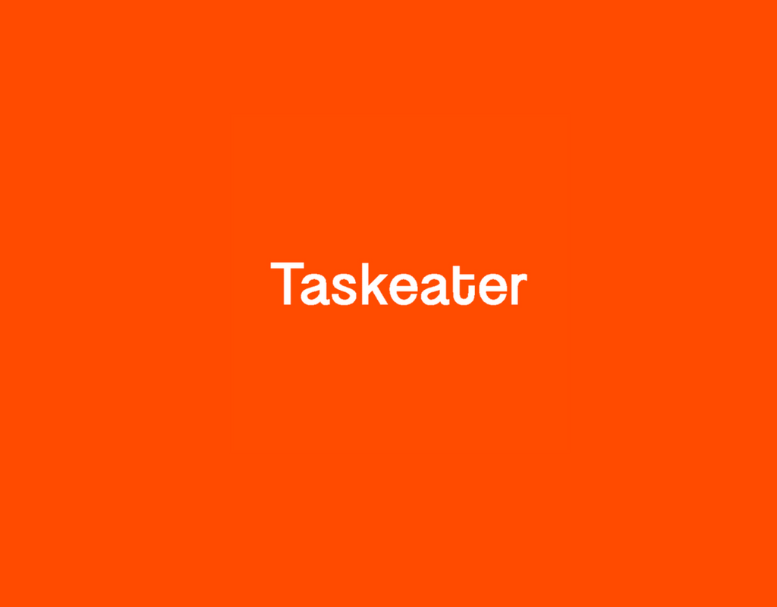
Organization Overview

2.1 Introduction: Taskeater Bangladesh Limited:
Taskeater was founded by Mikko Tamminen who is a very hard working businessman, when he started Taskeater back in 2014, 5th of March with only he and Zafrul Islam who is now Director of Leads, they two were there working for Danish client who was their first client apparently. Taskeater started their journey in a small room office which eventually turned into a 2 floor office with a area of approximately 10000sft of each floor in just 5 years and they are planning to hire more 500 people making the total number of employee to 1000 within 2019. Taskeater’s main focal point is to put together dedicated teams for their clients who will be dedicated for their one-sided business processes while the client can focus on innovation. Taskeater is providing service to some of the world's most exciting IT companies to build highly scalable teams, giving them an edge over their competition.
2.2 Organisation Structure:
The Taskeater organizational structure follows a horizontal design to maintain order, stability and transparency throughout the organization itself. The ideas is straightforward, to create a sense of excellence and friendly work surroundings that eradicates any discrimination and gradually increases every individual's productivity and dedication to the work.
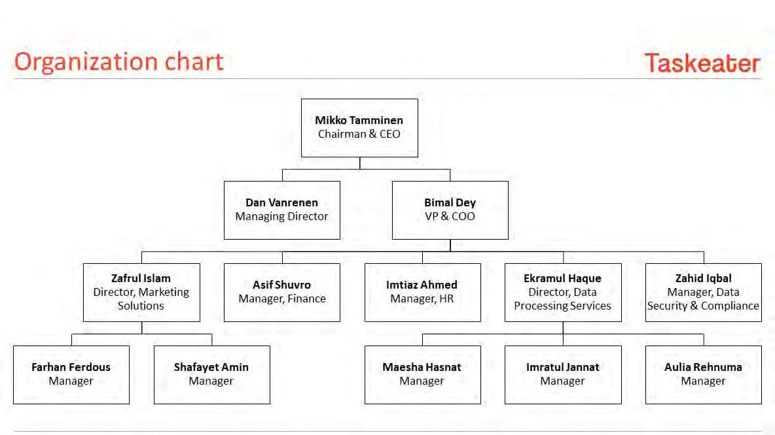
The organizational structure is given below:

2.3 SWOT Analysis of Taskeater:
SWOT analysis refers to the comparison and analysis of a company's Strengths, Weaknesses, Opportunities and Threats. The main purpose of this analysis is to establish a company’s most necessary strategies to operate in the competitive environment and to create a business model that best suits the overall environment and situation the company operates in. It also helps a company to allocate its valuable resources to the right channels and to change its business model if needed in accordance to any sort of change in its business environment.
An analysis of Taskeater's Strengths, Opportunities, Weaknesses and Threats are given below:
Strength:
- Abundance of young energetic employees
- Good management
- Clear concept of who does what for the organization
- Good networking system
- Competent sales representatives in Europe
Weaknesses:
- Relatively low chances of innovation
- Lack of proper internet connection
- Low infrastructural development
Opportunities:
- Flexible government regulations
- High potential for growth
- Relatively low number of competitors
Threats:
- New policies or regulations set by the government
- Slow infrastructural growth rate, in terms of business development

2.4 Job Description:
Initially as an intern at Taskeater I was required to work for "internal leads" department. I was first taught how to generate leads, which are actually email ids of different personals working at various types’ organizations abroad. My task was to generate leads for Taskeater's sales representative in United Kingdom, who would then contact the leads and setup meetings to sell Taskeater's services. The lead generation teams works in various industries and generates leads from a wide verity of companies. The company’s size, industry that it operates in and its products/services plays a great role in generating leads. For my first task, I was instructed to generate leads of CEO/COO/Head of Operations of companies in the Travel/Leisure industry; however the company size could not go over 200 employees. My work was classified as "internal leads' because the leads generated were for only Taskeater and were meant to utilize internally.
A few days later I was switched to a new client that was on trial period with the company. The work was quite similar, lead generation, however from a different industry and with very restricted search criteria. I am working with this client at the moment, this client is a very big Investment Bank in USA and my job is to create company profile for them which help them to identify the capability and credibility of the company which they might invest in future.
My team is now a team of six people that manages the profile creation part of our client. We help them to with the financial information, company overview, company news, company product category, etc.
2.5 Services offered by Taskeater:
-Lead Generation
-Content Moderation
-Order Processing
-Data-entry
-Tagging and Categorization
-Online Data Collection
-Security Camera Surveillance & Call Centre auditing etc.
2.6 Learning Experience:
Technology and Analytical Learning: At Taskeater our whole operation is based on different software. We use online spreadsheet to keep track of our work. I have to learn profile creation in Google drive templates. I had to learn utilizing other different software effectively. Before creating each profile, we need to acquire and evaluate data which we collect from different source and check those data effectively.
Communication Skills: As we need to maintain a daily basic communication with our client, my communication skills are getting better. Good Communication skills are essential here and considered one of the key factors in corporate life. This is not only helping me in the professional life but also in personal life too. I can easily mix with different people. This skill helps me to boost my confidence both in professional and personal life.
Dealing with Difficult Situation: Working with Taskeater gave me this experience; that I have learned meeting deadlines, handling client’s feedbacks. Most challenging tasks were ensuring quality as we were bound by time. There is no proper solution for all situations. In different situations I have to use my own creativity and improvise given solutions. Most of the times I have to give prompt as well as correct decision. This is helping me developing my analytical skills. Sometimes we need to get an outside prospective. Our Line managers and co-workers are very helpful. Recently, our manager have introduced stand up meeting where we share our ideas about solving different problems. This helps bringing a sense of team spirit among the employees.
Event Participation and Organizing: We had the chance to perform and organize different event in the office premises as we used to have festival programs in office and I had the opportunity to organize one program as a volunteer and my head organizer was very happy by my work and appreciated by our Founder Mikko Sir these gave me to show my internal talents and creativity.
Experience Vs Expectation: As a business student, I had learned a lot of theory regarding managerial skills. My expectation was, I would see implement of those from my office. But Real life experience was a bit different from theory. As Taskeater follow a flat organizational Hierarchy, each member get to work very closely with their managers. It motivates us to directly learn from our manager. I have learned that customers are supposed to get the best attention. Without joining a corporate office, it is very hard to imagine how much effort has to be given to make a client happy. In Taskeater our dedicated teams and managers try their best to satisfy our clients. Unquestionably, this is a good practice, but sometimes management does not pay enough attention to employees. Employees are as vital as clients. Sometimes management cannot give proper attention to individuals, especially new ones. At times proper training and orientation are not provided to the new talents. Recently Taskeater have taken some initiatives to get rid of those gaps. But still there is a lot of room for improvement. Taskeater is trying to introduce some good initiatives for their employees and working environment, and also they are planning to get the ISO certification soon, as a result it will be then fully compliance workplace.

Chapter-3
Client Management Practice

3.1 The Business Process Outsourcing:
Business process outsourcing (BPO) is the contracting of a precise business task, such as payroll, to a third-party service provider. Generally, BPO is implemented as a cost-saving measure for tasks that a company requires but does not depend upon to keep their position in the marketplace. BPO is often separated into two categories: back office outsourcing which includes internal business functions such as billing or purchasing, and front office outsourcing which includes customer-related services such as marketing or tech support.
3.2 Client Relationship Management Practices of Taskeater:
As discussed before, client management plays a very important part in any business, especially in outsourcing business. The practices that Taskeater Bangladesh abides by in order to manage a proper client relationship with their client start with ensuring a good, regular communication with the client. The aspects of the client management process of Taskeater can be listed below:
- Maintaining regular communication with the client.
- Weekly feedback on the work, usually at the beginning or at the end of the week.
- Real time communication through Skype or other means on a daily basis.
- Clients can monitor the work, while it’s being done and give instant feedback or suggestion if there's any mistake.
- The client is notified if there is any change in the work teams allocated to them.
- Feedback from client is used to monitor and improve the productivity of working analysts.
- Lastly, the most important part, getting the job done for the client, on time and exactly as the clients wants it.

When I begun working with the Houlihan Lokey team, there were already four people working for it. My addition to the team was a result of the client's expanding business and taking on more work than usual. It's been 2 months since I joined the team and is a part of the client relationship management process of the company. After joining the team, I was taught how the client wants his work done, through instructional videos and other forms of digital instructions. Then I had my first meeting with the client before joining the team. After the client met me, through Skype, he authorized my joining the Houlihan Lokey team and that is how and when I started to work for the team. A lot of our work involves using google drive services. In addition to all these, I was also provided with the URLs of a few other websites such as "onliceOCR.net" or "typeswedis.com” etc. to assist us work properly. The client management process for Houlihan Lokey is done on a weekly basis. On every Monday we meet the client through Skype usually around 5.30 (Bangladesh time). The client gives us feedback for the work done preceding week and also discusses about the work plan for the week after updating the weekly profiles. Usually a line/team manager of Taskeater is also always present at these meetings to ensure proper communication between the client and analysts. The client relationship management for Houlihan Lokey is now pretty easy. The client has been with Taskeater for quite some time now and is very pleased with the work that we have been doing for them. Conventional CRM approaches are understood by the managers to ensure good communication and client management.

3.3 Challenges:
There are some challenges which should be addressed before the industry can thrive, Bangladesh gained a “poor” rating in three very important areas which are, infrastructure, language skills and data, and intellectual property security. Poor infrastructure, along with numerous power crises slower and undependable internet connections are the main instant problems for outsourcing. The president of the Bangladesh Association of Call Centre and Outsourcing (BACCO) assured that they have told the government that they need an uninterrupted power supply and a second connection with high bandwidth speed, adding that progress on these issues is slow.

Chapter-4
Conclusion

Conclusion

BPO means the contracting out of the business work to a different party who will then be taking the responsibility to complete the work within the given time is known as business process outsourcing. Companies mostly outsource their work to reduce certain costs such as nonessential or "non-core" business expenditures, higher taxes, higher energy costs, extreme government regulation, production and labor costs. As government provides incentives to the IT sector of Bangladesh which eventually attracts investments in these companies and also open the doors for foreign firms. The demand of Bangladesh services in the outsourcing market is putting the maximum tax facilities in this industry and there outsourcers from overseas are making the benefit of spending less in any work from Bangladesh. This also represents a great opportunity for the outsourcing business to improve and strengthen its CRM practices. Proper CRM practice is a must for a outsourcing business to flourish and to survive among competition. Rising labor cost in India, China, Philippines, and other countries, Bangladesh is getting the privileged outsourced destination for foreign companies and they are now looking forward to give more work to Bangladesh as our labor cost is low compare to neighboring countries and also the work quality is also good. BPO sector in Bangladesh has immense opportunity we just need to identify those and utilize the opportunity because it is the time to be more concern about this sector as it is growing everyday and it has a good future I believe the people who are involve in this sector they should consult to the government of Bangladesh and explain them about the challenges they are facing and also the challenges they will face in future, It will eventually help them in their long term growth of this sector.

References

- https://www.daily-sun.com/printversion/details/300853/2018/04/09/BPO:-Endless-opportunities-for-Bangladesh
- https://www.thedailystar.net/city/modernising-the-outsourcing-business-in-bangladesh-1569325
- https://dailyasianage.com/news/53126/bangladesh-rising-potential-in-bpo-industry
- https://www.dhakatribune.com/opinion/2018/07/12/at-the-core-of-our-potential-2
- http://english.kalerkantho.com/online/capital/2018/04/16/9341
- https://www.thedailystar.net/business/bpo-sector-showing-signs-promise-1529644
- https://www.thedailystar.net/frontpage/bpo-summit-2018-outsourcing-firms-eye-1-lakh-jobs-3-yrs-1563157
- https://www.thedailystar.net/news-detail-102276
- https://www.dhakatribune.com/uncategorized/2015/12/21/business-process-outsourcing-summit-2015-with-a-vision-of-a-digital-bangladesh

