

United International University

“Customer satisfaction regarding E-commerce in Bangladesh”

Title: Project on “Customer satisfaction regarding E-commerce in Bangladesh”

Submitted To
Mr. S.M. Asif-Ur- Rahman
Assistant professor
School of Business & Economics,
United International University.

Submitted By
Farjana Rafiq
Id – 111 143 034
United International University

Date of Submission: 16.05.19
LETTER OF TRASMITTAL
16 April 2019
Mr. S.M. Asif-Ur- Rahman
Assistant professor
School of Business & Economics,
United International University.
Subject- Submission of project on “Customer satisfaction regarding E-commerce in Bangladesh”
Dear Sir,
With due respect, I have the pleasure to submit the project report as per the requirement of my Bachelor of Business Administration (BBA) program.
Here is my project report on “customer satisfaction regarding E-commerce in Bangladesh” which you recommend as my report topic. The report is completed by the information I have gathered from different sources. I have tried my level best to complete my report correctly & meaningfully in due time as much as possible. I hope this report will give us the whole view of E-commerce & its customer’s satisfaction.
I hope that my report will meet all the standard requirements that you set for me & you will appreciate my effort.
Sincerely yours,

Farjana Rafiq
Id – 111 143 034
School of Business & Economics,
United International University

Acknowledgement
At first I would like to thank almighty Allah for giving me the opportunity & strength to complete my assigned task on time.
The work on this report was exciting, challenging, interesting but I have learned a lot of things by the assigned work.
I would like to thank my honorable supervisor “S.M. Asif-Ur-Rahman”, Assistant Professor, Schoolof Business & Economics, United International University for giving me the opportunity to work on such an interesting topic by which I get knowledge about E-commerce site.
He has supported me all the time with his guidance & motive me to complete the work on due time. He patiently listen all my quarries & solve them. The level of kindness shown by him beside of this busy work life is really appreciated.
I would also like to UIU authority for giving me the opportunity to work on this project report.
I would also like to thank the authority of UIU computer lab & library staff who helped me to complete my task.
And at last my friends, classmates & many others who support me to complete the survey which is conducted during collecting data.

Table of Contents
Chapter One: Introduction 1
Introduction: 2
a. Origin of the Report- 2
b. Background of the report 2
c. Literature review – 4
d. Purpose of the Report- 6
e. Scope & Limitation of the report- 6
f. Methodology of Data Collection- 6
Chapter 2: Findings & Analysis 9
Findings & Analysis 10
2.0 What is E-commerce (Electronic commerce) – 10
2.1 Background or History of E-commerce- 10
2.2 Types of E-commerce- 11
2.3 Classifying ecommerce merchants according to what they’re selling- 11
2.4 Classifying ecommerce according to the parties involved- 12
2.5 The Benefits of EC 13
2.6 Benefits to Organizations- 13
2.7 Benefits to Consumers 14
2.8 Benefits to Society 14
2.9 Limitations of E-commerce- 14
Chapter 3: Suggestion & Recommendation 15
3.0 Recommendations for future development in Bangladesh for Online Shopping: 16
Chapter 4: Conclusion 17
Conclusion 18
Append Part 19
A. Reference- 20
Websites: 20
B. Questionnaire 20

Executive Summery
Internet is one of the rapidest growing media during the past decade. Especially online shopping is a rapidly growing e-commerce area. Basically online stores are available 24 hours a day and many customers have internet access both at work and at home. This study aims to establish a preliminary assessment, evaluation and understanding of the characteristics of online shopping. Although the benefit of online shopping is considerable when the process goes poorly it can create a thorny situation. There might be a trust issue problem, using card issue, theft identity and return policy etc. there have some precautions to be taken are studied in this paper.

Chapter One: Introduction

Introduction:

a. Origin of the Report-
For a business student research is the most important part. It helps to increase knowledge level on a particular sector. The project report on “customer satisfaction regarding E-commerce in Bangladesh” is prepared as a part of academic requirement under the supervision of Mr. S.M. Asif-Ur-Rahman, assistant professor of School of Business & Economics.

b. Background of the report
By E-commerce (Electric commerce) we understand online transaction. Selling products & giving service via internet is E-commerce. One a day’s E-commerce just become the most important platform of doing business. E-commerce is growing rapidly because it is the expansion of internet service. E-commerce introduced new shape of business 'structure in this era. This paper is the analysis of customer satisfaction regarding E-commerce in Bangladesh. Number of internet users in Bangladesh is over than 80.829 million at the end of January, 2018.
In our country almost 5 years back we didn’t think that we will buy anything ordering via internet. But now a days the situation has been changed. This happened because of the improvement of technology. Ecommerce was introduced 40 years ago to anticipate the customer demand and more pursue customer satisfaction E-commerce got a whole new level in1970’s.
In our country E-commerce has been introduced some years ago, it become popular in 2013 in our country. So in that year many companies started their journey in E-commerce as online shop.
As in our county E-commerce is doing well, that’s why Bangladesh government is also emphasizing on its growth. In our county almost 13% of the overall population are internet users so there is huge opportunity for growth.
E-commerce sites in our country-

- Online shopping
- Online banking
- Digital wallet
- Job circular
- Online ticket booking
- Online health service

And many more but among of those online shopping is more famous in our country. Most of the male customers look for watches & electronic device; on the other hand, females look for dresses, shoe, home decoration & many more. In this paper I have gather knowledge about business policy & customer’s satisfaction about E-commerce.
I have also done a survey to know about what is customer’s expectation and perception of online shopping. Since ensuring good quality service& product quality is the most important nowadays I have tried to find out what can be done on this aspect.

c. Literature review –
Online shopping is a way of shopping where the buyer can order a product or service by using internet. Virtual world is showing its influence day by day. We are living on the virtual world. As this article is about customer’s satisfaction regarding E-commerce in Bangladesh. A significant amount of research work has been done on E-commerce earlier. A large group of researchers has figure out the possibilities & future of Online Shopping. Others pointed out on the limitations and at the same time they provided necessary suggestion to make E-commerce more useful. Online shopping is a more convenient purchasing channel for consumers because online stores offer greater time savings. That is one of the most ultimate reason people want to prefer online shopping. But there is another important issue which is ‘Trust’. Lack of trust is one of the most frequently mentioned reasons for consumer’s not shopping online. Consumers may not be purchase due to the risks associated with internet shopping, such as the possibility of credit card fraud, the incapacity to touch or feel something before buying it. “Wee &Rama Chandra” has mentioned in their research that the reasons for not buying from online are “insecurity, lack of physical contact, uncertainty about product quality and distrust of retailer”. These reasons are similar to trust issue.To solve this trust issue,“Lee& Turban (2001)” proposed a theoretical model for examination the four main preceding influences on consumer trust in Internet shopping, “which are trustworthiness of the internet dealer, trustworthiness of the internet as a shopping medium, infrastructural factors and other factors”. They have considered security third party certification as contextual factors and company size and demographic variables as other factors. Wang, Chen & Jiang (2009) mentioned in their study that “online activities and knowledge are very much associated and linked with the trust of consumers. The more the consumer knows about the activities of online shopping the more they will trust it”.Karim (2013) showed in his research that the exclusion for online shopping were delivery system faults, online payment systems, personal privacy and personal customer services. On the other hand, the motivators for online shopping were available 24/7, easy use, less stress and time saving. “Ahn, Ryu&Han (2004) categorized the activities of internet shopping in two ways. One is Online (System, information & service quality) and the other one is offline (Product delivery)”. On time product delivery and customer service have been one of the most important issue of online shopping after the trust issue. Many researchers have done their research work on the topic of the behavior of the online shoppers. On the basis of the behavioral attitudes of the consumers, researchers have classify the online shoppers. “According to Kau, Tang, and Ghose (2003), there are six kinds of online shoppers. They are on-off shopper, comparison shopper, traditional shopper, dual shopper, and e-laggard and info surfers”. “Jaillet HF (2003) mentioned that the behavior of the consumers can vary whether the consumers are ‘expert’ or ‘novice’. ‘Expert’ shoppers are those who know their product well. ‘Novice’ shoppers are those who do not have that much knowledge about the product”. Consumers attitude vary on their product knowledge. Many of the researchers who did their research work on E-commerce, proposed theoretical models for the development, acceptance and satisfaction of the consumers.“ Liu and Arnett (2000) mentioned that the success of the e-commerce site depends on several factors which are- Information and service quality, System use, Playfulness and System design quality”.

“According to pachuari (2002), we should prefer online shopping because of convenience, time saving, better prices, availability of the product and for better customer service. The negative sides are privacy/security issue, dissatisfying customer service, lack of interaction with the product, high price of the product, lack of time and inability to feel the product before purchasing”. ‘Customer Satisfaction’ is also one of the most important targets of the online shops. To obtain the customer satisfaction, several researches have been done. In those researches, some models have been offered by the researchers. “Alam&Yasin (2010) suggested in their article that website design, reliability, product variety and performances are the antecedents of customer satisfaction”. A lot of research activates also has been done on E-commerce from Bangladeshi perspective. “Chowdhury&Hossain (2013) proposed a model derived from Technology Acceptance Model (TAM) to explain consumer acceptance of e-shopping in Bangladesh”. “Howladar, Mohiuddin& Islam (2012) also showed a qualitative study where they showed how to develop online shopping growth among Bangladeshi people. Online shopping has been on its high level in Bangladesh. A lot of online pages & sites are launching. In this research, the satisfaction level of Online Shopping in Bangladeshi people will be found out. This paper will help the future researchers and e-commerce site owners to understand the opportunities and limitations of online shopping.

d. Purpose of the Report-
In this report I tried to focus on by which factors customers satisfied in E-commerce. I also focused on many other criteria of electronic commerce. This report is mainly on customer’s satisfaction.

e. Scope & Limitation of the report-

As the research paper not represents all the side of E-commerce site & its customer’s satisfaction factors, but it can be used as the secondary information source. But it also face some limitations during collecting data-
- Time limit
- Lack of up to date information
- Unwillingness of provide information during survey.
- Survey on 100 people cannot provide the exact information

f. Methodology of Data Collection-
Data can be collected by two types of methods one is primary & the one is secondary method. Here I mainly used primary method. I conducted a survey on 100 persons for collecting data about customer’s satisfaction. I also read many blog, newspaper, and article.

The source of information-
Almost 106 respondent filled out the survey question. There profile is below-
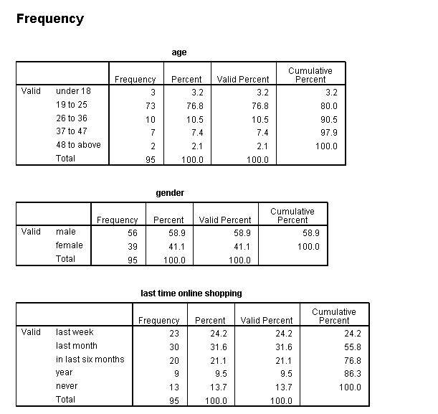
As from the table it is clear that majority in this age group is 18 to 26 years, and the second highest is between 26 to 36 years.
I survey on 106 persons, among them 95person do online shopping, other 11 person never purchase from online. Among them 56 are male & 39 are female.

- Last time online shopping- To understand the acceptance level of Online.Shopping among the internet users of Bangladesh, a specific questionnaire is created. The first measure was to know that how many people actually purchase from online shop. The potential online buyers would come out of that. Among the 106 respondents, majority of the respondents indicated that they frequently visit online shop last month. The second highest is last week which means very frequently.

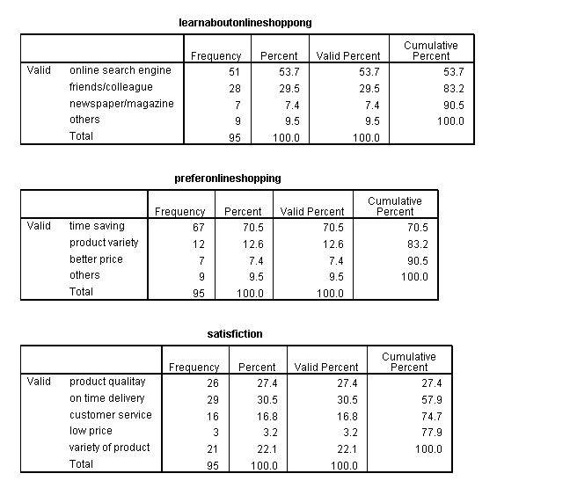

Chapter 2: Findings & Analysis

Findings & Analysis

2.0 What is E-commerce (Electronic commerce) –

E-commerce (EC) the full meaning or abbreviation is Electronic commerce.
E- Commerce or (electronic commerce) is commercial transaction which is conducted by internet electronically. It is the buying and selling way of goods and services, or the dispose of funds or data, over an electronic network, by the internet. These business transactions happened either as business-to-business (B2B), business-to-consumer (B2C), consumer-to-consumer or consumer-to-business. The terms e-commerce and e-business are often used synonym. The term e-tail is also sometimes applied in reference to the transactional processes for online shopping.

2.1 Background or History of E-commerce-

The oncoming of e-commerce can be found out at1960s, when businesses started using Electronic Data Interchange (EDI) to share business records with other companies. In 1979, the American National Standards Institute promoted ASC X12 as a catholic standard for businesses to share records or information’s through electronic networks.
After the number of independent users sharing electronic documents with each other arise in the 1980s, the rise of eBay and Amazon in the 1990s revolutionary change to the e-commerce industry. Consumers can now purchase many items from online, from e-tailors, typical brick-and-mortar stores with e-commerce capabilities and one another.

2.2 Types of E-commerce-
There are many ways to categorize ecommerce. You can segment them according to the products or services that they sell, the parties that they operate with, or even the entresol on which they manage.

In this report, we’ll give attention to all three prospects to give you a clear knowledge of what pattern of ecommerce sites are out there.

2.3 Classifying ecommerce merchants according to what they’re selling-
Let’s begin with the products and services normally sold online. There is a list below of ecommerce merchants according to what they sell online.

1. Stores that sell physical goods
These are your typical online retailers. They can include apparel stores, homeward businesses, and gift shops, just to name a few. Stores that sell physical goods showcase the items online and enable shoppers to add the things they like in their virtual shopping carts. Once the transaction is complete, the store typically ships the orders to the shopper, though a growing number of retailers are implementing initiatives such as in-store pickup.

2. Service-based e-tailors
In online service can both buy & sell nowadays. Online health consultant, educational tips giver, freelancer are usually are also involved in ecommerce. On the merchant, the buying process depends on of the service. Some may allow you to purchase their services immediately from their website or platform.

3. Digital product
By nature, E-commerce is highly digital so it’s no interjection that many merchants sell “e-goods” online. General types of digital products along with eBooks, online courses, software, graphics, and virtual goods.

2.4 Classifying ecommerce according to the parties involved-

Another useful method to classify ecommerce sites is focusing at the parties participating in the platform. These typically include:

- Business to consumer (B2C) – Trade which is happen in between businesses and consumers. In B2C ecommerce, businesses are the ones selling products or services to the ultimate –user.

- Business to business (B2B) – This types of transaction happened within two business companies. One business company is the customer of other business company.

- Consumer to business (C2B) – when a consumer sells or contributes monetary value to a business companies in that situation consumer to business happened.

- Consumer to consumer (C2C) – when something bought & sold between to consumer in that situation consumer to consumer happened. C2C takes place on online platform such as bikroy.com in which one individual sells a product or service to another.

- Government to business (G2B) – when a company due for government goods, services, or fees online. Examples could be a business liable for taxes using the Internet.

- Business to government (B2G)– The transaction may fall under B2G ecommerce When a government being uses the Internet to buy goods or services from a business,

- Consumer to government (G2C) – Consumers can also involve in B2C ecommerce. People paying for traffic tickets or paying for their car planting renewals online may fall under this class.

2.5 The Benefits of EC
- The new markets could be accessed by the online and pervading the service offerings to customers internationally.
- Internet scream the globe and broaden current geographical parameters to operate globally
- Marketing and promotional campaigns can be done internationally at the less cost.
- Maintain the customer and the customer services could be improved.
- Build strong relationships with customers and suppliers.
- Streamline business processes and administrative task
- No extra sales staff

2.6 Benefits to Organizations-
- Electronic commerce created platform of business not only nationally but also internationally.
- Ability for creating highly customized businesses.
- Electronic commerce reduces the time between the expenditure of capital and the receipt of products and services.
- Electronic commerce rearrange business process for that reason productivity increase
- Lower telecommunications cost & internet cost.

2.7 Benefits to Consumers
- Electronic commerce create scope for shopping 24 hours from any location
- Quick delivery.
- Customers can receive related and detailed information in second about product or service
- Virtual auctions also take place in E-commerce.

2.8 Benefits to Society
Electronic commerce consumer can buy product from home so that they don’t need to travel for shopping, that’s why lass traffic jam & air pollution occur
There is many more benefit of E-commerce but also have some limitations. Those are given below.-

2.9 Limitations of E-commerce-
- Lack of trust
- Lack of security
- Feuding about product quality
- More competitors
- Cost justifications

Chapter 3: Suggestion & Recommendation

3.0 Recommendations for future development in Bangladesh for Online Shopping:
As our country is still developing country, Bangladesh is not so E-commerce oriented. A lot of online shops are growing. We can hope that Bangladesh will be initiator in this sector in the coming future. But before that they need to correct the lacking’s which are present. There are some basic requirements to be fulfilled to achieve the satisfaction of the consumer. Let’s give a guideline to the online shop owners.

Building trust among the People of a developing country are very much critical. They are insecure when it comes to the quality of the product. The online shops have to make them believe that whatever the product or service they are selling, it is perfect. At the end of the day, customer satisfaction depends on the quality of the products. Making the product quality high is one of the fundamental objectives for shoppers. In this way we can ensure the consumers that the products from online shops are of best in quality. They keep promises as they make promises.

People are still afraid of using cards for online shopping. There are various online pages which do not have online payment options. They transact on ‘Cash-on-delivery’ method. Most of the e-commerce site of Bangladesh has this method. The reason for that is people are scared to use debit or credit card for frauds. Online shop owners need to ensure them & keep this fear of the consumers. The banks of Bangladesh also need to give that security to the internet shoppers. The government of Bangladesh should make the payment gateway as secure as possible.

Develop return policy Pictures can be effective sometimes. In the e-commerce sites, the pictures of the products are showed sometimes the expectations & reality do not match. But the online shops don’t have return policy that’s why people don’t want to purchase from online.

Chapter 4: Conclusion

Conclusion

The aim of this paper was to show the present scenario of E-commerce in Bangladesh. The satisfactions factors are shown here. Future researchers can use the findings of this paper for further research. Bangladesh is still in a learning process in the E-commerce. Consumer to consumer online pages is getting very popular here. The payment system still needs to be improved especially return system. The most challenging issue would be building the trust among the consumers about the online purchase. People of Bangladesh do know the positive sides of online shopping. They know that online shopping saves time and it is very easy to use.

Append Part

A. Reference-
Websites:
- Hoque, T. (2017). Analysis of customer satisfaction of Global Digital Mart Ltd.
- Haque, M. (2016). Web usability, SEO & digital marketing of Pickaboo. com.
- Atanassova, A. (2018). Accounting problems in e-commerce. Ekonomiczne Problemy Usług, 131(2/1), 19-30.
- Rabbani, M. (2019). Strategic Marketing of Chaldal. com.

Book & articles:

- “Definition of digital marketing” financial times retrieved 22 august 2015

B. Questionnaire
“Customer Satisfaction regarding E-commerce site in Bangladesh”
Dear Sir/ Madam,
This study is conducted as part of my internship report which fulfills partial requirement of BBA program in United International University. Though this study is intended for educational purpose only, the findings may help the e-commerce sites of Bangladesh in satisfying their customers better. The survey will take less than 10 minutes. Data collection will be completely anonymous.
Answers the following questions by put a () mark on the most appropriate answer-

1 | Age | a. under 18 | b.19 to 25 | c. 26 to 36 | d. 37 to 47 | e. 48 to above
2 | Gender | a. Male | b. female | c. Others
3 | When is the last time you did online shopping | a. Last week | b. Last month | c. In last six months | d. Year | e. Never
4 | How do you learn about online shopping-? | a. online search engine | b. friends/  colleague | c. newspaper/  magazine | d. others
5 | Why you prefer online shopping | a. time saving | b. product variety | c. better price | d. others
6 | What is the key to satisfaction according to you | a. product quality | b. on time delivery | c. customer  service | d. low  price | e. variety of product
7 | What type of products you purchase from online | a. dress and accessories | b. daily life of product | c. electronics | d. others

Describe shortly the answers of those questions -
- Would you recommend online shopping to your friends - a. yes b. no
- What you think about online shopping price - a. reasonable b. average c. high
- So far how much amount you purchase from online (maximum) & what was the product –

- Do you face any negative experience ever? If yes, then why?

- Do you complain to the page/ web site- a.Yesb. No

- What steps they took to solve it –

- Would you like to anything on online product inventory-?

- If you could change one thing about online shopping, what it would be-

