Internship Report
On
Recruitment & Selection Process Of
Acorn Infrastructure Services Limited



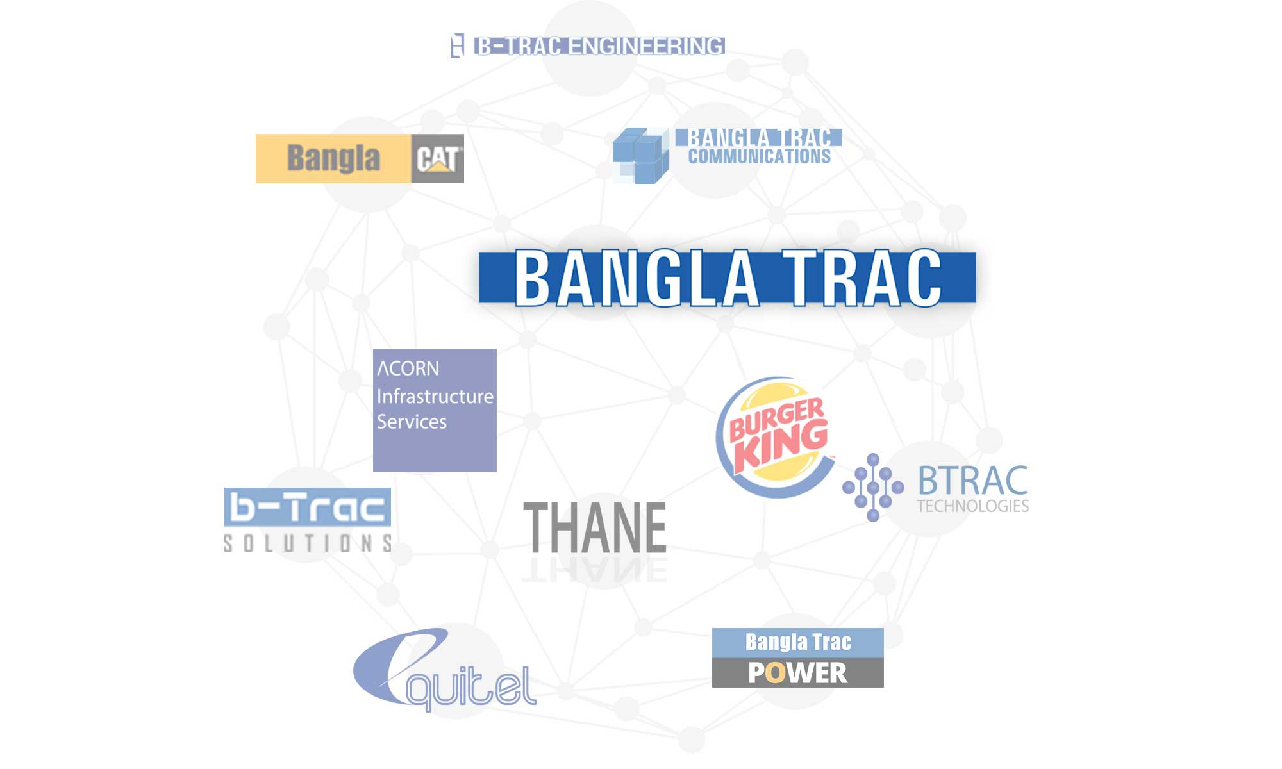


UNITED INTERNATIONAL UNIVERSITY
Internship Report
On
Recruitment and Selection Process
Of
Acorn Infrastructure Services Ltd.

Submitted to
Ishrat Sultana
Assistant Professor

Submitted by
Mohammad Yasin Ar Rashid
ID: 111 153 120
DATE OF SUBMISSION – 11th July 2020
Letter of Transmittal

Ishrat Sultana
Assistant Professor
United International University
United City, Madani Avenue Badda, Dhaka, Bangladesh.
Dear Madam,
With all respect here I present you my Internship Report on Acorn Infrastructure Services Ltd. It was a great journey of 3 months internship program and I experienced many different things from it. My Internship topic is “Recruitment and Selection Process of Acorn Infrastructure Services Ltd”. I have tried to focus on the process of recruitment and selection procedure of Acorn Infrastructure Services Ltd.
I tried my level best to make the report successful and capable of your expectation from my side. This Internship program helped me to experience a real life situation in the corporate world.
I welcome your all query and criticism of this report and give me more opportunity to learn. I hope you will consider any of mistakes that might be present though I have tried my best.
Sincerely, -------------------------------------------
Mohammad YasinAr Rashid
ID: 111 151 120

Acknowledgement
At first I would like to thank my faculty Ishrat Sultana, Assistant Professor, of United International University to provide me with the necessary guidance and proper advice during my internship report.
And then I would like to thank Mahmuda Sultana and Abhishek Nandi, Senior Hr Executive to help me in my internship report and for providing me with the necessary details for the internship report.

Table of Content

Executive Summery | v
Chapter One:  Introduction | 7-11
Chapter Two:  Company Overview | 12-18
Chapter Three:  Literature overview | 19-23
Chapter Four:  HR Management practices of this company | 24-29
Chapter Five:  Recruitment and Selection | 30-33
Chapter Six:  My Internship Experience at AISL | 34-36
Chapter Seven: Activities Undertaken  Findings and Analysis | 37–38
Chapter Eight:  Conclusion and Recommendation | 39-43
Chapter Nine:  Bibliography | 44-45
Chapter Ten :  Appendix | 46-49

Executive Summary
The report represents the Internship period I experienced at Acorn infrastructure services which was from October 6th to January 5th. I was working there as an intern on their human resources department. Acorn Infrastructure Services Ltd is an Electricity Generation and Transmission company.
The report is all about the recruitment and selection process at Acorn infrastructure services. The whole report is based on only data that I have experienced day to day during my internship program.
Recruitment system is one of the most complicated and significant activity that every organizations have to undergo. Putting right people at the right place is not as easy as it sounds. And for big and prominent companies like AISL, the recruitment process is never easy when the company ensures the quality of the work as well as quality of the people. But AISL has been in that business for a long enough for coping up with the difficulties. They have their own structure and way of selecting people. The fact that took my attention to work on the matter is AISL’s smooth recruiting system.

Chapter One:
Introduction

Introduction
Objectives of the Report

Primary Objective:
The objective of this report is to provide a clear idea of the recruitment and selection process followed by the ACORN INFRASTRUCTURE SERVICES LTD. (AISL).

Secondary Objective:
The prior intention of this report is to see if the concepts and theories learnt in the BBA program could be connected with the real situation recruitment and selection process of different organizations in Bangladesh.
The secondary objectives are
1. To take in recruitment and selection system as a part of HR activity.
2. Information regarding the recruitment and selection procedures followed by Acorn Infrastructure Services Ltd.
3. To gain knowledge on the topic so that it can be used in the future to boost company’s performance.

4. To present my view and suggestions to management for their further practice on the process

Scope of the study
As my topic is “Recruitment and Selection process of Human Resource Division in Acorn Infrastructure Services Ltd.” the report will give a brief view of how the organization select the right people to plug a post. So, it will help in the future to identify about the all the functions of Human Resources Department practiced in Acorn Infrastructure Services Ltd.
For example:
    - The diverse department of HRD
    - The functional system of the recruitment and selection process
    - Benefits Acorn Infrastructure Services Ltd. propose to their employees to encourage their work

The Human Resources Department of Acorn Infrastructure Services Ltd. and their functions is clearly presented here in this report.

Methodology of the study
Starting from picking of the topic to final report research, in a systematic formula the study is conducted. The integral part, to find the vital points, were off the record and was to identify and collect data; analyzed, interpret and presented in a systematic manner.
In this paper, methodology includes direct examination, face to face chat with the employees as well as incisive on their websites and studying on their practical work.

Selection of the Topic
I communicated with my academic supervisor to help me on selecting the topic after taking suggestions from my executive supervisor.

Sources of Data
In order to make the study more momentous and reasonable, both primary and secondary sources of data and information had been used. The two sources of data are:

Primary Sources
➢ By observing the organization
➢ By discussing with executive members and concerned experts.

Secondary Sources
Different Books of HRM
➢ Different yearly reports
➢ Various Newspapers
➢ By following Internet
➢ By analyzing Textbooks
Collection of Data
I collected Primary data from observation method. I have communicated face to face with the officials. Then I collected Secondary data from AISL publications and further interconnected websites and documents.

Limitations of the study
I have faced some limitations in preparing this report. I faced difficulties in gathering data from the diverse sources basically. Some people were not that much interested with helping me out.

There are also some problems I faced during the preparation of my report.
Those problems are,

➢ The time was too inadequate to collect all the data that were required.
➢ Everyone was keeping their information very classified to share it with me.
➢ Internal actions were not allowed by interns to access.
➢ It was very hard to organize analytical data and theoretical data within a very short time limit.
➢ The three months time was not very much adequate to gain a greater scenario of this company.
➢ As the organization remains confidential to interns, significant data collecting was very tough.
➢ Load of works was also a great barrier for me to prepare the report in earlier time.

Chapter Two:
Company overview

Company overview
ACORN Infrastructure Services Ltd, is a growth-oriented power producer of Bangladesh. They are also a concern of reputed business conglomerate of Bangladesh, Bangla Trac Limited. They create dependable, safe and innovative energy solutions to power a sustainable future for Bangladesh.
As a group of experts and innovators in power and energy field, they work to deliver responsible power for communities across Bangladesh. They develop, acquire, own, and operate power generation facilities using a variety of energy sources. Currently, they are supplying electricity to national grid of Bangladesh under the contract signed with Bangladesh Power Development Board to contribute in meeting energy &power demand of the country. Its power plants are built with state-of-the-art technology using German made Caterpillar 16CM43 model reciprocating engine, which is the most fuel-efficient engine installed and commissioned in Bangladesh. Since the announcement of commercial operation dated on 26th March 2012, ACORN plant is most utilized HFO based power generating facility in Bangladesh. Started with its initial capacity of 100 MW in 2012, the present combined capacity is 800 MW and counting.

They are innovative and committed to sustainability. This is reflected in their consistent and ongoing efforts to\

Continually improve the effectiveness and execution of their capacity producing offices. Invest in efficient natural gas and renewable alternatives.

Participate in innovative work for condition well disposed and clean force and vitality sustainable.
Invest in mechanical headway to help low carbon emanations in force and vitality age.
Excel in particular building and activities mastery in venture advancement and development, and in our continuous office tasks.
Track record and skill for building ventures securely, finishing them on schedule and on financial plan and working all around kept up, solid offices.

Mission and Vision of AISL

Mission
“Provide reliable & sustainable energy solution using state-of-the-art technology, innovation and people excellence, ensuring best customer service.”

Vision
“A Dynamic Global Company driving Stakeholders’ Success through Excellence, Integrity, Humility & People Leadership”.

Values

- People First
- Customer’s success
- Excellence Through Humility
- Integrity
- Innovation
- Socially & Environmentally Responsible
Company Details

Website
https://www.aisl.com.bd/
Headquarter
House No: 04, Road No: 19/A, Block: E, Banani, Dhaka.

Year founded
2010

Company type
Privately Held

Company size
Around 400 employees

Specialties
Energy & Power, Power Plant, and Infrastructure Services

Acorn Infrastructure Services Ltd. (Associate Company of Bangla Cat) Specialized in Electricity Generation and Transmission (100MW HFO Based Power Plant) whose power plant is in Juldha, Chittagong. The parent company of the organization is known as Bangla Trac. Since January 2009, nearly 40 contracts have been signed to increase the capacity by 4,504 MW using light diesel oil, natural gas or heavy fuel oil (HFO). The investor, Dhaka-based Acorn Infrastructure Services Ltd. (AISL), signed a five-year rental agreement with BPDB and Caterpillar Power Generation Systems. Under the agreement, Caterpillar provided equipment and services for eight Cat® 16CM43 HFO-operated generator sets. Local Cat dealer, Bangla Cat, supported the project with onsite supervision and engineering services.
It’s ongoing plants.
1. Acorn Infrastructure Services Ltd.
Location: Juldha, Chattogram.
Current Capacity: 100 MW
Fuel Type: HFO
2.Acorn Infrastructure Services Unit-3 Ltd.
Location: Juldha, Chattogram.
Current Capacity: 100 MW
Fuel Type: HFO
3. Bangla Trac Power Unit-2 Ltd.
Location: Noapara, Jashore.
Current Capacity: 100 MW
Fuel Type: HSD
4. Bangla Trac Power Unit-2 Ltd.
Location: Noapara, Jashore.
Current Capacity: 100 MW
Fuel Type: HSD

Health, Environment and Safety (HES)
They full need to the wellbeing and security of their representatives. They have created wellbeing and security manual, approaches and have set up best practices at all their plants. To ceaselessly improve their wellbeing and security framework, on location preparing and standard responsiveness and boost meetings are directed for both lasting and transitory representatives.
They explored their wellbeing and security framework as they wanted to fortify the wellbeing procedures and improve them to world-class levels. To accomplish the security target of 'Zero Accident", they have gone ahead on the wellbeing social change venture. To inspire all workers and train a culture of positive rivalry between their working plants, they normally sort out various rivalries and inner wellbeing grant programs. They welcome all the workers and offices for their extraordinary wellbeing acquiescence, which has contributed definitely in accomplishing operational greatness.

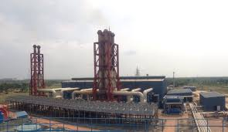

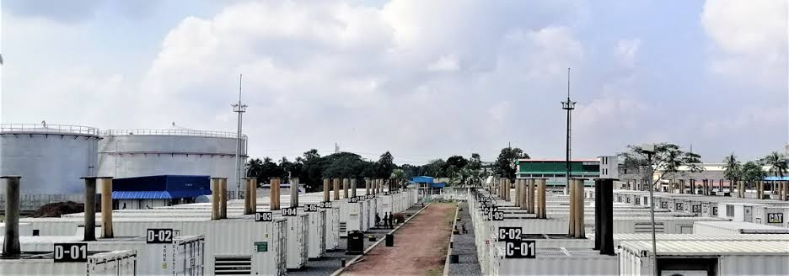
Chapter Three:
Literature Review

What is human resource management?
Human asset the board is a key way to deal with oversees business connection that underscores utilizing individuals ability is basic to increase feasible upper hand, this being accomplished by means of an unmistakable arrangement of coordinated work strategies, projects and practices (Bratton J and Gold J, 2003). The real capital of the association is the human capacities to use the individual as a capital. Every association has a lot of money to start the business however have not proficient bodies to utilize them at the correct pace and at the perfect time. Also, HR is key accomplice of the business which runs with the business and takes the business towards the achievement.

The worldwide and serious market condition has prompted new challengers for the people and association. Without having a very much prepared and decidedly ready work power, organizations drop the capacity to contend with national and worldwide adversaries, bringing about diminished financial achievement. Throughout the previous ten years, the working environment in the association has a great deal of issues, as expanded global and national rivalry, quick advancements and logical changes, workforce demography, more extensive usage of data innovations and so on. Human asset administrators ought to see a wide range of these issues and should create appropriate procedures so as to support their association. Human asset the executives are imperative for the association to make its objectives and progress. The significance of HR division to the workers, supervisors should attempt to show the connection between human asset the board and hierarchical achievement. (UKessaysLiterature Review Human Resource Management, 2016)

The Historical Background of Human Resource Management

Human asset the board has changed in name different occasions since the beginning. The name change was basically because of the adjustment in social and financial exercises since the beginning.
Industrial Welfare
Modern government assistance was the main type of human asset the board (HRM). In 1833 the industrial facilities act expressed that there ought to be male production line monitors. In 1878 enactment was passed to control the long periods of work for kids and ladies by having a 60 hour week. During this time worker's organizations began to be framed. In 1868 the first worker's organization gathering was held. This was the beginning of aggregate bartering. In 1913 the quantity of mechanical government assistance laborers had developed so a meeting sorted out by Seebohm Rowntree was held. The government assistance laborers affiliation was shaped later changed to Chartered Institute of Personnel and Development.
Recruitment and Selection
Everything began when Mary Wood was approached to begin connecting with young ladies during the first universal war. In the First World War staff advancement expanded because of government activities to energize the best utilization of individuals. In 1916 it got mandatory to have a government assistance specialist in hazardous processing plants and was energized in weapons manufacturing plants. A great deal of work was done in this field by the military powers. The military concentrated on the most proficient method to test capacities and IQ alongside other examination in human elements at work. In 1921 the national foundation of clinicians set up and distributed consequences of studies on determination tests, talking with strategies and preparing techniques.
Acquisition of other Personnel Activities
During the second world war the emphasis was on enrollment and determination and later on preparing; improving assurance and inspiration; discipline; wellbeing and security; joint conference and pay approaches. This implied a faculty office must be set up with prepared staff.
Industrial Relations
Meeting among the executives and the workforce spread during the war. This implied work force divisions got liable for its association and organization. Wellbeing and security and the requirement for experts turned into the core interest. The requirement for masters to manage mechanical relations was perceived so the work force director became as representative for the association when conversations where held with worker's guilds/shop stewards. In the 1970's modern relations was significant. The warmed atmosphere during this period fortified the significance of an authority job in mechanical relations arrangement. The faculty supervisor had the position to arrange bargains about compensation and other aggregate issues.
Enactment

In the 1970's work enactment expanded and the faculty work played the job of the expert counselor guaranteeing that chiefs don't disregard the law and that cases didn't wind up in mechanical courts.

Adaptability and Diversity

In the 1990's a significant pattern developed where bosses were looking for expanding adaptable courses of action in the hours worked by representatives because of an expansion in number of low maintenance and transitory agreements and the innovation of separation working. The workforce and examples of work are getting differing in which customary enlistment rehearses are pointless. In the year 2000, development in the utilization of web implied a transition to an all day, every day society. This made new openings in web based business while positions were lost in conventional zones like shops. This implied an expanded potential for representatives to telecommute. Associations need to contemplate the issues these advancements raise. HRM director's job will change as changes happen.

Data Technology a few frameworks where IT helps HRM are: Systems for e-enrollment; On-line short-posting of candidates; creating preparing techniques on-line; Psychometric preparing; Payroll frameworks; Employment information; Recruitment organization; References; Pre-work checks. IT enables HR supervisors to offload routine errands which will give them additional time in fathoming complex undertakings. IT additionally guarantees that a more noteworthy measure of data is accessible to decide.

Role of HR department
During the 1990, the HR capacities were performed by the line directors in the huge association. They were answerable for supporting every day individuals the executives and go about as key colleagues run from counselors to line supervisors. In the association, the line directors are the principle bodies who execute the HR systems and approaches and put it into the real world.

Presently as of late, there nearly in all the enormous association, there is a different office named HR office that performs HR capacities.

This division plays out a ton of capacities like determination of new representatives, their preparation and learning programs, an arrangement of remunerating them, a framework for leaves, maintenance strategies and so on

HR the executives practices and framework have been connected to the expanded efficiency, greater work, more elevated level of benefit, and hierarchical seriousness. Here the seriousness mean in the worldwide economy is, to take high beneficial situation in the changing business sector condition. For this connected to be cultivated between the human asset the board and authoritative achievement, the job of HR office ought to be key rather than operational, adjusting the HR practices and capacities with the key needs of the association. The blending of HRM with business technique is uncommon and fundamental even among the huge associations. In numerous associations, they have issues in changing the HRM into vital capacities. They center around the authoritative and administrative undertakings leaving the HRM division. At long last, their chiefs neglect to make changes through the workers in the association

Chapter Four:
HR Management practices of the company.

Human Resource

Human resource planning is a method that identifies current and future human resources requirements for an organization to achieve its goals efficiently. Human resource preparation should serve as a connection between human resource management and the overall strategic plan of an institute. The company follows the basic steps of planning in their Hr practices.

1. Environmental Scanning: Environmental scanning is the first step in the process of HRP. In order to have an HR plan, the external environment which essentially comprises economic factors, labor market, technological changes, socio-cultural-political factors and so on must be carefully studied and strongly monitored. It is necessary to look into changes in the external environment and line up the business of the institute and HR plans with the environmental demands.

2. Business Plan: After knowing the objectives of the institute, the next essential step in the method of HRP is to get caught up in the business plan, that is, to get there at the scale of business action over a period of time to be able to calculate approximately the structure and size of the organization over a period of time. This is to be done keeping in view all the factors of internal and external environment.

3. Forecasting Future HR Requirements: Having estimated the structure and size of the organization over a period of time, the next work to be done in the HRP process is forecasting the future manpower requirement. These days, a lot of forecasting techniques, many of which are extremely mathematical, numerical and sophisticated, have been recognized.

4. HR Audit and Forecasting the HR Supply: Having determined the HR needs of the organization over a period of time, the next step in the process of HRP is to audit the existing HR in the organization. (The primary objective of auditing the existing HR is to know the full details of what exists in the stock and what is required for the stock.) In other words, it gives a signal for the gaps that needs to be filled in through the external sources. It is, therefore, very important that human resource information system (HRIS), which is one of the most important things of the HRP process, should be very effective so that every bit of information about the manpower could be gathered.

5. Job Analysis: Once manpower has finished done auditing is done and forecasting of supply of human resources has been made, the list of future vacancy over a period of time is organized, and sources of manpower supply are identified. It is necessary to arrange a job analysis. Job analysis provides information about the environment of the job (job description) and the characteristics and qualifications that-are desirable in the job holder (job specification). The job description is a foundation of basic information for the HRP. The information provided by the job description and job specification—the two ingredients of job analysis—is essential for selection, training, workload, incentives and salary management. Job analysis has been dealt with in detail separately.

6. Development of Plans for Action: Having analyzed the requirement for supply of human capital in the stipulated future period, it is time to choose a path of action to fill up the gap between demand for and supply of human resources.

Human Resource Staffing
Staffing is the capacity of worker enlistment, screening and determination performed inside a foundation or business to top off employment opportunities. Some connected terms and divisions incorporate HR, work force the board and employing.

Recruitment:
Enrollment is the technique for looking and moving an enormous number of possible representatives for a specific activity in an association.

It incorporates the accompanying exercises:

(i) Determining the various wellsprings of flexibly.

(ii) Evaluation of the authority of these sources.

(iii) Selecting the most reasonable sources.

(iv) Inviting applications from the possibility for the opportunities

Determination:

Under the procedure of determination, great candidates are chosen out of an enormous number of pools of applicants. It must be remembered that the ability of the candidate and the idea of work must match. It implies that correct man ought to be chosen for the correct activity. This will prompt better execution on all fronts for example quality, amount, time, cost and so forth.

Situation and direction:

Situation includes putting the chose right man at the opportune spot thinking about his aptitudes and capacities. It is the clear presenting of a representative on a specific activity for which he/she has been picked.

Direction is otherwise called presentation. It implies presenting the as of late chose representative for example to different aspects of the organization his activity, different occupations, nature of items, approaches, leads and existing representatives and so forth. It targets drafting new workers into the association productively.

Training and Development:

The term preparing infers a precise act of giving information and abilities for a particular activity. It benefits both the association and the representative. Preparing builds the aptitudes and capacities of workers to follow up on specific occupations. Preparing can be given for the improvement of present place of employment or to set up the representatives for some arranged occupations. The endeavor additionally gets the benefit of preparing as decrease in the creation cost, best utilization of apparatuses and machine and improvement in the quality and so on.

In the wake of enrolling a potential applicant the following significant capacity of HRD is to find out about the new contestant to the association and giving him/her with all the necessary information about their obligations and tasks. This is done to ensure successful contribution from the workers into the association in this way, their most proficient degree of execution. The preparation program utilized in the association likewise guarantees lower leg conservation. To AISL spending in preparing programs for workers isn't considered as a cost, however as a venture. Every single lasting worker must have 30 days of preparing. The program incorporates: Orientation Training: Orientation program comprises of five days' workshop which incorporates brief thoughts regarding AISL and its Human Resource area in the initial two days; Anti-illegal tax avoidance, Negotiable Act and Financial issue are conversation subjects of most recent three days. In-house preparing: This preparation is directed by the organization's own coaches when it is essential for the new or existing representatives. Here the coaches are paid 500 taka in weekdays and 700 taka in weekend. Training are directed by recruiting outside mentors or sending the worker in the outer preparing houses by remembering commercials of preparing offers in papers or through email or from some other helpful sources. As these are costly trainings so each and every representative can't take an interest. Selections are given from money office and afterward understanding is taken from division head and just the designated workers can participate in these preparation programs.

Compensation:

The association has reasonable pay or pay bundles and gives as precise as potential motivating forces to the individuals who merit it. This implies occupations must be assessed and positioned in a way that adds to that commitment.

The Salary structure of the association depends on the previously mentioned Job Grades. Occupation scales are settled on the base of an efficient estimation of the position dependent on the size, obligations, choice - making specialists and the idea of the job.The compensation of workers comprises of Basic Salary House Rent and Medical Allowance Salaries are private for these are classified between the representatives concerned and the Management. Essential Pay Salary Ranges is equivalent with the activity reviews and is controlled by the Board on the proposition of the Managing Director. The Board surveys the BSR at any rate once in each a few years. House Rent Allowance might be paid to the workers at such rates as might be endorsed by the Competent Authority every once in a while, Medical Allowances might be paid as per the activity grades and on such setting that might be recommended by the Competent Authority now and again. Workers get two celebration rewards every year.

Chapter: Five
Recruitment & Selection Process

Recruitment Process of Acorn Infrastructure Services
Acorn Infrastructure Services Ltd has a clear concept of recruiting and selecting candidates. They always focus on keeping their standard towards Bangladesh. It gives specific guidelines of operation of human resource division, with a vision to maintain the expected standards that are maintained. It provides proper guidelines of HR division to introduce organizational policy.
They have a very simple method of selecting candidates and carefully consider their qualification for their required post.
One of the important tasks of Acorn Infrastructure Services Ltd is Recruitment and Selection process. Through these tasks, Acorn Infrastructure Services Ltd attracts people who have the perfect qualification
“Acorn Infrastructure Services Ltd ensures that they can get right candidate on right time to meet the human resources demand across the organization”

Sources of Recruitment
- Internal sources: Curriculum Vitae are collected through internal sources of the organization. Internal sources are helps HR division by reducing the cost. To internal resources are utilize in the following ways:

- Referrals: Acorn Infrastructure Services Ltd encourages their employees for referrals of applicants who are great and strong. The employee of Acorn Infrastructure Services Ltd’s employee has to sign on applicant’s resume. Intern employees may also get refer.

- On Notice board: To attract candidates Acorn Infrastructure Services Ltd puts their vacancy advisement on their company’s notice board where they can apply for their desired position. For lower level post like security guard, driver, and technician the responsibility is taken by External HR of Acorn Infrastructure Services Ltd.

- Transfer and promotion: For emergency fulfillment of an important designation such way is adapted.

- External sources: A huge gathering of candidates is pooled byAcorn Infrastructure Services Ltd through the following external sources:
Newspaper advertisement: HR Division provides advertisement about the job recruitment. Initially it requires management to approve the advertisement. After the approval the advertisement is finally published in newspaper.

Online advertisement: the HR Division of Acorn Infrastructure Services Ltd has contract withBDjobs. A circular is posted by HR manager there. The mid-level and high level jobs are basically published here.

Interns: Interns are one of the best external sources. HR division of Acorn Infrastructure Services Ltd chooses interns’ from different Universities. Students are also welcomed if they want to send their CV’s to the company.

CV Bank: ACV bank is also maintainedbyHR Division of Acorn Infrastructure Services Ltd. There two parts in CV banks. Unsolicited CVs are first. Some applicants send their CVs on their carrier service mail. Those CV’s are collected by HR Division if they are suitable for Acorn Infrastructure Services Ltd. Some CV’s are rejected from different selection. CV’s those are excellent are kept in a separate file.

Functions of the Recruitment and selection panel

Acorn Infrastructure Ltd has their own way of recruiting employees:
Among the selected CV’s the journey from interview to joining is conducted.
Written Test: For the fresher a written test is conducted at the initial level which mainly contains basic questions required for the applied designation.
First level Interview: If the candidates successfully pass through the written test then he/she is called over phone or mail for an interview session. The candidate then faces the first level interview conducted by HR Board, the Concern Department and the Cross Department who are dependent bodies.
Second Level Interview: After the first level interview the finally selected candidate(s) goes through the final interview. This final interview is conducted by the CEO of the organization, Head of HR and members of the concern department. If the candidate impresses the top management then he gets an appointment letter and an orientation is provided for joining the new organization.

Conditions which needs to be fulfilled while selecting suitable candidates
For fresher:
While recruiting a fresher the conditions which needs to be looked are:
1.CGPA of the candidate/applicants. For a fresher his/her CGPA must be 3 or above.
2. The candidate must be from a good university, which is regarded as standard according to Bangladesh’s perspective. Universities preferred by Acorn Infrastructure Services are: NSU, BRAC, UIU, EWU, AIUB, IUB, and AUST.
For Experienced:
While recruiting an experienced candidate CGPA and University preference if not needed if relevant work experience is there.

Chapter: Six
My Internship Experience

The internship:
My internship program’s duration was 3 months from October 6th to January 5th. It was a great journey for me and I hope it does give my future corporate life to come a big boost as I learned a great deal of work here. I have done my major in human resource management and I worked here as a hr intern for Acorn infrastructure services limited
Description of my internship program
At the first day of my office my supervisor introduced me to almost all the employees working over there and it was really nice meeting them then at the very last moment of the very first day I was given my laptop and my place was fixed at 1st floor every other member of the hr department was on the ground floor but my desk was at first floor because of the lack of space on the ground floor.
During these 3 months I was involved in quite a good amount of work:
1. The very first work that I was given was that of filing out the employee forms of the company and to check and give a report if something was missing from somebody file. This work included photocopying important papers sequentially arranging documents.
2. Basically my work was to analyze. Later on I was given to check the insurance lists and see if any employee misses out on any time.
3. I was given promotion orders from that I had to updated the promoted post of that particular employees who are promoted.
4. I was asked to invigilate in written exams.
5. I was also asked to make or update the list of employees of which employees have how many days left for their LFE.
6. And at last I helped my supervisor creating the annual appraisal form for the company’s employees also

Observations that I did make during my internship program:

Some positive points
Everyone in the office quite friendly with each other
Everybody is quite aware of their tasks and they do that with honestly and never miss out to put in their hard work for the betterment of the organization
Everybody is quite helpful to each and they are good at working in teams
Some negative points
There department does a lot of paper work so they are always busy doing the paper works of the employees and they do not observe the day to day activities of the employees.
The organization does not have any kind of training for the interns and because of that it took me quiet an amount of time to do as was expected of me and it took time for me to adjust if there was any training programs for interns it would have been a lot of helpful for me
Sometimes I did see that some of the lower level employees like the kitchen cook and other persons working in the kitchen and sometimes employees of various departments are given training but they are not happy with that and they act like that it is a burden to them.

Chapter: Seven
Findings & Analysis

Some major findings in my Internship program:
Overseeing Director has the total rights and power to endorse the end choices. At that point subsequent to accepting endorsement from the Managing Director, HR Division starts every one of their obligations as they are prompt.

AISL doesn't have any online demand process. For instance, director of deals in Gulshan, raises a demand structure. He should send this demand structure right through their in-house mail administration. In the event that there is any strike, that day is difficult to lead any enlistment exercises. As a result, enlistment process goes to burglary.

HR division of AISL maintains resumes poorly. They often lose their resumes for their poor way of maintaining them.
There is only one senior executive in their HR department. That one employee does the complete recruiting and selecting process alone. So every now and then that one employee has to face vast pressure for the lack of employee.
AISL doesn’t publish their ad on their own website rather on the other foundation of job site.
But however they give their top most priority to the safety of their employees and they provide any necessary things needed to ensure the safety of their employees
Everybody work willingly it is not like that they are being forced to work and everybody seems to enjoy whatever the work they are doing.

Chapter: Eight
Recommendations & Conclusion

Recommendations
As I have seen that the organization is quite a big one and the documents are sometimes not collected or kept sequentially so they can improve on this area by doing things effectively.
They can do a phone interview for the candidates to lower down the candidates to call for the interview this can lower down the time wastage and can be beneficial to both of the parties
They can make online requisition forms that will also be helpful and be a time saver
They can store all the CV’s and necessary documents online so that it becomes easy to whenever check them and also it reduces the chance of any particular document getting lost
Hr department can hire more people so that that releases the pressure from the ones doing all the work there
They should make sure they are training the interns well and if possible hire them as it will save them some time as the intern has done some work in their organization and aware of many things
They should give training to interns
And before giving trainings make sure that the employee is mentally prepared for the upcoming training sessions.
Motivate the employees and make them understand the benefits of receiving those trainings selected for them, they can do that by giving real life examples as how the training has previously helped the previous employees who have done it
They can take Skype interview so that it saves the time
They should let know the rejected candidates why they are not being selected this will just not benefit the candidate but also bring a positive vibe for the company in the minds of those rejected candidates.

Managers should be trained more and more on how to take a successful interview and get the best out of an employee
They should always highlight their mission vision to their employees at all time so that they know what are working for this also builds a positive image for the organization
They should arrange annual picnics and get to together so that the employees can know each other informally also and be more co operative with each other

They should provide career counseling to their employees so that the employees would think that their organization cares for them they would be more willingly give their best efforts for the organization.
Provide the employees with more freedom and responsibility in their tasks in order to get the best out of them
Rotate them across jobs in order to get rid of any boredom if they might feel
Encourage the employees so that they can have their say and whenever possible make sure advice is taken or at least given priority.
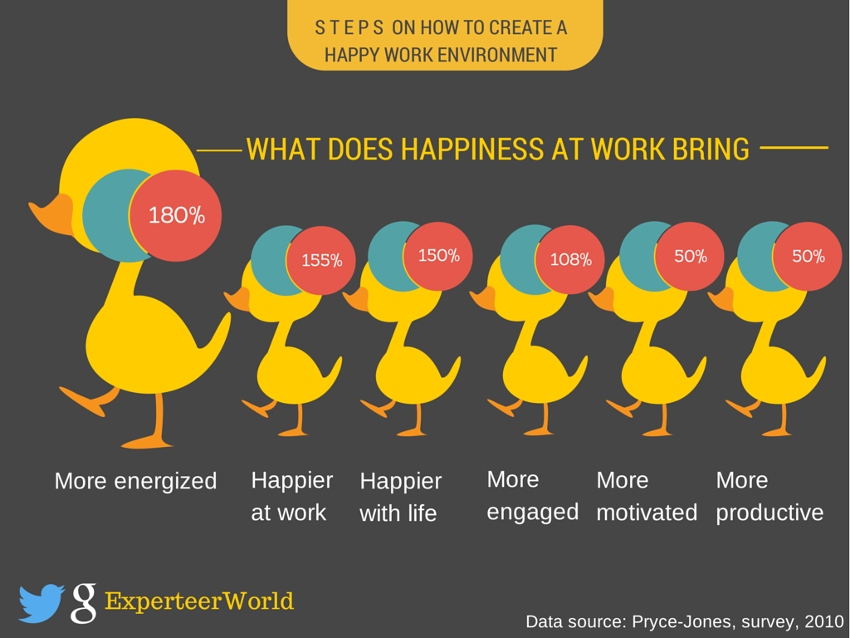

Conclusion
Recruitment alludes to the general procedure of drawing in, short posting, choosing and delegating reasonable contender for employments (either changeless or transitory) inside an association. Enlistment can likewise allude to forms engaged with picking people for unpaid jobs. Supervisors, human asset generalists and enrollment experts might be entrusted with doing enlistment, yet at times open segment business offices, business enrollment offices, or authority search consultancies are utilized to take on parts of the procedure. Web based advancements which bolster all parts of enrollment have gotten normal.

Enlistment is a key issue for any organization. Enlistment and choice permits a business to pick the best individuals who will demonstrate the path to the association in future, survey the opportunity too. So the association should give more features on choosing an individual. An individual who can convey sent the association as far as development, principles and morals. For the most part the important asset is the information based ingenious specialists for any association. The association ought to be increasingly careful on this issue so as to guarantee the quality and morals.

Human Resource isn't the head include up of individuals working in an Organization. It is sum aggregate of their insight, expertise, roused capacities, gifts and aptitudes just as their qualities approach and perspective and valuable attitude.

An individual can convey forward the association as far as development, qualities and morals. For the most part the exorbitant asset is the information based clever laborers for any association.

Chapter: Nine

Bibliography

Bibliography
UKessaysLiterature Review Human Resource Management. (2016, december 5). Retrieved november 2018, from UKessays: https://www.ukessays.com/essays/management/literature-review-human-resource-management-management-essay.php

https://www.aisl.com.bd/
Human Resource Management 16th edition by Gary Dessler
Strategic Human Resource Planning 2nd edition by Kenneth J. McBey& Monica Belcourt
Strategic Management of Human Resources 3rd edition by Jeffrey A. Mello

Chapter: Ten
Appendix

Questions
How do you recruit people do you have any recruitment policy?
What Are Characteristics Which An Interviewer Needs To Observe Or Test In an Applicant?
What Is Selection And What Are The Steps Involved In Selection Process?
What are the sources used in order to create a pool of candidates?
Do you look for specific things in a CV?
How do you evaluate if a CV is good or bad?
Is the recruitment and selection process effective?
How successful recruitment does differ from that an unsuccessful one?

Questions done to employees
I am satisfied with the level of work that is each day expected of me
AVG ANSWER 4 out of 5
The training which Is received by me, adequately prepared me for this position
AVG ANSWER 3 out of 5
My work environment is allowing me to do my job without difficulty and it is very comfortable
AVG ANSWER 5 out 5
The equipment I use makes my job stress-free because of the well functions
AVG ANSWER 5 out of 5
During my workday, my supervisor is always available to answer any questions that I may have
AVG ANSWER 4 out of 5
I always feel as though I am a part of the team
AVG ANSWER 5 out of 5
There is always reward for hard work and attention to detail.
AVG ANSWER 4 out of 5
The pay and benefits of this company are reasonable.
AVG ANSWER 5 out 5
I am motivated to come to work every day
AVG ANSWER 5 out 5
There are ample opportunities for promotions within this company I believe
AVG ANSWR 5 out of 5
I would definitely recommend my family and friends to apply for a job here.
AVG ANSWER 5 out of 5

