

Internship Report
On
Evaluation of the Clients’ Digital Marketing Engagement:
A Study on D’reach

Submitted to:
Muhammad Hasan Al-Mamun
Assistant Professor
School of Business and Economics
United International University

Submitted by:
Nazia Khan Eusufzai
ID: 111 152 230
BBA Program
School of Business and Economics
United International University

Submitted on:
Janurary 13, 2021

Letter of Transmittal
Janurary 13, 2021
Muhammad Hasan Al-Mamun
Assistant Professor
School of Business and Economics
United International University
Subject: Submission of Internship Report.
Dear Sir,
Here is my internship report on Evaluation of the Clients’ Digital Marketing Engagement: A Study o D’arch. The report has been completed by the knowledge that I've gathered from my internship period working in D’reach. I am thankful to all who provided me with essential information and gave me valuable advice. I have tried my best to finish this report meaningfully and properly. I do believe that my relentless efforts will facilitate the meaningful comprehension of this report. I hope this report will give us a true scenario of how a digital marketing agency works.
I will be ready to provide any clarification at your demands.

Nazia Khan Eusufzai
ID.- 111152230
BBA Program
School of Business and Economics
United International University.
Student's declarations
This is to notify you that this report, "Evaluation of the Clients Digital Marketing Engagement: A Study on D’reach” has been prepared as a part of my internship requirement. It is an obligatory a part of our BBA program to submit an internship report. Moreover, I was inspired and instructed by my supervisor, Muhammad Hasan Al-Mamuns Sir,United International University.
In this regard, I confirm that the report is only prepared for my academic requirement, not for any other purposes. The internship report is submitted in the parts of requirements for the completion of the Degree of Bachelor of Business Administration (BBA).
I also ensure that the information embodied in this report has not been submitted to any other Universities or Institutions for the grant of any degree.

Nazia Khan Eusufzai
ID- 111152230
BBA Program
School of Busines and Economics
United International University.

Acknowledgment

First of all, I would like to acknowledge the Almighty for giving me sound health and mind to complete this report under extreme work pressure. Secondly, I would like to thank United International University for the academic life I have passed and enjoyed entirely.
I am deeply indebted to my internship supervisor for his wholehearted guidance and supervision. His suggestions and comments to make the report a good one were a good source of strength.
I am very grateful to all the Chief Operating Officer, Manager, Assistant Manager, Executives, and every one of my team at D'reach and all other members from the client service department who have given their wholehearted cooperation during my period. I would like to extend my gratitude, especially to Sajid Nurul Kabir (Chief Operating Officer), Walid Bin Karim (Manager), Monirul Islam (Assistant Manager), Md. Ashikur Rahaman (Executive) for their unforgettable guidance, mentoring, and cooperation throughout the entire period.
Lastly, I would like to give special thanks and greetings to my fellow BBA students and colleagues for giving me some required information, valuable advice, and suggestions to complete the report comprehensively. I thank them all from the core of my heart.

Executive Summary
D'reach is a digital marketing agency that aspires to go beyond the basics and generics of the digital advertising landscape and infuse innovation and next-level digital advertising integration to create business impact-driven digital advertising, and to assist brands in taking leadership in digital frontiers. The primary objective of this report is to understand the roles, implication, and impacts of digital marketing and to analyze the clients of D’reach and its competitors' digital marketing communications.

The report's specific scope is to analyze the clients and their competitor's digital marketing communications. In preparation for the report, no structured questionnaire was used. Data about the digital marketing process and most of the information about the related aspects were collected from my company's project guide and other team members by taking interviews and first-hand observation.

D'reach works for many brands to build their client's brand awareness and meaningful digital marketing communication to ensure the success for their clients and think for the betterment of the company. And their clients are LOVELLO, Standard Chartered Bank, Yellow, Kumarika Soap & Hair Oil, HONDA, LAUGFS Gas, IOM, TOSHIBA, USA AID, JAQUAR, etc.

During my internship period, I had to demonstrate every detail of the client's monthly position on the Facebook page compared to their competitors through an excel report. The whole Excel sheet was divided into several segments according to the number of the client's competitors, and each element of the client's competitors are divided into six parts. These six segments are Page Likes, Date, No. of Post, Content, and Engagement. Here, engagement includes a total number of like, comment, and share on each Facebook post of that month. I have prepared six months of the Competitor Analysis report for Standard Chartered Bank and LOVELLO Ice-cream through my internship journey. From these monthly reports, clients can easily understand their progress and they can also quickly compare their customers’ digital marketing engagement to those of their competitors.
Keywords: Digital Marketing, Customer Engagement

Table of Contents
CHAPTER: 1……………………………………………………………………………………………9
1.1 INTRODUCTION…………………………………………………………………………………..10
1.2 OBJECTIVES OF THE STUDY……………………………………………………………………11
1.3 SCOPE OF THE STUDY……………………………………………………………………………11
1.4 METHODOLOGY…………………………………………………………………………………..12
1.5 RATIONALE OF THE STUDY…………………………………………………………………….12
1.6 LIMITATION………………………………………………………………………………………..13
CHAPTER: 2 …………………………………………………………………………………………...14
LITERATURE REVIEW………………………………………………………………………………...15
CHAPTER: 3 …………………………………………………………………………………………...23
3.1 OVERVIEW OF THE COMPANY………………………………………………………………….24
3.2 THE JOURNEY OF D'reach………………………………………………………………………...26
3.3 ORGANIZATIONAL STRUCTURE OF D'reach…………………………………………………..26
3.4 FUNCTIONS OF D'reach……………………………………………………………………………27
3.5 JOB AT A GLANCE………………………………………………………………………………...28
3.6 TASK AND RESPONSIBILITIES………………………………………………………………….28
3.5 LESSON FROM THE INTERNSHIP PROGRAM…………………………………………………30
CHAPTER: 4……………………………………………………………………………………………33
CLIENTS & ITs COMPETITORS' DIGITAL MARKETING ENGAGEMENT………………………33
4.1 CLIENTS OF D'reach……………..…………………………………………………………………34
4.2 CLIENTS' DIGITAL MARKETING ENGAGEMENT…………………………………………….35
4.3 COMPETITORS DIGITAL MARKETING ENGAGEMENT ……………………………………...37
4.4 OBSERVATION FOR FUTURE IMPROVEMENT………………………………………………..39
4.5 STRATEGY DESIGN……..………………………………………………………………………...42
4.6 BUDGETING……….……………………………………………………………………………….46
4.7 WHAT D'reach DID…………………………………………………………………………………47
CHAPTER: 5……………………………………………………….…………………………………...49
RECOMMENDATION & CONCLUSION………………….………………………………………….49
RECOMMENDATION……..……………………………………………………………………………50
CONCLUSION………………….……………………………………………………………………….51
REFERENCE……………..……………………………………………………………………………...52

Chapter 1
INTRODUCTION

Chapter 1
  - INTRODUCTION
This internship report has been prepared as a requirement for the completion of the Bachelor of Business Administration (BBA) program at United International University. After completing the BBA program, I started my internship program at my workplace, D'reach – A digital marketing agency. Chief Operating Officer of D'reach, Mr. Sajid Nurul Kabir, choose me for a required field, and the primary purpose of this field is Community Management. D'reach is a differentiated digital agency that aspires to go beyond the basics and generics of the digital advertising landscape and infuse innovation, next-level digital advertising integration, create business impact-driven digital advertising, and assist brands in taking leadership in digital frontiers. I chose digital marketing because it is a blooming method; digital marketing growth is tremendous and expected to grow. Every industry is affected by the advances in digital marketing, especially the e‐commerce sector. Digital marketing is one of the most popular and effective marketing methods in this techno-savvy world regarding cost and customer engagement. This internship has taught me many aspects of digital marketing, including business development, content writing, and social media management.
Working in D'reach proves to be a challenging and exciting experience for me as I am getting to work in an organization with immense knowledge and reputation in this field. I feel like I have a broader scope of contributing and learning here compared to other organizations.
During the period of my internship, not only I have got to learn a lot of new things that will help me perform efficiently in the corporate world in the future, but I also got to know many people and made a lot of new contacts that might significantly help me in the future. Communicating with people in social media and managing them is another excellent quality that I have earned during my internship in D'reach. My responsibility taught me how to take leadership, manage, and make real-time decisions in urgent situations. Working in the Digital Marketing department, there is not much opportunity to construct a research-based and quantitative report. Therefore, my story is experienced-based and qualitative. Nevertheless, I have put my best effort into creating a constructive piece that might serve my academic purposes and help the organization.
I was assigned to create competitive analysis, communicate with potential clients, lead generation, and develop innovative promotional activities revolving around the products and services, all of which required me to know these products and services inside out. The whole Digital Marketing team of D'reach has been tremendously helpful in providing me with information and insights from their experience, which has proven instrumental in constructing this report.
  - OBJECTIVES OF THE STUDY
Broad Objective:
The primary objective of this report is to understand the roles, implication, and impacts of digital marketing and analysis the clients and its competitors' digital marketing communications
Specific Objectives:
Some of the more specific objectives of the internship and the report are listed as follows. I have tried best to fulfill these objectives during my internship period at D'reach.
- To analysis the clients and its competitors' digital marketing communications.
- To get a better understanding of Digital Marketing and its impact.
- I was relating my academic knowledge to the real-world corporate scenario.
- Acquire knowledge and learning by participating actively in a corporate environment.
- To find out how digital marketing is helping the conventional marketing process.
- To evaluate the purpose, methods, elements, and effectiveness of Digital Marketing.
- Contribute to the organization's growth

  - SCOPE OF THE STUDY
The report's specific scope is to analyze the clients and their competitor's digital marketing communications and understand digital marketing concepts. Still, while implementing, it might differ from client to client. This study helps me get the reality check of a market where an actual comparison between classroom knowledge and the real situation can be made. By just learning theory and facing existing problems, concepts, and practices might vary. This study helps to understand and know how to deal with different kinds of customers and make an impressive online campaign. This report will also try to illustrate how digital marketing is the most important and effective marketing method for all kinds of industries from the context of D-reach.

  - METHODOLOGY
This report has been prepared based on the experience and knowledge acquired during the period of my internship. To prepare this report, I even have used both primary and secondary data.
Primary Data:
In preparation for the report, no structured questionnaire was used. Data about the digital marketing process and most of the information is collected from my company's project guide and other team members by taking interviews and first-hand observation.
Secondary Data:
In the report, I have used secondary data on a large scale. Information regarding organizational structure and corporate culture was collected from D-reach's company profile by accessing dreach.com. For this study, data is collected from secondary resources such as websites, books, and previous studies.
  - RATIONALE OF THE STUDY
D'reach, although a new standalone entity, has been in the I.T. solution and advertising content idea provider industry for a long time serving as MACCOM and now collaborates with prestigious global advertising agency ISOBAR & I-PROSPECT. Working in such an organization operating in such a booming industry enables me to observe an organization's growth. It also allows me to contribute a fresh perspective and assist in growth activities right at the conceptualization stage. The learning experience I have got is the true essence of what the internship program was designed to do. Therefore, preparing a report on this matter helps me document my progress and record these valuable learnings. This study will explain how and why digital marketing is essential for their clients and all over Business Industries.
My report "Analysis the client and its competitor's digital marketing engagement: A study on D'reach" is mainly focused on understanding the application of Digital Marketing. It will represent how different products and services require various media in Digital Marketing in a broader sense. Therefore, this report will be a worthwhile endeavor and will contribute to the study of business administration.

  - LIMITATION
Lack of in‐depth knowledge regarding real-world corporate activities was one of the most significant limitations. Yet my organizational supervisors have been kind enough to walk me through all the processes and familiarize me with the organization and its culture. Some of the significant limitations are as listed:
Time: Time has been a substantial limitation of this report. I had to be busy with my assigned work and official activities. Due to a comparatively shorter submission deadline, I did not have enough time to conduct more in‐depth interviews and gather more knowledge before writing this report.
Confidentiality of Sensitive Information: Many of the information regarding their clients and their organizational structure were confidential and sensitive; there might some information gap left in the report at some places.
The Human Factor: Since many of the information presented in this report is based on interviews with the authorized personnel of D'reach, we have to consider the human factor. Some of the opinions and information presented in this report may not be wholly accurate and impartial.
At times my supervisor finds it hard to give me enough time to guide me to write this report due to meetings with clients and other official commitments, understandably. The time frame is also short to thoroughly understand the inner workings and develop a research-based quantitative report.

Chapter 2
LITERATURE REVIEW

Chapter 2
LITERATURE REVIEW
D Chaffey, F Ellis-Chadwick points out that Digital Marketing has transformed how businesses and other organizations communicate with their audience. Digital marketing is that the promotion of products or brands via one or more sorts of electronic media like search engines, websites, social media, email, and mobile apps; differs from traditional marketing therein it uses channels and methods that enable a corporation to research marketing campaigns and understand what's working and what isn't – typically in real-time. consistent with the researcher, Digital Marketing is an umbrella term for the targeted, measurable, and interactive marketing of products or services using digital technologies to succeed in and convert leads into customers and retain them. The key objective is to market brands, build preference, and increase sales through various digital marketing techniques. it's embodied by an in depth selection of service, product, and brand marketing tactics, which mainly use the web as a core promotional medium, additionally to mobile and traditional T.V. and radio.
Alexa Kierzkowski, Shayne Mcquade, Robert Waitman, and Michael Zeisse (1996) focused that the interactive consumer market has evolved together of the foremost promising sectors eyed by international investors; the web continues to form waves within the digital marketing industry. By using digital marketing strategies, firms are ready to identify and target market needs accurately but deliver information to client's real-time. one among the foremost popular modes of conducting digital marketing is that the Internet, where data could also be processed at a minimal cost.
According to D Ryan (2016), the planet of digital media is changing at an outstanding pace. Its continually evolving technologies, and therefore the way people are using them, are transforming not just how we access our information but also how we interact and communicate with each other on a worldwide scale. it is also changing the way we elect and buy our products and services. People embrace digital technology to speak in ways in which would are inconceivable just a couple of short years ago. Digital technologies are not any longer the preserve of tech-savvy early adopters, and today ordinary people are integrating them seamlessly into their everyday lives. From SMS updates on their favorite sports teams to a free video call with relatives on the opposite side of the world to collaborative online gaming, and much, much more: ordinary people – your customers – are beginning to use digital media without giving it a reconsideration.
The global online population was around 1.3 billion at the top of 2007. Projections suggest that figure will hit 1.8 billion by 2010. In the developed world, internet access is becoming practically ubiquitous. The widespread availability of always-on broadband connections means people are now logging on daily to try to to everything from checking their bank statements to buying their groceries to playing games. What makes this digital revolution so exciting is that it's happening immediately . We're living through it, and that we have a singular opportunity to leap in and be a part of this historical transition. In the pages that follow, we'll take you on a journey into the planet of digital marketing. We'll show you ways it all started, how it need to where it's today, and where thought leaders within the industry believe it's heading within the future. Most importantly of all, we'll show you – during a practical, no-nonsense way – how you'll harness the burgeoning power of digital media to drive your business to the crest of this digital marketing wave and the way to stay it there.
MTPMB Tiago, JMC Verismo (2014) points out that consumer behavior changes require firms to rethink their marketing strategies in the digital domain. A significant portion of the associated research is currently focused more on the customer than on the firm. To redress this shortcoming, this study adopts the firm's perspective to facilitate an understanding of digital marketing and social media usage and its benefits and inhibitors. The second generation of Internet-based applications enhances marketing efforts by allowing firms to implement innovative communication forms and co-create content with their customers. This article shows that firms face internal and external pressures to adopt a digital presence in social media platforms supported the marketing managers' survey. Firms' digital marketing engagement are often categorized consistent with perceived benefits and digital marketing usage. To improve digital marketing engagement, marketers must specialise in relationship-based interactions with their customers. This article demonstrates how some firms are already accomplishing just that.
G Urban (2003) describes that Digital Marketing Strategy emphasizes how digital technologies make marketing more effective because they allow for individual attention, better campaign management, better product, marketing design, and execution. The book does not ignore the fundamental theories of marketing but emphasizes its usefulness in developing a response to the Internet's threats and opportunities. It is organized around an easy-to-understand flow chart for formulating marketing strategies: understand customer needs, develop an idea , implement the system, and build trust with customers.
Digital technology discussed includes customer relationship management software, sales department automation, wireless technology, marketing automation software, and decision support systems. Throughout the book, case studies illustrate real-life digital technology scenarios; they include Mothernature.com, Dell, Insite, Terra Lycos, MarketSoft, OSRAM Sylvania, Logistics.com, Travelocity, and Citibank Online. Anyone pursuing a career in marketing, practitioners, marketing professionals, consultants, executive trainers, et al. is used in corporate training.
A Parsons, M Zeisser, R Waitman (1998) defined that the rapid development of new interactive media such as online services and the World Wide Web has surprised most consumer marketers. Many are struggling to "guesstimate" the likely impact of interactive media on consumer marketing, wondering what they should do and how they should go about doing it. Those who move forward do so with mixed success. Their recent analysis of nearly 100 internet sites of Fortune 500 consumer marketing companies shows that the majority of today's interactive media marketing applications are uninspiring and, they might argue, fall far short of interactive media potential. They have developed an integrated perspective on leveraging interactive media for marketing to address this apparent gap, which they refer to as digital marketing. Our view on digital marketing is articulated around four key issues: for who does digital marketing represent a significant opportunity, what elements should be included in the digital marketing program, and how should the digital marketing organization be designed.
PK Kannan (2017) emphasized that we develop and describe a framework for digital marketing research that highlights the touchpoints in the marketing process and the marketing strategy process where digital technologies are having and can have a big impact. Using the framework, we organize the developments and extant research round the elements and touchpoints comprising the framework and review the research literature within the broadly defined digital marketing space. We outline the evolving issues in and round the touchpoints and associated questions for future research. Finally, we integrate these identified questions and set a search agenda for future research in digital marketing to look at the problems from the firm's perspective.
KT Smith (2011) thinks that with the increasing usage of digital media by consumers, more companies are using digital marketing to reach their target markets. This study examines various marketing strategies commonly utilized in digital media and ascertains, which of them are preferred by Millennials and are useful in influencing behavior. Millennials are identified as a drive behind online shopping. While there are numerous studies about online advertising, little academic research focused on what Millennials prefer sorts of digital marketing strategies that influence their behavior. A survey of 571 Millennials indicated a preference for online coupons and side-panel ads; Millennials don't like pop-up advertising. Graphics are highly effective in grabbing their attention. Millennials will repeatedly visit a website that has competitive prices and fair shipping rates. If given an incentive, like a reduction or reward, Millennials will write a web product review.
LP Baltes (2015) showed that in the digitalization era, the importance of digital marketing has increased from one year to another as part of the marketing strategy practiced by organizations of any type and any size. Given that digital marketing requires content marketing, the success or the failure of the company's online communication depends significantly on the standard of its content marketing. In this context, besides promoting a high rate of content marketing, digital marketers must analyze the target to adapt their content and choose the right way of promoting it. This article defines content marketing and its importance within the marketing policies and the proper means of developing a correct content marketing strategy.
PK Kannan (2017) emphasized that we develop and describe a framework for digital marketing research that highlights the touchpoints in the marketing process and the marketing strategy process where digital technologies are having and can have a big impact. Using the framework, we organize the developments and extant research round the elements and touchpoints comprising the framework and review the research literature within the broadly defined digital marketing space. We outline the evolving issues in and round the touchpoints and associated questions for future research. Finally, we integrate these identified questions and set a search agenda for future research in digital marketing to look at the problems from the firm's perspective.
KT Smith (2011) thinks that with the increasing usage of digital media by consumers, more companies are using digital marketing to reach their target markets. This study examines various marketing strategies commonly utilized in digital media and ascertains, which of them are preferred by Millennials and are useful in influencing behavior. Millennials are identified as a drive behind online shopping. While there are numerous studies about online advertising, little academic research focused on what Millennials prefer sorts of digital marketing strategies that influence their behavior. A survey of 571 Millennials indicated a preference for online coupons and side-panel ads; Millennials don't like pop-up advertising. Graphics are highly effective in grabbing their attention. Millennials will repeatedly visit a website that has competitive prices and fair shipping rates. If given an incentive, like a reduction or reward, Millennials will write a web product review.
LP Baltes (2015) showed that in the digitalization era, the importance of digital marketing has increased from one year to another as part of the marketing strategy practiced by organizations of any type and any size. Given that digital marketing requires content marketing, the success or the failure of the company's online communication depends significantly on the standard of its content marketing. In this context, besides promoting a high rate of content marketing, digital marketers must analyze the target to adapt their content and choose the right way of promoting it. This article defines content marketing and its importance within the marketing policies and the proper means of developing a correct content marketing strategy.
From the viewpoint of YS Wang & TI Tang (2003), the e-commerce literature has rarely addressed customer perceptions of website service quality in digital marketing environments. It is argued that the current instruments need to be refined and validated to fit the digital marketing environment, as they are targeted primarily towards either traditional retailing or information systems contexts. This article validates and refines a comprehensive model and instrument for measuring customer-perceived service quality of internet sites that market digital products and services. After discussing the service quality construct's conceptualization and operationalization, the procedure used in modifying items, collecting data, and validating a multiple-item scale is described. Subsequently, evidence of reliability and validity based on analyzing data from a quota sample of 260 adult respondents is presented. Implications for practice and research are then explored. Finally, this paper concludes by discussing the limitations that could be addressed in future studies. The final instrument with good reliability and validity will be essential to developing and testing e-business theories and providing researchers with a common framework for explaining, justifying, and comparing differences across results.
According to Negroponte, the difference between a television screen and a computer screen becomes one sheer size. And formerly 'mass' media evolves into a personalized two-way street of communication. Information is no longer 'pushed' at consumers.
PSH Leeflang, PC Verhoef, P Dahlstrom (2014) defined that Internet usage continues to explode across the world, with digital becoming an increasingly important source of competitive advantage in both B2C and B2B marketing. A great deal of attention has been focused on the tremendous opportunities digital marketing presents, with little attention to the real challenges companies face digitally. This study presents these challenges based on a survey among a convenience sample of marketing executives worldwide. The results reveal that filling "talent gaps," adjusting the "organizational design," and implementing "actionable metrics" are the foremost significant improvement opportunities for companies across sectors.
From the perception of A Yasmin, S Tasneem, and K Fatema (2015), marketers face new challenges and opportunities within this digital age. Digital marketing uses electronic media by marketers to promote the products or services into the market. The main objective of digital marketing is attracting customers and allowing them to interact with the brand through digital media. This article focuses on the importance of digital marketing for both marketers and consumers. We examine the effect of digital marketing on the firms' sales.
Additionally, the differences between traditional marketing and digital marketing during this paper are presented. This study has described various forms of digital marketing, its effectiveness, and its impact on its sales. The examined sample consists of one hundred fifty firms and fifty executives, randomly selected to prove digital marketing's effectiveness. Collected data has been analyzed with the assistance of varied statistical tools and techniques.
HM Taiminen, H Karjaluoto (2015) were found that the Journal of Small Business and Enterprise Development. Digitization has become part of our daily routines. It is shaping the normal ways during which consumers and businesses interact with one another . Digitization, especially social media, has been claimed to rework consumer behavior (Kaplan and Haenlein, 2010), with significant consequences for firms, products, and makes (Muntinga et al., 2011). Consumers are increasingly spending their time online and using social media (Forrester Research, 2008; Nielsen, 2012). They use online services for browsing, storing and playing music, to email, to access Facebook, Twitter, and apps with various connected devices such as smartphones, tablets, and laptops and that are transforming the way the Internet is being used (Ericsson Consumer Lab, 2012). The adage, 'If a corporation can't be found in Google, it doesn't exist' seems to typify consumer behavior today. It should be clear that digital channels' utilization is important for brands, and it should be a progression that SMEs should follow, too, if they need to remain competitive and grow. However, it seems that a lot of SMEs don't use the complete potential of those new digital tools (see, e.g., Gilmore et al., 2007). SMEs are a big a part of the planet economy. For example, in Europe, 99 you look after companies are SMEs (of which 92 you're micro-enterprises), and people companies provide quite 75 you look after private-sector jobs (European Commission, 2011). The importance of these companies cannot be ignored.
From the viewpoint of R.D. Todor (2016) Bulletin of the Transilvania University of Brasov. It is a matter of the fact that we are in the digital era, and internet marketing and social media significantly impact the way consumers behave. Companies do business, and it's a requirement for companies to adapt to the new reality. Due to the fast evolution of the technology, the continuous increase in demand and supply, the supply chain elongation, and the significant amount of data, the only solution to face the substantial changes in the automation of all the processes. But even though the new communication era is here, specialists suggest that companies should not ignore traditional methods and try to blend digital marketing with conventional campaigns to achieve their goals.
J Järvinen, H Karjaluoto (2015) focused that this study proposes that the advantages gained from marketing performance measurement are determined by how a corporation exploits the metrics system under specific circumstances.
For this purpose, the authors review performance measurement literature and apply it to Web analytics, which offers companies a metrics system to live digital marketing performance. By performing an in-depth investigation of the utilization of Web analytics in industrial companies, the study shows that an organization's efforts to use marketing metrics systems and therefore the resulting outcomes can't be understood without considering the reasoning behind the chosen metrics, the processing of metrics data, and therefore the organizational context surrounding the utilization of the system. Given the continuously growing importance of digital marketing within the industrial sector, this study illustrates how industrial companies characterized by complex selling processes can harness Web analytics to demonstrate how digital marketing activities benefit their businesses.
According to D Chaffey, M Patron (2012), web analytics to enhance online marketing dates back to the 1990s when the primary web analytics systems were developed. Yet, recent research suggests that a lot of companies are failing to utilize core web analytics best practices and are therefore not getting the potential return from web analytics that they might . This paper reviews the opportunities for companies to apply web analytics better to improve digital marketing performance. An approach is defined to create a strategy to enhance the value contributed by web analytics. The paper describes techniques that can be used to set up a digital marketing optimization program, including reviewing how people, processes, measures, and tools can be combined.
AT Stephen (2016) published an article that reviews recently published research about consumers in digital and social media marketing settings. Five themes are identified: (i) consumer digital culture, (ii) responses to digital advertising, (iii) effects of digital environments on consumer behavior, (iv) mobile environments, and (v) online word of mouth (WOM). Collectively these articles shed light from many different angles on how consumers experience, influence, and are influenced by the digital environments in which they are situated as part of their daily lives. Much is still to be understood, and existing knowledge tends to be disproportionately focused on WOM, which is only part of the digital consumer experience. Several directions for future research are advanced to encourage researchers to consider a broader range of phenomena.

Chapter 3
OVERVIEW OF THE COMPANY

Chapter 3
3.1 OVERVIEW OF THE COMPANY
D'reach is a differentiated digital agency aspiring to go beyond the basics and generics of the digital advertising landscape and infuse innovation, next-level digital advertising integration, create business impact-driven digital advertising and assist brands in taking leadership in digital frontiers. Now, D'reach is an independent subsidiary of MediaAxis and official affiliate of Dentsu Aegis Network in Bangladesh, having supportive global collaboration with Isobar, I-Prospect, and SVG Media. When other organizations think of examples of a product type or category, they usually think of promoting their product & service and capturing the market by digital integration. One of the unique features of D'reach is that it triggers engagement between the product/service and customers through digital media. Such two-way communication between brands and consumers requires end-user action to analyze the applied campaign's effectiveness. For example, a Facebook page of specific brand posts a creative on an issue that some consumers are offended by; thus, the advertisers are now aware of the limitations that particular post offers. Moreover, D'reach is the first agency from Bangladesh to launch in Africa, aiming to work not only within Bangladesh but also on a global platform. With the dream to help worldwide, D'reach wishes to become a globally recognized digital marketing platform. D'reach hopes to seek to spearhead the advertising industry of Bangladesh into a new era.
Mission & Vision:
The mission statement of D'reach can be best expressed in two words – Original Thinking. Since the inception on April 1st, 2018, as the first pure-play media planning and buying agency, D'reach has sought to innovate and invigorate the communications marketplace through new ways to connect brands with consumers' unrivaled buying power in the media market. This combination of science, scale, and imagination is borne out of the founders' Original Thinking ethos, which still permeates the business from top-down. The company's Original Thinking mission informs and inspires the team to advise the clients, innovate in the marketplace, and produce ground-breaking work. To invent the future of media, D'reach defines media as space where content, people, and technology meet. This space is continually evolving, driven by innovation in technology, increasing data intelligence, and an open, collaborative creative culture. To succeed in this fast-changing space, D'reach believes brands and businesses need to be both adaptive and inventive. D'reach seeks out the opportunity in this change, bringing together a diversity of talent, colliding people with different skills and perspectives, with one ambition: To Invent the Future of Media for our Clients. In doing so, D'reach helps them build future commercial and cultural success.

Chart: 3 Collaborated Global Organization of D'reach
Objectives:
There are a few objectives of D'reach. It includes:
- To create a compelling digital presence on the web and social platforms.
- To manage business information across the online channel.
- To facilitate the discovery of content across customers' digital assets.
- To drive traffic, leads, and revenues from online channels.
- To represent Bangladesh on a global platform, Spread its service worldwide.
- To create a benchmark in the competitive digital marketing sector.
- To represent Bangladesh on a global platform

3.2 THE JOURNEY OF D-reach
The idea of D-reach first came to the thought of its Founder Rabeth Khan, CEO-MediaAxis, and now, Managing Director of D'reach. Then he launched D'reach on April 26th, 2018, with full support from Dentsu Aegis Network leadership and the senior leadership team of some of the leading DAN digital companies along with a fast-growing local talent pool. In the first year of 2018, D-reach successfully deals with more than ten clients, and most of these clients are the prestigious local brand of Bangladesh. 2019 has been a turning year for D'reach, and recently D'reach wins Bronze Award for Best Social Media Campaign Category at Digital Marketing Award 2020.
3.3 ORGANIZATIONAL STRUCTURE OF D-reach
D'reach has a flat structured organization, an organization with no or few middle management between staff and executives. D'reach has almost 50 employees managing the media of the top brands of the country. Mr. Rabeth Khan, CEO of D'reach and Managing Director of D'reach, is the founder of this digital advertising agency. My supervisor, Mr. Sajid Nurul Kabir, is the Chief Operating Officer of D'reach. My line manager, Mr. Walid Bin Nasir, is the manager, Digital Operations, and Key Client Unit Performance Management.

Figure: Organizational Structure of D'reach

3.4 FUNCTIONS OF D-REACH
D'reach digital services delivery efficiency is backed by global practices and expertise of Dentsu Aegis Network's digital arms – Isobar, i-Prospect, SVG, and others and main functions that they serve to their clients that are bellowed:

Chart: Functions of D'reach
- A complete inventory of day to day services ranging from consumer insights:
Through Customer insight, we can understand clients' customers based on their buying behavior, their experiences, beliefs, or needs. Customer insights go beyond raw data or research; it is a multi-view of clients' customers derived from a strategic analysis of qualitative and quantitative data.
- Competitive insights, planning, buying & campaign optimizations:
A competitive analysis may be a critical a part of any company's marketing plan. With this evaluation, we can establish what makes the client's product or service unique and, therefore, what attributes you play to attract your target market.
By optimization, we can make something as good as possible. But in programmatic by optimization, we can utilize data to identify and modify campaigns towards the highest possible performance. Campaign optimization should be top of mind every time we set up and launch digital campaigns.
- Reporting to the future-ready service capabilities of Artificial Intelligence (A.I.):
Artificial intelligence (A.I.) marketing is that the process of utilizing data models, mathematics, and algorithms to get insights. We will use AI-derived insights to guide clients' future decisions about campaign spending, strategy, and content topics. Also, we use A.I. marketing for clients that can be used in planning, production personalization, promotion, and performance stages of marketing. Besides, A.I. can be utilized in an unattended manner to directly instrument and optimize campaigns without human intervention.
- Virtual Reality (V.R.), Augmented Reality (A.R.):
Virtual reality marketing enables brand owners to put their brand image closer to the eyes of consumers. V.R. provides values through new business models and offers clients an immersive experience to connect with a product in a new way.
Augmented reality (A.R.) is an emerging trend within marketing and sales strategies, one that permits brands to offer their customers unique experiences with the convenience of tapping into their mobile devices.
- In-app Video Advertising.
The advertisement type integrated into the mobile apps includes banners and videos displayed right in an app's context and ecosystem. Implementation: the ad network provides the developer with the code that's getting sewed into the appliance.
3.5 JOB AT A GLANCE
Preparing monthly Competitor Analysis for 'LOVELLO Ice-cream' and 'Standard Chartered Bank' was one of my monthly work. Side by side, Community management for both of these clients was one of my regular tasks, which included answering all sorts of queries from the fans and monitoring their official Facebook page. With our continuous support, we gained a special badge from Facebook for being 'Very aware of messages.' This badge is given to a specific Facebook page when the response rate is over 90%, and the response time is 15minutes. Along with my other colleagues, I achieved this badge for the first time, and we could hold on to it for a very long time.
3.6 TASK AND RESPONSIBILITIES
During these three months of my internship, one of my main tasks was to prepare monthly reports on the two clients' social media activity - Standard Chartered Bank (SCB) and LOVELLO Ice-cream. These reports included the overall performance of each of the clients.
I was also part of many campaigns conducted by LOVELLO Ice-cream and Standard Chartered Bank (SCB). Such as-
- LOVELLO Unlimited Ice-cream- There were unlimited LOVELLO Ice-cream in tk100 under this campaign. Among the 3 of them had a T-shirt free. The campaign was so successful that we generated around 20,000 consumers' responses through this campaign. This campaign lasted for two months.
- LOVELLO GIF contest- A Facebook fan of LOVELLO had to provide us with the correct GIF for the excellent LOVELLO ice-cream flavor. One lucky winner got a gift hamper from LOVELLO ice-cream. We had to select 20 potential eligible contestants for this GIF contest.
- Standard Chartered Inter School & College Programming Competition- Through this campaign, SCB & Prothom Alo collaborate to sponsor the Inter-School & College programming competition, and the whole event broadcasted on Duronto TV. The primary purpose of this event was created for social awareness and spreading the importance of technology.
- Standard Chartered Discover the World with Buy tickets Offer – Through this offer, any customers could enjoy 15% off on road trips and 7% off in a one-way air ticket from buyticket.com if they use an SCB card. This offer lasted for October 31st, 2019.
Some campaign pictures are given below:







Pictures: Campaign Contents of D'reach for Clients

3.5 LESSON FROM THE INTERNSHIP PROGRAM
An internship is a phenomenon created for fresh graduate students as part of their graduate program for development. Under this developmental aspect, I found many things. I have developed myself effectively over the last three months. I have become more punctual and professional now. The main lesson that I learned from my previous two months was applying the knowledge gained from what I have learned from studying at Comilla University. Not just this, D-reach has built me up to think out of the box now. My supervisor was very cooperative in sharing their knowledge and helped me in every aspect of my learning process. He helped to develop the skills that are going to help me in my future life. The skills that I have learned in the time of working in D-reach are listed below:
- Ability to work under pressure: There was a time when I had to handle multiple tasks under severe pressure and work late to late hours at the office and strict deadlines. This has taught me how to prioritize my workload and work effectively and efficiently.
- Team skills: The work I did was based entirely on team skills. Communicating with my team members frequently, updating everyone with a replacement update, backing up other team members was prioritized. Such experience has sharpened my ability to figure during a team environment effectively.
- Technical skills: During my three months at D-reach, I have used the software Smash board to do community management. Using this software for the primary time was a challenge on behalf of me . This software links up with the Standard Chartered Bank Bangladesh Facebook page directly. Apart from the software, I did all the data analysis from the Facebook ads manager and the Standard Chartered Bank Bangladesh Facebook page.
- Personal Development: During my internship, it developed a sense of professionalism in me like- dressing up gently to look smart and confident, having punctuality, maintaining confidentiality, and working with responsibility. Moreover, it helped to know various rules and regulations in the corporate world and fit in there.
- People Skills: Working in an office environment for three consecutive months has exposed me to the office culture in an expanded vision, which I have not experienced during my academic years. This internship has enriched my communication skills as I have communicated with my colleagues, supervisors, and other executives outside the office. The training has also improved my interpersonal skills, as I have spoken with different executives regarding different queries. Overall, it's boosted my confidence to interact better with people both formally and informally.

Chapter 4
CLIENT & ITS COMPETITORS' DIGITAL MARKETING ENGAGEMENT

Chapter: 4
4.1 CLIENTS OF D-reach
D'reach works for many brands to build their client's brand awareness & its value is to get success for their clients and think for the betterment of the company. And their clients are LOVELLO, Standard Chartered Bank, Yellow, Kumarika Soap & Hair Oil, HONDA, LAUGFS Gas, IOM, TOSHIBA, USA AID, JAQUAR, etc.





Though they have lots of clients from the first day of my internship, I am working for two clients – one is LOVELLO Ice-cream, and another one is Standard Chartered Bank. So, I write details based on my experience for these two clients - LOVELLO Ice-cream company and Standard Chartered Bank.

4.2 CLIENT'S DIGITAL MARKETING ENGAGEMENT
Digital marketing engagement has helped both businesses and customers from different aspects. In digital marketing engagement, people can meet their actual data hunger where conventional media is a teaser. Both are interconnected as both help people get a message, and here is that the great thing about marketing. Nowadays, marketing departments are becoming the Marketing and Communication department. According to the research, several reasons make this digital marketing engagement popular day by day, which are given below:
1.Urban people are the primary users of digital media. From my experience at D'reach, while managing the Facebook pages of LOVELLO Ice-cream and Standard Chartered Bank, I had the opportunity to analyze the fan-base where I had seen the same. The percentage of urban people is higher than rural people in social media. Due to non-disclosure issues, I cannot give much information.
2. Social Media user base has been increased in Bangladesh. Cheap Mobile phones and smartphones are the keys to increasing this number. Again, Students and the young generation are the massive numbers of Bangladeshi Social Media users' user-base.
3.Online advertisement is significant in promoting business nowadays.
4. Digital Media helps conventional media to succeed in more effectively.
5. Privacy issues are significant while doing e-commerce.
Every month, D'reach has to prepare a Competitor Analysis for each client from which clients can get an idea about their Competitor's Digital Marketing Engagement methods. By comparing this, they can improve their own Digital Marketing Engagement process. D'reach has lots of clients, but I am working on preparing clients' digital marketing progress report through a competitor analysis for LOVELLO Ice-cream and Standard Chartered Bank from
the beginning of my internship.Here, I write details based on my experience for these two clients - LOVELLO Ice-cream company and Standard Chartered Bank. I have to make two separate files for preparing this report – One is an Excel file and a Powerpoint file. I have to demonstrate these two clients' monthly growth rates on their Facebook page comparing their competitors in these two files. Later, I will write about how D'reach creates awareness for their client through their overall observation like LOVELLO Ice-Cream and Standard Chartered Bank with digital marketing or social media marketing. As an example, some pictures from the Facebook Page Insights (2019) of our two clients' is bellowed:
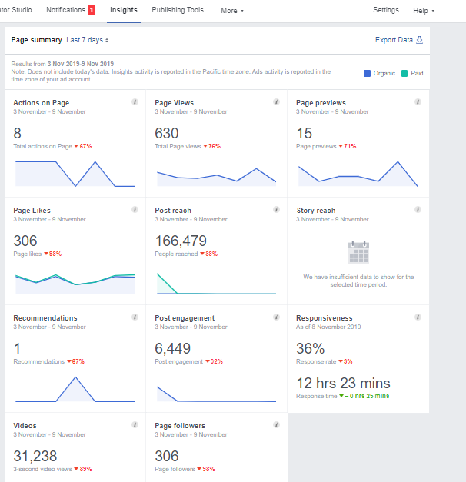

Picture: Facebook Page Insights of LOVELLO Ice-cream 2019
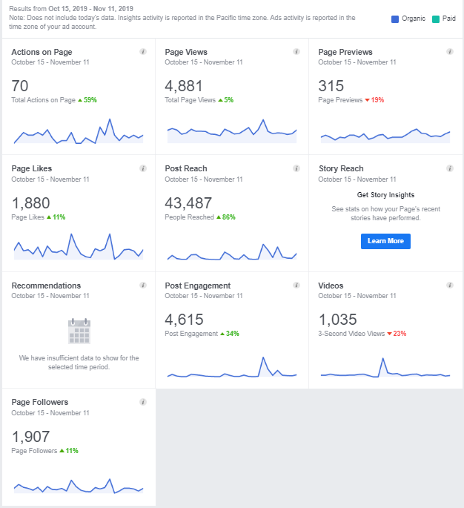

Picture: Facebook Page Insights of Standard Chartered Bank 2019

4.3 COMPETITOR'S DIGITAL MARKETING ENGAGEMENT
Through this excel report, I have to demonstrate every detail of the client's monthly position on the Facebook page compares to their competitors. The whole Excel sheet was divided into several segments according to the number of the client's competitors, and each element of the client's competitors are divided into six parts. These six segments are Page Likes, Date, No. of Post, Content, and Engagement. Here, engagement includes a total number of like, comment, and share on each Facebook post of that month. I have prepared six months of the Competitor Analysis report for Standard Chartered Bank and LOVELLO Ice-cream through my internship journey. From this monthly report, clients can easily show their progress and quickly compare their current condition to their competitors. As an example, some pictures from the Excel file of the Competitor Analysis of Standard Chartered Bank and LOVELLO Ice-cream are bellowed:

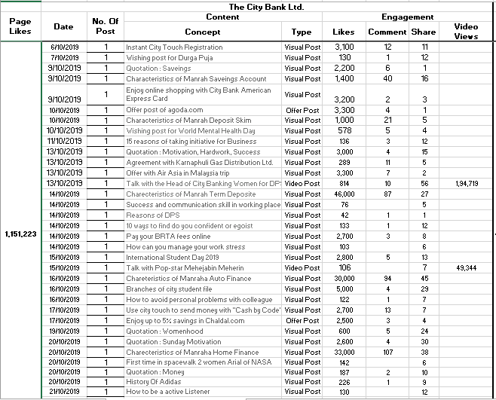

Figure: Standard Chartered Bank's Competitor Digital Marketing Engagement 2019

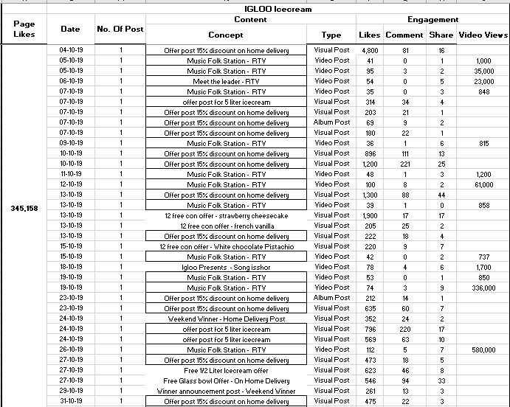

Picture: LOVELLO Ice-cream's Competitor Digital Marketing Engagement 2019

4.4 OBSERVATION FOR FUTURE IMPROVEMENT
I also have to present a visual condition of our client's current position and their competitor's current position on their Facebook page engagement. At the end of the file, I recommend observing how they develop their current condition compared to their competitors. Here, I have to show an overall observation of that particular month of each competitor of clients. After that, I have to present a word where I offer each client's response rate. From our statement, a client can easily compare their current growth in social media than their competitors. Now, the Current Digital Marketing Engagement rate of Standard Chartered Bank is bellowed:
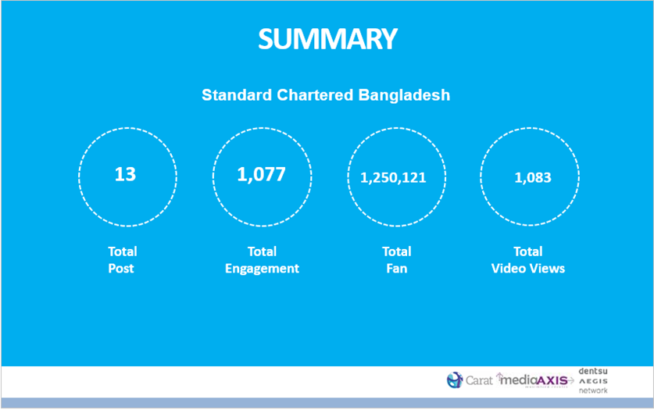
Figure: Current Digital Marketing Engagement rate of Standard Chartered Bank (SCB)
Here, we made an assumption. Suppose Standard Chartered Bank (SCB) has 100,000 customers and sends at least 3 SMS per person. That means per month they send 300,000 SMS that cost 300,000*.60= 180000*12=2,160,000. Now, if they would spend this amount of money, the impression would have been served to 25,000,000 people, and for each people, the impression would have done for 256 times where Standard Chartered Bank (SCB) is reaching one person in a year for 36 (3*12) times.
Audience Reached:
- Content that we uploaded during this Ramadan, we got 1.4 million reaches from this. It means that 1.4 million people saw our contents, posts, and ad. Among these, 557,056 people reached by Facebook post promotion, and 842,981 people arrived by multi-product advertisements.
- For Facebook post, each people got to know about our post 2.38 times, and for the multi ad, the frequency was 1.11

Post Engagement:
Post Engagement means how many likes, comments, shares, photo views, and website click we got. Here, we can see from post promotion; our engagement was higher. It is 118,989, and the likes are 85,777. However, website clicks are higher in the post engagement section that is 34,449.
After completing the monthly competitive analysis, we provide an overall observation from which clients get quick feedback. At the same time, we give them an idea for making an Ideal Digital Plan for their upcoming project and campaign. Sometimes some clients demand monitoring their Webpage and Facebook page to update their page to boost their content and increase their Digital Marketing Engagement. For example, I give a structure of an Ideal Digital Plan idea for the Standard Chartered Bank Campaign.
Figure: Ideal Digital Plan for SCB Ramadan Campaign

Figure: How to execute the whole Campaign for SCB
4.5 STRATEGY DESIGN
The strategy is a high-level plan to achieve one or more goals under conditions of uncertainty. In the sense of the "art of the general," it included several subsets of skills including Tactics, Siegecraft, Logistics, etc. the term came into use in the 6th century C.E. in East Roman terminology. As an example, I will describe every three stages of the Standard Chartered Bank Campaign's strategic plan that we did to make the campaign successful.

Figure: Strategic plan of SCB Campaign

- Targeting Right People
The first stage of this strategy is targeting the right people who are our audience. Here, our targeted audiences are both male and female whose age is 24 to above 24. As this offer is only for the cardholders of Standard Chartered BANK, we targeted all mid-level to upper-level employees who attend clubs, attend various social parties, frequent Restaurant visitors, travel abroad. Their interest is in Posh brands, Shopping, Exotic Food, Fine Dining. We planned to target them in two different ways. One is by Facebook targeting, and the other one is Google Display Network (GDN) targeting.

Figure: Targeting the Audience for SCB Campaign
Targeting Right People on Facebook:
Based on the above category, we can target our audience by showing Facebook posts or Facebook multiple add.
1. Facebook post: There are two things in a Facebook post. One is creative, and another one is post copy. For the superstore base, we can write, BRAC BANK is offering Tk300 cash back up to your purchase at 3000tk to enjoy this Eid with your family, in our post copy. Also, creative may contain a picture of meat or vegetables, or spices available in the superstore to grab our customers' attention.
2. Facebook Multiple add: Here, we can add at least 3 to 5 different posts together in one position and give five additional website links that directly take our audience to land on that website link. The main benefit of this is we can add other links for our other products.
Targeting Right People in Google Display Network (GND):
Nowadays, whenever we visit a website, we see lots of ads besides that page; some of them are the ads of Grameen phone or kaymu.com or amazon.com, etc. This is called Google Display Network. To do this kind of ad promotion, we need to be very specific regarding the keywords because keywords will show my ad on that website where it needs to be delivered. For example, here we have chosen credit card from critical words, business and economics from interest, banking from topics, and Prothom Alo for placement. Now Google will show our client's ad in the Business and Economics Section of the Prothom Alo website so that people interested in banking can see this offer.

Figure: Targeting Right People in Google Display Network (GND)

- Right Communication
The explanation of Facebook promotion, Multi ads, and Google Display Network (GND) banner is already given. When these are posted, we got lots of queries regarding the product or the services. Therefore, we need to answer all of those queries on behalf of the brands. Sometimes, we are not aware of some questions; we ask our clients on behalf of our customers and again get back to our customers. This is how communication is built up.

Figure: Right Communication for SCB Digital Campaign

- Right Action
Total Reach: This is the number of unique people our communications are exposed to. It says that after boosting a post, how many audiences reached in our position.
Impressions: The number of times the communications have been shown to the audience. It shows how many times we reached the same person for our post.
Engagement: Number of clicks, likes, comments, and shares by the audience. We can see this at the bottom of our post.

4.6 BUDGETING
If the client likes our plan, we send a budget to them. After that, there is a negotiation between the client and us. When both parties agree with the store, we execute the plan. Budgeting falls under finance or operational management. After completing the planning, the client service department takes it to the operation and finance department. Then, the Finance department makes the budget. Here, the account for Standard Chartered Bank Campaign is given.

Sl. No. | Particulars | Monthly Cost (BDT)
1 | Reimbursement Direct Labor Cost for Facebook Management | 68,075/-
2 | Visualization Cost | 30,000/-
3 | Agency Commission on Visualization Cost (10%) | 3,000/-
 | Total Cost with Agency Commission | 1,01,075/-
4 | Ad Campaign Cost | 1,96,666/-
 | Total Cost with Ad Campaign | 2,97,741/-
5 | 4.5% VAT | 13,398/-
 | Grand Total | 3,11,140/-

Figure: Budget Plan for SCB Campaign

4.7 WHAT D-reach DID
Content Creation:

Figure: 3 Steps for Content Creation Plan
A.D. Campaign:
Figure: Execution of Plan

As an example, here we take one of our valuable client Standard Chartered Bank and write in details that what we did to Execute their Content Creation and Ad Campaign plan
- At the first stage, we select a relevant image from clients' official Facebook and websites such as Arong, Anjan's, Cats Eye, Tangail Sarre Kutir, Shapnow, Agora, and Meena Bazar, etc.
- After that, we design catching creativity to engage our audience.
- Creative contains a message that highlights the standard Chartered Bank offers for its cardholders.
- We run Facebook posts and multi-product ad posts.

Chapter 5
RECOMMENDATION & CONCLUSION
Chapter: 5
RECOMMENDATION & CONCLUSION:
RECOMMENDATION
According to the analysis and findings, there are some recommendation for the marketers based on the study-
- Marketers should do something that can make the female users encouraged to use digital media, which may increase the number of female user base in Bangladesh.
- The businesses that are still thinking of doing only conventional marketing should start investing in digital media and make their communications more effective.
- uoiWhoever doing businesses, especially online shopping-related companies, should take some essential measures to secure customer information and give a good customer experience. Customer Privacy and customer experience should be the concern of all marketers.
- Digital marketing communication is not so costly as any other media, but content management in digital marketing communication is essential.
- So, marketers should emphasize content management and integrate that with conventional media and invest virtually both in digital and traditional media.
- According to research, the reason for brands failing today is because of the low budget allocated for digital media communications; digital media communication gets, on an average, only 1.2 % of the total communication and promotion budget. So, brands should go digital and increase the digital marketing communication budget.
- Facebook page indeed significant to create a digital presence. But Facebook is not the only digital platform out there. Website content, YouTube channels, Twitter,and Instagram,etc. are all needed to make an overall impression on the consumer's mind. It's a consumer-driven industry; the industry moves where the consumers move.
- Industries need to improve their website for mobile users so that those who are mostly using their smartphones than desktop or laptop can order they are necessary products whenever they want. Customer satisfaction is the ultimate key to any business growth.
CONCLUSION:
Working in a multinational advertising agency like D'reach was one of my dreams when I was an undergraduate level student. I am so happy that I could complete the last phase of my undergraduate life working in such an advertising agency. For young blood like me, working with creative minds and professionals was an excellent experience for me. The office and people there were great, like home. We used to have fun, work lately with high encouragement because we felt like we are working not only for the client but also for the nation and its people. Every communication counts. 360-degree communication is done by D'reach, though three months attachments are not enough for a person to learn all those, the relationships made there is a lifetime asset who are still with me helping understand so many things. It was an incredible journey working with so many local and international brands that it had been a great learning opportunity for me. This has been a great learning experience for my career. The project in this report is done based on digital vs conventional marketers' arguments. Both traditional and digital marketing communication is highly essential to uplift brand awareness and brand performance. Digital marketing communication is necessary to make today's brands successful and reach locally and internationally.
In today's modern age of technology and innovation, people are almost always occupied with something or the other to do. No longer do people only sit in front of the television after a day of hard work. As people are always on the move, smartphones have become the media to witness all the day's happening activities as content includes podcasts, news,and YouTube views,etc. Such new drastic changes in the way people view content are a testament to the impact Digital Marketing Industry has had on Bangladesh people.
To conclude,my internship helped me a lot to delevelop my skills and build the confidence I needed the most.I believe that I still have a lot to learn from them and a lot to contribute.I am looking forward to coniuning working here in the future.

REFERENCE:
- D Chaffey, F Ellis-Chadwick – 2019. Digital Marketing (7th edition)
- Alexa Kierzkowski, Shayne Mcquade, Robert Waitman, and Michael Zeiss - 1996. Current research: marketing to the digital consumer. The McKinsey Quarterly (8th edition)
- D Ryan – 2016. Understanding digital marketing: marketing strategies for engaging the digital generation. Kogan Page Publishers
- MTPMB Tiago, JMC Verismo - 2014. Digital marketing and social media. Business Horizons (Volume 57)
- G Urban – 2003. Digital Marketing Strategy. (3rd edition)
- A Parsons, M Zeisser, R Waitman – 1998. Organizing Today for The Digital Marketing of Tomorrow. Journal of Interactive Marketing. (Volume 12)
- PK Kannan - 2017. Digital marketing: A framework, review, and research agenda. International Journal of Research in Marketing (Volume 34)
- KT Smith, – 2011. Digital marketing strategies that Millennials find appealing, motivating, or just annoying. Journal of Strategic Marketing (Volume 19)
- LP Baltes – 2015. Content marketing - the fundamental tool of digital marketing. Bulletin of the Transilvania University of Brasov. (Volume 8)
- YS Wang, TI Tang – 2003. Assessing Customer Perceptions of Website Service Quality in Digital Marketing Environments. Journal of Organizational and End User.
- J Royle, A Laing – 2014. The digital marketing skills gap: Developing a Digital Marketer Model for the communication industries. International Journal of Information Management.
- J Wind, V Mahajan - 2002. Digital Marketing. Symphony Emerging Issues in Management.
- A Yasmin, S Tasneem, K Fatema – 2015. Effectiveness of Digital Marketing in the Challenging Age: An Empirical Study. International Journal of Management Science and Business Administration. (Volume 1)
- R.D. Todor – 2016. Blending traditional and digital marketing. Bulletin of the Transilvania University of Brasov. (Volume 9)
- J Järvinen, H Karjaluoto - 2015. The use of Web analytics for digital marketing performance measurement. Industrial Marketing Management.
- D Chaffey, M Patron – 2012. From web analytics to digital marketing optimization: Increasing the commercial value of digital analytics. Journal of Direct, Data, and Digital Marketing Practice. (Volume 14)
- AT Stephen – 2016. The role of digital and social media marketing in consumer behaviour. Current Opinion in Psychology. (Volume 10)
- D'reach World official website: http://www.dreachbd.com/
- D'reach Facebook page: https://www.facebook.com/Dreachbd/
- LOVELLO Ice-cream Facebook Page: https://www.facebook.com/LovelloIceCream/
- Standard Chartered Bank: https://www.facebook.com/StandardCharteredBD/
- Bangladesh Telecommunication Regulatory Commission (2017, February). Internet Subscribers in Bangladesh: http://www.btrc.gov.bd/content/internet-subscribersbangladesh-february-2017
- Digital Marketing: https://en.wikipedia.org/wiki/Digital_marketing
- Digital Marketing Strategy: http://www.smartinsights.com/digital-marketing-strategy/digital-strategydevelopment/10-reasons-for-digital-marketing-strategy/
- BrouseBee Digital: https://www.facebook.com/browsebeedigital/

