Financial Performance Analysis
Of
Dhaka Bank Limited





Internship Report On

“Financial Performance Analysis of Dhaka Bank Limited”

Submitted To

Ishrat Jahan

Asst. Professor

School of Business & Economics

United International University (UIU)

Submitted By

Papia Rahman

ID: 111 142 315

BBA

United International University (UIU)

Date of Submission
21 January, 2021

Letter of Transmittal

Date: 21 January, 2021
Ishrat Jahan
Assistant Professor
School of Business & Economics
United International University (UIU)
Subject: Submission of Internship Report on “Financial Performance Analysis of Dhaka Bank Limited”.

Dear Mam,

I would like to make reference to you that I am a student of United International University in BBA department and finishing my internship and occasion to present my internship report on “Financial Performance Analysis of Dhaka Bank Ltd". I have attempted to most extreme exertion to gather all the essential data to finish the report. It was an incredible experience for me to do the report on this topic. This task has assisted me with applying my hypothetical information into training. I have perceived that hypothetical information isn't sufficient. We need practical experience and information moreover.

I therefore, hope that the experiment that I have finished is on to my assumption. This report is enlightening. It has been an extraordinary encounter for me doing the report and I have made an honest effort to put all that is identified with the report.

Yours Sincerely,
Papia Rahman
ID: 111 142 315
Department: BBA
United International University (UIU)
Acknowledgement

Notwithstanding whatever else I should offer appreciation to Allah. By then all the individuals who were fused both obviously and by recommendation in the arrangement of this report. I'm sorry to the individuals whose names that I have not alluded to, and their obligation is remarkably regarded by me. From the earliest starting point, I ought to thank my instructor Ishrat Jahan, Asst. Teacher UIU Business School, United International University, for managing me and for allowing me the chance to start this report. Much more unequivocally, I may have to offer thanks toward him for giving his time and expertness.

I was set in the General Banking Division of Dhaka Bank Limited, Jatrabari Branch to fill in as an understudy from 02 February to December 30 April 2020. I need to thank all the experts of Dhaka Bank Limited that were fused. I may particularly have to offer thanks toward Md. Moniruzzaman (FVP), Md. Monjur Hasan Bhuiyan (AVP& Manager-Operations, Munshi Mahmudur Rahman (boss Officer), Shefa Parveen (Officer) for offering individual time and sharing their considerations. I may have to offer gratitude to them for giving me the fundamental data to start this report and for giving me the consistence to do the principal assessment work.

I in comparable way should give my appreciation to a superstar who has gotten everything going for me at Dhaka Bank Limited - Mr. Khondker Fazle Rashid (Managing Director). At last, I ought to thank my kin and my family whose impact and motivation has empowered me to finish theory report.

Table of Contents
Chapter -01 8
1.1 Introduction 9
1.2 Objective of the report 9
1.3 Methodology 10
Sampling Techniques 11
1.4 Limitation of the report 11
Chapter-02 12
2.1 An Overview of Dhaka Bank Limited (DBL) 13
2.2 Background of Dhaka Bank Limited 13
2.3 Corporate Information 13
2.4 Mission 14
2.5 Vision 14
2.6 Corporate values of Dhaka Bank: 14
2.7 Organizational Structure: 15
2.8 Operational Activities of the Organization: 15
2.9 Corporate social Responsibility 18
2.10 SWOT Analysis of Dhaka Bank: 23
Chapter-03 25
3.1 Ratio Analysis of Dhaka Bank Ltd: 26
Chapter-04 41
4.1 Recommendations 42
4.2 Conclusion 42
Chapter-05 43
5.1References 44

Abstract

This entry level position report relies upon my passageway temporary job program and spending frameworks of 2015 to 2019 of Dhaka Bank Limited. In my brief occupation session, I tasked in General Banking. It was a wonderful occasion to participation and accumulate information on various types of banking tasks. My educator assisted me with picking the subject "Financial Performance Analysis of Dhaka Bank Limited".

In the new business time period, the private money related region is getting more genuine in Bangladesh. Around there the most utilized money related reports are the bookkeeping report and advantage and setback account where the accounting report shows the financial position and advantage and deficit account shows the net bit of leeway or outright inadequacy of a bank. Extent Analysis manages these verifications.

Proportion examination is the most well-known example to judge a bank's introduction over years or with various associations in an industry. In my report I expected to ponder Financial Performance Analysis of Dhaka Bank Limited's monetary rundowns all through the past five years by then expected to separate and give basic comments concerning the changes in the money related position. Assessment and comprehension of these fiscal reports through extent investigation has now become a huge strategy for execution assessment because the examiners account subject matter experts, the board bosses and the speculators reliably rely upon these extents to make huge decisions. The administrative gathering of any bank, monetary trained professional and the public position workplaces continually stress over liquidity extents and adequacy extents of a bank which interprets the viability of a bank.

As a piece of my Bachelor’s Business Administration program, I have encountered 3 months in Financial Performance Analysis of Dhaka Bank Limited, Jatrabari Branch & learning the exercises of general banking. I have investigated the money related reports of Financial Performance Analysis of Dhaka Bank Limited to discover its degrees by utilizing its former and modern records. Coming about to setting up this report I came to comprehend that evaluation of spending rundowns between extent assessments with keeping an essential separation from the past stumble and settle on the future choices and system. Consequently, it is critical for every association whether the affiliation's size is to offer financial explanation and to investigate it to a degree.

Chapter -01

Introduction

Introduction
For the most part by "Bank" we can beyond question handle that the cash related affiliation administering cash. The entire situation of the economy of a nation can be learned by inspecting the state of the financial zone. Banking zone has a fundamental task to do in the monetary exercises and improvement of any country. There are various types of banks like Central Banks, Commercial Banks, Savings Banks, Investment Banks, Industrial Banks, and Co-employable banks, and so on notwithstanding, when we utilize the enunciation "bank" with no prefix or cutoff, it suggests the Commercial Banks. Business Banks are the key partners of the economy of a nation like Bangladesh. In Bangladesh, the business banks are regulating the monetary zone and macroeconomic association all things considered relies on the showcase of the business banks also as the financial zone. Banking filled basically in the public zone with fundamental supplement on changing of the monetary construction and progress needs of the war-torn economy with persevering development in after years. It was constantly felt that banks should be a permitted in the private area for giving a fillip to advance measure based.

On private activity. In the 80's startlingly various banks in the privatize region were permitted. Dhaka Bank is one of them. Today the monetary thought isn't continuing inside the branches or the motel of the branches. The monetary experts are correct currently rehearsing relentless banking. The attestation of the transparency of the master place is a fundamental factor in bank association. Thusly, it has gotten fundamental for each individual to have some thought on the bank and banking technique. As of now, there are 56 booked banks working any place in the country. Out of these, 9 are state-had (checking 5 unequivocal banks), 38 are privatize issue banks and the rest 9 are new business banks.

Notwithstanding the way that the money related zone in Bangladesh is experiencing a crazy change, it truly experiences consistent shortcoming. The most concerning issue of Bangladesh banking framework is the bank advance default issue. Different activities have been attempted to manage the credit default issue in Bangladesh. One of them is to have a credit strategy and frameworks rule coordinated by the Bangladesh Bank.

1.2 Objective of the report

The goal of the report can be seen in two structures:

• General Objective

• Specific Objective

General Objective

This entry level position report is organized essentially to achieve the Bachelor of Business Administration (B.B.A) degree essential under the Department of UIU Business School, United International University.

Specific Objective
Even more expressly, this assessment includes the going with points:

- To give a short survey of Dhaka Bank Ltd.

- To assess the monetary presentation of Dhaka Bank Limited over the most recent five years.

- To present my discernment and suggestion to the bank.

- To perceive the strength and inadequacy of the bank rely upon the monetary situation over the latest five years. (2015-2019).

1.3 Methodology
To create this report just auxiliary information has been utilized. The source that have been used to amass and accumulate data is referenced underneath:-
Secondary Sources

    - Annual Report of Dhaka Bank Limited from 2015-2019.
    - Previously published records of Dhaka Bank Limited.
    - Diverse composed documents of Dhaka Bank Limited.
    - Newspaper
    - Web site

Sampling Techniques
This report represents the sample techniques but on this report sample techniques are for financial performance analysis for different years. Ratio analysis, performance evaluation is the main focus of the sample technique.

Sample Size

Sample size can be suggested for distinct annual performances. In this report I am using the annual record of Dhaka Bank Limited (2015-2019). These annual reports are utilized for the overall performance evaluation of Dhaka bank Ltd.

Ratio Analysis

Proportion investigation is a quantitative strategy of acquiring discernment directly into an association's liquidity, operational effectiveness, and benefit by perusing its fiscal summaries which incorporates the solidness sheet and income proclamation. Proportion examination is a foundation of fundamental decency assessment.

1.4 Limitation of the report
It was an uncommon possibility for me to work in Dhaka Bank Limited as an Intern and to make a report on its monetary display yet there were certainly a couple of imperatives while creating this report. These given below:-

    - Receiving the data and deciphering it, based on my arrangement and afterward actualizing it.

    - Bankers are exceptionally engaged individuals. I attempted to reach some high authorities for more itemized data and counsel yet they couldn't oversee time for me.
    - Difficulty is insufficient of time. I had to acquire all the records in this insufficient time and decided on vital records to finish the file.
    - Unfinished & obscure files are also a drawback.
    - Unavailability of good enough written records as considered necessary completing an extensive take a look at.
    - Unavailability of data
    - Privacy of records.

Chapter-02

Organizational Background

2.1 An Overview of Dhaka Bank Limited (DBL)
Dhaka Bank Limited is the fundamental private territory bank in Bangladesh offering full extent of Personal, Corporate, International Trade, Foreign Exchange, Lease Finance and Capital Market Services. Dhaka Bank Limited is the supported choice in banking for all around arranged and tweaked organizations, cutting edge development, uniquely crafted answers for business needs, overall reach in return and exchange and exceptional yield on endeavors, ensuring Excellence in Banking Services.

2.2 Background of Dhaka Bank Limited
Dhaka Bank Limited is a booked bank that was melded under the Companies Act 1994, started its method in July 1995 with a target to accept the irreplaceable part in the monetary progression of the country. Focusing on contribution business banking organization to the customers' passage around the country. This affiliation gaining customers' conviction following its establishment. Inside this time the bank has been viable in arranging itself as a reformist and dynamic money related establishment in the country. This is as of now by and large acclaimed by the business organization, from little money manager to gigantic transporter and totals, including five star corporate and new theorists, for present day and contemporary contemplations and commercial game plan.

2.3 Corporate Information

Name of the Bank: Dhaka Bank Limited
Status: Private Limited Company
Date of Founded: July 5, 1995 Headquarters: Dhaka
Registered Office: Biman Bhaban (1st Floor), 100 Motijheel C/A, Dhaka-1000, Bangladesh

Swift Code: DHBLBDDH

E-mail: info@dhakabank.com.bd

Web Page: www.dhakabankltd.com

Subsidiaries: Dhaka Bank Securities Limited

2.4 Mission

To be the head money related foundation in the country giving first rate things and organizations supported by latest advancement and a gathering of significantly lively workforce to pass on Excellence in Banking.

2.5 Vision
At Dhaka Bank Limited we draw our motivation from the closed off stars. Our social event makes arrangements to guarantee a standard that makes each money related exchange a pleasurable encounter. Our undertaking is to offer you the incredibly sharp radiate through exactness, endurance, accommodating vehicle, and bleeding edge progression, custom fitted reactions for business needs, by and large reach consequently and trade and outstanding yield on your undertakings. Our family, things and cycles are changed as per satisfying the requirements of our sharp client. We will apparently accomplish an ability like the illuminators in the skies. Our incredible goal is to pass on a quality that shows a genuine impression of our vision Excellence in Banking.

2.6 Corporate values of Dhaka Bank:

- Consumer focus
- Wholeness
- Exorcism
- Teamwork
- Respect for the Individual
- Responsible Citizenship

2.7 Organizational Structure:
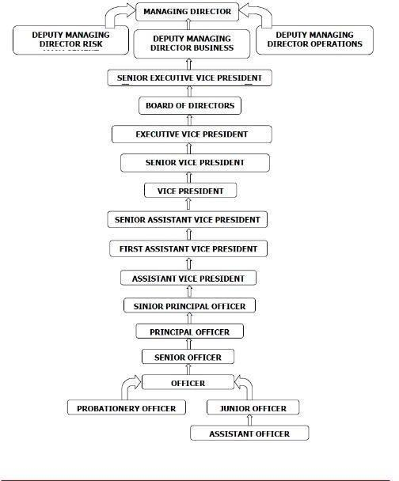

2.8 Operational Activities of the Organization:

Product of the Bank:

    - Opening Account
    - FDR (Fixed Deposit Receipts)
    - DPS (Deposit Pension Scheme)
    - Cheque Book
    - Debit Card
    - Credit Card
    - Internet Banking
    - Remittance
    - Pay order form
    - Bank statement
    - Information to the customer.

Opening Account:

The way to open an account in Dhaka financial institution in the beginning is a financial savings a/c or cutting-edge a/c or other specific form of a/c in Dhaka bank has a/c within the bank and introducer for a/c holder. Introducer is an account in Dhaka bank in any department. Introducer file should be the right manner to the bank due to the fact introducer is the grantor for a new a/c holder. Introducer reports are right manner inside the shape. Introducer Name, address, cell range, a/c name and a/c range are well clean ways to state the shape. Secondly a/c holder national identity card photocopy and original card take in the bank due to the fact some of time country wide identity card are now not nicely picture and records aren't clear so need to be take inside the bank and nominee country wide identification card photocopy need to be take the financial institution and nominee one replica passport image and a/c holder copy image inside the bank. Banker are right way top off the form and document the a/c holder details inputted the bank server. Server has a/c wide variety for depositing the money against the a/c. In the end a/c holder different offerings in bank cheque e-book, debit card and other centers inside the bank a/c holder told the banker and they can properly way the outlet the account.

FDR (Fixed Deposit Receipts) & DPS (Deposited Pension Scheme):

FDR & DPS are another sort of merchandise of Dhaka Bank Limited. FDR are in particular deposited for massive amounts of cash for constant sure time and in this product are beneficial for depositors due to the fact they may be in this deposit are a few earnings to adulthood of time clients are major of cash and add the profit in the certain time period. And any other product of Dhaka bank is DPS. DPS are monthly foundations are deposited the cash. Depositor is some of the deposits are whole properly and they are able to effortlessly maturity of date earnings and are important to get hold of in the financial institution.

Cheque Book:

Cheque book is every other offering in Dhaka Bank Limited. An e-book is needed for each purchaser due to the fact consumers withdraw their cash and take some other customer, bank, customer and personal trouble to apply the cheque. Dhaka bank cheque books are kind. One cheque book web page has twenty first-rate leaf and hundred leaf. Twenty 5 leaf take a look at book cost are twenty hundred 75 taka and hundred leaf take a look at e book are one thousand 100 taka. Requests to take a look at e-book are delivered for running days 3 to 5 days.
Debit & Credit Card:
Debit & credit card is one other kind of service in Dhaka Bank. It is necessary for every customer. This card is made of plastic and highly security chips are noted on this card. These cards are different ways to purposely use the customer. Platinum, Gold, silver and different cards give the customer their different needs and wants. These cards are prepared by ten to fifteen days later when customers receive the bank.
Internet Banking:
Dhaka Bank other services in banking and internet banking are important for the customer and banking sector. This banking is helpful for customers and bankers because they can easily access it at any time any place. Account holders properly use their transaction of cash and withdraw in any sort of activity in the bank to alert for information properly. Every bank uses the internet banking for customer and banking information for different activities.

Remittance:

Remittance is another kind of service in Dhaka Bank. Because it is an important issue for outside money, the money sent for Bangladeshi people for send to foreign people is cash in through like western Union, cash express, Ria and other different sources of remittance money. Customers withdraw the money in the process for cash the money. Procedure for needing a national id card photocopy and pin number given and fill up the form properly and receiving the money.

Pay Order:

Managing huge amounts of money is hard for some organizations or clients some of the time, individuals use pay requests as an alternate choice. For a pay request client needs to dispatch a compensation request structure where he is giving the compensation request and the fundamental sum is composed. As indicated by that the compensation request is set up properly.

Bank Statement:

Giving ledger explanation is another normal help of any banking branch. Bank has a record to request a financial balance explanation where the bank can earliest starting point to end of that record all cash transactions are given. Banks are statements for individuals for personal and business in their income tax related issue when it is important for customers.

Information to the Customer:
Information to the customer is one kind of service in Dhaka Bank. Because it is an important role in the banking sector for every bank. It is related to customer different needs and wants are properly related in satisfaction for banking services for different issues. Customers are judging the banking sector for significant data about the bank. As a result, they try to best serve their customers. Dhaka Bank are 24/ 7 services in the banking sector and hot numbers for any help for the customer in banking related help are 16474. This information is helpful for customers. Customers can easily share their different issues and properly solve problems. They are getting their services firstly and short timely properly. Another way to inform the customer for transaction and card related and different serious issues to solve for the information to the customer.

2.9 Corporate social Responsibility

DBL recalls itself for cause, social government help and other unselfish exercises towards the progress of the goal of its establishment which would go presumably as an upgrade in gaining care on ground issues and as a facilitator for building ranges with the shared objective of monetary improvement of the general populace, giving direct help to different improvement activities and individuals. Dhaka Bank Ltd. has plot a five-segment CSR board headed by the Managing Director to control the general exercises and the main gathering of the CSR asset of the bank. Dhaka Bank Foundation, set up in 2002 as a non-beneficial, non-managerial connection, is exclusively dedicated to the clarification behind a good reason, social government help and other charitable exercises towards the progress of the target of the establishment. Dhaka Bank has taken the choice to give 2% of the pre-charge advantage every year as its CSR works out.
- Health

- Donation of explorer lifts and two hemodialysis machines to BIRDEM Hospital and Tk. 1.2 million every year from 2006 for supporting working costs.
- Donation of Tk. 10 million to Center for Women and Child Health Hospital for setting up a fanatical lab.
- Setting up of a 10-bed ward at the proposed Ahsania Mission Cancer and General Hospital, supporting Society for the Welfare of Autistic Children (SWAC).
- Donating to Bangladesh Eye Hospital, Sponsorship for Shield Trust.

Disaster alleviation

- Among Dhaka Bank's responsibility as corporate social commitment, a few exercises are given to Asiatic Society of Dhaka.

- Alleviation action for flood losses to a detriment of Tk. 5.0 million.

- The bank coursed 10 kg rice, 1 kg heartbeat, and 1 kg salt to all of the 10,000 disturbed gatherings of Araihazar, Sirajdikhan and Belkuchi.

Social government assistance

- Redesign of the amphitheater of Dhaka Reporters Unity.

- Supporting of Anti-Drug Debate Festival, Distribution of winter textures by the delegates of the bank.

- Supporting of Bangladesh Under-19 cricket group.

- Mindfulness creation for Road Safety, Blood Donation, Eye Donation, Prevention of AIDS.

- Given money related assistance to Educational Development Trust of Scholastica to help and support academically talented understudies.

- Sponsorship for BADC School.

Environment

- Supported the city beautification program started by Dhaka City Corporation by redoing.

- Dhaka Bank Fountain before the Ministry of Foreign Affairs and Dhaka Bank Park.

- Dhaka Bank Head Office, beautification at Jashimuddin Crossing at Uttara costing 1.5 m, furthermore before Dhaka Bank Head Office costing 1.2 m.

Department of the Dhaka Bank:

Human Resources Department
      - Credit Department
      - Central Accounts Department
      - Operation Department
      - Investment Department
      - Information Technology Department
      - Dhaka bank Training Institution
      - Personal Banking Department

Human Resources Department:

Dhaka Bank Limited are well trained employees for their organization. HR departments circulate the different position wise responsibilities and qualifications are given below the circular and they are providing examinations for candidates and selected candidates call for viva. Viva are different ways for educational, personal attitude and dedication for work and candidates wants and feedback for organization and different tests are given for proper candidates suitable for position in different departments wise their work duties and responsibilities are proper way to employees. Dhaka Bank are significant way to hire the employees.

Credit Department:

The Credit Department is the most important department in every bank because in this department are the main part of the financial division in the bank. Credit Departments are different in loan processing and how to recover loans for the customer. Because this department is different from loan related and LC related work in this department. This department is hazed working for different work in this division. This department mainly works for different customer loan, car loan, staff loan, house loan, land mortgage and different financial lease and LC related different issues are handled for this department.

Central Accounts Department:
Dhaka Bank Limited has a central department to record all branches keeping safe and proper way of observation for particular branches. This department are proper way to maintain their work properly and a different strategy to handle the department properly.
Operation Department:
For the achievement of any branch a completely working tasks office is totally significant. This office is dependable to guarantee that every one of the works are finished. This division is answerable for making arrangements, setting rules, creating execution measures and observing norms and planning reward approaches. This office is the spirit of the establishment and adds to the accomplishment of the association.

Investment Department:
Investment departments are mainly related to how customers are invested in Dhaka Bank share market. In this department are works for different analysis of market survey and market position in financial condition for banking for local and global region. Investment Department analysis is a different analysis for financial portfolio, market share needs and wants and different particular units are development of the bank.

Information Technology Department:

Information & Communication Technology is at the point of convergence of Dhaka Bank's operational techniques. The innovative piece of room is installed in everything and associations. Dhaka Bank has made its methods and development channels on the world class place financial framework which gives dependable and skilled associations to the entirety of our clients. At Dhaka Bank, consistent improvement and updating of construction and frameworks is reflected to its most prominent bit of leeway in ICT. The entirety of the branches are correct currently associated with online associations and Dhaka bank works on one bank however. Dhaka Bank Limited is building up its ATM eases back down and has a wide program to extend its systems in 2010. To guarantee that everything is going adequately Dhaka Bank Limited has a substitute data and headway office which contains fundamentally competent specialists who in a short second arrangement with IT issues.

Dhaka Bank Training Institute:

HR improvement through arranging is the most key part for genuine progression since it moves information, limit and expert strength. The reasonable essential for skilled movement of workers is inconceivably gigantic for the accomplishment of any connection and because of that the Dhaka Bank Training Institute was framed. Dhaka Bank Training Institute is decided to build up the HR through facilitated confined preparing projects. To accomplish fit importance in Banking, Dhaka Bank Training Institute conducts different courses, workshops, official progress programs essentially for financiers.

Personal Banking Department:

The Personal financial segment of Dhaka Bank Limited is otherwise called the usual financial segment. This segment is principally answerable for giving general administrations to customer for example opening and shutting records, store and withdrawal reserves, giving compensation requests and blessing checks and so forth. The primary duty of this division is to create plans to draw in customers. Because of the constant execution of this office, Dhaka Bank is consistently thinking of new items to fulfill its customers.

Business Units of Dhaka Bank:
There are some businesses units are given below-
- Corporate Banking
- Personal Banking
- Information Technology

Corporate Banking:
Dhaka Banks are some business unit is one of them are corporate banking. Corporate Banking are one kind of credit departmental working in the organization because in this banking are most hazed and customer oriented. In this banking activities are work for safe and safety places for banking. Some are corporate banking are Letter of Credit, Guarantee, Leasing, Working Capital Finance, Import and Export Finance, Syndicated Loan etc.

Personal Banking:

Personal banking is one kind of business unit in Dhaka Bank ltd. Because is not an other banking in the organization. Personal banking is related personal business related or partnership related banking activities in the organization. Customer different types of banking in the business the organization. Because people are different financial banking in the organization. Dhaka Bank is most popular bank which is properly presented the personal banking. Dhaka bank different kind of incentive activities for banking division. Especially for new personal banking holder different facilities are given for the encouraging.
Information Technology:
Information Technology are most important issue for every business unit and the Dhaka bank are especially good relationship with customer. Because it is important for every organization. Dhaka Bank creating a good relationship for every customer. So, they can strong their information technology proper ways for different incentive plan and activities for the customer.

2.10 SWOT Analysis of Dhaka Bank:
SWOT investigation is refined for an association, to discover its customary Strengths, Weaknesses, Threats and openings prompting measuring the forceful ability of the association. The SWOT examination allows an endeavor to perceive its commercial center standing and embrace methods subsequently. Here SWOT investigation of Dhaka Bank Limited is made to perceive the area of the bank higher.

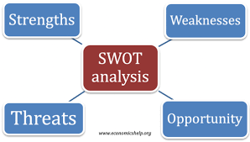

Strengths
- Healthy commercial identification
- skilled worker bonding and assets
- Effective performance
- young enthusiastic group of workers
- Empowered work pressure
- Hospitable operating surroundings
- strong economic role
Weakness
- High charges of L /C.
- Avoiding small entrepreneurs.
- Poor marketing activities.
- Lack of diversification to expand the business.
- Lack of proper incentives.
- High cost of maintaining accounts.

Opportunities
- Different operating procedures.
- Broader network across the country.
- Expert Managers.
- Huge population.

Threats

- Forthcoming bank and branches.
- Comparable products are offered by various banks.
- Default Loans.
- Mechanical Downturn.
- Monetary emergency.

.

Chapter-03

Findings and Analysis

3.1 Ratio Analysis of Dhaka Bank Ltd:

Current Ratio= Current Asset/ Current Liabilities

2015 | 1.40%
2016 | 1.47%
2017 | 1.57%
2018 | 1.72%
2019 | 1.57%

Current Ratio:

The running extent is a liquidity extent that checks an affiliation's capacity to pay brief timeframe period responsibilities or the ones due inside a year. It tells monetary subject matter experts and agents how an affiliation can grow the current property on its resource report to meet its bleeding edge commitment and different payables.

A current proportion that is dependable with the business ordinary or to some degree higher is generally pondered authentic. The current proportion that is beneath the business ordinary may similarly exhibit a higher chance of awfulness or default. Further, if an association has a totally high current proportion when appeared differently in relation to their buddy foundation, it suggests that control may not use their property gainfully.

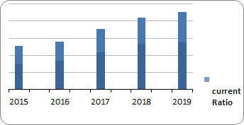

Interpretation: In the analysis of current ratio the percentage of 2015 is 1.40% which increases in 1.475% in 2016 and 1.57% in 2017, 1.72% in 2018. In the year of 2019, it decreases to 1.57%

Capacity Ratio= Loans & Advances/ Total assets.

2015 | 66.8%
2016 | 66.6%
2017 | 67.12%
2018 | 65.9%
2019 | 68.64%

Capacity Ratio:

Limit proportion is the proportion of net advances and leases hard and fast assets. It's far from a powerless liquidity marker, since credits and rentals are routinely the absolute most illiquid things that a bank can hold. Dhaka bank's potential proportion is given beforehand. The lower the limit proportion of a bank, the better. Redesigns inside the limit proportion may be credited to an also quicker improvement in outright assets than all things considered advances continually, and the opposite way around.

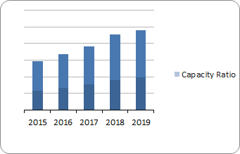

Interpretation: In the capacity ratio the percentage of 2015 is 66.8%, The year 2016 decreases by 0.2%, 2017 year increase in 67.12% and compared to the previous year it decreases in 65.9% in 2018 and finally increased in 68.64 in 2019.

Cash Position Indicator= Cash= Deposits/ Total Assets

2015 | 87.34%
2016 | 85.9%
2017 | 80.06%
2018 | 77.61%
2019 | 77.95%

Cash Position Indicator:

Money position marker is the extent of money and stores due from safe establishments, to amount to assets, which an extra degree of money surmises the bank is in a more grounded position to manage second money needs. Dhaka bank's money position pointer is given beforehand. The higher the money position marker, better for the association.

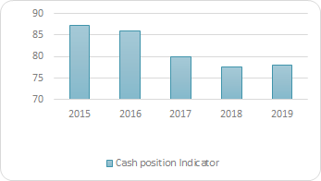

Interpretation: In the observation of these ratios in 2015 the ratio is 87.34% which is consequently decreased in 85.9% in 2016, 80.06% in 2017, 77.61% in 2018 and 77.95% in 2019. It indicates that the cash position is getting low year by year.

Cash Ratio= Cash in hand and at bank/ Total deposits.

2015 | 1.10%
2016 | 1.14%
2017 | 1.08%
2018 | 1.22%
2019 | 1.44%

Cash Ratio:

The money proportion is an assessment of an association's liquidity, unequivocally the proportion of an association's full scale money continually similar to its current liabilities. The estimation determines an association's ability to repay its transitory commitment with money or close money resources, for instance, viably alluring assurances.

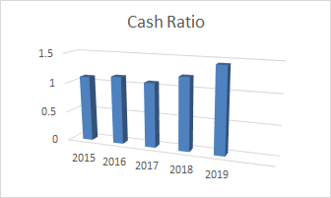

Interpretation: In 2015 the cash ratio was 1.10%. In 2016 it increased in 1.14% and in the year of 2017 the ratio decreased in 1.08%. Finally, the ratio increased in 1.22% and 1.44% in the following year.

Deposit Composition Ratio= Demand Deposit/ Time deposit.

2015 | 28.81%
2016 | 32.25%
2017 | 30.50%
2018 | 26.49%
2019 | 26.94%

Deposit Composition Ratio:

Store structure proportion is the proportion of call for stores to time stores, where solicitation stores are needy upon second withdrawal with the guide of check forming, while time stores have fixed turns of events. It gauges how solid a theory base the monetary establishment has. Dhaka Bank's store association extent is given previously.

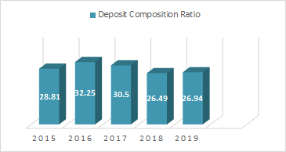

Interpretation: In this deposit composition ratio the ratio of 2015 is 28.81% which increased in 32.25% in 2016. In 2017 it decreased 30.50%. In the last two years it decreased by 4.01% (2018) and 3.56% (2019) compared with the previous year.

Loans to Total Deposit= Loans/ Deposit.

2015 | 84.73%
2016 | 85.70%
2017 | 90.57%
2018 | 91.60%
2019 | 95.65%

Loans to Total Deposit:

This is an ordinarily used estimation for reviewing a bank's liquidity with the guide of dividing the banks total advances through its general stores. This variety, also called the LTD extent, is conveyed as a rate. If the extent is exorbitantly high, it suggests that banks probably won't have enough liquidity to cover any astounding resource necessities; if the extent is simply unnecessarily low, banks most likely won't gain as incredible a plan as they may be. These extents are used to pick whether a monetary establishment may be allowed to open or get an office out of entrances of its home domain, and this extent is frequently utilized by system makers to choose the crediting practices of cash related foundations.

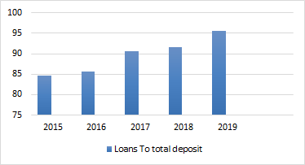

Interpretation: Debts to total deposit ratio is 84.73% in 2015, 2016 year increased in 85.70%, 2017 year increased in 90.57%, and in the following year of 2018 and 2019 it increased in 91.60% and 95.65%.

Loans to Total Asset=Loans/ Assets.

2015 | 66.81%
2016 | 66.61%
2017 | 67.12%
2018 | 65.92%
2019 | 68.64%

Loans to Total Asset:

The advances to property proportion degree the overall credits striking as a percent of absolute property. The better this proportion proposes a financial association is credited up and its liquidity is low. The higher the proportion, the more unsteady a financial establishment may be to higher defaults. It's a far all things considered used estimation for assessing a money related association's liquidity by techniques for separating the bank's general advances through its general property.

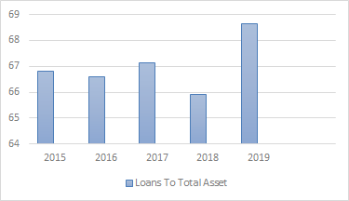

Interpretation: Loans to total asset ratio is 66.81% in 2015, 2016 year increased in 66.61%, 2017 year are some increases in 67.12%. In 2018 the ratio decreased in 65.92% and in the next year it increased in 68.64%.

Equity to Asset= Total equity / Total asset.

2015 | 13.17%
2016 | 13.99%
2017 | 15.05%
2018 | 16.48%
2019 | 16.56%

Equity to Total asset:

The value proportion is a monetary proportion showing the general degree of value used to finance an affiliation's belongings. Its miles used to help pick how much speculators would get in case of an association's gigantic liquidation. The proportion, conveyed as a percent, is controlled by isolating supreme financial specialists' value by using hard and fast property of the firm, and it addresses the proportion of assets on which speculators have a waiting affirmation. The figures used to determine the proportion are taken from the affiliation's accounting report.

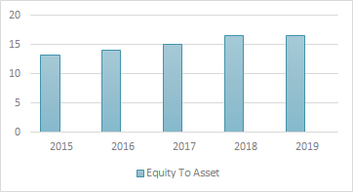

Interpretation: Equity to asset ratio is 13.17% in 2015, increased in 13.99% in 2016, and in the following year of 2017 increased in 15.05%, 2018 increased in 16.48%, 2019 year increased in 16.56%.

Equity to Net Loans= Total Equity / Net Loans.

2015 | 11.36%
2016 | 10.72%
2017 | 9.89%
2018 | 9.19%
2019 | 8.79%

Equity to Net Loans:

This proportion is a piece of the Capital and venture proportions of a bank, and measures an organization's money related influence by methods for figuring the extent of decency and obligation the business is utilizing to back its resources. General value covers by and large reasonableness saves, complete rate capital and depository stock. Net advances incorporate advances to banks or credit foundations, client web advances and advances to association offices.

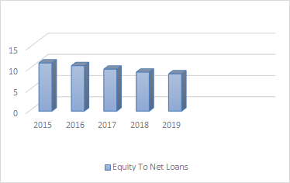

Interpretation: In this ratio analysis 2015-year equity to net loans ratio is 11.36%, In the year 2016 ratio decreased to 10.72%, 2017 decreased to 9.89% it also decreased in 2018 to 9.19%, finally decreasing by 0.4% in the year of 2019.

Fixed Asset Turnover= Revenue / Net fixed Asset.

2015 | 1.63%
2016 | 2.08%
2017 | 2.19%
2018 | 2.21%
2019 | 2.12%

Fixed Asset Turnover:

A fixed Asset Turnover Ratio figures the assessment of arrangements wrapped up by dollar of financing. The fixed-resource turnover extent measures an affiliation's capacity to deliver web bargains from fixed-resource adventures - particularly resources, plant and gear (PP&E) - web of degrading. A higher extent shows better resource the chiefs and use and the reverse way around.

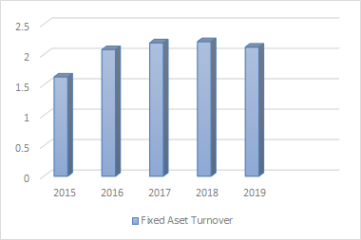

Interpretation: Fixed Asset Turnover Ratio 2015 is 1.63%. There was some increase of 2.08% in 2016. In the year 2017 fixed asset turnover ratio is 2.19%, 2018 year increases 2.21%. In the year of 2019 there is a decrease of 0.09% compared with the previous year percentage of 2.21%.

Net Asset Turnover= Revenue / Net Asset.

2015 | 3.80%
2016 | 4.32%
2017 | 4.08%
2018 | 3.97%
2019 | 3.78%

Net Asset Turnover:

The net asset turnover proportion quantifies the capability of the executives to apply the property of the venture to create pay deals. A pleasantly overseen endeavor will make the possessions turn out hard for the venture by means of limiting inactive time for machines and frameworks. Too high a proportion may likewise advocate over-purchasing and selling, this is an exorbitant measure of deals with too little venture. Too unreasonable a proportion may likewise exhort under exchanging and the wasteful administration of assets.

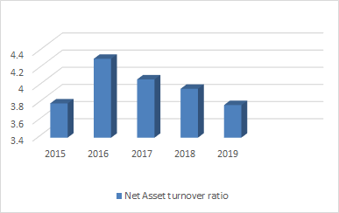

Interpretation: Net Asset Turnover Ratio in 2015 was 3.80%, 2016 year increased in 4.32%, 2017 year decreased in 4.80%, 2018 year are some decrease in 3.97% and also decreased in 3.78% in 2019

Return on Asset= Net Profit / Asset.
.

2015 | 8.15%
2016 | 7.25%
2017 | 6.15%
2018 | 4.96%
2019 | 5.51%

Return on Asset:

ROA is a brand name of an endeavor's productivity. ROA is determined through isolating an organization's total compensation in a monetary year via its general resources. It's known as a benefit or productiveness proportion, since it gives data about the control's presentation in the utilization of the resources of the little undertaking to create benefits. ROA can be utilized as a significant gadget to quantify advancement towards foreordained internal cravings, a positive contender, or the general business. ROA is moreover utilized by financiers, merchants, and business undertaking experts to assess a business venture's utilization of resources and money related dependability.

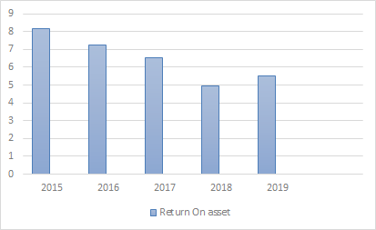

Interpretation: In the year 2015 return on asset ratio is 8.15%, in 2016 it decreased in 7.25%, 2017 year also decreased 6.51%. 2018 year also decreased to 4.96%, And the year 2019 decreases to 5.51%.

Return on Equity= Net Profit / Equity.

2015 | 10.73%
2016 | 10.14%
2017 | 9.80%
2018 | 8.17%
2019 | 9.13%

Return on Equity:

This ratio recommends the amount of net benefits lower back as a level of investors value. Backpedal on value gauges an undertaking's benefit via uncovering how much pay a business endeavor produces with the money investors have contributed. It recommends an organization's exhibition in utilizing ordinary investors' (regular investors') money.

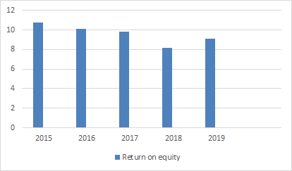

Interpretation: 2015 Year return on equity ratio is 10.73%, 2016 year decreased to 10.14%, in 2017 the ratio decreased to 9.80%, in 2018 year decreased in 8.17% and finally the return on equity ratio increased to 9.13% in 2019.

Return on Deposit= Net Profit / Total Deposit.

2015 | 1.03%
2016 | 0.93%
2017 | 0.87%
2018 | 0.68%
2019 | 0.76%

Return on Deposit:

This ratio proposes the measure of pay again as a percent of generally stores. backpedal on store quantifies a business endeavor's productivity by uncovering how much benefit a corporation creates with the money savers have saved in the bank. It shows an association's presentation in putting aside utilization of installments (liabilities) to acquire pay.

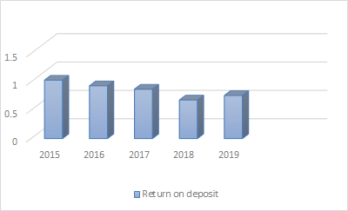

Interpretation: 2015 year return on deposit ratio is 1.03%, 2016 year decreased to 0.93% , 2017 also decreased to 0.87%. In 2018 the ratio decreased to 0.68%, at last in the year of 2019 the ratio increased to 0.76%.

Chapter-04

Conclusion and Recommendation

4.1 Recommendations
- Prior to giving a long-term period contract a bank needs to remember that if a bank has a long time store. In any case the monetary establishment will really confront the liquidity issue.
- A bank needs to upgrade the non-supported benefits with the expectation to develop the running income proportion.
- In the wake of giving the home loan to the customers, a broker ought to likewise complete sure commitments to the clients to diminish the awful obligation issue. Like-following, overseeing and agreeing with the home loan that is taken by the clients.
- Bangladesh Bank needs to force the rule of consistency for a wide range of plans. By this way clients can choose from wherein they may get hold of a supplier essentially based on the supplier overall quite hierarchical climate.
- Chief's obstruction on account of giving home loan should reduce in light of the fact that as such vulnerability may moreover develop and horrendous obligation may likewise develop.
- They should build up the amount of AD Branches wherever in the country with the consent of Bangladesh Bank. Consequently, the clients in every city can delight in their abroad change from their own city.
- They should make their contributions decentralized instead of brought together, so the arrangement of LC just as the home loan endorsement will at this point don't be time ingesting. Also, they will have the option to convey quicker and refreshed suppliers to the customers.

4.2 Conclusion

Current Commercial Banking is demanding business. What's more, Commercial banks are fantastic monetary foundations, essential to the overall government assistance of the economy extra than another monetary organization. Dhaka Bank Limited is one of the primary business banks in our country. In all financial conditions Dhaka Bank Limited has been working with top notch certainty and battling especially with Government orientated banks, neighborhood business banks identified with the worldwide banks besides. Dhaka Bank Limited consistently endeavored its stage high-caliber to do monetarily pleasantly. Regardless of hoping to do pleasantly in certain components Dhaka Bank Limited went up against a couple of money related issues occasionally. A portion of the inconveniences had been-extreme terrible credits, shortage of advances constantly, shortage of money in palms as a result of vault limitation, etc. These inconveniences stimulate time to time as a result of monetary stoppage, premium charge vacillation, rising capital commercial center, expansion in the money market, etc. Battling with these sorts of issues and rivaling various banks each second the monetary foundation is making an endeavor to do higher to pleasant. In the event that this issue keeps, we are trusting that Dhaka Bank Limited will widen even extra inside what's to come.

Chapter-05

Appendix

5.1References

Annual Report:
- Annual Report of Dhaka Bank (2014-2015)
- Annual Report of Dhaka Bank (2015-2016)
- Annual Report of Dhaka Bank (2016-2017)
- Annual Report of Dhaka Bank (2017-2018)
- Annual Report of Dhaka Bank (2018-2019)

Books:
- Stanley, B. b., & Geoffrey, A. H. (2008 - 2009). Foundation of Financial Management. International: McGraw-Hill
- Brigham, E. F., & Gapenski, L. C. (1995). Intermediate Financial Management (Fifth Ed.). International: The Dryden Press

Websites:

- https://www.bb.org.bd/fnansys/bankfi.php
- https://dhakabankltd.com/
- https://www.investopedia.com/
- http://www.activemedia-guide.com/busedu_banking.htm
- https://investinganswers.com/

