

Internship Report
On

Financial Performance Analysis of Jamuna Bank Limited (JBL)

Submitted To:
Muhammad Enamul Haque
Assistant Professor,
School of Business & Economics (SOBE)
United International University

Submitted By:
MD.Abdullah Al Mamun
ID: 111 161 057
Bachelor of Business Administration (BBA)

Submission Date: 28th September, 2021
Letter of Transmittal
September 28, 2021
Muhammad Enamul Haque
School of Business &Economics
United International University
Subject : Submission of Internship Report
Dear Sir,
With due respect, I feel happy to submit my internship report on “Financial Performance Analysis of Jamuna Bank Ltd”. To prepare the report, I managed the necessary data from the annual report of the bank. I learnt a lot from this report which will enrich my knowledge in future works.

I, therefore, pray and hope that you would be kind enough to accept my internship report and give your important judgement and forgive my mistakes.

Thanks sir
Sincerely Yours
Abdullah Al Mamun
111 161 057
BBA

Deceleration of the Student

I am Md. Abdullah Al Mamun.(Id 111 161 057).I am student student of United International University under BBA program. I completed my internship report on “Financial Performance Analysis of Jamuna Bank Ltd” under my respective supervisor Muhammad Enamul Haque sir. He was a more supportive giving guidelines for completing internship report. With 03 months experiences under Jamuna Bank Ltd Darshana Branch, I managed to finish my internship report. It is stated that I completed this report by my own efforts and did not copied from other sources.

Sincerely yours
Md.Abdullah Al Mamun
111 161 057
BBA

Acknowledgement

With the Great Pleasure to Almighty Allah, I would give a huge honor with my respective faculty Muhammad Enamul Haque sir. He always provided me a great support to complete this report. It was very difficult to complete without my supervisor’s guidelines. He always encouraged completing this report in a more effective way. He always encouraged me to apply the idea that I developed from academic understanding.

I like to thank to Md.Arif Hossain, the Executive of Jamuna Bank Ltd Darshana Branch. He always help me to gather knowledge from bank. He gave me an opportunity to work from all individuals sector of a bank. And he always encouraged learning something new and applying in my real life organizational work. All people working in this Brach were very cooperative. Whenever I wanted to learn something they always appreciated my learning approach and extended necessary cooperation in this regard.

Executive Summary

Jamuna Bank Limited as a third-generation bank started its banking services in 2001. Besides conventional activates, Jamuna Bank also provides Islamic banking services through some designated branches. The objective of the report is to assess the overall financial performance of Jamuna Bank Limited. I used the most commonly accepted performance measurement techniques of ratio analysis. It is a very useful approach to measuring the financial performance of an organization. I conducted ratio analysis on the basis of its major dimensions namely liquidity, efficiency, profitability, solvency, and market.
From the analysis, it is observed that Jamuna bank’s liquidity position remains on average stable over the period which is good for the bank. The total debt ratio, debt-to-equity ratios indicate that the bank has a moderate level of borrowed funds in the business. It seems that financial leverage is not high for the bank that can have a favorable effect on its overall performance. The operating efficiency ratio and other ratios suggest that Jamuna bank has been able to maintain its efficiency level in the current period and consequently, generates improved earnings over the recent periods. It can be said that although the rate of return was small they maintained consistent improvements over the years.

Table of Content

Chapter | Topics | Page
Chapter 1 | Introduction  1.1 Background of the study  1.2 Origin of the study  1.3 Objectives of the Study  1.4 Scope of the Study  1.5 Methodology of the Study  1.6 Limitations of the study | 8  09  09  10  10  10  11
Chapter 2 | Overview of The Jamuna Bank Ltd  Company overview | 12  13-16
Chapter 3 | Theoretical Analysis  Ratio Analysis | 17  18-19
Chapter 4 | Financial performance Analysis  4.1 Liquidity Ratio  4.2 Solvancy Ratio  4.3 Efficiency Ratio  4.4 Profitability Ratio  4.5 Market value Ratio | 20  21  22  26  29  32
Chapter 5 | Findings &Recommendations  5.1 Findings  5.2 Conclusion  Reference | 36  37  538  39

Chapter 1:

Introduction

Background of the Study

The performance of an organization needs to be known about their financial tools. The financial statements are the representation of disclosing the firm’s business activities for other stakeholders. Financial ratios are the common base about their financial statement. Financial statement helps to know about their depth all among the organizations. Findings the financial statement it helps to know about their investors, creditors and internal people’s easily identify their organizations performance in their business area. After ratio analysis part they are easily findings their position in business standings. Financial ratios are easily identifiable and put in the markets. If their position is too low they are easily findings and need to improve. If their position is too high they can more investment in money market and grow up their financial markets. Analysis their performance based on ratios. How actually they perform in the share market and how they are growth in market. Financial statement helps to their investors for more invest in the market if the organizations in better position .so called if you are want to know about their Money market value in market they need to justify their financial ratios. Jamuna Bank Ltd is 3rd generation bank the industry. They are more concern about time,managing change, develop human capital and giving true customers value. They started operation in 2001.

In the position of Bank industry it is more reliable to know about their financial ratios and know about their standing. It helps their customers to play their role in this organizations. If they are not see any better position in compares their others institutions they are not invest or any kinds of relationship they are not build up. So in the banking industry it was More important to know about the position in market they need to know about their ratio how actually they perform in market after justify ratios they can easily measures Organization recent position. So for their performance based ratios calculation is too much important. After their financial position in market is too good investors, creditors and internal peoples are more satisfied with their organizations and easily build up their financial relations. So finally we can tell about their position in the business purpose need to know about financial ratios and their standing in market is better.

1.2 Origin of the study
The report is prepared as part of the fulfillment of the Bachelor of Business Administration (BBA) degree. I have been placed for three months internship in Jamuna Bank Ltd, Darshana Branch under the supervision of Muhammad Enamul Haque, Assistant Professor, School of Business and Economics, UIU. I prepared my internship report on “Financial Performance Analysis of Jamuna Bank Limited”.
  - Objectives of the Study

The report is done on analyzing the financial performance of Jamuna Bank Limited

Other Objectives:

-To find out the effectiveness of the bank.
-To find out the impact of ratio for performance analysis.
- To find out the findings of the study.
- To giving idea for recommend the changes.
-To find out the theoretical impact in ratio measures.

1.4 Scope of the study
The report focuses on measuring the overall business performances of the Jamuna Bank limited. It will enable to look into the different aspects of bank activities. The analysis helps me to know about their present position in industry and gather the idea about how they run in future.

1.5 Methodology of the Study
There are two data sources to manage the report analysis.
Primary Data
- Working experience in bank.
- Gather knowledge from employees.
- Remain work with their customers actually when they are taking service in bank.
- Working tools used for giving service
Secondary Data
- Annual Report
- Company Website
- Dhaka Stock Exchange Website
The report is prepared based on the secondary data which I collected from the annual report of the bank.

1.6 Limitations of the Study
With completed my report there have some limitations not work so much fluently. Some of limitations
not giving me the proper idea about the study but some of giving me gather better.
Lack of Time
Time management one of the big reason of comply the best in the report. Because only 03 months is not enough for known about an organizations. There have many mistakes over the period.

Less updated Data
All kind of company data is not always updated. I cannot find out their recent data on their websites. They are not proper work on their websites. It is the barrier for proper knowledge gathering.

Employees Limitations
Employees who work in the organizations they actually are more busy and take pressure for completed their work. So they are not always giving time for my view.
Organization Nature
In this 3 months’ time there have been some organizational obstacles. For this reason I am not gathered all information as I wanted to know. This was difficult to manage over organizations nature.

Chapter 2:

Overview of the Jamuna Bank Limited

Jamuna Bank Limited is one of the leading private commercial banks in the country. This Bank registered under the companies Act, 1994 of Bangladesh with its Head office currently at Chini Shilpa Bhaban, 3, Dilkusha C/A, Dhaka-1000. In 3rdjune, 2001 the bank started its operation. JBL are gives all type of banking service like banking transaction, support the development of trade and business or comers in the country. Jamuna bank also give the BMRE for industrial sector and available for the entrepreneurs to set up new relation.

Throughout the country having smart IT-backbone and at present the bank has:
Real time online banking branches (both Urban and Ruralareas).
Sharing with other partner banks and consortium throughout thecountry
The bank has ATMs of its own for traditional deliverypoints.
•
The working hour of the bank is 10.00 A.M to 6.00 P.M from Sunday to Thursday and transaction hour from 10.00 A.M to 4.00 P.M. JBL remains closed on Friday, Saturday and govt holidays. It has wide correspondent banking relationship with local and foreign banks covering major trade and financial center at home and abroad. Its provide services in respect of international trade.

JBL’s vision

Jamuna Bank plays a significant role in the development of the country and wants to become a leading banking institution.

JBL’s mission

Jamuna bank limited mission to fulfill customers need through an array products at a reasonable rate. To achieve their mission the bank use appropriate machine, technology and provide good and timely services.

JBL’s Objective

-To establish relationship banking and increase service quality through development of strategic Marketingplans.
-To ensure an adequate rate of return oninvestment.
-To earn and maintain CAMEL RATINGstrong.
-To keep enough control systems and transparency inprocedures.
-To develop optimum utilization of all availableresources.
-To remain one of the best banks in Bangladesh in terms of profitability and asserts quality.

Service and product of JBL

The following services and product of JBL:

JBL introduced Q –cash ATM cards for its valued customers giving 24 hours banking services through debitcards.
-Remittance andcollection
-Deposit schemes
-Loan syndication
-Import export handling and finance
-Project finance
-Lease finance
-Investment banking
-Islamic banking
-Corporate banking
-International banking
-24 hours banking
-Consumer credit scheme
-Personal loan for woman

JBL’s corporate banking

JBL’s gives their corporate client to a complete range of advisory, operational and financial services. They have one package like combining trade, treasury, investment and transaction banking services. Their main sector is:

-Industry (import substitute/ exportoriented)
-Textile spinning dyeing/printing
-Agro processing industry
-Export oriented garments sweater
-Paper and paper products
-Food and allied
-Engineering, steel mills
-Chemical and chemical products etc.
-Information technology
-Telecommunications
-Real estate and construction
-Wholesale trade
-Transport hotel and restaurants
-Non-banking financial institution
-Projectfinance
-Loan syndication

Other services of JBL

Q-cash round the clock banking

Jamuna bank limited Q-cash ATM card enables to withdraw cash and do a variety of banking transaction 24 hours a day. ATMs are conveniently located covering major shopping centers, business and residential areas in Dhaka and Chittagong. The network will expand to cover the whole country within short time. JBL Q-cash ATM card customer can:
-Cash withdrawal round the clock from any Q-cash logo market ATMbooths.
-POStransaction
-On their card have overdraftfacilities.
-Any bill payments facilities like utilitiespayment.
-Branch to other branch cash transaction facilities and also selective branchesnationwide.

Jamuna bank limited online banking

Now customer can withdraw money from another branch to other branch. Their valued customer can used 24 hr banking services have real time at any branch banking on December 31st,2009. Online banking services key features are:
-Database arecentralize
-Independent platform
-Any branch banking real time maintain
-Internet banking facilities
-ATM banking facilities
-Corporate MISfacility

Chapter3:

Theoretical Analysis
Ratio analysis is a very effective technique of measuring financial performances of an organization. It enables us to identify and assess the various aspects about the business operations. It is fundamentally conducted on the different dimensions to understand about the kind of any business perspective. The dimensions are demonstrated on the following diagram to grasp the analysis process.

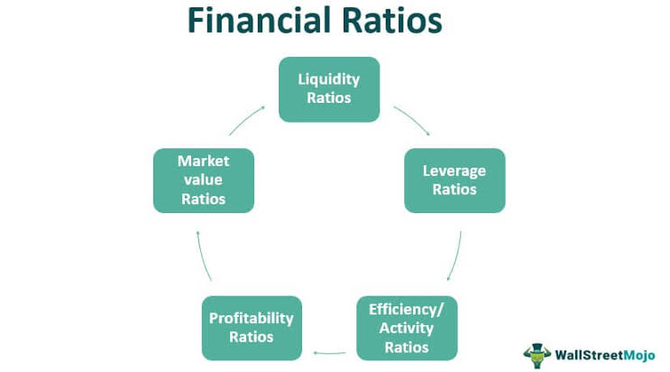

Financial ratio analysis helps to find out easily their financial statement in money market. The analysis of ratio helps to take decision for shareholders; investors and their employees for make decision among their position. Financial ratios conclude with some part like Liquidity ratio, profitability ratio, efficiency ratio and market value. This kind of part is given actual decision maker. This types of ratio have given all part of position.

Liquidity Ratios describe the capability of the firm to manage its current obligations. That means whether the firm has the sufficient liquid assets to pay off its short-term liabilities. The higher the liquidity ratios, the higher the firm’s abilities to absorb the obligations.
Efficiency Ratios are the base rations to measure how efficient the firm is to manage its assets in the business. The firm has assets to run the business and how much the firm is improving to handle the assets in the business is the key concern of the efficiency ratios,
Profitability Ratios represent the outcome of the business performances. It tells us how firm generates the earnings from the business. Profitability ratios reflect the ability of the firm to produce earnings from its operations. If the firm is efficient then it will have the ability to generate more earning from the business and the greater is the degree of the performances.

Solvency ratios focus on the debt burden aspects of the firm. It measures the extent of the borrowed funds that the firms use in the business as well as its capacity to satisfy the borrowed funds obligations. The debt-to-equity ratio and debt ratios are two fundamental ratios are under solvency dimension.

Market Ratios try to link the firm’s business performances with the market response. That means how the market recognizes the performances and represented in the market outcome. The common marker ratios are earnings per share, price-to-earnings ratio etc.

Chapter 4:
Financial Analysis

Ratio Analysis

4.1 Liquidity Ratio

Liquidity ratio measures the bank’s ability to satisfy its current obligations. That means how quickly bank can meet up its short-term liabilities.
- Current Ratio
The most common liquidity ratio to measure the short-term obligation is current ratio. The ratio can be calculated as:
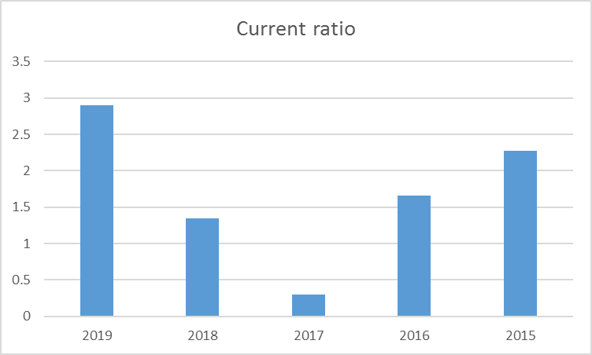

Particular | 2019 | 2018 | 2017 | 2016 | 2015
Current Ratio of JBL | 2.900 | 1.348 | 0.2966 | 1.662 | 2.272

It helps for investors to know about the ability of an organization to meet up its short term debt over current assets. The current ratio for Jamuna bank increases over the years. The bank’s ability to satisfy the short-term obligations remains good for the bank.

- Cash Ratio
Cash ratio is a part of liquidity. It is more relevant liquidity measure. It measures the ability of cash with their current liabilities into their cash or its equivalent. Cash ratio gives an idea to pay their short term debt with cash resources.
Cash Ratio= Cash/Current Liabilities
Year | 2018 | 2017 | 2016 | 2015 | 2014
Ratio | 0.004 | 0.019 | 0.0357 | 0.012 | 0.64

The above ratio shows that bank’s ability to pay the current obligation in terms of cash is very negligible and remains steady over the years except 2014.
- Net Working Capital to Total Asset
The net working capital to total assets measures the liquidity against whatever assets the bank has. This ratio gives the idea about how you can use for over the year. It is calculated:
Net Working Capital to Total Asset = Net Working Capital/Total Assets
Year | 2018 | 2017 | 2016 | 2015 | 2014
Ratio | 0.109 | 0.153 | 0.149 | 0.054 | 0.306

We can see that after satisfying current liabilities the bank has sufficient current assets against the total assets. This means overall Jamuna bank has enough cash flows to satisfy its current obligations.

4.2 Solvency Ratio

Solvency ratio measures the debt short or long term obligations. Totally we said it meet the debt obligations. It helps to justify satisfying long-term obligation. It becomes high and low with their performance. Low solvency ratio indicates on its debt obligations. We calculated this kind of ratios:

- Total Debt Ratio
- Debt-equity Ratio
- Equity Multiplier
- Long-term Debt Ratio
The debt ratio a company measures the organizations overall leverage. How the organization meets up their total position of total debt over their total assets.
Debt Ratio = $\frac{Total Debt}{Total Assets}$

Year | 2018 | 2017 | 2016 | 2015 | 2014
Ratio | 0.530 | 0.502 | 0.467 | 0.402 | 0.363

The debt ratio indicates that the bank has reasonably low borrowed funds used to finance its total assets and the trend remains same over the year which is good for the firm.
- Debt – Equity (D/E) Ratio
Total debt equity ratio helps to measure the total debt reflected the own funds. They meet up their overall development for a company with their remain fund. What they use for their own purposes.
D/E Ratio = $\frac{Total Debt}{Total Equity}$

Year | 2018 | 2017 | 2016 | 2015 | 2014
Ratio | 1.126 | 1.007 | 0.875 | 0.672 | 0.0571

The calculated data we can easily track the level of debt compared to equity funds. We can say the ratio is high for recent years. There have high ratio means more risk for creditor and their investors. But low ratio means the bank was financially more stable.
.
Equity Multiplier
The equity multiplier ratios can measure their organizations position with their assets and the shareholders equity. Its giving the idea about the position of total assets under their equity .
Equity Multiplier = $\frac{Total Assets}{Total Equity}$
Year | 2018 | 2017 | 2016 | 2015 | 2014
Ratio | 2.126 | 2.007 | 1.875 | 1.672 | 1.571

The overall equity multiplier is giving idea with their total assets and their equity. High equity multiplier indicates the extent of financial leverage for a bank. So we see from the calculation part in the recent year their ratio chart is goes higher. That's way it is sometimes better for a bank. If it goes down they need to more care about their recent position and make sure it is risk free investment for a bank.
- Long – Term Debt Ratio
The long-term debt to total asset ratio is simply cover up their oveall all long term debt with their equity for a organizations. Long term debt ratio covers up sing with their short term obligations.
Long – Term Debt Ratio = $\frac{Long-Term Debt}{Long-Term Debt+Total Equity}$

Year | 2018 | 2017 | 2016 | 2015 | 2014
Ratio | 0.223 | 0.262 | 0.234 | 0.229 | 0.043

From the ratio analysis part of long term debt ratio we an see the data from 2015 to 2016 simply increasing. In the year of 2017 it was also high from past year so we can told about it was more increasing part year by year. It was good sign for a bank. High long term ratio is better for the bank.

4.3 Efficiency Ratio

The efficiency ratio is an important part for an organization to know about the day-to-day activities. It is important to calculate for giving you an idea how organizations manage their assets and liabilities. It becomes more efficient to know how they use the resources and manage it. It measures the turnover over the receivables of their payment. And it makes the liabilities of a Organization and general use of their inventory and machinery.
Operating Efficiency measures the bank efficiency in handling the operating expenses relative to total assets. The lower this ratio, the higher is the efficiency of the bank.
Operating Efficiency ratio = Total operating expenses/Total assets

Year | 2018 | 2017 | 2016 | 2015 | 2014
Ratio | 2.31 | 2.11 | 1.335 | 1.45 | 1.63

The operating efficiency ratio slightly increases over the recent years indicates that the bank had to incur higher operating expenses against its assets.

- Total Asset Turnover Ratio: Asset turnover measures by the total credit sales of company compared with their total asset. How actually they gain from market.

- Total assets turnover=Revenues/Total assets
Year | 2018 | 2017 | 2016 | 2015 | 2014
Ratio | 0.49 | 0.46 | 0.25 | 0.23 | 0.28

It is easily clear about the analysis that high turnover ratio is always better for organizations. They meet up to turn the assets into revenues more efficient ways.. The higher the ratio, the better is the performance of the bank.
- Overhead Rate: The overhead ratio is measures from the overhead costs of organizations and their overall sales over the year. Understand their cost is higher their sales or not.
- Overhead Rate= Overheads/Revenue
Year | 2018 | 2017 | 2016 | 2015 | 2014
Ratio | 0.066 | 0.019 | 0.010 | 0.012 | 0.0325

The overhead ratio can measure their overall position in the market they are actually related their production goods and Service. But ratio means they are not related with production but they need to improve their total overhead ratio and adjust with good and service with their production.

- Cost of Fund: Cost of funds is a measure about the percentage of interest paid for their total use of the funds in the market. It is calculated as:

Cost of Fund = Interest Expense/Total Asset
Year | 2018 | 2017 | 2016 | 2015 | 2014
Ratio | 0.043 | 0.045 | 0.0385 | 0.0186 | 0.0500

The cost of funds actually tells us to know about the profit or loss for the organizations. They need to understand this rate to go for investment in the market. High cost of fund is better for grow capture the market. If low they need to capitalize their resources and gain the position.

4.4 Profitability Ratio
The ratio of profitability gives idea about the organizations how they pay attention on their profit gain and take strong position in the money market. The profitability ratio helps to identify about the earnings per share with their respect to sales and assets. Sales of their organisations help to adjust their owners investment. The higher the profitability ratios, the better would be the ability of the bank to generate more earnings from the banking operations. The ratios are described below.
- Profit Margin: It is a ratio to measure the bank profitability.It measures how much net income bank generates against the per taka revenue. The formula for net profit margin is given:
Profit Margin = Net Income / Net Sales (revenue)
Year | 2014 | 2015 | 2016 | 2017 | 2018
Ratio | 0.1721 | 0.1726 | 0.1831 | 0.2456 | 0.2501

It can clearly observed that the net profit margin remains stable for the bank over the recent periods.

- Return on Asset (ROA):
The two primary profitability ratios for any organization can be identified as return on assets and return on equity. The return on assets can be calculated as:
ROA=Net income/ Total assets

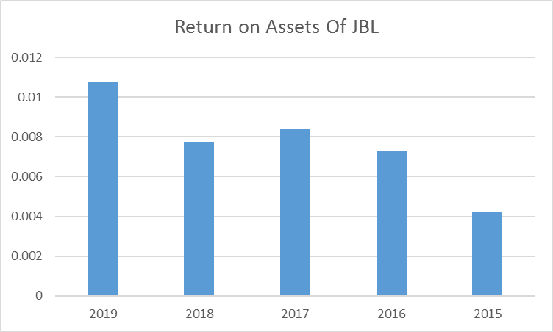

Particular | 2019 | 2018 | 2017 | 2016 | 2015
Return on Assets Of JBL | 0.0107 | 0.0077 | 0.0083 | 0.0072 | 0.004

The return on assets ratio is higher for the recent periods indicate that the bank produces more earning against the investment in assets. Although the return increase in most recent years but it remains very small for the bank.
- Return on Equity (ROE): The return on equity is calculated the part of net income over their shareholders equity investment in organization. It tells about how much profit the bank earns for its shareholders.
Return on Equity = Net Income/Shareholder's Equity
Year | 2018 | 2017 | 2016 | 2015 | 2014
Ratio | 0.04176756 | 0.02990724 | 0.01352337 | 0.02002270 | 0.05009186

The return on equity is also improved over the recent years means that bank earns more return for its shareholders which is good.
- Operating margin Ratio:
Operating margin ratio is the operated with their Total net income of a Organization with measures the net sales actually over the year.
Operating Margin ratio = Net Income / Net Sales
Year | 2018 | 2017 | 2016 | 2015 | 2014
Ratio | 0.04164789 | 0.03345408 | 0.02886328 | 0.01371604 | 0.03205597

The higher the net profit margin ratio, the better the performance of the company. We can see that in terms of net profit margin 2015 was the worst year, because the net profit margin is 1.37% which is comparatively lower than other four years which is not a good sign .In terms of net profit margin the best year for the bank was 2018, the ratio was 4.06%.

4.4 Market Value Ratio

Market value ratios are the measures to understand about the market performance and know about the current share price of the bank. .These market value ratios are giving the idea about whether the share price is overrated or underrated. These ratios are the very important for the investors to know about the bank performances.
Price Earnings Ratio
The price earnings ratio (P/E ratio) is determined about their total value of the market per share over the earnings per share from the money market. It indicates about their total share of price actually earn from the market. It’s give idea about how fluently run market. The formula of p/E ratio given.
Price earnings ratio = Price per share/earnings per share
Year | 2018 | 2017 | 2016 | 2015 | 2014
Ratio | 20.4081633 | 30.3030303 | 25.6410256 | 35.7142857 | 13.6986301

We know that the whole things see the ratio is high means their value of the share is overrated . So we can see when the share price is high it is not good.in the year of 2014 they maintain share is underrated. So organizations should maintain and keep up the market.

- Dividend Payout Ratio
These dividend payout ratio measures the total dividend paid for the stockholders out of the net earnings that the bank generates. It gives you about the position under the market value ratio.The formula of calculated ratio is here.
Dividend Payout Ratio = Dividend Paid/Net Income
Year | 2018 | 2017 | 2016 | 2015 | 2014
Ratio | 1.02040816 | 1.51515152 | 1.28205128 | 1.78571429 | 0.68493151

We can see the information of the dividend payout of an organizations. High dividend payout is better for organizations. In the ratio is on good so easily called about organizations is on a good position over their market value.
- Book Value Per Share
This ratio of book value per share can measures their total equity over the year difference with their preferred equity compare their total shares outstanding over the year. The formula is given for understand the value of the share and determine their position.
Book Value per Share = (Total Equity-Preferred Equity)/Total Shares Outstanding

Year | 2018 | 2017 | 2016 | 2015 | 2014
Ratio | 19.0992732 | 19.5461371 | 19.4950259 | 19.1087722 | 19.7825381

After complete the ratio analysis we can see high rate means their liquidation per share is easily occur. So we can tell about the organizations maintain their position over their market.
Retention Rate
The retention rate of an organizations measures from difference between net income and dividends distributed after compare with Net income over the year. It indicates about how much the bank retains for the further investments.
Retention rate = (Net Income-Dividends Distributed)/Net Income
Year | 2018 | 2017 | 2016 | 2015 | 2014
Ratio | 18.6177658 | 29.155168875 | 24.3533425 | 33.0246013 | 13.3796874

It is clear that the retention ratio is fluctuating for the bank over the years. This indicates that bank has a varying policy to retain its earnings for further investments.

Chapter 5:

Findings & Conclusion
5.1 Major Findings

- Their findings of the report after calculation part. Jamuna Bank Ltd current ratio is more or less remains stable in recent year. Higher current ratio is better for the organizations. Help ti holding higher position.
- The debt ratios indicate that Jamuna bank does not have excessive borrowed funds in the business. It means financial leverage remain moderate for the bank.
- Profit margin ratios in good percentage in 2018. So the meaning is best for the organizations. Lower is bad. Not growth up for their industry.
- Operating efficiency ratios remain relatively steady over the years.
- Return on Asset and return on equity are increasing over the years though rate becomes small..
- Price earnings ratio becomes lower in most recent period that is lucrative for investment perspective
- Retention ratio is changing indicating that bank follows different investment policy.
- Net income to total operating income gives the recent value of analysis part is too low than others years. So i can say their recent year income was low compared their total assets.

5.2 Conclusion

The banking sector in Bangladesh is saturated and getting highly competitive day-by-day. The Jamuna Bank Ltd is 3rd generation bank in this industry. In the report I analyzed the financial performance of the Jamuna Bank Limited. Ratio analysis has been conducted to assess the overall performances of the bank.
Liquidity ratios found stable over the period indicate that Jamuna bank has the sufficient current resources to satisfy the short-term obligations. Operating efficiency ratios reveal that bank was consistent to utilize its assets in the business. The interesting finding can be observed from the solvency ratios that bank does not have large amount of borrowed funds in the business. Findings document that financial leverage was not high over the years analysis. We can find out that bank’s ability to generate the earnings from operations increasing over the years which was evidenced by the two major profitability ratios retrun on assets and return on equity. It can be concluded that although the rate of return was small but Jamuna maintained a consistent operating performances over the years.

References
http://Jamuna Bank Limited
http://Annual Report of 2013-2018
http://Ratio Analysis Classification

