Procurement and Accounts & Finance Operations at
United Medical College

Nowshin Anjum

This report is submitted to the School of Business and Economics, United International University as a partial requirement for the degree fulfillment of Bachelor of Business Administration

Internship Report on
Procurement and Accounts & Finance Operations at United Medical College
Submitted to: Dr. Md. Shariful Alam
Professor, School of Business & Economics (SOBE), United International University

Submitted by:
Nowshin Anjum
Id:111 212 033
Major: Supply Chain Management
Trimester: Fall 2025

School of Business and Economics
 United International University

Date of submission: 10th March, 2026

Letter of transmittal
Date: 10th March
To
Dr. Md. Shariful Alam
Professor
United International University
Subject: Internship Report on "Internship Report on Procurement and Accounts & Finance
Operations at United Medical College"
Dear Sir,
With due respect, I would like to submit my internship report titled "Internship Report on Procurement and Accounts & Finance Operations at United Medical College" as a partial requirement for the Bachelor of Business Administration (BBA) program with a major in Supply Chain Management at United International University.
This report is based on my internship experience at United Medical College under the Procurement section of the Accounts & Finance Department. It highlights the organization's procurement practices, including supplier selection, quotation collection, vendor evaluation, purchase order (PO) issuance, and documentation, along with coordination between the procurement, finance, and accounts departments.
The report also describes my roles, responsibilities, and learning experiences, and how I applied my academic knowledge in a real organizational setting. I have prepared this report sincerely following your guidelines and academic requirements. I hope the report meets your expectations.
I would be grateful for your kind evaluation and remain available for any further clarification if required.Sincerely,
Nowshin Anjum
ID: 111 212 033

Certification of similarity index

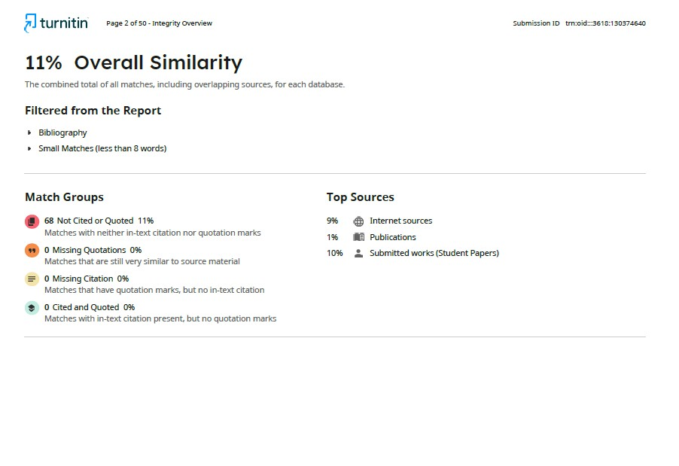

Declaration of the student

I, hereby declare that the internship report entitled "Internship Report on Procurement and Accounts & Finance Operations at United Medical College" An Internship Experience has been prepared by me, Nowshin Anjum; ID: 111 212 033 as a partial requirement of the Bachelor of Business Administration (BBA) degree in the United International University.
I further declare that this report is an original work as a result of practical experience and observations acquired during my internship at United Medical College. The information and data provided within this report have been gathered from real sources and through hands-on experience in the organization.
I am confirming that this report has not been submitted to any other university or institution for the award of any degree, diploma or certificate. All source of information used in preparing this report have been properly acknowledged.

Nowshin Anjum
ID: 111 212 033
BBA Program
United International University

Acknowledgement

At the very beginning, I would like to give my sincere thanks to Almighty Allah for giving me strength and ability to complete this internship report successfully.
I would like to present my deepest respect and heartfelt thanks to Dr. Md. Shariful Alam, Professor, School of Business & Economics, United International University, for his precious guidance, continuous supervision, constructive feedback and motivation throughout the preparation phase of this report. His insightful suggestions helped me a lot to conduct this study in a systematic and effective way.
I also wish to express my sincere gratitude to the Management and Co-workers of United Medical College for giving me a chance to complete my internship in their organization. I would like to express my special thanks to my supervisor and team members for their cooperation, support and guideline during my internship period. Their practical insights and professional help allowed me to learn highly valuable knowledge about the practices of logistics management.
Finally, I will like to express my gratitude to my family and well-wishers for their constant support, inspiration, and motivation throughout my academic journey.

Executive Summary
This report is a presentation of my internship at United Medical College, where I was working in the Procurement section in the Accounts and Finance Department. The internship was undertaken as the partial requirement for the Bachelor of Business Administration (BBA) program with major in Supply Chain Management from United International University. The primary goal of this report is to introduce the practical knowledge that was acquired in the internship program and how the theoretical knowledge was utilized for the practical activities in the organization. The report primarily focuses on the procurement practices followed by the organization and details the structured purchasing system of the institutional reports. During my internship, I observed and assisted in some major procurement process like Supplier Selection and Quotation Collection, Vendor Evaluation and Selection, Purchase Order (PO) Issuance, Work Order Preparation and proper Documentation and Record keeping. These processes are critical to ensuring that efficiency, transparency, and accountability are maintained in the procurement activities. The report also highlights the coordination from the Procurement unit and the Accounts and Finance Department in the area of proper financial control and smooth functioning of the purchasing process. Throughout the internship period, I was actively participated in supporting various purchase daily and financial work. My responsibilities involved gathering quotes from various suppliers, preparing comparative statements for consideration and working with vendors under supervision. I was also involved in supporting Purchase Orders (POs) and Work Orders preparation ensuring that required approvals were taken and documents maintained. These activities helped me understand the practical knowledge of procurement procedures, management of suppliers and internal control systems. In addition to procurement duties, I also helped with several accounting and financial reporting activities. I supported in the preparation of tuition fee collection reports and penalty fee collection reports keeping accuracy in data entry and financial calculations. I also helped organize and review financial documents which helped me gain a better understanding of accounting practices and financial documentation procedures. Overall, the experience involved in this internship helped in bridging the gap between what I had learned in my academics and to apply this knowledge in a professional setting. I developed important professional skills such as analytical thinking, attention to detail, communication, teamwork, time management and maintaining confidentiality in financial matters. This report is a summary of my roles, responsibilities, and key learning outcomes in my internship at United Medical College.

Table of contents for Internship
Table of Contents
Letter of transmittal 1
Certification of similarity index 2
Declaration of the student 3
Acknowledgement 4
Abstract/ Executive summary 5
Table of contents for Internship 6
List of Acronyms and Abbreviation 8
CHAPTER I: INTRODUCTION 9
I.1 Overview and Background of the Report 9
I.2 Purpose and Objectives of the Report 10
I.3 Data Collection Method 11
I.4 Limitations of the Report 12
CHAPTER II: COMPANY AND INDUSTRY PREVIEW 13
2.1 Company Analysis 13
2.1.1 Company Background and History 13
2.1.2 Market Trend and Growth Pattern 15
2.1.3 Customer Segmentation 17
2.1.4 Product and Service 18
2.1.1 Operational Procedure 22
2.1.2 SWOT analysis 24
2.2 Industry analysis 26
2.2.1 Specification of the industry 26
2.2.2 Size, Trend, and Maturity of the industry 27
2.2.3 External economic factors 29
2.2.4 Barriers to Entry 29
2.2.5 Supplier Power 30
2.2.6 Consumers Power 30
2.2.7 Threat of Substitutes 31
2.2.8 Industry rivalry 31
CHAPTER III: INTERNSHIP EXPERIECNE 32
3.1 Position, duties, and responsibilities 32
3.2 Orientation and Training Experience 33
3.3 Contribution to Departmental Functions 33
3.4 Performance Evaluation 34
3.4 Practical Skills Utilized 35
3.6 New skills developed 37
3.7 Application of academic knowledge 38
CHAPTER IV: CONCLUSIONS AND KEY FACTS 39
4.1 Suggestions of Improving Departmental Efficiency 39
4.2 Major Learnings and Insights 40
4.3 Final Remarks 41
Reference 42

List of Acronyms and Abbreviation

MBBS | Bachelors of Medicine & Bachelors of Surgery
SCM | Supply Chain Management
UMC | United Medical College
HSC | Higher Secondary Certificate
MOHFW | national regulatory bodies of the ministry of Health and  Family Welfare
SOPs | Standard Operating Procedures
DGHS | Directorate General of Health Services
GDP | Gross Domestic Product
R&D | Research and Development
EMI | Equated Monthly Installment
BMDC | Bangladesh Medical and Dental Council
PL | Packing List
ERP | Enterprise Resource Planning
AWB | Air Waybill
PI | Proforma Invoice
CI | Commercial Invoice
COO | Certificate of Origin
PO | purchase order
CS | Create comparative statements

CHAPTER I: INTRODUCTION

I.1 Overview and Background of the Report

As a compulsory requirement of Internship Program at United International University, this report has been prepared on the basis of my internship experience in United Medical College, a renowned medical education institution of Bangladesh. The internship project was completed to fulfill partly the requirement of the Bachelor of Business Administration (BBA) degree.
In the healthcare and education sector nowadays, efficient administrative management, proper documentation, financial control, procurement of medical equipment and supplies, academic coordination are the key for smooth functioning of the institutions. A medical college functions under a coherent administrative structure which encompasses an integration of academic, procurement, financial and hospital coordination functions for the provision of quality education and clinical training.
This report provides a detailed report of administrative and operational activities of United Medical College, and special focus has been paid on activities like documentation management, procurement procedures, financial coordination, and inter-departmental communication. It also relates to my hands on involvement in keeping the records, helping in procurement documentation, support with finance related tasks and coordination with academic department.
Through this report, I have gained practical exposure to a professional healthcare education environment and highlighted the contributions that structured administrative systems have toward the efficient environment of the institution as a whole.

I.2 Purpose and Objectives of the Report

The major aim of this internship report is to attain a detailed knowledge of the administrative and operational procedures followed by United Medical College. The purpose of the internship was to fill the information gap regarding the disparity between knowledge acquired in school business administration and its application in medical education against practice in a medical education institution.
Through the structured assignments under the administrative department, I obtained hands-on experience with documentation handling, procurement coordination, financial record management and departmental communication.
Specific Objectives:
- To know the administrative pattern and the working procedure of a medical education institution.
- To examine procurement process of medical supplies, equipment and academic material.
- To see financial documentation, billing and record keeping processes.
- To understand mandate requirements related to healthcare and education regulations
- In order to investigate the practices of coordination between academic, procurement and finance departments;
- To assess physically and digitally within institutional systems of record-keeping system.
- To identify operational problems and propose efficiency improvements.
- To understand the support of effective communication to the performance of the institution.

I.3 Data Collection Method
This report is conducted following a mixed method approach using both primary and secondary data.
Primary Sources:
- Direct supervision from administrative officers.
- Participation in documentation, procurement follow-up and maintenance of financial records.
- Observation of academic co-ordination and administration meetings.
- Conversations with the people working in the financial and procurement departments. Secondary Sources
- Institutional policy documents and administrative guidelines. Most procurement records and financial documentation samples.
- Academic texts, and journals pertaining to administration and operations management.

Secondary Sources:
- Internal documents such as trade document samples (PI, CI, COO, AWB, and PL) compliance guidelines.
- Company policies, and SOPs for logistics
- Academic textbooks and online articles and journals concerning international trade and supply chain management.
- Relevant regulatory and banking guidelines concerning import procedures
These sources ensured a good understanding of the theoretical concepts as well as the practical implementation of the same in a multinational corporate environment.

I.4 Limitations of the Report

Despite taking genuine attempts to give a detailed analysis on the processes of logistics and supply chain, the internship had some limitations which are as follows:
- Confidentiality restrictions imposed for sensitive financial and student records.
- The internship period was on the shorter side.
- Limited exposure to high-level strategic decision-making process
- Certain operational areas of the hospitals were limited to interns.
Despite all of these limitations, the report reflects practical insights gained from working within the administrative framework of United Medical College.

CHAPTER II: COMPANY AND INDUSTRY PREVIEW

2.1 Company Analysis

2.1.1 Company Background and History

United Medical College
United Medical College (UMC) is a reputed and prestigious private medical institution in Dhaka, Bangladesh. The college was founded with the vision of providing outstanding medical education and creating competent, ethical and skilled healthcare professionals who can serve both the nation and the international healthcare sector.

Background
United Medical College is performing its academic activities under the academic affiliate of the University of Dhaka, which determines that the academic curriculum, examination system and degree standard of the institute is well-suited according to the national regulations. The institution is also recognized by Bangladesh Medical and Dental Council (BMDC), the statutory body incharge of regulating the medical education and practice of Bangladesh.
The college is closely associated with United Hospital Limited which is one of the top private hospitals in the country. This robust hospital affiliation can give students extensive clinical exposure and hands-on training in a modern medical care facility with cutting-edge medical technology.

History and Development
United Medical College came up in 2013 with the overall healthcare and education initiatives of United Group. Since its inception the institution has been focused on maintaining international norms of medical education, infrastructure and clinical education.
Over the years, UMC has developed modern academic facilities such as well-equipped laboratories, digital classrooms, libraries and research resources. The integrated teaching approach integrates both theoretical learning and practical clinical experience, making sure that students acquire the real-world medical competence. The college has slowly increased in size with regard to its academic activities, faculty strength and its students while keeping its dedication to academic excellence, ethical medical practice and community healthcare service.



Mission and Vision
The main mission of United Medical College is to:
- Provide quality medical education in accordance with global standards.
- Develop competent and sympathetic medical personnel.
- Promote research, innovation and community health awareness.
- Contribute to the improvement of the national healthcare system.
Through its belief in high-quality education, clinical training, and research, United Medical College continues to grow farther in its trajectory as a reputed private medical institution in Bangladesh.

2.1.2 Market Trend and Growth Pattern

- Recent Establishment and Expansion: United Medical College is a new establishment (around 2019-2020) and its mission was to produce qualified doctors who would be applicable both to the society of Bangladesh and internationally to meet healthcare challenges. Despite its young age compared to other long-standing medical institutions, UMC has already taken quite a few batches of MBBS students and has plans to increase the academic offerings further.
- Infrastructure and Campus Development: UMC's permanent campus is at United City, Dhaka with ongoing construction of a modern academic building with an attached teaching hospital. The development of the fully-equipped campus and future hospital facilities reflects a trajectory of growth that is focused on improving the educational infrastructure as well as clinical training capacity over time.
- Increasing Enrollment, Inclusion of a More Diverse Student Body: UMC has admitted a number of batches of MBBS students from wide areas of background, that is a sign of growing and stable demand of medical program. The institution also intends to enroll more foreign students in its courses and have a broader market reach outside Bangladesh.
- Academic Recognition and Quality Focus: UMC is approved by national regulatory bodies of the ministry of Health and Family Welfare (MOHFW), Directorate General of Health Services (DGHS), Dhaka University, and Bangladesh Medical & Dental Council (BMDC). Continued efforts to meet international standards (e.g., seeking listing in the WHO World Directory of Medical Schools and registration with medical councils abroad) represent a growth trend towards international academic recognition and quality assurance.

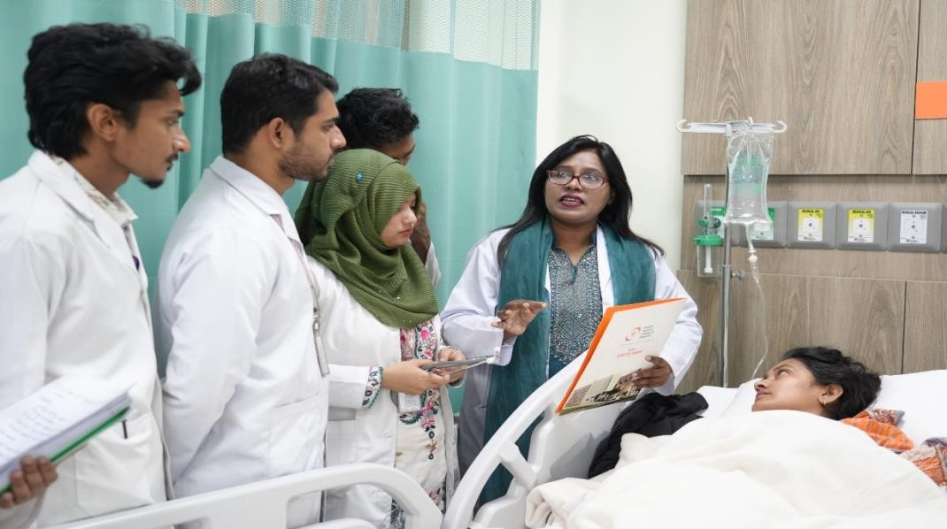
- Market Dynamics of Medical Education: The medical education industry in Bangladesh is booming in response to high demand for qualified doctors, the shortage of places in the public medical college system, and thus, more entrants to private medical colleges such as UMC. Bangladesh is considered as a cheap but quality learning destination for MBBS education which is attracting local and foreign students who are drawn to the low cost of education in Bangladesh, especially in neighboring countries where the education costs are comparatively high.
- Competitive Position: Private medical colleges in Bangladesh have a competition on the basis of maintenance of infrastructure, clinical exposure, international exposure, and affordability. UMC's emphasis on creating excellent facilities, veteran faculty, and a clinical teaching hospital place it favorably to compete in this environment.
- Future Market Trends: Movement for demand of medical education continues as the population and healthcare demand increase in Bangladesh. UMC's strategy to attract international students and the pursuit of global recognition is consistent with wider trends of internationalization of medical education.
As there is growing public awareness in terms of quality private medical colleges, there will be continued admissions growth and widening of academic programs at institutions such as that of UMC over the next decade.

2.1.3 Customer Segmentation

Customer segmentation involves segmenting the target market into different groups on the basis of some characteristics such as demographics, geography, behavior and needs. For United Medical College (UMC), the customer segmentation primarily revolves around the prospective students, their guardians and other stakeholders involved in the education of medicine.

1. Demographic Segmentation
- Age Group: Mainly students between 17-22 years who have passed Higher Secondary Certificate (HSC) or its equivalent. Graduate applicants who wish to pursue medical education as a second career path (limited cases).
- Educational Background: Students from Science background (Biology, Chemistry, and Physics). Candidates that meet in medical admission requirements set by regulatory authorities.
- Income Level: Middle-income families and upper middle-income families. High-income families preferring private medical education because of the limited places in the public institutions.

2. Geographic Segmentation
- Domestic Students: Students from Dhaka city and urban surroundings. Applicants from different districts of the country Bangladesh.
- International Students: Students coming from adjacent countries like India, Nepal and other South Asian countries, African countries (subject to regulatory approval).
UMC is located in Dhaka and hence readily accessible and attractive for urban students who are looking for quality medical education.

3. Psychographic Segmentation
- Career-Oriented Students: People with a very high motivation to become a professional in the field of medicine. Students intending to pursue higher studies abroad (e.g., postgraduate specialization).
- Quality-Focused Families: Guardians that care more about institutional reputation, clinical facilities and academic excellence. Families who prefer colleges that are affiliated to reputed universities and famous hospitals.
- Socially Motivated Students: Students with motivation to serve the society and contribute towards the development of healthcare.

4. Behavioral Segmentation
- Admission Seekers after Attempting Exam Publicly: Students that could not get their place in public medical colleges and opt for good private institutions.
- Applicants that have brand sensitivity: Students affected by the hospital affiliation of the college, the faculty profile, and graduate success rate.
- Value Based Decision Makers: Families doing pre-enrollment comparison of tui􀆟on fees, facilities, the quality of internships, and clinical exposure before making decisions about enrollment.

5. Stakeholder Segmentation
Besides students, UMC also serves:
- Guardians/Parents - Most important decision makers in enrollment population.
- Healthcare Institutions - For Internships and clinical collaboration.
- Regulatory Bodies - Such as Bangladesh Medical and Dental Council and Affiliated University.
- Alumni Network - Former students helping reputation and referrals.

2.1.4 Product and Service

The Product and Service of United Medical College (UMC) is comprised of academic program, clinical training services, student support services and academic development activities designed to ensure comprehensive medical education and professional growth.

1. Core Product - Academic Programs
a) MBBS Program: Bachelors of Medicine & Bachelors of Surgery (MBBS) degree. Curriculum as evaluated by Bangladesh Medical and Dental Council (BMDC). Academically linked with the University of Dhaka. Structured academic program with 5 years, followed by 1-year obligatory internship. This is the main and Flagship Offering of the institution.

2. Clinical Training Services
- Hospital Based Clinical Education:
Practical Training carried out in collaboration with United Hospital Limited. Exposure to actual patent care in departments such as Medicine, Surgery, Gynecology & Obstetrics, Pediatrics and others. Hands on learning under the supervision of senior consultants and consultants.
- Internship Program: One-year compulsory internship program. Rotational training of major clinical departments. Focus on the practical aspects of skill development, diagnosis, patent management and professional ethics

3. Academic Support Services
- Advanced Facilities for Learning: Well-equipped laboratories (Anatomy, Physiology, Biochemistry, Pathology etc.). Lecture before halls with multimedia Digital and physical Library Resources. Simulation and demonstration rooms for skill-based training.
- Research and Scholarly Activities: Seminars, workshops and medical conferences. Student research opportunities and engagement with scientific publishing. Academic mentoring/faculty guidance.

4. Student Support Services
- Admission and Counseling Assistance: Information during admission process. Orientation programs for newly-admitted students.
- Accommodation Facilities: Hostel Facilities (subject to Availability). Secure and Supportive Campus Environment.
- Career Guidance: Support for post graduate studies and specialization pathways.
Internship placement advice, and preparation work for licensing exams.

5. Value-Added Services
- Professional development training (communication skills, ethics, leadership).
- Community health camps and outreach programs.
- Extracurricular and co-curricular Activities for holistic development.
- Alumni engagement and networking opportunities.

B. Service Portfolio
The Product and Service Portfolio of United Medical College (UMC) is comprised of academic program, clinical training services, student support services and academic development activities designed to ensure comprehensive medical education and professional growth.

1. Core Product - Academic Programs
a) MBBS Program: Bachelors of Medicine & Bachelors of Surgery (MBBS) degree. Curriculum as evaluated by Bangladesh Medical and Dental Council (BMDC). Academically linked with the University of Dhaka. Structured academic program with 5 years, followed by 1-year obligatory internship. This is the main and Flagship Offering of the institution.

2. Clinical Training Services
- Hospital Based Clinical Education:
Practical Training carried out in collaboration with United Hospital Limited. Exposure to actual patent care in departments such as Medicine, Surgery, Gynecology & Obstetrics, Pediatrics and others. Hands on learning under the supervision of senior consultants and consultants.
- Internship Program: One-year compulsory internship program. Rotational training of major clinical departments. Focus on the practical aspects of skill development, diagnosis, patent management and professional ethics
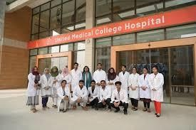

3. Academic Support Services
- Advanced Facilities for Learning: Well-equipped laboratories (Anatomy, Physiology, Biochemistry, Pathology etc.). Lecture before halls with multimedia Digital and physical Library Resources. Simulation and demonstration rooms for skill-based training.
- Research and Scholarly Activities: Seminars, workshops and medical conferences. Student research opportunities and engagement with scientific publishing. Academic mentoring/faculty guidance.

4. Student Support Services
- Admission and Counseling Assistance: Information during admission process. Orientation programs for newly-admitted students.
- Accommodation Facilities: Hostel Facilities (subject to Availability). Secure and Supportive Campus Environment.
- Career Guidance: Support for post graduate studies and specialization pathways. Internship placement advice, and preparation work for licensing exams.

5. Value-Added Services
- Professional development training (communication skills, ethics, leadership).
- Community health camps and outreach programs.
- Extracurricular and co-curricular Activities for holistic development.
- Alumni engagement and networking opportunities.

2.1.1 Operational Procedure

The operational procedure of United Medical College (UMC) means the orderly process by which the institution administers the academic functions, administrative functions, clinical training and the services to the students in order to ensure smooth and efficient operations.

1. Admission Process
The examination procedure of the admission is carried out following guidelines from the Government of Bangladesh and Bangladesh Medical and Dental Council (BMDC).
Steps include:
- Publication of advertisement for admission on the basis of the national medical admission policy.
- Application submission-using centralized medical admission system.
- Selection on the basis of merit (admission test score and academic results).
- Checking of documents and eligibility criteria.
- Enrollment and registration of study under the University of Dhaka - final

2. Academic Operations a) Implementation of the Curriculum
- Following and teaching MBBS curriculum as approved by BMDC.
- Academic calendar prepared yearly.
- Division of subjects into pre-clinical, para clinical and clinical phases

b) Teaching Methodology
- Lectures/Tutorials/Practical Laboratory Sessions.
- Problem based learning (PBL), case discussions.
- Continuous evaluation in form of class tests, item exams and exams of professional.

c) Examination System
- Internal assessments as and when it is needed.
- Professional examinations conducted under the University of Dhaka.
- Results evaluation and publication according to regulations of the university.

3. Process of Training for Clinical Practice
UMC offers clinical education through this affiliation with the United Hospital Limited.
Clinical operational steps:
1. Departmental Rotation Schedule Preparation 2. Allocation of students to clinical supervisors.
- Bedside teaching & case presentation.
- Maintenance of log books and records of performance.
- Evaluation by clinical exams and viva voce.

4. Internship Management
- One-year compulsory internship at the end of the 5 years of MBBS program.
- Rotational posting in major departments (Medicine, Surgery, Gynecology & Obstetrics, Pediatrics etc.).
- Supervision of monitoring by hospital supervisors and internship's committee.
- Issuance of completion certificate of internship for satisfactory performance.

5. Administrative Operations a) Student Administration
- Upkeep of student records & attendance keeping.
- Academic counseling and management of discipline.
- Issuing transcript, certificates and official documents.

b) Faculty Management
- Recruitment based on BMDC standards.
- Faculty evaluation and professional development programs.
- Regular academic meetings; departmental coordination.

c) Financial Operations
- Tuition fee collection and financial record keeping.
- Budget formulation and allocation of academic and infrastructural developments.

6. Quality Assurance and Compliance
- Meeting BMDC and university regulations.
- Internal Academic audits and monitoring.
- Feedback collection from both students and faculty.
- Continual improvement of teaching standards and clinical standards.

2.1.2 SWOT analysis

SWOT Analysis of both internal and external forces, including the strengths and weaknesses of an organization and the external opportunities and threats facing the organization. For United Medical College (UMC), the SWOT analysis is the following:

A. Strengths
- Highly Academic Affiliation: Affiliated with the University of Dhaka, ensuring degree is recognized and has academic credibility.
- Regulatory Recognition: Approved and regulated by the Bangladesh Medical and Dental Council (BMDC) which is compliant with the national standards of medical education
- Hospital Collaboration: Clinical training carried out at United Hospital Limited, which is a well-equipped tertiary care hospital. Access to modern medical technology and a variety of patient cases leads to practical learning.
- Location Advantage: Located at Dhaka which makes the place accessible for students from all over the country.
- Modern Infrastructure: Well-equipped laboratories and lecture halls and academic facilities to support good teaching and learning activities.

B. Weaknesses
- High Tuition Fees: Being a private medical college may restrict the availability of tuition to students from lower-income families.
- Limited Program Diversity: Primarily focused on the MBBS course (fewer diversified academic programs when compared to larger medical universities).
- Dependence on Affiliation to the Hospital: Heavy reliance on a one affiliated hospital for clinical training may not allow for wider exposure.
- Competitive Branding Challenges: Faces the strong competition with other well-established private and public medical colleges that are present in Bangladesh.

C. Opportunities
- Growing Demands of Medical Education: Increasing population and healthcare demands in Bangladesh gives more demand of qualified doctors.
- International Student Market: Potential for attracting foreign students from South Asia and other parts of the world;
- Expansion of the Academic Programs: Assessment of opportunity to introduce post graduate programs, nursing or allied health sciences courses.
- Research and Collaboration Internationally: Potential partnership with international medical institutions in research and exchange programs.
- Healthcare Sector Growth: Expansion of private healthcare services in Bangladesh generates more and more demand for trained medical graduates.

D. Threats
- Regulatory Changes: Strict or changing policies by BMDC or government could affect operations.
- Intense Competition: Growing number of private medical colleges leads to more competition amongst students as well as faculties.
- Economic Instability: Economic downturns might have an impact on enrolling in private institutions because of the high cost of tuition.
- Brain Drain: Graduates may move abroad, and have an effect on the long term contributions to national healthcare.

2.2 Industry analysis

2.2.1 Specification of the industry
The healthcare and medical education sector is a booming industry, and thus, needs great administration, financial and procurement systems to ensure smooth running. United Medical College is in this industry of healthcare education, where the management of accounts, finance and procurement is very important and plays a crucial role in maintaining the performance and the quality of services to the organization.
The Accounts and Finance Department of United Medical College is in charge of taking care and managing all financial transactions of the institution. This includes such activities as tuition fee collection, preparation of financial reports, budgeting, financial record keeping and monitoring of financial performance. Proper financial management assures transparency, accountability, and effective use of financial resources of the institution.
The Procurement function is another important part of the organisation's operational system. The procurement section is in charge of buying medical equipment, office supplies, laboratory materials, and other necessary resources needed for the academic and administrative activities. The procurement process in general starts with supplier selection, gathering quotation, evaluation of the vendor, preparation of a purchase order (PO), preparation of work order, and documentation. These procedures ensure that the organization is cost efficient, has quality control, and the supply management is reliable.
In this industry, there must be coordination between the procurement, accounts, and finance departments. Procurement is responsible for ensuring that required goods and services are purchased and the accounts and finance department is responsible for payment processing, budget control and financial documentation. This collaboration assists in keeping the purchasing activities in a transparent manner and with proper financial controls.

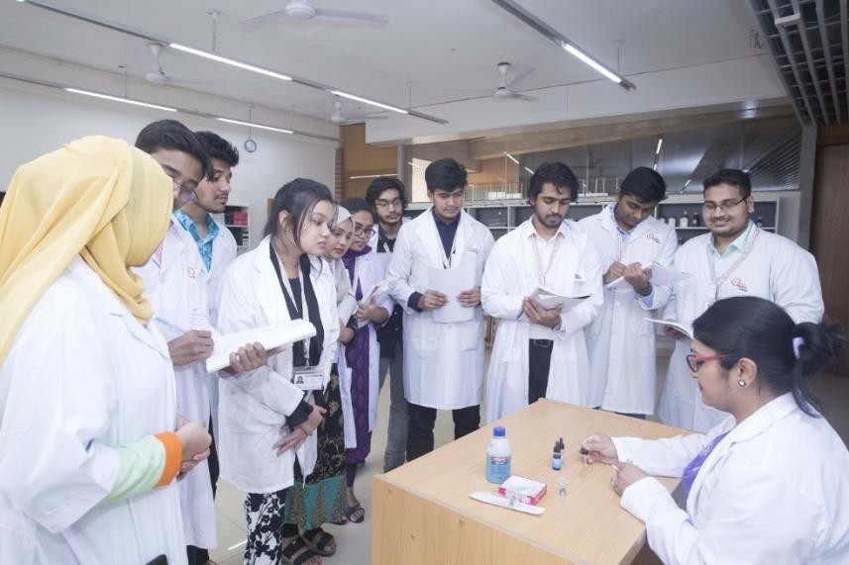

Overall, this healthcare education industry needs a nicely-structured financial management and procurement operation system in place to support and sustain academic services, upkeep of institutional resources, and smooth functioning of organizations. United Medical College has a structured approach in such areas to ensure efficiency and accountability in the functioning.

2.2.2 Size, Trend, and Maturity of the industry

- Recent Establishment and Expansion: United Medical College is a new establishment (around 2019-2020) and its mission was to produce qualified doctors who would be applicable both to the society of Bangladesh and internationally to meet healthcare challenges. Despite its young age compared to other long-standing medical institutions, UMC has already taken quite a few batches of MBBS students and has plans to increase the academic offerings further.
- Infrastructure and Campus Development: UMC's permanent campus is at United City, Dhaka with ongoing construction of a modern academic building with an attached teaching hospital. The development of the fully-equipped campus and future hospital facilities reflects a trajectory of growth that is focused on improving the educational infrastructure as well as clinical training capacity over time.
- Increasing Enrollment, Inclusion of a More Diverse Student Body: UMC has admitted number of batches of MBBS students from wide areas of background, which is a sign of growing and stable demand of medical program. The institution also intends to enroll more foreign students in its courses and have a broader market reach outside Bangladesh.
- Academic Recognition and Quality Focus: UMC is approved by national regulatory bodies of the ministry of Health and Family Welfare (MOHFW), Directorate General of Health Services (DGHS), Dhaka University, and Bangladesh Medical & Dental Council (BMDC). Continued efforts to meet international standards (e.g., seeking listing in the WHO World Directory of Medical Schools and registration with medical councils abroad) represent a growth trend towards international academic recognition and quality assurance.
- Market Dynamics of Medical Education: The medical education industry in Bangladesh is booming in response to high demand for qualified doctors, the shortage of places in the public medical college system, and thus, more entrants to private medical colleges such as UMC. Bangladesh is considered as a cheap but quality learning destination for MBBS education which is attracting local and foreign students who are drawn to the low cost of education in Bangladesh, especially in neighboring countries where the education cost is comparatively high.
- Competitive Position: Private medical colleges in Bangladesh have a competition on the basis of maintenance of infrastructure, clinical exposure, international exposure, and affordability. UMC's emphasis on creating excellent facilities, veteran faculty, and a clinical teaching hospital place it favorably to compete in this environment.
- Future Market Trends: Movement for demand of medical education continues as the population and healthcare demand increase in Bangladesh. UMC's strategy to attract international students and the pursuit of global recognition is consistent with wider trends of internationalization of medical education.
As there is growing public awareness in terms of quality private medical colleges, there will be continued admissions growth and widening of academic programs at institutions such as that of UMC over the next decade.

2.2.3 External economic factors

External economic factors play important role in determining the financial and procurement activities of United Medical College. The changes in the national economy, rate of inflation, exchange rate, and government policies have a direct impact on the operational costs of the institution. In the Healthcare and Medical Education sector, a lot of Medical Instruments, Laboratory Equipment and Pharmaceutical are imported from overseas vendors. Therefore, changes in foreign currency exchange rates can make procurement go up quite high.
Inflation also impacts the cost of medical supplies, office material and operational services. When the inflation rate increases, the procurement department has to manage the purchasing with high care in order to keep economical cost for the company. Additionally, government healthcare policies, taxation rules, and regulatory requirements may have an impact on financial planning and budgeting. Economic conditions also mean the financial ability of students to pay tuition fees and other academic charges, thus having a direct impact on the revenue management and financial reporting under the Accounts and Finance Department.

2.2.4 Barriers to Entry

The healthcare education industry has substantial barriers to entry, which make it hard for new healthcare institutions to enter the market. Establishing a medical college requires very huge financial investment on infrastructure, medical labs, hospitals, academic blocks, and high-end medical equipment. In addition, institutions need to have government approvals, accreditation from medical regulatory bodies, and adhere to strict academic and healthcare standards.
From a financial and procurement point of view, new entrants will need to have effective financial management systems, procedures, and the networks in place to procure suppliers efficiently. Recruiting the right doctors, professors and administrative staff also takes a lot of money. These high capital requirements and regulatory standards make it difficult for new competitors to enter the market and compete with established institutions such as United Medical College.

2.2.5 Supplier Power

Supplier power in the healthcare and medical education industry can be quite high since the education establishment relies on specialized suppliers for medical equipment, laboratory materials, pharmaceuticals, and hospital relevant products. Many of these items have high quality standards and certification requirements, which makes the number of suppliers limited. When there are only a few suppliers of certain specialized equipment or medical instruments, for example, they may be able to have more control over pricing, product availability, and delivery terms.
To control this situation, the procurement department of United Medical College has a planned approach of evaluating suppliers. This includes the process of collecting multiple quotations, preparation of comparative statements, assessing reliability of vendors, and the choice of suppliers on the basis of quality, price, and delivery performance. Maintaining relationship with several suppliers also helps in reducing supplier dependency and steady supply chain.

2.2.6 Consumers Power

The consumers in the medical education industry are mainly the students, patients and their guardians. Their expectations with respect to quality education, medical facilities, tuition fees, and reputation of the institution have a big impact on the financial performance of the organization.
Students and guardians compare various medical colleges before making decisions for enrolling.
If the other institutions offer a better facility, experienced faculty members, advanced laboratories, or better tuition fees, students may be attracted to these alternatives. As a result, United Medical College needs to maintain high academic standards and good financial management to ensure its attractiveness to prospective students. Transparent financial systems, proper functioning of fees, provision of quality healthcare services are the features that contribute to the maintenance of consumer trust and satisfaction.

2.2.7 Threat of Substitutes

Threat of substitutes in the Healthcare education sector is moderate. Students, who want to study for medical education, have a number of options like they can opt for other private or public medical colleges, universities, which offers medical related programs or they can study abroad in international institutions. Some students might also pursue alternative healthcare-related degrees like nursing, pharmacy, public health, etc. due to an inability to gain admission in medical programs.

However, medical education entails a lot of clinical education, lab work as well as work in a hospital which cannot be completely replaced by online education or distance education. Because of these special requirements, the threat of substitutes is not too high as in many other industries.

2.2.8 Industry rivalry

Competition in the medical education and healthcare industry is slowly increasing by the number of private and public medical colleges that are increasing in number day by day. Institutions are in competition with one another in respect of the academic reputation, quality of the faculty, infrastructure, hospital facilities, tuition fees, research opportunities and support system for the students.
Efficient financial management and procurement practices are important factors in staying competitive. By ensuring proper budgeting, cost control, and transparency in financial operations, the Accounts and Finance Department helps in the sustainable growth of organizations. At the same time, the procurement department ensures that the availability of good equipment, medical supplies, and learning resources is available for academic and healthcare activities. Effective coordination between these departments ensures the continued operational efficiency of United Medical College; it also enhances the ability of this healthcare education institute to increase its market standing.

CHAPTER III: INTERNSHIP EXPERIECNE

3.1 Position, duties, and responsibilities

As an Intern in the Finance and Accounts Department of Procurement section at the United Medical College, I was selecting the quotation from the vendors to purchase furniture for the college. I have also collected the samples from them to make sure for purchasing furniture with good qualities. Also, I have prepared the work orders for the different vendors. I kept the financial records with the vendors. Moreover, I was helping to maintain the financial records, prepare vouchers, organized invoices tuition fees report. I was also working with the bank reconciliation, tuition even fee tracking, and budget tracking. Additionally, I helped with documentation of audits and ensured that we are in touch with different departments to ensure smooth financial operations. This role has improved on my practical knowledge of accounting procedures and financial management.
Roles and Responsibilities:
During the internship at United Medical College, I was allocated to the Procurement- Finance and Accounts Department. My responsibilities were as follows:
- Communicate with the vendors and collect quotations from them according to the requirements.
- Create comparative statements (CS) and select the capable vendors from the CS.
- Bargaining with vendors to maintain the fair price.
- Collect the samples from them and finalize products
- Create the work orders.
- Collecting tuition fees and make financial reports.
- Monitor outstanding dues and ensure their timely payments.
- Keep proper financial records and bookkeeping for the institution.

3.2 Orientation and Training Experience

- Went through an organized orientation to know the financial operations of the college and its accounting procedures.
- Learned about institutional policies, documentation standards and compliance requirements (BMDC guidelines)
- Improved knowledge and comprehension of the role procurement financial management plays in the total operations of an organization

3.3 Contribution to Departmental Functions

As my internship on procurement at the Finance and accounting Department, United Medical College, I actively participated in few of the departmental activities that speak about the smooth running of the financial functioning:
- Kept clear communication between the vendors and institution to avoid any errors.
- Helped to keep current and maintain daily financial records to keep them accurate and complete.
- Assisted with processing vouchers, invoices, and payment documents for striving timely transactions
- Supported accounts receivables activities by tracing tuition fees in advance by follow up on outstanding payments.
- Made sure get the right products at fair price by selecting the capable vendors.

3.4 Performance Evaluation

During my internship on procurement in the Finance and Accounting Department at United Medical College, I have been evaluated on my performance which includes the ability to learn, help the department with various tasks and maintain accuracy and professionalism in our financial operations and procurement process.
I collected the proper requirements and communicated with each of shortlisted vendors. After collecting the quotation from them I have created the comparative statements. After properly communicating with the vendors and bargaining with them I have selected the proper vendors and made sure to get the products with good quality by taking sample from them. I kept tracked until the final products get delivered with the same quality, they provided during showing the sample.
I consistently showed attention to detail while working with financial records, vouchers, and invoices in an accurate and timely manner. My experience with accounts receivable and payables processes, tuition fee tracking, petty cash, and bank reconciliations were all examples of how I was committed to assisting the department with their day-to-day business. I was able to coordinating with the team members and other departments, a very effective communication and organizational skills.
Feedback from supervisors noted my desire to learn, flexibility, and willingness to accept the responsibility for tasks assigned. Inhibitive: I have also demonstrated initiative in understanding accounting procedures, usage of accounting software and compliance requirements. Overall, my performance met departmental expectations and contributed to the effective management of work flow and enhanced my practical knowledge gained in the field of finance and accounting concepts in an institutional setting.

3.4 Practical Skills Utilized

During my internship at the Finance and Accounting Department at United Medical College, I was able to apply and develop some of the practical skills which are essential for growing up in a professional career in the finance and accounting fields:
- Communication and Interpersonal Skills: I frequently communicated with department staff, faculty and other administrative teams to gather financial information, clarify instructions and coordinate departmental work. This helped me to be better at communicating information effectively and being able to maintain professional relationships.
- Documentation and Record Management: I saved correct financial data, prepared financial vouchers, filed invoices, and updated the ledgers. This helped me improve on attention to detail and the ability to organize the information in an orderly manner for auditing and compliance purposes.
- Time Management: Having to manage multiple tasks like preparing financial reports, helping with accounts receivables/payables, and reconciling bank accounts gave me the knowledge of prioritizing tasks well and completing them in time.
- Teamwork and Coordination: Working with the Finance Manager, Accounts Officers and other departments has increased my capacity to work in a team, coordinating responsibilities and contributing to the successful achievement of departmental objectives in an efficient manner.
- Basic Financial Documentation Handling: I have gained practical experience in handling of vouchers, invoices, tuition fees, petty cash were handled, bank statements which enhanced my understanding of the institutional accounting processes.
- Analytical and Problem-Solving Skills: As I reviewed financial transactions, reconciled discrepancies, and helped in budget monitoring, I was able to develop the skill to analyze data, identify errors, and propose solutions.
- Technical Skills: I improved my knowledge on Microsoft Excel used in everyday operations, such as the preparation of spreadsheets, reports and summaries.
- Professional Ethics and Confidentiality: Dealing with sensitive financial information meant following rules of confidentiality and ethical practices which reinforced my knowledge about professional responsibility.
- Adaptability and Learning Agility: Working in a dynamic environment with various financial processes assisted me in preparing to new tasks in a short time, learning procedures with very little effort, and handling challenges without the need for assistance.
- Attention to Compliance and Regulatory Standards: I learned to comply with compliance to the institutional guidelines conformed by the regulations and institutional policies such as Bangladesh Medical and Dental Council (BMDC) ensuring all financial activities to be in accordance with the compliance and standard requirements.

Through these experiences I developed a well-rounded skill set with a combination of technical knowledge on accounting, professional behavior, analytical thinking, and interpersonal skills which will be invaluable in my future career of working in the field of finance and accounting.

3.6 New skills developed

During my internship in Finance and Accounting Department in United Medical College, I developed some new competencies, which helped me in gaining a better professional and practical understanding of financial management:
- Practical Accounting Skills: Acquired hands-on experience with preparing vouchers, handling invoices, keeping track of tuition fees paid and accurate financial records.
- Financial Analysis and Reporting: Learned to analyze financial information, reconcile accounts, and help to prepare summaries and reports for review by management.
- Budgeting and Expenditure Monitoring: Developed the ability to track departmental budgets, monitor spending, and learn about cost management in an institutional context.
- Problem-Solving and Analytical Thinking: Developed the skills to detect discrepancies, fix minor errors and suggest improvements in the financial processes.
- Professional Communication: Enhanced ability to communicate effectively with supervisors, colleagues, and other departments with respect to financial data and documentation.
- Time Management and Multitasking: Learned to prioritize and manage multiple tasks, tackle various responsibilities at once and meet deadlines in the proper workflow.
- Ethical and Regulatory Compliance: Ethical awareness and compliance Gained awareness of professional ethics in finance and accounting, including maintaining confidentiality, following BMDC, and adhering to institutional financial policy.
- Team Collaboration: Enhanced proficiency to work collaboratively in a professional team, coordinate tasks, and contribute to departmental goals effectively.

These competencies allowed me to have a broad coverage of real-world financial and accounting operations as it prepares me to face future work in the field professionally.

3.7 Application of academic knowledge

During my internship in Finance and Accounting of United Medical College, I got an effective chance to use the theory learnt during my academic knowledge in the practical, real-life financial operations and procurement. The theory of accounting, financial management, and procurement that I learned in the classroom was directly applied to such activities as communicating with the vendors, preparing comparative statements (CS), preparing vouchers, maintaining ledgers. I made use of concepts of budgeting, financial reporting and internal control mechanisms that ensured the understanding of the workflow within the department and also aiding in decisionmaking processes. For example, knowledge of double entry bookkeeping and financial statements helped me to accurately record transactions and to help in preparing reports for the management to review. Similarly, theoretical knowledge on cost monitoring and expenditure control helped me in making contributions to budget tracking and reconciliation of discrepancies in accounts. This combination of theory and practice helped me to better understand the principles of institutional financial management, develop analytical thinking and give me practical understanding of the application of accounting and finance principles in the professional healthcare-educational setting. Overall, it filled the gap between academic learning and practical application and got me ready for a future financial and accounting career.

CHAPTER IV: CONCLUSIONS AND KEY FACTS

4.1 Suggestions of Improving Departmental Efficiency

Based on my experience of internship at the Finance and Accounting Department of United Medical College, suggestions that can help in increasing the efficiency of Finance and Accounts Department include:
- Implement Advanced Accounting Software: The adoption of advanced accounting software with automated features can streamline the process of preparing voucher, managing the ledger and generating reports, reducing the manual errors that may be committed and saving time.
- Digital Record Keeping: Migrating paper-based records to a digital system for documentation can enhance accessibility, organization and audit readiness.
- Regular Staff Training: Regular conducted staff trainings on new accounting tools, updates on regulations, and best practices can help to improve competency and efficiency of staff.
- Standardized Workflow Procedures: Creating unambiguous Standard Operating Procedures (SOPs) for daily financial tasks like invoice processing, fee collection, and reconciliation may reduce confusion and delays.
- Improved Internal Communication: Beter coordination and communication among the finance department and other administrative units can help to ensure that data is collected on time and that the workflow is smooth.
- Periodic Review and Monitoring: Regular audits, financial checks, and performance evaluations can be implemented to ensure that bottlenecks are identified and that institutional and regulatory standards are met.
- Delegation of Tasks: According to the staff's strengths and expertise, the delegation of responsibilities can help optimize workload distribution and boost overall productivity.
- Integration of Analytical Tools: The use of data analytics for monitoring budget, tracking expenditure, and forecasting can be used to support informed decision-making and financial planning.
Through these measures, the Finance and Accounting Department can work to enhance accuracy, decrease workload, and boost operational efficiency while adhering to high standards of financial management.

4.2 Major Learnings and Insights

During my internship in the Finance and Accounting Department from the United Medical College, I have learned a lot of knowledge and practical concepts that led developers to delighted reality steadies the distance between the learning in the rote and financial operation:
- Application of Accounting Principles: I learned how the theory of accounting principles such as double-entry bookkeeping, ledger management and financial reporting are applied to the day-to-day operations of an institution.
- Financial Record Management: In this area I got good hands-on experiences at addressing the maintenance of accurate records, preparing of vouchers, organizing of invoices, and ensuring that documentation is proper for audits and compliance.
- Budgeting and Expenditure Monitoring: I learned the importance of budget monitoring, expenditure control, and cost-control in the support of the financial stability of the institution.
- Banking and Reconciliation Procedures: I learnt to carry out bank reconciliations, control petty cash and monitor cash flow to ensure accuracy and transparency.
- Professional Communication and Teamwork: I developed interpersonal skills through working with finance staff and communicating with other departments and financial information effectively.
- Problem-Solving and Analytical Thinking - I developed my abilities to spot the discrepancies, analyze the financial data and propose the practical solutions.
- Compliance and Ethical Practices: I gained an awareness of the importance of adherence to institutional policies, regulatory standards and maintaining confidentiality in financial operations
- Integration of Theory and Practice: The internship allowed me to bridge the theoretical knowledge with practical tasks that helped me reinforce my knowledge on accounting, finance management, and institutional operations.

Overall, this experience strengthened my technical skills, professional competences and knowledge of the financial workings of a medical educational institute and will equip me for future positions in finance and accounting.

4.3 Final Remarks

My internship in the Finance and Accounting Department in the United Medical College has been a very valuable and enriching experience. It gave me a good exposure to hands-on finance operation (such as record keeping, accounts management, budgeting and reporting) where I can utilize the theoretical knowledge that I have studied in my academic life. Working closely in the finance team, I developed key professional skills like communication, teamwork, time management and problem-solving. The experience was also great for my knowledge on compliance, ethical practices and institutional financial procedures which provided a holistic view of financial management applications within an educational organization.
Overall, this internship has helped to sharpen my technical skills, gain a more hands-on knowledge in finance and accounting, and has helped to prepare me for future professional duties. I am quite convinced that the knowledge and skills that I will learn are a definite foundation (a solid foundation) for the career that I will have in finance and accounting.

Reference
Nicoletti, B. (2018). New solutions for procurement finance. In Procurement finance: The digital revolution in commercial banking (pp. 107-154). Cham: Springer International Publishing.
https://link.springer.com/series/14627
Nicoletti, B. (2018). Procurement Finance: the digital revolution in commercial banking.
Springer. https://link.springer.com/series/14627
Maksymenko, I., & Melikhova, T. (2017). Accounting and analytical procurement of state financial control and directions of its implementation in Ukraine. Baltic Journal of Economic Studies, 3(5), 268-275. https://cyberleninka.ru/journal/n/baltic-journal-ofeconomic-studies
Owens, A. (2013). Improving the performance of finance and accounting shared service centres. Journal of payments strategy & systems, 7(3), 250-261. https://www.ingentaconnect.com/content/hsp/jpss;jsessionid=25plupddabr68.x-ic-live-03
Zhao, L., & Huchzermeier, A. (2015). Operations–finance interface models: A literature review and framework. European Journal of Operational Research, 244(3), 905-917. https://doi.org/10.1016/j.ejor.2015.02.015
Moosa, I. A. (2003). International financial operations. Arbitrage, Hedging, Speculation, 10, 9781403946034. https://link.springer.com/series/13977
Churchman, C. W., & Ackoff, R. L. (1955). Operational accounting operations research. Journal of Accountancy (pre-1986), 99(000002), 33.
https://www.proquest.com/openview/65515674eda7bf998c7f775ab0729291/1.pdf?pqorigsite=gscholar&cbl=41064
Verdaasdonk, P., & Wouters, M. (2001). A generic accounting model to support operations management decisions. Production Planning & Control, 12(6), 605-620. https://doi.org/10.1080/09537280010014703

