

CUSTOMER SATISFACTION & SERVICE QUALITY PRECTICE IN MUTUAL TRUST BANK LIMITED


Internship Report

On

Customer satisfaction & service quality practice in Mutual Trust Bank Limited


Prepared for

Dr. KawsarAhmmed
Associate professor
School of Business and Economics
United International University

Prepared by:

Mehedi Arafat

ID: 111-132-083

Date: Tuesday, February 19, 2019

Transmittal Letter

February 19, 2019

Dr. KawsarAhmmed
Associate professor
School of Business and Economics
United International University
Satarkul, Dhaka-1212

Subject: Submission of the Internship Report.

Dear sir,

This is my pleasure to inform you that for the completion of internship; I am submitting my report titled “Customer satisfaction & service quality practice in mutual trust bank limited by Using SERVQUAL Model”. I have tried my best to make this report effective by following your instructions. This internship report is based on my practical knowledge by using theoretical ones which I have gained so far. Within this title limit I tried to make this report as informative as possible. But there may be some mistakes due to various limitations. So I expect your kind consideration in this regard.

Thank You.

Sincerely Yours,

…………………….

Mehedi Arafat

ID: 111 132 083

School of Business Economics

Acknowledgement

First and foremost, I am grateful to the Almighty Allah for whom I was able to work hard on this report. I am also grateful to my parents for supporting my efforts. Internship Report is an essential part of BBA Program as one cannot gather practical knowledge and experience without observing and doing work at chosen Organization. It is a matter of pleasure that I have done an internship from Mutual Trust Bank Limited.

I am very much fortunate that I have received almost and sincere guidance, supervision and cooperation from various persons while preparing this report. I am also thankful to my academic supervisor Dr. Kawsar Ahmmed, Associate Professor, School of Business and Economics,United International University for her continuous and proper guidance, inspiration, affectionate encouragement and valuable suggestions throughout this internship period.

Last but not the least; I would also like to thank Md. Arifulislam FAVP & DM of Branch, Mrs kanis fatema JAVP, pallabi for being patient and supporting me throughout my internship program. My endless thanks go to my excellent organization supervisor MrskanisfatemaJAVP. Along with them Md.Kamal Hossain Senior Officer, Mrs. Farhana Islam Officer and Md.Mojibur Rahman assistant officer; they have all provided their precious time and effort to teach and support me throughout my time at the bank. My gratefulness goes to the entire members of Mutual Trust Bank limited Pallabi Branch for helping me to prepare this report through providing necessary information and to let me do the survey which was essential for my report.

Executive Summary

The purpose of this study is to examine the quality of banking service and customer satisfaction at Mutual Trust Bank Limited. Service quality refers to how service is delivered so that customers need are fulfilled and service performance meed and sometimes exceed customer expectation. In this study, the service quality of Mutual Trust Bank Limited has been evaluated with the help of the SERVQUAL Model.

Five dimensions namely tangibles, reliability, responsiveness, assurance, and empathy of the SERVQUAL Model with twenty-two items are included in the questionnaire and a survey has been conducted to examine them. Results from the one hundred respondents, it is evident that customers give more emphasis on reliability of services followed by the responsiveness of services in the banking service sector.based on the findings, a discussion has been forwarded along with some recommendations.

This report is divided into several parts including the prefatory part which contains some informative areas on the subject matter of this report. The organization part is given. It follows the internship experience at the Mutual Trust Bank Limited. Finally, analysis, result, discussion, recommendation, and conclusion are provided.

Keywords: Service quality, customers satisfaction, customers expectation and perception, organization, Mutual Trust Bank Limited.

Table of Contents
Organization, Part

MTBL. 9

Activities of internship 10

Department of general banking 10
Clearing department 11

Loan and advance department (credit) 11

Report, Part 12

Introduction 12

Beginning of the report 12

Objective of the Report 12

General objective 13
Specific objective 13

Narration of the problem 13

Methodology 13

Generation of Data 14

Primary generation 14

Secondary generation 14

Sampling recipe 14

Extension of the Study 15

Restriction 15

Composition Review 15

Service Quality Dimensions 16

Data Analysis & results 17

Reliability Test 17

Analyzing Gaps of Service Quality & Mean Scores of Expectation and Perception of MTBL

Customers 18

Importance of Dimensions 21

Explore Gaps between Service Quality & Demographic factors 22

Recommendations 24

Conclusion 25

References 32

Survey Questionnaire 33

Table of Tables

Table 1: Service & Mean Scores according to Tangibility 18

Table 2: Mean Scores & Service Gap on Reliability 18

Table 3: Mean Scores & Service Gap on Responsiveness 19

Table 4: Mean scores & Service Gap on Assurance 19

Table 5: Mean Scores & Service Gap on Empathy 20

Table 6: UNWEIGHTED SERVQUAL Gap Score 21

Table 7: Average Weighted SERVQUAL Score 22

Table 8: Cross Tabulation of Gender & Service Quality Gap 22

Table 9: Cross Tabulation of Occupation & Service Quality Gap 23

Table 10: Cross Tabulation of Income Group & Service Quality Gap 23

Table of Figures

Figure 1: Organogram of MTBL, pallabi Branch 9

Figure 2: SERVQUAL Model (Kumar et al, 2009) 17

Figure 3: Cronbach's alpha of the dimensions 17

Figure 4: Importance Given on Each Dimension by Respondents 21

Organization, Part

Mutual Trust Bank Ltd.
There are several non-public industrial banks in Bangladesh. MTBL is one amongst them. they're giving company, personal, international trade, interchange and lease finance, in line with capital market service within the full vary like alternative banks in Bangladesh. MTBL contains a very little observation on retail banking. MTBL was winning Business award by competitive with others bank that’s why it's one amongst the most effective run banks in Bangladesh Business award right away. MTBL has in total one hundred ten branches everywhere Bangladesh and every one activates take care of, operates and supervised by the top workplace of these branches. MTBL head workplacesettled in Gulshan. On the opposite hand, these banks proceed a world network with foreign banks to affix international business. MTBL is attempt to offer higher service to its shoppers, change of integrity in expansion of civilization further as was to be improved to the expansion of the Bangladeshi financial system is that the trade system that mutual trust bank follow.

(Source://www.mutualtrustbank.com/about-us/)

 |  |  |  |  |  |  |  |  |  |  |  |  |  |  | In Charge/ manager
 |  |  |  |  |  |  |  |  |  |  |  |  |  |  |  | 2nd Officer (DM)
Cash in Charge Asst. Officer |  |  |  |  |  |  |  |  |  |  |  |  | Clearing |  |  |  |  |  |  |  |  |  |  | Deposit in Charge |  |  |  |  |  |  |  |  |  |  |  |  |  |  |  | Acct
 |  |  |  |  |  |  |  |  |  |  |  |  |  |  |  |  |  |  |  |  |  |  |  |  |  |  |  |  |  |  |  |  |  |  |  |  |  |  | Section
 |  | Payment |  |  |  |  | Receive |  |  |  |  |  |  | Receive |  |  |  |  |  |  |  |  |  |  |  | Deposit |  |  |  |  |  |  |  |  |  | Deposit
 |  |  |  |  |  |  |  |  |  |  |  |  |  |  |  |  |  |  |  |  |  |  |  |  |  |  |  |  | Loan & Advance
 |  | Payment |  |  |  |  |  |  |  | Acct Opening
 |  |  |  |  |  | Foreign Exchange
 |  |  |  |  |  |  |  |  |  |  |  |  |  |  |  |  |  |  |  |  |  |  |  | Loan & Advance |  |  |  |  |  |  |  |  |  |  |  |  | Loan &
 |  |  |  |  |  |  |  |  |  |  |  |  |  |  |  |  |  |  |  |  |  |  |  |  |  |  |  |  |  |  |  |  |  |  |  | Advance
 |  |  |  |  |  |  |  |  |  |  |  |  |  |  |  |  |  |  |  |  |  |  |  |  |  |  |  |  |  | Remittance
 |  |  | Foreign Exchange |  |  |  |  |  |  |  |  |  |  | Foreign
 |  |  |  |  |  |  |  |  |  |  |  |  | Exchange
 |  |  |  |  |  |  |  |  |  |  |  |  |  |  |  |  |  |  |  |  |  |  |  |  | Remittance |  |  |  |  |  |  |  |  |  |  | Remittance
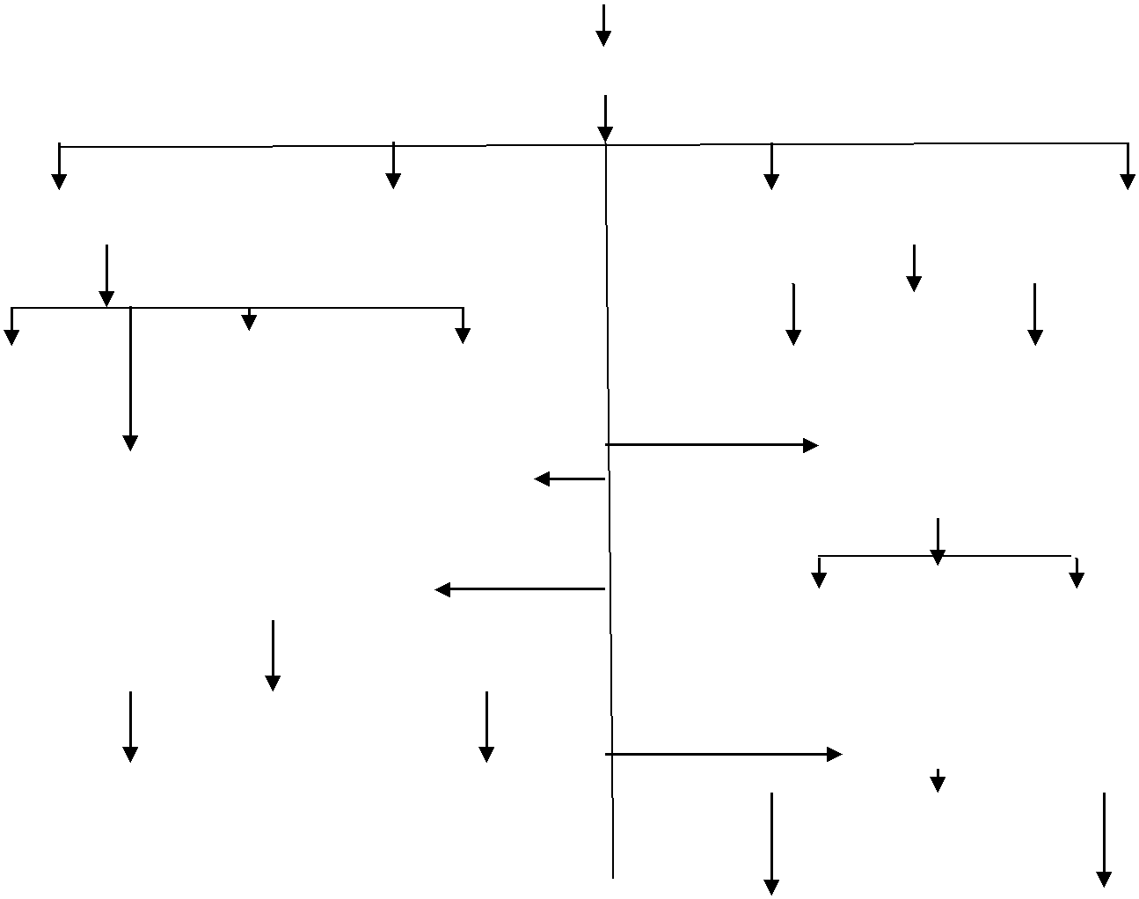

FIGURE: Organogram of MTBL, Pallabi Branch

Internship Activities

As an intern, I was working in MTBL at the pallabi branch for four month long internship program has given Pine Tree State a good probability and opportunities to be told and acquire the sensible data on banking which can facilitate to develop my career within the future. throughout my berth amount i've got chiefly worked on common Banking Department& even have an orientation on Lone proceed that was below Credit Department.

Department of General Banking

When I was unification in the Mutual Trust bank at first I was assign to work in the general banking department. Here I was assigned for several tasks those help me to learn about a lot of things. With General Banking Department I work under Farhana Islam (Asst. Officer in GB) and KanisFatema (JAVP).
This department basically responsible for some tasks such as:
- Account Opening.
- Account Closing.
- Transferring.
- Opening various deposit schemes.
- Creating & Updating TP.
- Issuing pay Order.
- Delivery of cheque book.
- Debit card delivery.
- Balance checking.

By operating with the front table staff i've got a transparent plan regarding the responsibility that has given to the final banking department. There are some key responsibilities normally banking like account gap and shutting, superintendence of inward and outward registers, making ready every kind of statements and financial condition certificates, issuance demand draft, payorder, cheque book, giving account, change transfer profile of accounts, count vouchers, finishing the procedure for gapaccounts and to require an indication from manager, doing inward and outward connected works properly.

Clearing Department

I have conjointly worked for cheque clearing beneath Amina Akter (Officer). it's a straightforward however risky job that has three seals on the cheque and singing later. First, I had to mark those cheques with the MTBL name referred to as crossing. Then I place the date and later the licensed signature seal wherever the worker had to sign. Up to the present the method is understood as cheque creating. After that getting into the account range and therefore the quantity written on the cheque. then all knowledge send to Bangla Desh bank via web and once sooner or later future} the cheque is there in the financial organization. the following day it'stransferred to the specified account. The cheque involves clearing they ne'er proceed while not being confirmed and taking the consent of the individual shopper doesn't matter for wherever the shopper is that gave Pine Tree State the good learning of being sincere.

Loan & Advance Department (credit)

Here I have shown the different types of loans provided by MTBL. When I prepare to know about credit department I have a supervisor & my supervisor was made by MD. Ariful Haque (FAVP & deputy manager). My supervisor was a DM that is why he was too much busy with his responsibility. However, he provides an officer to guide me. His name was Sajib Hossain (JAVP). He guides Pine Tree State to grasp concerning differing kinds of loans that are provided by MTBL. If I give an example, it should be like many times I was imposed to count some customers who applied for loan to understand about their information which is given by them, however, I was under the supervision of Sajib Hossain so that there is not happening any mistake. This connotation is termed loan KYC wherever i would like to understand regarding various client’s demographic background like academic background, income, family/parents' profession, manner and alternative things.

Report, Part

Introduction

Here I want to represent & considered about the lesson that might go with my report title such as SEVQUAL Model, five dimensions of the model represents my report title. According to the requirement and to finish this internship report I have grown up with survey questionnaire which is about to apply the SERVQUAL Model on MTBL to achieve customers’ perception and expectation regarding banking services is it appropriate or not. There is an opportunity that is why I will try to find out the service quality of MTBL perceived by its customers’ & try to find out the customer satisfaction about MTBL. There is a hope that can i will be able to get the considered the scale that makes higher for this bank and wherever Mutual Trust Bank will must target to boost so as to realize client satisfaction within the future.

Beginning of the Report

Because of the completion of Bachelor of Business Administration (BBA) program authorized by United International University, this internship report has been done. I have completed my internship from MTBL. I was gaining some work experiences & knowledge when I worked at MTBL for five months & I have been using those experiences and knowledge to prepare my internship report. The report has been completed under the supervision of my academic supervisor Dr. KawsarAhmmed assistant professor, School of Business and Economics of UIU. My organization supervisor was Ariful Haque, FAVP & Deputy Manager, MTBL, pallabi branch.

Objective of the Report

I had some objective to make report, as follows-

General objective

Specific objective

General objective

The major objective was to achieve information about the service quality of MTBL. On the other hand, I want to know whether the obligatory customers of the particular institution are comfortable with the service that are provided by the bank. Searching whether there is any dissatisfaction concealed in the customer's mind that can back the overall service quality of MTBL. I conjointly determine the effective magnitude to ease those measures completely to accumulate the optimum goal of this organization notably.we also know about how mtbl slove their service quality problem.

Specific objective

Specific objective was:

- understand operational activities of MTBL and to know the present circumstance of the bank.
- Organize and analyze the precise and general factors of client satisfaction.
- determine the factors/lacking’s of customer’s discontentedness.
- turn out totally different alternatives and produce group action recommendation for customer’s discontent.

Narration of the Problem

In accordance with Manjappa, Osmane, & Niranjan (2010), the customer satisfaction is a constantly very significant to ensure any service/product popular. According to acquire the service quality of MTBL; there is no in depth study has been done so far as I am concerned. I have concerns about my objective.

Methodology

When I was using SERVQUAL Model it was imposed on Mutual Trust Banks pallabi branch customers to know about the services that they receive from MTBL is fulfilling customers' expectation or not & to recognize the zone of promotion according to the perception that is held by its customers. This survey was about 100 customers those customers are considered as a sample size. There is a structured questionnaire which consisted 22 questions according to the five service dimensions & used it on the customers. All the customers take it seriously and read all the questions in more details so that they can provide an opinion about the service quality. There are many customers, however I was focusing on MTBL deposit holder, employees, peoples who want to know about the MTBL service quality.

Generation of Data

Primary generation

Questionnaire development

Survey

Observation

Direct conversation with the clients

Secondary generation

Journals & articles

Books

Sampling recipe

Elements: Customers of Mutual trust bank , Pallabi branch wherever my components of analysis.

Sampling size: Sample size required 100 so questionnaire is 100 customers of the MTBL Pallabi branch.

Extension of the study:

The program provides myself an awesome opportunity to extend my knowledge and experience in many banking activities. The opportunities of the report have to limitation to Mutual Trust Bank Limited, Because the report is based on practical observations that why I can't log in any certain places. I was assigned at MTBL, pallabi branch for the purpose of my internship program. I have complete my job as an intern student and do job in different departments of the bank such as general banking and credit division. However, it has to impossible to know about all job activates within five months.

Restriction

When ready for this report any problems happened like:

it was impossible to use servey on every customers who are very high-profiled personnel and more frequent users of accounts because of time & price constraints.
That research is implied on only MTBL, pallabi branch. That is why it was very hard to know the actual condition and all information about the service quality of the Mutual Trust Bank.

Many customers are not agree, participate, respond when survey & interview occur that was the limitation.

There is another limitation which is time are fixed & confidential issues of the bank.

Composition Review

Parasuraman was the person who is the inventor of the SERVQUAL model in 1984. which is represented the customer satisfaction and shows gap within customer perception that means help of the bank and expectation that means help get. Though this way was providing measurement as attitude of the clients. All measurements rely by which clients achieve the way of the service provided . If the expectation of customers crossed by a service quality then it counts as a best way (Parasraman at el., 1984).

Dimensions of Service quality

There are five dimensions such as Tangibles, Reliability, Responsiveness, Assurance, and Empathy that is used to acquire service quality by SERVQUAL model (Parasraman, eithaml, & erry., 1987).
Let's talk about those five dimensions:
Tangibles:

The procedure to find attention and importance by the service holder physically when they provide service through the surroundings. Tangible dimension provide which is physically present to help the clints used to serve customers to offer a service and other things.

Reliability:

Reliability represents the ability to incur a service which had given to a clint accurately with independence. Whether a service is provide perfectly on the mean time, as the accurate way, after that it will considered as a reliable service.

Responsiveness:

According to the responsiveness dimension, it should offer a service to a client as soon as possible without any delay. The reputation will be hampered that particular service provide when customers wait long to avail a service with none solid reason If a service provider provides a hurry service or quick response to a problem creates which makes a good impression on customers that’s called responsiveness.

Assurance:

The confirmation by the agreegation between the service providers/employees and customers it represents assurance. On the other hand the way of completing a service and to provide information that they have the best services for their clients.

Empathy:

This means the standard of understanding the precise wants of specific customers. that creates each client feels equally treated or they got attention.

Figure 2: SERVQUAL Model
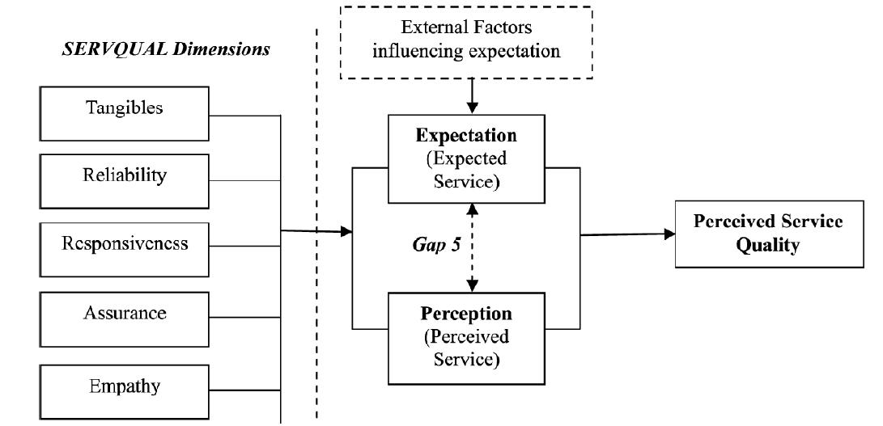
Analysis & results of Data

Reliability Test

Figure 3: Cronbach's alpha of the dimensions

 |  | Perception | Expectation
22 Items [Questionnaire] |  |  |  |  | .812
22 Items [Questionnaire] |  |  |  |  | .889
Tangibility |  |  |  | .709
Tangibility |  |  |  |  | .719
Empathy |  |  |  |  | .787
Empathy |  |  |  |  | .745
Assurance |  |  |  | .712
Assurance |  |  |  |  | .739
Responsiveness |  |  |  |  | .752
Responsiveness |  |  |  |  | .762
Reliability |  |  |  | .715
Reliability |  |  |  |  | .765
0 |  | 0.2 | 0.4 | 0.6 | 0.7 | 1


Here is a study, at first where i've got complete a dependableness check that count through “Cronbach’s Alpha” to be make sure that information used here are reliable to proceed additional. When complete Fujian et al. (2007) Cronbach’s alpha results are found greater than 0.6 then all the data are remaining consistent.

Describing Gaps of Service Quality & recognized Mean Scores of Expectation and Perception of MTBL Customers

 | Table 01: Service & Mean Scores according to Tangibility
 | Statement |  |  | P | E
 | Tangibility |  |  | Mean | Mean
1. | 1. MTB has a modern-looking equipment’s like computers, fast ICT facilities, etc. |  |  | 4.46 | 4.20
2. | 2. Employees of MTB branch are professionally dressed |  |  | 4.40
 |  |  |  |  | 4.60
 |  | 3. The exterior and interior of MTB are visually spacious and appealing . |  | 4.64 | 4.20
 |  | 4. Materials and equipment’s associated with the services (computer, ATM machine, Teller station, bank statement, pamphlets, etc.) are visually appealing |  | 3.64 | 3.90
Average of the tangibility dimension

There is a positive outcome were came from Questions related to tangibility. When the average results are counted for this dimension is also being positive. However, we can see in attribute 4 has a negative (-0.26) gap which should be notified by MTBL. There is an example given to confirm that why this negative result has come the reasons behind that is the bank charge tk 615 for providing the solvency certificate for that reason most of the customers of our sample size in keeping with the quantity of charge the bank take.

 | Table 02: service & mean Gap on Reliability
 | Statement |  | Perception
 | Reliability |  | Mean | Mean
 | 5. Whenever I request for banking service MTB provides it at the promised time. |  | 3.70 | 3.66
 | 6. Whenever I request for banking service MTB performs it right first time. |  | 3.80 | 3.92
 | 7. Whenever I request for services like cash deposit, cash withdrawal, bank statement, etc. MTBstaffs provides it as promised. |  | 3.86 | 3.80
 | 9. Always MTB maintains on error-free records services. |  | 4.00 | 3.94
 | 10. Whenever I experience a problem, MTB staffs handle it in a constant manner. |  | 4.24 | 4.24
Average for the reliability dimension

All the attribute shows positive outcome, according to reliability dimension with focus on customer satisfaction. The MTBL Call Center requires more employee, but there is a low number of human resource for that reason we have got an adverse result for attribute six. Statements that were created on reliability; got a bigger perception mean score that the expected one apart from attribute six. we are able to additionally see that attribute got no service gap which implies MTBL makes no error to organize balance statements and reports. So we can say MTBL should be more reliable than others.

Table 03: Service & Mean Scores according to responsiveness

 |  |  | Statement |  |  | Perception | Expectation
 |  |  | Responsiveness |  |  | Mean | Mean
 |  |  | 11.whenever I need service MTB staffs give me prompt service |  |  | 4.74 | 4.74
 |  |  |  |  |  | 3.02 | 3.08
12.Whenever I ask for service MTB staffs to serve me readily in a good manner
 |  | 13.Always MTB staffs are willing to solve customer problem |  |  |  | 3.17 | 3.17
 | 14.Always MTB keeps me informed as to when service will be performed. |  |  |  |  | 3.12 | 3.24
Average for the responsiveness dimension

According MTBL freeness to their customers hope, motivates of stuffs give any services which represent that the expected mean scores were higher than the perception mean score. On the other hand, the negative responses come from the average mean score. On the contary this branch comparatively smaller in size than other branches in terms of employment that is why customers is waiting a long time when they look for a banking service. In the end they are dissatisfied about the service quality of MTBL which is provided by the bank. Thought there is no service gap for attributes 11 & 13 which is given in the table above.

Table 04: Service & Mean Scores according to Assurance

 | Statement |  | Perception | Expectation
 | Assurance |  | Mean | Mean
 | 15.The attitude of all members in MTB instills confidence in me when they interact |  | 4.20 | 4.18
16. I always feel safe in my transactions like account maintenance, cash transfer, cash withdrawal and deposit, ATM PIN number, etc. with MTB |  |  | 3.16 | 3.12
17.Always employees of MTB have the knowledge to answer my questions |  |  | 4.20 | 4.38
18..Every time employees in MTB are consistently courteous with me |  |  | 4.20 | 4.22
 | Average for the assurance dimension

The average gap of mean score of assurance has negative impact on this bank service. There are some question got a lower perception mean score, then the expectation. some questionnaire respondent, many stuffs' ability to ask an experienced person to do a job or they do not concern with their task and though take longer to give the service .

Table 05: Service & Mean Scores according to empathy

 | Statement |  |  |  |  |  |  | Perception |  | Expectation
 | Empathy |  |  |  |  |  |  | Mean |  | Mean
14 | 20. All employees at MTB pass transactions in a caring manner |  |  |  |  |  |  | 3.86 |  | 3.96
 |  |  |  | 21. Always MTB employee has my best attraction at heart when I’m asking for service. |  |  | 2.62 |  | 3.72
 |  |  | 22. MTB has convenient branches and operates in extended hours to all its customers without spending much time on long queues |  |  |  | 3.62 |  | 3.96
 |  |  | 23. All employees of MTB understand my specific needs with a specific attention |  |  |  | 3.18 |  | 3.82
1 |  | 24. Whenever I request or service, MTB staff gives me individual attention. |  |  |  |  | 3.64 |  | 4.04
Average of the empathy dimension

According this empathy dimension AVERAGE GAP represents negation and the perception mean score is smaller than expected mean. The table shows that, all the attributes got smaller perception scores for mean than that of expectation which refers that MTBL must study on it so that in future they can achieve their goal for empathy.

Table 6: UNWEIGHTED SERVQUAL Gap Score

1. Average SERVQUAL score for Tangible |  | 0.20
2. Average SERVQUAL score for Reliability |  | 0.06
3. | Average SERVQUAL score for Responsiveness | -0.045
4. | Average SERVQUAL score for Assurance | -0.035
5. | Average SERVQUAL score for Empathy | -0.516
 | TOTAL | -0.336
AVERAGE UNWEIGHTED |  | -0.0672
SERVQUAL SCORE (-0.336 / 5)

There is a negative result from the average unweighted SERVQUAL score was (-0.0672) which represents that the services give by MTBL are not appropriate to the mark to cross the expectation of their clients. We know when a customer does not get his/her expectation customer will be dissatisfied with the service quality.

Importance Given on the Dimensions

This table shows the importance of the service quality measurement dimensions

Figure 4: Importance Given on Each Dimension by Respondents
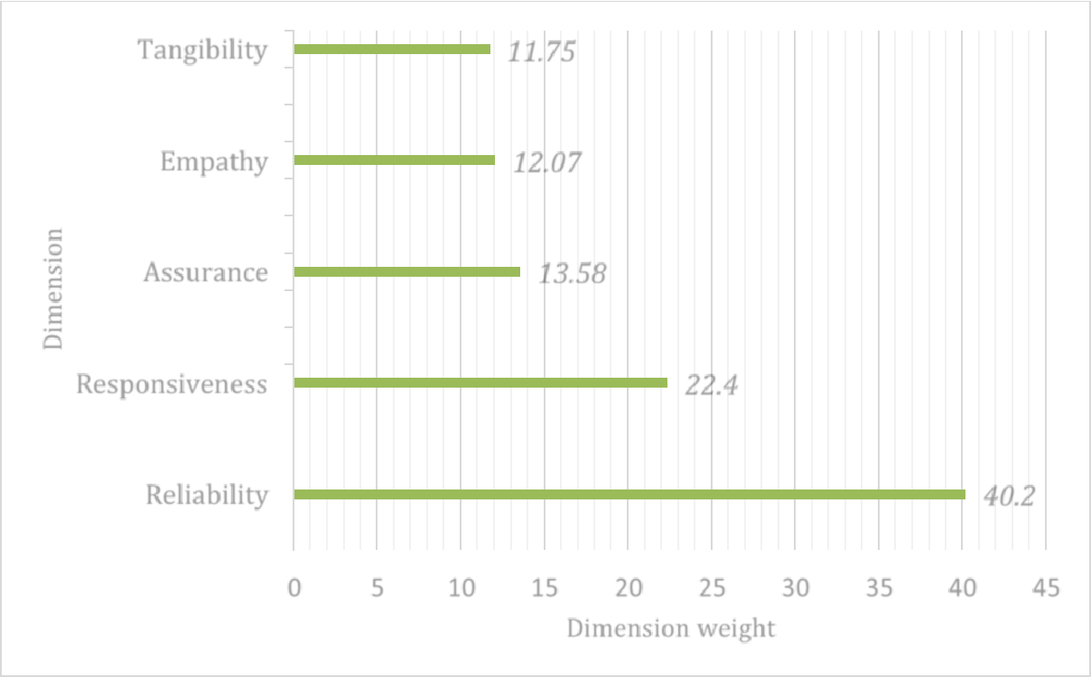

Dimension

Tangibility 11.75

Empathy 12.07

Assurance 13.58

Responsiveness |  |  |  |  |  |  | 22.4
Reliability |  |  |  |  |  |  |  |  |  |  | 40.2
0 |  |  | 5 | 10 | 15 | 20 | 25 | 30 | 35 | 40 | 45
 |  |  |  |  |  | Dimension weight

Table 7: Average SCORE of Weighted SERVQUAL
SERVQUAL Dimensions | Importance weight *average for dimension | Weighted score
Reliability | 40.20%*0.06 | 0.024
Responsiveness | 22.4%*-0.045 | -0.010
Assurance | 13.58%*-0.035 | -0.005
Empathy | 12.07%*-0.516 | -0.062
Tangibility | 11.75%*0.20 | 0.024
 | Total | -0.029
AVERAGE WEIGHTED SERVQUAL SCORE (0.029/5) |  | -0.006

After multiplying the weights we have gotten from the previous results, when we follow the table, we can see there is change has come which is show alternative scenario that before tangibility was the first however here it become lost. On the other hand reliability getting 1st place. We can see the average weighted servqual score is -0.006.

Analyzing Gaps between Demographic Factors & Service Quality

It is analyzed so that we can confirm or understand whether demographic factors of customers have an influence on service quality or not. There is another analysis requires so that cross tabulations can be made by gender and factors score.

Gaps between Gender & Service Quality of MTBL

 | Table 8: Service quality & Cross Tabulation of Gender Gap
Gender | Reliability | Responsiveness | Assurance | Empathy | Tangibility
Male | 0.026 | -0.014 | -0.019 | -0.325 | 0.09
Female | 0.034 | -0.031 | -0.016 | -0.191 | 0.11
Total | 0.06 | -0.045 | -0.035 | -0.516 | 0.2

It can illustrate that under the tangible attributes (Gap: 0.09) a minimum number of males are satisfied according to the reliability part (0.026) gap cover by male and there are many respondents they really dissatisfied with empathy dimension (-0.325).

Gaps between Occupation & Service Quality of MTBL

Table 9: Service quality & Cross Tabulation of Occupation Gap

Occupation | Reliability | Responsiveness | Assurance | Empathy | Tangibility
Student | 0.019 | -0.006 | -0.001 | -0.38 | 0.06
Self- | 0.011 | -0.006 | -0.024 | -0.0212 | 0.02
Employed
Govt. | 0.009 | -0.023 | -0.003 | -0.0218 | 0.08
Employee
Private sector | 0.021 | -0.01 | -0.007 | -0.093 | 0.04
Employee
Total | 0.06 | -0.045 | -0.035 | -0.516 | 0.2

According this specific demographic i might wish to mention that students feel not that a lot of safer, insecure and feel that the banks’ workers ought to provide a lot of attention (Empathy,-0.380). On the opposite hand, this cluster is generally glad with the dependability attributes (0.019) however no more than a personal worker cluster (0.021). Government workers are found not happy once it involves the responsiveness dimension (Gap: -0.023) with a promise created or the amount of service.

Gaps between Income Group & Service Quality of MTBL

Table 10: Cross Tabulation of Income Group & Service Quality Gap

Income Group | Reliability | Responsiveness | Assurance | Empathy |  | Tangibility
0-10000 | 0.002 | -0.001 | -0.007 | -0.05 | 0.04
10001-22,000 | 0.005 | -0.006 | -0.003 | -0.02 | 0.04
22,001-42,000 | 0.002 | -0.006 | -0.002 | -0.245 | 0.05
42,001-62,000 | 0.006 | -0.009 | -0.005 | -0.05 | 0.02
62,001 & above | 0.045 | -0.023 | -0.018 | -0.151 | 0.05
Total | 0.06 | -0.045 | -0.035 | -0.516 |  | 0.2

We can see here the sixty,001 & higher than cluster are sad with responsiveness (-0.023), sympathy (-0.151) still. Moreover, some respondents underneath this financial gaincluster are discontent with this specific attribute also. it's clear that almost all of the respondents United Nations agency falls below 0-8,000 cluster a lot of or less not happy in terms of tangible and dependableness factors, however at the identical time a number of them are discontent with the responsiveness dimension ( Gap:0.001).

Recommendations

There are many customers who think that they don not have equal importance in this bank. Specially they think inequality when They have to wait a long time to have a service. The high profile customers, known customers are always getting faster service than others & also they get extra service from the bank.mtbl needs to increase their employee.

MTBL must be concerned about their different product which they are offering nowadays. Specially, if the service is not cost effective customer think negative way about the bank service. when a bank offers a new service. Though customers always take those services which is secure and more comfortable in the banking sector.

Customers feel dissatisfied when an employee fails to show willingness to help because of workload & this dissatisfaction come from when a customer feel not comfortable with asking anything to the employee.

Conclusion

MTBL can grab their highest number of customer satisfaction by ensuring prompt service. MTBL is a fast growing bank that’s why they should go for new studies to invention new & specific services so that they can understand their customers need and the factors which can satisfy the customers. Moreover, when they utilized their resources properly, they can provide proper service, provide a service in a better way. MTBL should concern about the employee training so that employees can learn from the training how to measure the customers need, how provide the service at a right time in the right way, if there is any mistake occurring then how to handle it in a proper way.MTBL must consider all the problem they are facing in future & identifies those problem and solve it in a proper way.

References

Ilyas, A., Nasir, H., Rizwan Malik, M., Ejaz Mirza, U., Munir, S., & Sajid, D. A. (2013). Assessing the service quality of Bank using the SERVQUAL model, Interdisciplinary Journal of Contemporary Research in Business, 4(11), 391–392. Retrieved from www.ijcrb.webs.com

Kumar, M., Kee, F. T., &Manshor, A. T. (2009). Determining the relative importance of critical factors in delivering service quality of banks; an application of dominance analysis in SERVQUAL model, Managing Service Quality. Journal of Marketing, 2, 211–228.

Manjappa, D. H., oarsman, & Niranjan, R. (2010). Determinants of investment pattern in Indian manufacturing industries- A panel data study. Indian Journal of Economics &Business, 9 (1), 25–28.

Mohd Tahir, D. I., Mohd Tahir, D. I., &Mohd Tahir, D. I. (2008). Customer Expectations

And Perceptions of Service Quality in Islamic Banking: Evidence from Malaysia.

Research Gate, 72–73. Retrieved from

https://www.researchgate.net/publication/202016023_Customer_Expectations_and_Perceptio

ns_of_Service_Quality_in_Islamic_Banking_Evidence_from_Malaysia

Nabi, N. (2012). Customer Expectation of Service Quality: A Study on Private Banks of Bangladesh. World Review of Business Research, 2, 172–186.

Olaleke O, O. (2010). Assessing the Relationship between Service Quality and Customer Satisfaction; Evidence from Nigerian Banking Industry. Global Journal of Management and Business Research, 10 (3), 2–5.

Parasuraman, A., Zeithaml, V., & Berry, L. (1985). A Conceptual Model of Service Quality and its Implications for Future Research. Journal of Marketing, 49, 41–50.

Parasuraman, A., Zeithaml, V., & Berry, L. (1988). SERVQUAL: A multi-item scale for measuring consumer perceptions of the service quality. Journal of Retailing, 64 (1), 12–40.

Tahir, I. M. And Bakar, N.M.A. (2007), Service Quality Gap and Customers’ Satisfactions of Commercial Banks in Malaysia, International Review of Business Research Papers, 3 (4), 327-336.

Vidisha Devi, R., & Singh Ramburuth, H. K. (2012). Assessing Service Quality in the Mauritian Banking Sector Using SERVQUAL. Prestige International Journal of Management
- IT- Sanchayan, 1 (1), 115–126.

Supplementary Part

Appendix

Survey Questionnaire

Expectations of Service Quality Provided by Banks

This part of the survey will show your expectations about institutions those are offering banking services. Kindly score the features below to show the extent to which you think banks should possess.

Please rank each statement as follows:

Strongly |  |  | Average |  |  | Strongly
Disagree |  |  | Average |  |  | Agree
1 2 3 4 5

Items for the Study Variables | - Strongly disagree | - Disagree | - Average | - Agree | - Strongly agree
R1: Whenever I request for banking service MTB provides it at the promised time. | 1 | 2 | 3 | 4 | 5
R2: Whenever I request for banking service MTB performs it right first time. | 1 | 2 | 3 | 4 | 5
R3: Whenever I request for services like cash deposit, cash withdrawal, bank statement, etc. MTBstaffs provide it as promised. | 1 | 2 | 3 | 4 | 5
R4: Always MTB maintains on error-free records services. | 1 | 2 | 3 | 4 | 5
R5: Whenever I experience a problem, MTB staffs handle it in a constant manner. | 1 | 2 | 3 | 4 | 5
RES1: Whenever I need service MTB staffs give me prompt service | 1 | 2 | 3 | 4 | 5
RES2: Whenever I ask for service MTB staffs serve me readily in a good manner | 1 | 2 | 3 | 4 | 5
RES3: Always MTB staffs are willing to solve customer problems | 1 | 2 | 3 | 4 | 5
RES4: Always MTB keeps me informed as to when service will be performed. | 1 | 2 | 3 | 4 | 5
A1: The behavior of all employees in MTB instills confidence in me when they interact | 1 | 2 | 3 | 4 | 5
A2: I always feel safe in my transactions like account maintenance, cash transfer, cash withdrawal and deposit, ATM PIN code, etc. with MTB | 1 | 2 | 3 | 4 | 5
A3: Always employees of MTB have the knowledge to answer my questions | 1 | 2 | 3 | 4 | 5
A4: Every time employees in MTB are consistently courteous with me | 1 | 2 | 3 | 4 | 5
EM1: All employees at MTB pass transactions in a caring manner | 1 | 2 | 3 | 4 | 5
EM2: Always MTB staffs have my best interests at heart when I’m asking for service | 1 | 2 | 3 | 4 | 5
EM3: MTB has convenient branches and operates in extended hours to all its customers without spending much time on long queues | 1 | 2 | 3 | 4 | 5
EM4: All employees of MTB understand my specific needs with a specific attention | 1 | 2 | 3 | 4 | 5
EM5: Whenever I request or service, MTB staff gives me individual attention. | 1 | 2 | 3 | 4 | 5

Items for the Study Variables | - Strongly disagree | - Disagree | - Average | - Agree | - Strongly agree
TAN1: MTB has a modern-looking equipments like computers, fast ICT facilities, etc. | 1 | 2 | 3 | 4 | 5
TAN2: Employees of MTB branch are professionally dressed | 1 | 2 | 3 | 4 | 5
TAN3: The interior and exterior of MTB is visually appealing and spacious (comfortable conditions, waiting queue chairs, audio-visual screen, public notice board, etc.) | 1 | 2 | 3 | 4 | 5
TAN4: Materials and equipments associated with the services (computer, ATM machine, Teller station, bank statement, pamphlets, etc.) are visually appealing | 1 | 2 | 3 | 4 | 5
CS1: I am fully satisfied with MTB services | 1 | 2 | 3 | 4 | 5
CS2: MTB always fulfills my expectations. | 1 | 2 | 3 | 4 | 5
CS3:MTB has never disappointed me so far | 1 | 2 | 3 | 4 | 5
CS4: My experiences with MTB services are excellent. | 1 | 2 | 3 | 4 | 5

